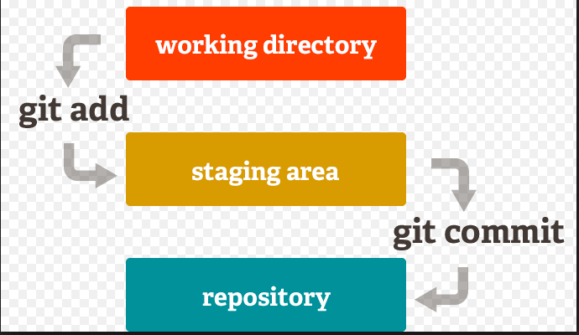

mkdir C:\Users\ratulp\Desktop\Git\gitExercise\01basics

cd C:\Users\ratulp\Desktop\Git\gitExercise\01basics

**initialize git here from directory** 01basics

all changes from this directory will be recorded in local git repository

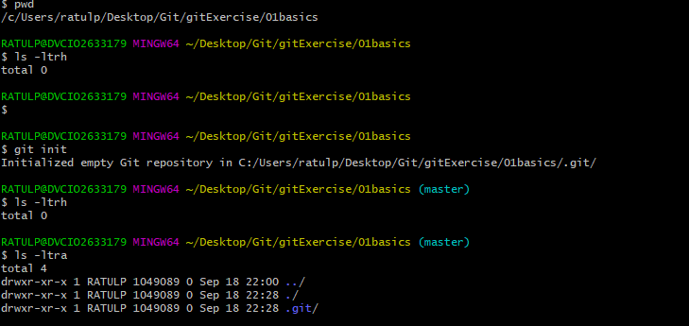

No need to go inside .git but for observation of contents of head, one can observe once

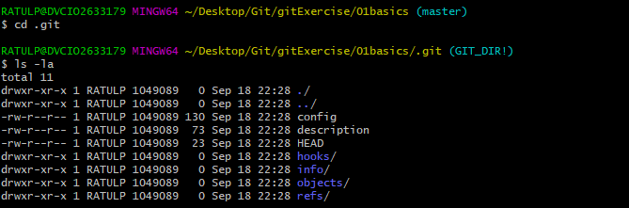

Git status will show whether any files are left to commit, or any files modified but the changes are not commited in git/or added in staging.

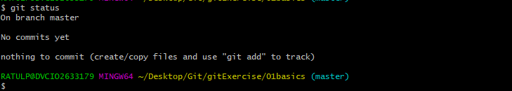

Added a file 01basics.txt in folder 01basics

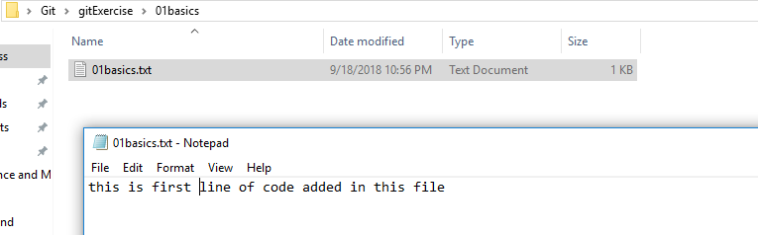

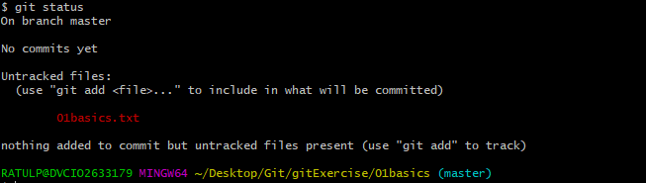

File added in staging area, but not commited to git repo

To add all the files in directory, git add .

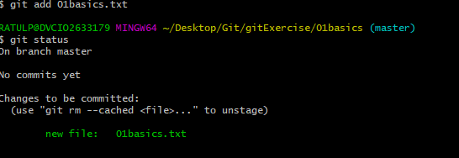

Changed file 01basics.txt

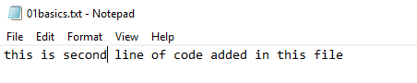

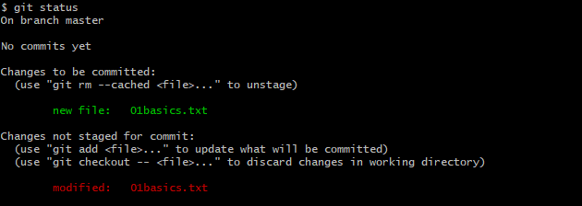

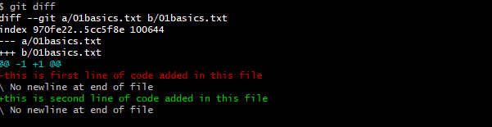

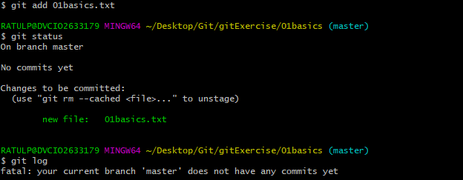

Commit the changes to git from staging area.

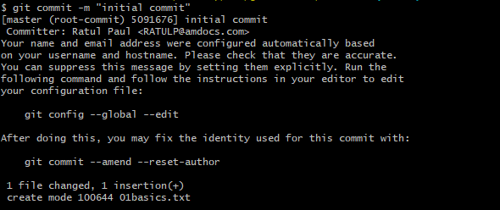

Check the git log to see the commits

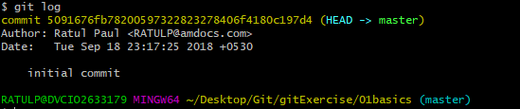

Changed the file 01basics.txt

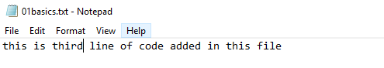

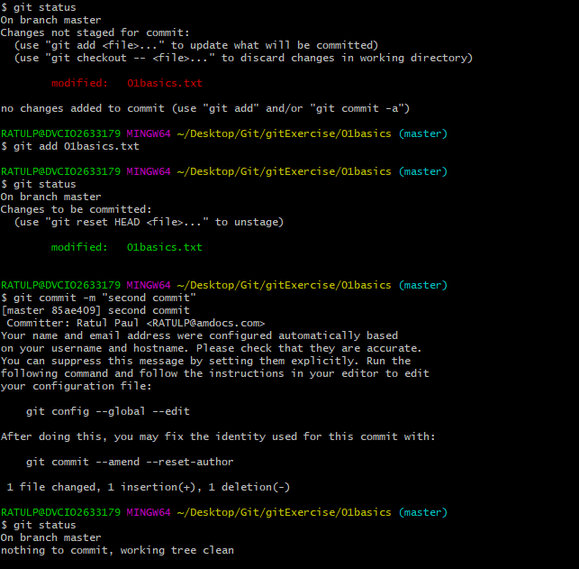

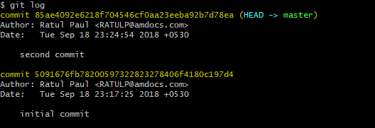

Rollback to initial commit, where it was written “second”

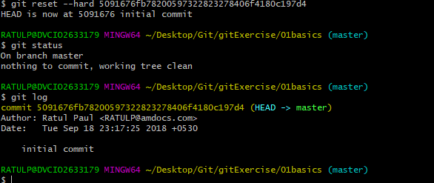

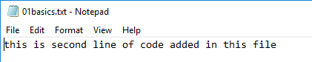

**Changing second to third in the file, and commit again with “third commit”**

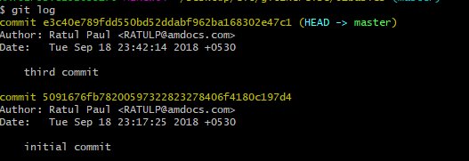

This time we go back to initial commit but the HEAD still points to third commit and changes of initial commit are visible in file but third commit contents are not blown away like before.

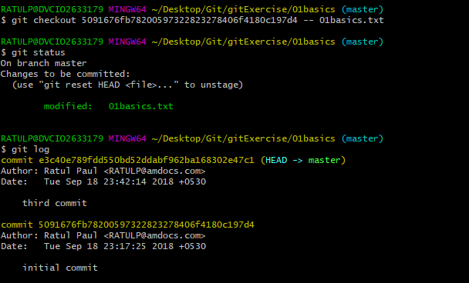

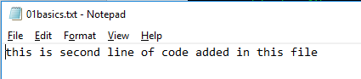

To list all files inside master



To drop files from git repo

Created a file delete.txt

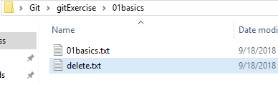

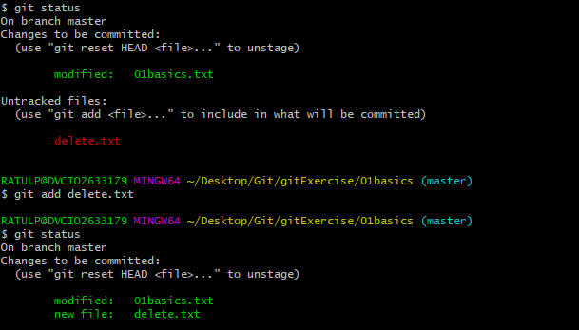

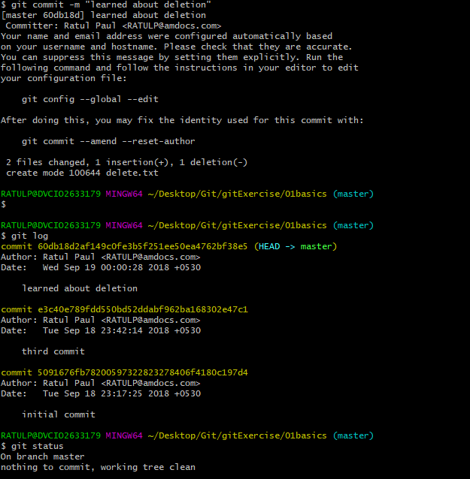

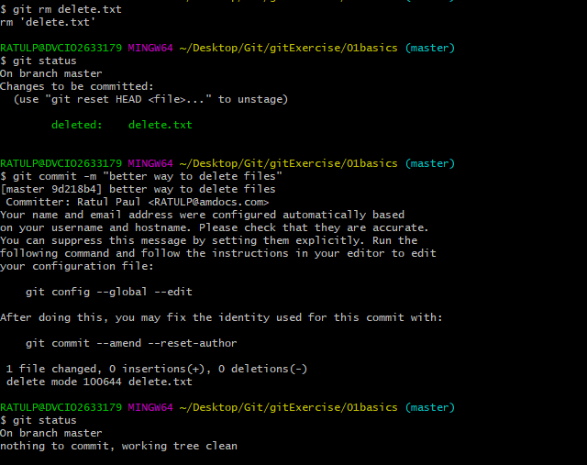

To keep the files of git in remote cloud provided by github

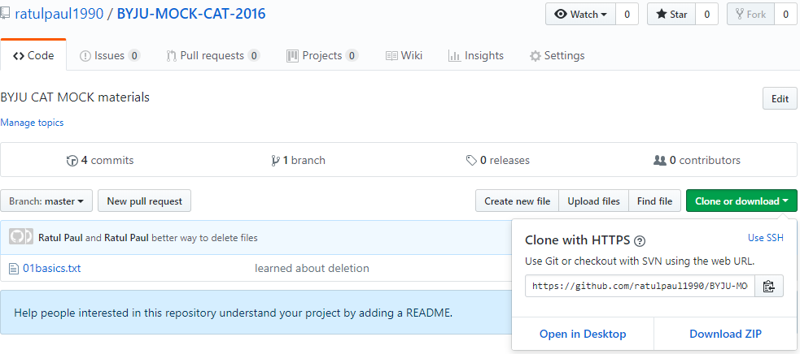

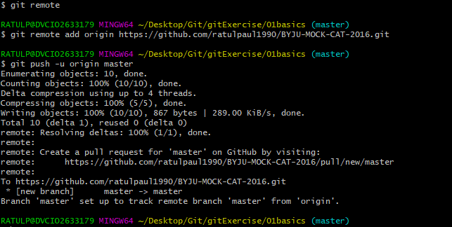

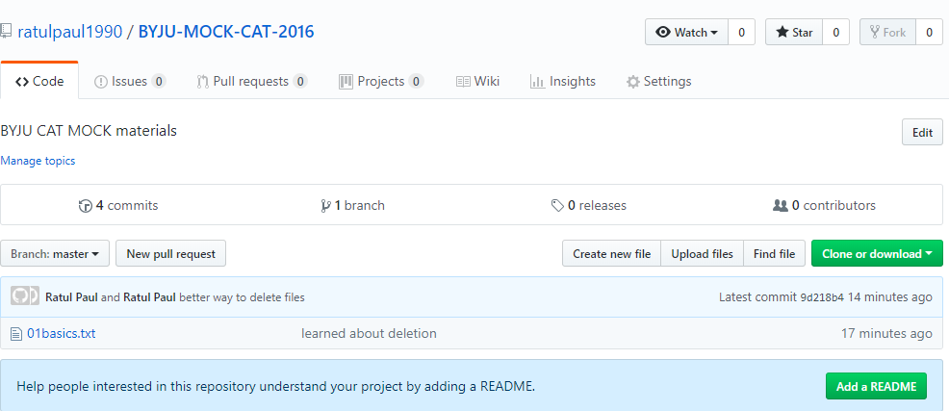

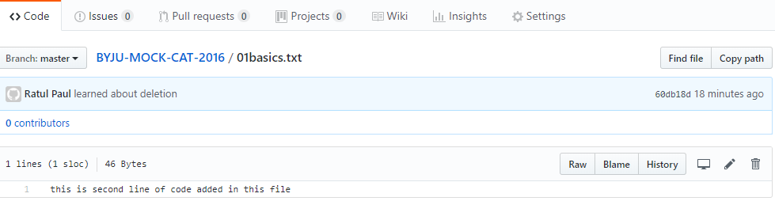

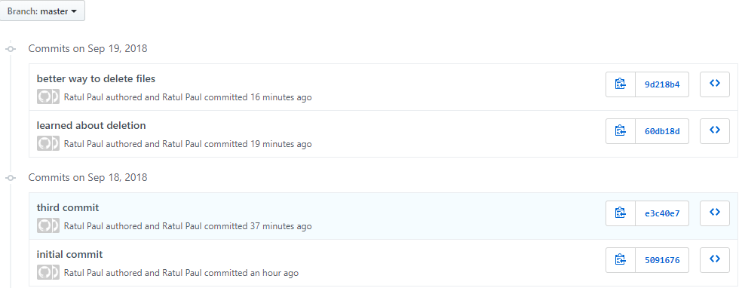

Git clone to bring from remote github to local repository

go to empty directory not present in git repository

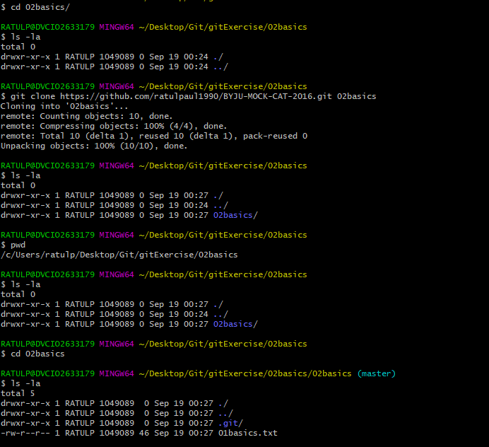

**Additional commands**

git reset HEAD filename (to remove from stage)

.gitignore( to ignore files from working directory)

git rm --cached filename(in case the extension of file to not keep in repository is already committed, then can remove this way)

.gitkeep(to keep track of empty folder,else empty folder is not tracked) not in official document

git log --online

git log --online -3

git log --since="2018-08-22"

git log --until="2018-08-22"

git log --since="2018-08-22" --until="2018-08-22"

git log --since="1 week ago"

git log --author"ratul Paul"

git log --grep="ignoring"

git log commitno..commitno

git branch new_nav

git merge fasty(will add branch to main branch)