My Spacetime is Made of Numbers and Poor Decisions

***Inside the Quantum Golomb Simulator That Accidentally Discovered the Universe***

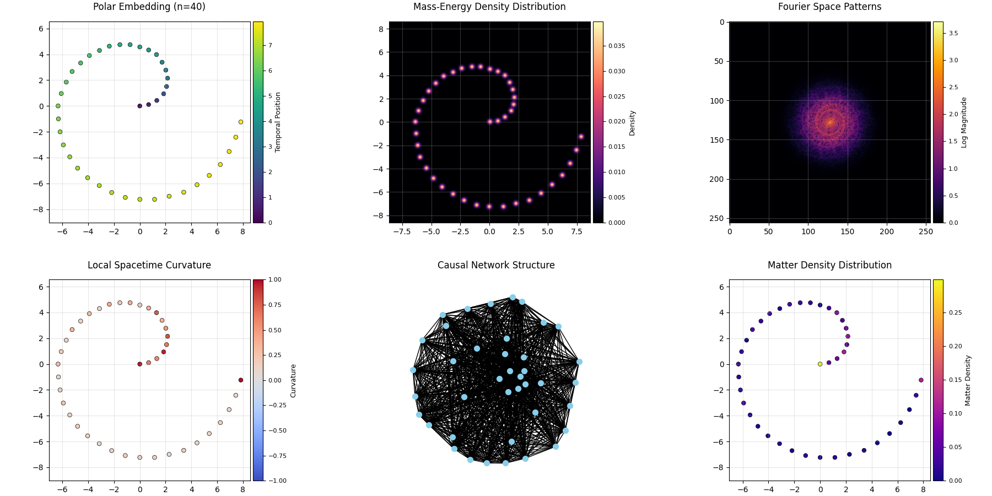

"Some say the universe began with a bang. Mine began with [0, 1] and a poorly tuned random number generator."  
  
Welcome, traveler.  
Have you ever looked at the cosmos and thought:  
"This would make more sense if it were entirely based on Golomb rulers and mild quantum chaos"?

**No?**

Well, buckle up anyway, because that's exactly what I built.  
Alternate title for my Nobel submission:  
Emergent Quantum Geometry in Golomb Rulers: A Computational Approach to Spacetime Foam

# Prelude: What Is a Quantum Golomb Spacetime?

A Golomb ruler is a set of marks placed along a line such that no two pairs of marks measure the same distance. It's basically a comb where every gap is uniquely awkward. In math circles, they're prized. In my simulator, they're weaponized. Now, fuse this with:  
  
**- Quantum fluctuations  
- Curved space  
- A completely made-up (but emergent) matter field  
- A sprinkle of guilt-based causality**  
  
…and you get something suspiciously like a universe.

# Step 1: The Birth of My Sad Little Cosmos

My universe begins with two lonely marks:  
  
**initial_marks = [0, 1]**  
  
They are the Adam and Eve of our integer Eden.  
But rather than fruit and snakes, we have a growth function:  
simulator.quantum_growth(max_marks=40, temperature=0.1)  
This lets our ruler expand by randomly choosing new integers that don't share distances with any existing ones.  
It's like Tinder for prime-time spacetime candidates:  
  
✔️ Unique distances  
✔️ Stable under rejection  
✔️ Occasionally influenced by gravity and regret

# A Quantized Spacetime, by Construction

Every mark in this ruler doesn't just sit at some random location — it defines a unique chunk of space. No two distances are the same, which means each tick carves out a non-overlapping quantum of length.

The result? A naturally quantized spacetime, where each interval is irreducible and unrepeatable — a discrete skeleton that stretches as far as you let it grow.  
  
Unlike grid-based quantization, this isn't uniform or optimal. But that's the beauty: non-optimal Golomb rulers give us wiggle room for structure, emergence, and chaos. The longer the ruler, the weirder (and more cosmic) the geometry becomes.

# Step 2: Quantum Decisions (and Other Mistakes)

The growth isn't deterministic. We add a temperature parameter — which determines how likely our simulator is to make, well… poor life choices.  
  
Low Temp (T ≈ 0.01): Rational, calculating mark  
High Temp (T ≈ 1.0):   
  
Party marks that pick their neighbors while blindfolded on a trampoline  
  
Sometimes, a mark is about to join but is nudged by what I call matter-curvature coupling:  
  
potential += matter_density[i] / (dist**2)  
  
It's like gravity… but only if gravity read a few blog posts and decided to freelance.  
An emergent matter field bubbling from the ruler's own curvature (like existential dread).  
And yes, despite quantum tantrums, the ruler remains rigorously Golomb-valid throughout.

# Step 3: Everything Gets Curvy

Once enough marks are born, I embed them in polar coordinates. Why? Because nothing says serious physics like taking something linear and twisting it into a circle for no reason.  
  
x = r * cos(θ)  
y = r * sin(θ)  
  
We then compute curvature at each point based on its two nearest neighbors. The more they lean in, the more our universe gets… squishy.  
The result: a tangled ring of events bending under their own numeric angst.

# Step 4: Density, Curvature, and Cosmic Cheese

We then ask questions no sane physicist ever should:  
  
- Where is matter densest in our polar Golomb spiral?  
- Can we estimate the fractal dimension of this chaos?  
- If I FFT the density, will I find God?  
  
Answer to the last:  
**No**.  
But I did find suspicious symmetry.

# Step 5: Causality… Sort Of

This simulator builds a causal network. Events are connected if one happens after another, and they're close enough in angular space.  
Each connection has a weight based on how "hard" it is for information to travel — kind of like inter-office emails, but with fewer reply-alls:  
  
weight = matter / (dt * (dtheta + 0.1))  
  
From this, we analyze:  
🕸️ - Who influences who  
📉 - How long messages take to travel  
📊 - Whether massive events are more connected (they are — just like on LinkedIn)

# Step 6: Measuring the Dimension of My Poor Choices

We estimate the fractal dimension of the resulting mass density field. This tells us if my universe is:  
  
- Flat and boring (D ≈ 2.0)  
- Slightly spicy (D ≈ 2.3)  
- A full-blown spaghetti dimension (D > 3), call CERN…  
  
Let's just say… I may have broken the dimensional barrier and entered fractal absurdity.

# Step 7: Physics Insights (or What Passes for Them)

My simulator even prints a helpful breakdown:  
  
**QUANTUM FLUCTUATIONS**  
Avg Position Deviation: 70.26 (Classical = 0)  
Fluctuation/Structure Ratio: 0.089  
  
Translation: Your universe jitters more than a caffeinated raccoon. It also tracks energy conservation, curvature–matter relationships, and how fast causality spreads. I don't guarantee these are meaningful, but they are formatted nicely, which is half the battle in theoretical physics.

# Theoretical Framing: Why This Might Not Be Total Nonsense

Let's pretend, for a moment, that this isn't just math and caffeine.  
Marks as Quantum Events

**Each mark represents a discrete spacetime event**— a fundamental unit of separation. Think of them as ticks on a cosmic clock, but spaced irregularly to avoid redundancy.  
This granularity provides a natural resolution to the singularity problem.  
Unique Distances as Superposition Protection

**The Golomb constraint** ensures no two intervals overlap. That's like quantum superposition — every state unique. Nothing gets overwritten or duplicated. Very unitary for something built from integers and regret.

**Growth as Quantum Cosmology**  
The ruler expands over time, driven by randomness and curvature. It behaves like a toy model of inflation: chaotic early on, but slowly revealing structure and dimensional flattening.

# Visualization: Because Pictures Distract From Regret

The simulator generates a six-panel infographic:  
📍 Polar Mark Embedding  
🌋 Mass Density  
🔊 FFT Analysis ("What if space made sound?")  
🪐 Curvature Field  
🌐 Causal Network  
🌈 Matter Distribution  
  
And yes — there are colorbars. Because even my fake spacetime has standards.

# Final Verdict

This quantum spacetime slice reveals a dimensionality of ≈2 + ε, efficient causal transport, and stable curvature–matter relations — suggesting hidden or compactified degrees of freedom beyond the apparent fractal structure.

# Final Thoughts (or How I Accidentally Created a Universe)

What started as a humble attempt to optimize Golomb ruler growth — just [0, 1] and a dream - somehow snowballed into a tiny quantum spacetime universe.  
By loosening the reins of optimization and sprinkling in quantum chaos, this code stopped just building rulers… and started building reality. Sort of.

Here's the kicker:  
As the simulation adds more marks, the fractal dimension drops.  
At teeny-tiny scales, spacetime looks like a wild fractal mess — all foam and fuzz.  
Zoom out, and things smooth out, settling into the neat, orderly cosmos we know and love.

This echoes serious physics ideas:  
Quantum foam at Planck scales giving way to classical smoothness.  
You may not reach the edge of the cosmos, but you'll definitely find the edge of common sense.

# Want to Try It Yourself?

Source Code (Python):  
🔗 https://github.com/ratwolfzero/Spacetime  
  
The full code and detailed simulation are available at the GitHub repository above for those curious to dive deeper.

# Quantum Spacetime Physics: Snapshot Summary

**Fractal Geometry**  
Estimated Dimension: 2.181  
➡️ Suggests spatial dimension ≈ 2 + ε → compactified geometry  
  
**Causal Network Analysis**  
Nodes: 40  
Edges: 780  
Connection Density: 0.500  
Causally Connected Pairs: 780 / 1560  
Avg Causal Time Distance: 904.35  
  
**Structure Insights:**  
🟢 First Event → 39 future events  
🔵 Midpoint → 19 future events  
🔴 Last Event → 0 outgoing  
  
**Matter–Curvature Coupling**  
Curvature Range: 3.0621  
Avg. Matter Density: 0.0398  
  
**Quantum Fluctuations**  
Avg Position Deviation: 70.2564  
Fluctuation/Structure Ratio: 0.0886  
  
**Causal Efficiency**  
Causal Efficiency: 0.3254  
Max Causal Horizon: 2779 time units  
  
**Energy Conservation**  
Total Matter: 1.5932  
Avg Curvature: 0.3632  
Matter/Curvature Ratio: 4.3866 → ✅ Stable

