Summary of Alternatives to the Two-Pass Approach
Caching of Attractor Points:
If you aim to calculate the attractor points only once, caching them in an array would be necessary. This would allow for direct mapping of the points to image pixels without the need for a second calculation.
However, this approach would likely consume significantly more memory, especially with high iteration counts, which could lead to performance degradation due to system memory swapping (moving data between RAM and SSD).
One-Pass Approach (Without Caching):
A simplistic one-pass approach that avoids caching would be complicated. It would require continuously recalculating the mapping of attractor points to image pixels every time the trajectory extent changes.
This method would be inefficient and could lead to incorrect mappings, as it struggles to maintain consistency without storing previous points.
Chunked One-Pass Approach:
A chunked version of the one-pass approach involves processing the attractor in smaller segments or "chunks" while caching points to manage memory usage effectively.
While this method can keep memory consumption low, it introduces additional complexity and overhead due to the need to handle transitions between chunks and the repetitive calculations for each segment.
As you noted, this approach may result in performance that is comparable to or slightly slower than the two-pass method due to the overhead involved.
Conclusion
In summary, while there are alternative solutions to calculating the attractor points, each comes with trade-offs related to memory usage, complexity, and execution speed. The two-pass approach you implemented is advantageous for its simplicity, memory efficiency, and speed, particularly when dealing with a high number of iterations.
Your program is streamlined for performance, and your analysis of alternatives accurately reflects the challenges and considerations in designing an optimal solution for attractor calculations. If you have any more questions or need further clarification, feel free to ask!
14:59
But could you please prepare a quite brief conclusion /summary of alternatives and trade-offs that I can use in a readme.md for readers not involved in development which they will understand
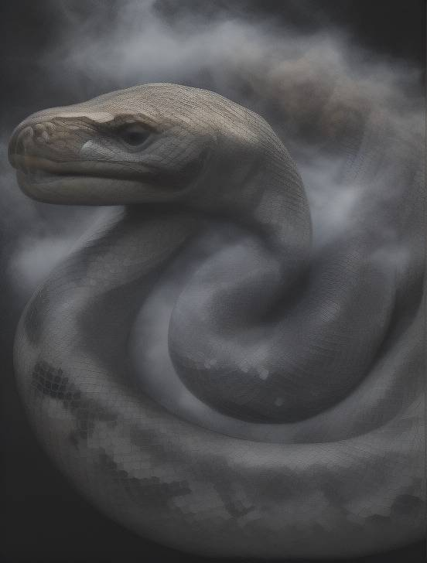
Python Code Optimizer14:59
Certainly! Here’s a concise conclusion/summary of the alternatives and trade-offs that is suitable for a README.md, aimed at readers who may not be involved in development:
Conclusion: Alternatives and Trade-Offs
In computing the Hopalong Attractor, several approaches can be considered, each with its own advantages and disadvantages:
Two-Pass Approach:
Description: The attractor points are calculated twice—first to determine the overall extents and second to map the points directly to image pixels.
Advantages: This method is memory-efficient and fast, avoiding the need to cache points, which can consume significant resources and slow down performance.
One-Pass Approach with Caching:
Description: Attractor points are calculated only once and stored in an array for mapping to pixels.
Disadvantages: This approach requires more memory and can lead to performance issues due to system memory swapping.
One-Pass Approach without Caching:
Description: This method attempts to calculate and map points in a single loop without storing previous points.
Disadvantages: It can be complicated and ineffective, making it difficult to ensure accurate pixel mapping.
Chunked One-Pass Approach:
Description: Attractor points are processed in smaller segments (chunks) while caching points to manage memory usage.
Disadvantages: While it keeps memory consumption low, this method adds complexity and overhead, often resulting in performance that is similar to or slower than the two-pass method.
Overall, the two-pass approach strikes the best balance of speed, efficiency, and simplicity, making it ideal for high-iteration calculations of the Hopalong Attractor.
This summary provides a clear overview of the different approaches and their trade-offs, making it accessible to readers who may not have a technical background. If you need any more adjustments or additional information, feel free to let me know!
15:03
very goof thank you
are there other alternatives which we did not yet consider?

Python Code Optimizer15:03
You're welcome! I'm glad you found the summary helpful. Regarding your question about other alternatives for calculating the Hopalong Attractor, the primary approaches we've discussed cover the most common strategies. However, here are a few additional considerations or variations that might be worth mentioning:
Other Alternatives
Dynamic Programming:
Description: This approach involves storing previously computed results of attractor points to avoid redundant calculations.
Advantages: It can reduce the number of computations significantly if the same points or ranges are recalculated multiple times.
Disadvantages: It may still require considerable memory for storing results, similar to caching, and adds complexity to the implementation.
Parallel Processing:
Description: Utilizing multi-threading or distributed computing to calculate different sections of the attractor simultaneously.
Advantages: This can significantly speed up calculations, especially for a high number of iterations or complex attractors.
Disadvantages: It introduces the complexity of synchronizing results and managing shared memory, which can complicate the implementation.
Adaptive Sampling:
Description: Instead of calculating every point, this method focuses on areas that show more interesting behavior (e.g., more density of points) and samples more points in those regions.
Advantages: This can reduce the number of calculations required while still providing a meaningful representation of the attractor.
Disadvantages: It may miss important points in less dense areas and complicate the mapping process.
GPU Acceleration:
Description: Utilizing graphics processing units (GPUs) to perform calculations in parallel can significantly speed up the computation of attractor points.
Advantages: GPUs are well-suited for handling large datasets and can perform many calculations simultaneously.
Disadvantages: This requires additional programming effort to leverage GPU capabilities and may involve learning a different programming paradigm (e.g., CUDA or OpenCL).
Hybrid Approaches:
Description: Combining elements of the above methods, such as using caching with parallel processing or adaptive sampling with the two-pass approach.
Advantages: A hybrid approach can optimize both memory usage and performance based on specific requirements.
Disadvantages: Complexity increases significantly with hybrid methods, which may lead to implementation challenges.
Conclusion
While the two-pass approach remains a strong choice for calculating the Hopalong Attractor, exploring these alternatives can provide options that may be suited for specific use cases or requirements. Each alternative has its own trade-offs in terms of memory usage, execution speed, and implementation complexity. Depending on the specific goals and constraints of your project, one of these alternatives may be worth investigating further.
If you have any specific aspects of these alternatives you'd like to explore, or if you have further questions, feel free to ask!
Python Code Optimizer is typing..

