10_We_Python_session
#91 Write a Python program to swap two variables.
Python: swapping two variables
Swapping two variables refers to mutually exchanging the values of the variables. Generally, this is done with the data in memory.
The simplest method to swap two variables is to use a third temporary variable :
define swap(a, b)
temp := a
a := b
b := temp
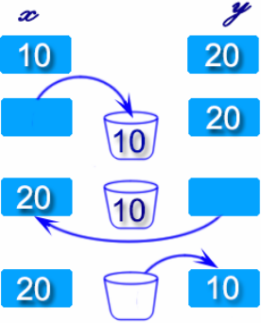
Python Code
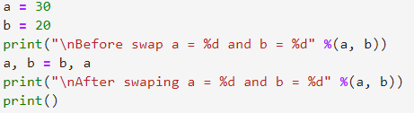
Output
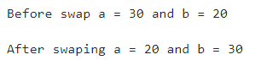

#92 Write a Python program to define a string containing special characters in various forms.
Python Code
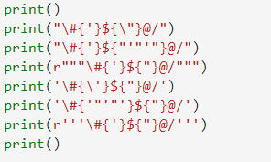
Output
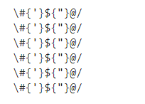

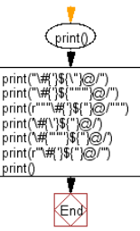

#93 Write a Python program to get the identity of an object.

Python Code
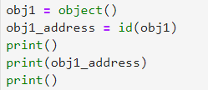
Output
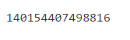

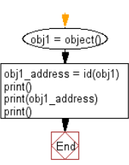

#94 Write a Python program to convert a byte string to a list of integers.

Python Code
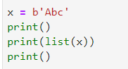
Output
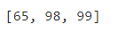

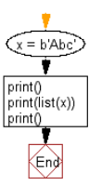

#95 Write a Python program to check whether a string is numeric.

Python Code
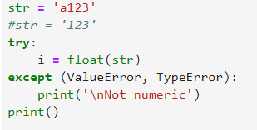
Output
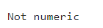

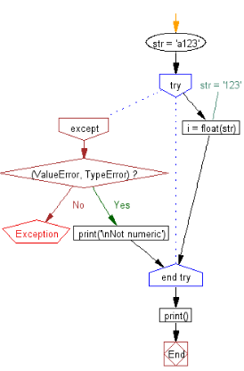

#96 Write a Python program to print the current call stack.

Python Code
Output

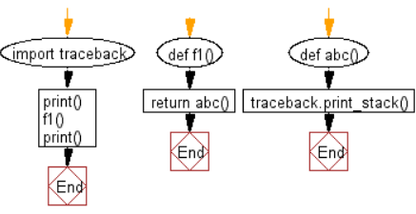

#97 Write a Python program to list the special variables used within the language.

Python Code
Output
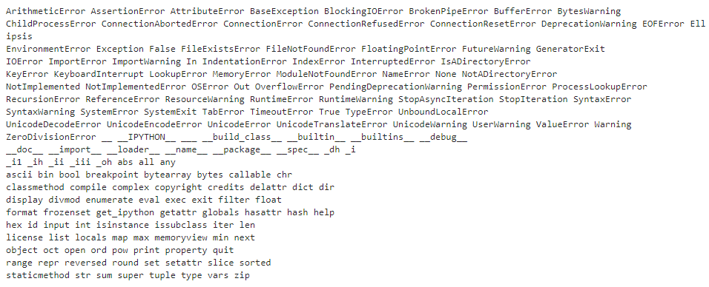
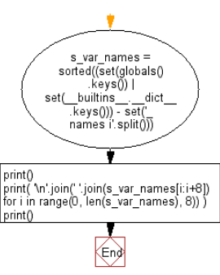

#98 Write a Python program to get the system time.

Note : The system time is important for debugging, network information, random number seeds, or something as simple as program performance.

Pictorial Presentation:

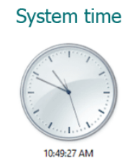

Python Code
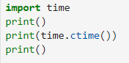
Output
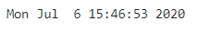

#99 Write a Python program to clear the screen or terminal.

Python Code
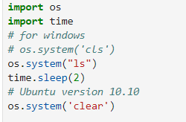
Output

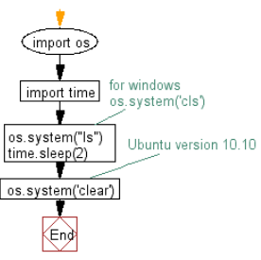

#100 Write a Python program to get the name of the host on which the routine is running.

Python Code
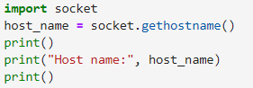
Output

