11_We_Python_session

# 101 Write a Python program to access and print a URL's content to the console.
Python Code
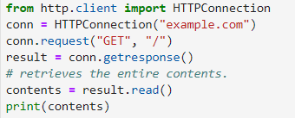
Output
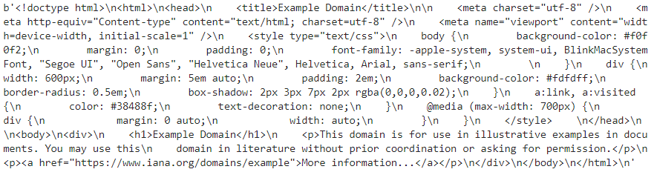
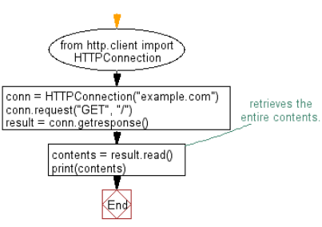

#102 Write a Python program to get system command output.

Python Code
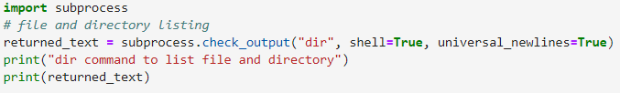
Output
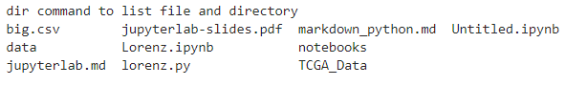

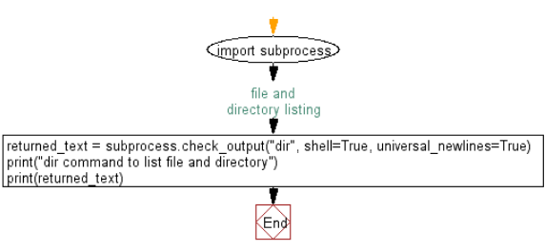

#103 Write a Python program to extract the filename from a given path.

Python Code
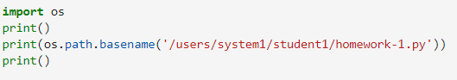
Output


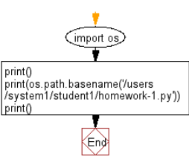
#104 Write a Python program to get the effective group id, effective user id, real group id, a list of supplemental group ids associated with the current process.
Note: Availability: Unix.

Python Code
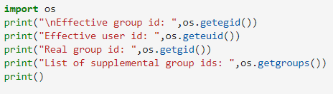
Output
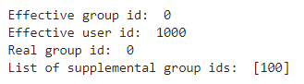

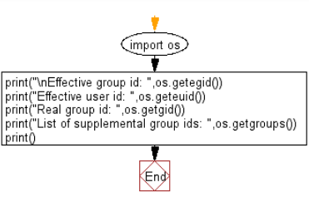
#105 Write a Python program to get the users environment.

Python Code
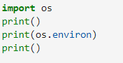
Output
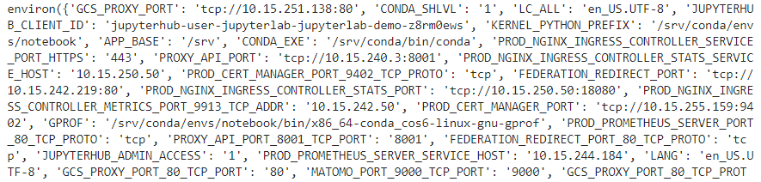

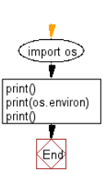
#106 Write a Python program to divide a path on the extension separator.

Python Code
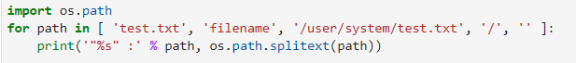
Output
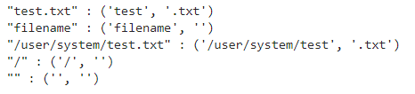

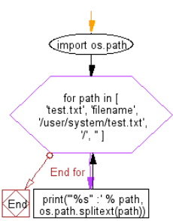
#107 Write a Python program to retrieve file properties.

Python Code
Output

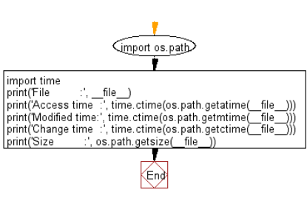
#108 Write a Python program to find path refers to a file or directory when you encounter a path name.

Python Code
Output

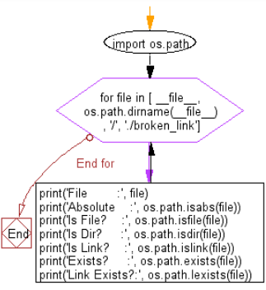
#109 Write a Python program to check if a number is positive, negative or zero.
Python Code
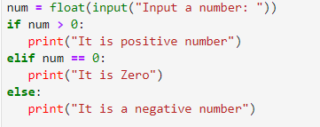
Output
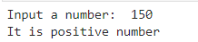

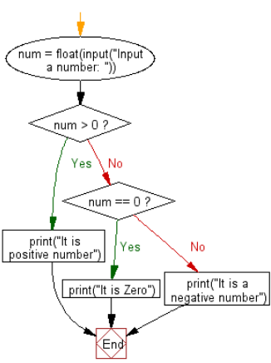
#110 Write a Python program to get numbers divisible by fifteen from a list using an anonymous function.

Python Code
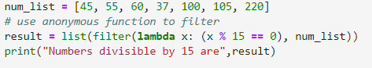
Output

