12_We_Python_session

# 111 Write a Python program to make file lists from current directory using a wildcard.

Python Code
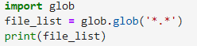
Output

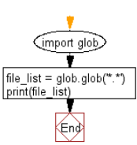
#112 Write a Python program to remove the first item from a specified list.

Python Code
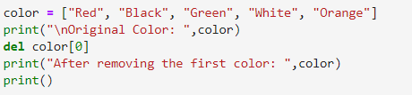
Output
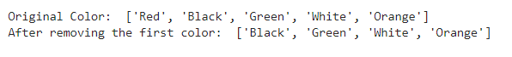

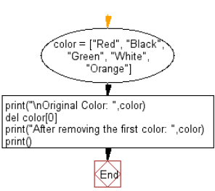
#113 Write a Python program to input a number, if it is not a number generate an error message.

Python Code
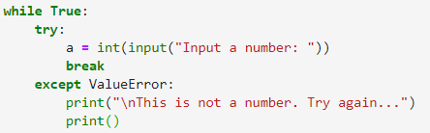
Output
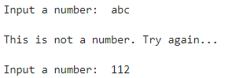

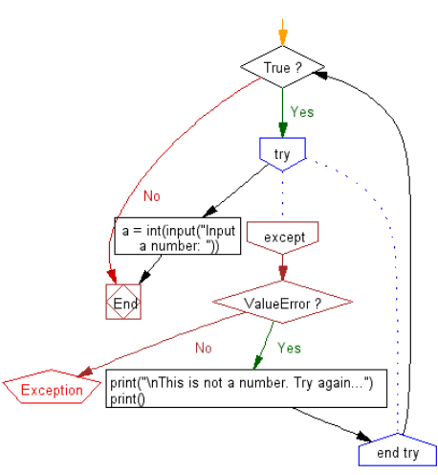
#114 Write a Python program to filter the positive numbers from a list.

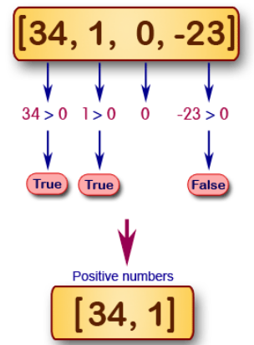

Python Code
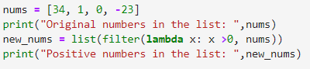
Output
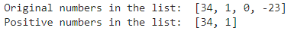

#115 Write a Python program to compute the product of a list of integers (without using for loop).

Python Code
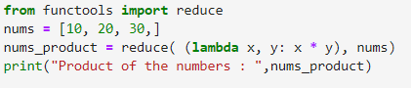
Output

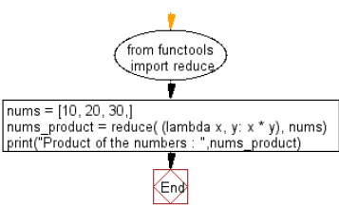
#116 Write a Python program to print Unicode characters.

Python Code
Output
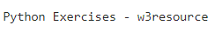

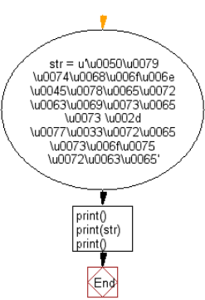
#117 Write a Python program to prove that two string variables of same value point same memory location.

Python Code
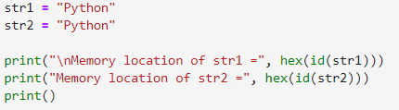
Output
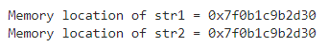

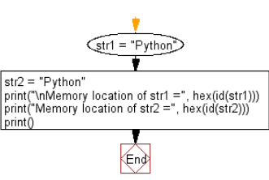
#118 Write a Python program to create a bytearray from a list.

Python Code
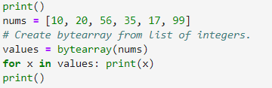
Output
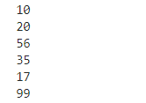
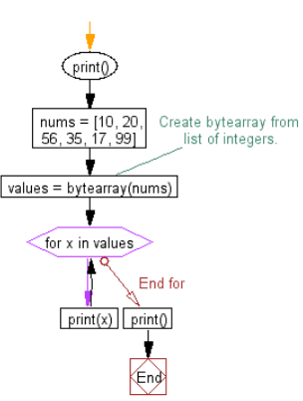
#119 Write a Python program to display a floating number in specified numbers.

Python Code
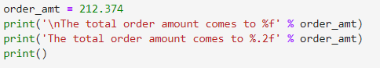
Output
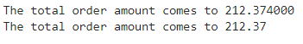

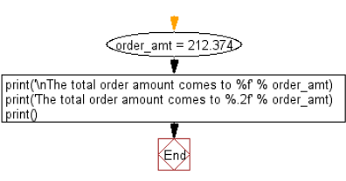
#120 Write a Python program to format a specified string to limit the number of characters to 6.

Python Code
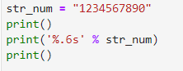
Output
