13_We_Python_session
# 121 Write a Python program to determine whether variable is defined or not.
Python Code
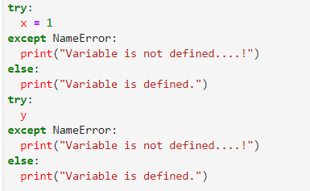
Output
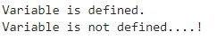
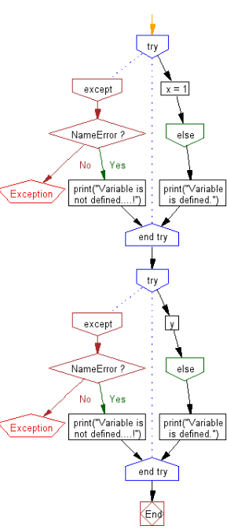

#122 Write a Python program to empty a variable without destroying it.

Sample data: n=20
d = {"x":200}
Expected Output: 0
{}

Python Code
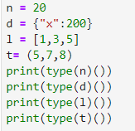
Output
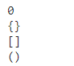

#123 Write a Python program to determine the largest and smallest integers, longs, floats.

Python Code
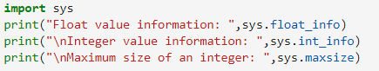
Output
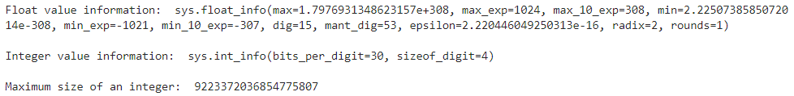

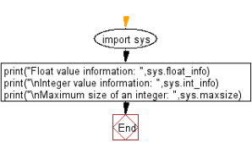
#124 Write a Python program to check whether multiple variables have the same value.

Pictorial Presentation:
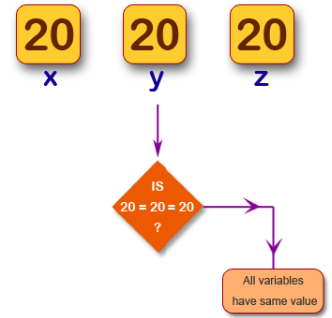

Python Code
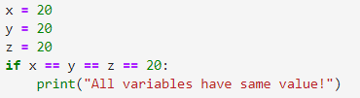
Output

#125 Write a Python program to sum of all counts in a collections.

Pictorial Presentation:
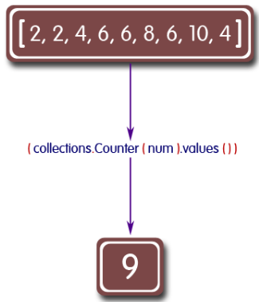
Python Code
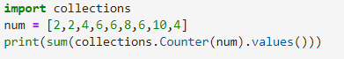
Output

#126 Write a Python program to get the actual module object for a given object.

Python Code
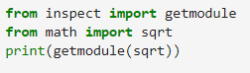
Output

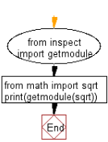

#127 Write a Python program to check whether an integer fits in 64 bits.

Python Code
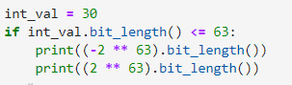
Output
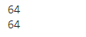

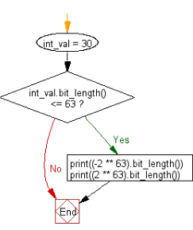
#128 Write a Python program to check whether lowercase letters exist in a string.

Pictorial Presentation:
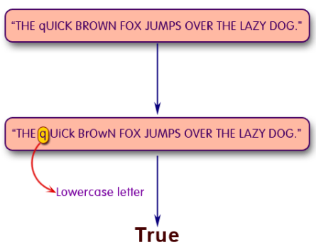

Python Code
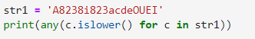
Output

#129 Write a Python program to add trailing and leading zeroes to a string.

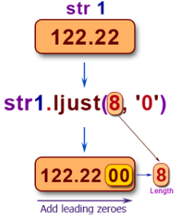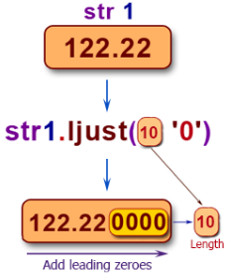

Python Code
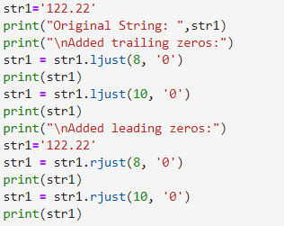
Output
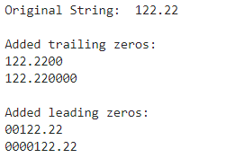

#130 Write a Python program to use double quotes to display strings.

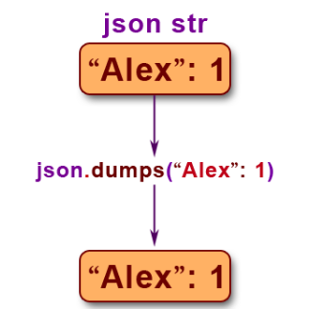

Python Code
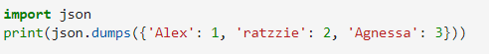
Output

