14_We_Python_session

# 131 Write a Python program to split a variable length string into variables.

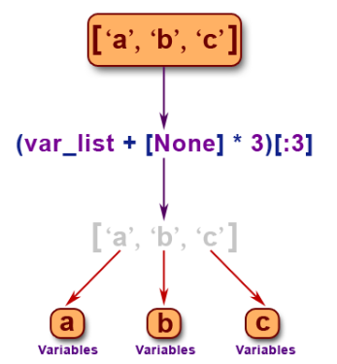
Python Code
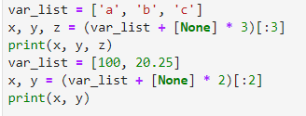
Output
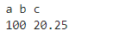

#132 Write a Python program to list home directory without absolute path.

Python Code
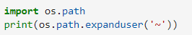
Output

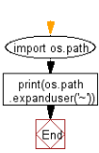
#133 Write a Python program to calculate the time runs (difference between start and current time)of a program.

Python Code
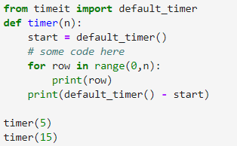
Output
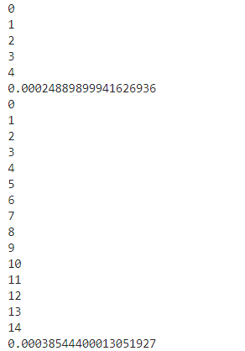

#134 Write a Python program to input two integers in a single line.

Python Code
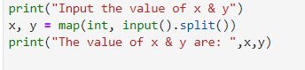
Output
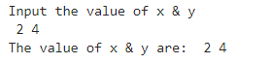

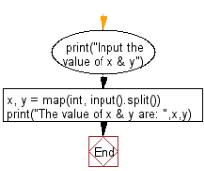
#135 Write a Python program to print a variable without spaces between values.

Sample value : x =30
Expected output : Value of x is "30"

Python Code
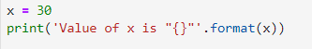
Output

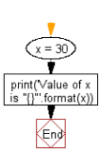
#136 Write a Python program to find files and skip directories of a given directory.

Python Code
Output

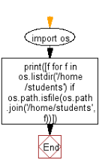
#137 Write a Python program to extract single key-value pair of a dictionary in variables

Python Code
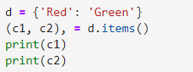
Output
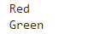

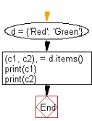

#138 Write a Python program to convert true to 1 and false to 0.

Python Code
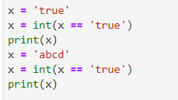
Output
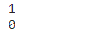

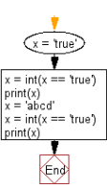
#139 Write a Python program to valid an IP address.
Python Code
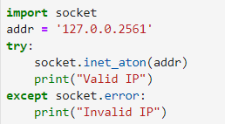
Output

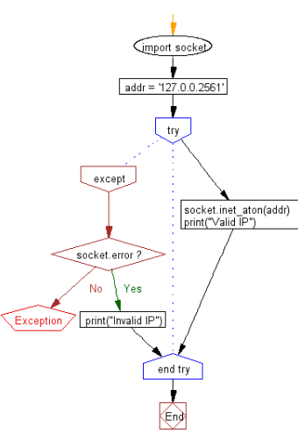
#140 Write a Python program to convert an integer to binary keep leading zeros.

Python Code
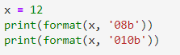
Output
