15_We_Python_session

# 141 Write a python program to convert decimal to hexadecimal.
Pictorial Presentation:
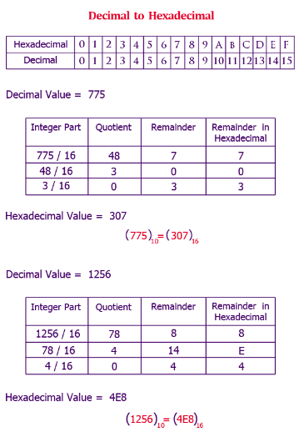
Python Code
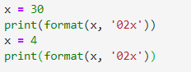
Output
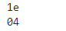

#142 Write a Python program to find the operating system name, platform and platform release date.

Python Code
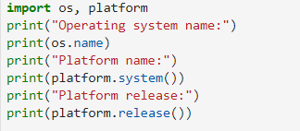
Output
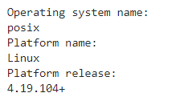

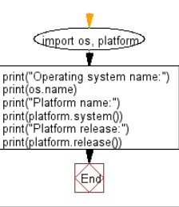
#143 Write a Python program to determine if the python shell is executing in 32bit or 64bit mode on operating system.

Python Code
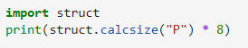
Output

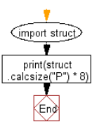
#144 Write a Python program to check whether a variable is integer or string.

Python Code
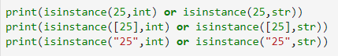
Output
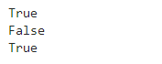

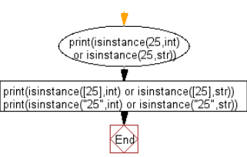
#145 Write a Python program to test if a variable is a list or tuple or a set.
Python Code
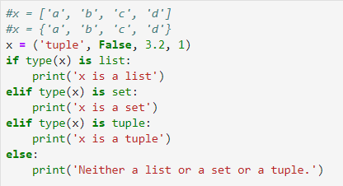
Output


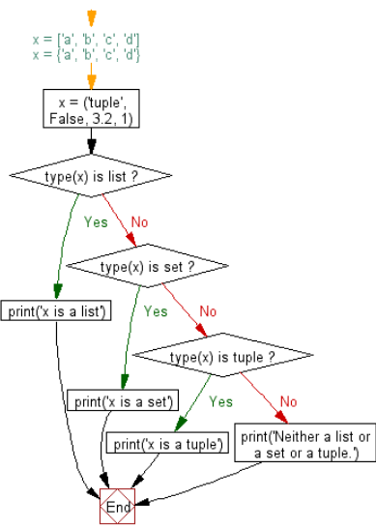
#146 Write a Python program to find the location of Python module sources.

Python Code
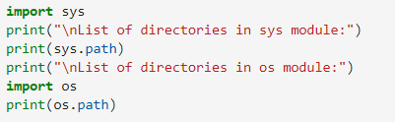
Output
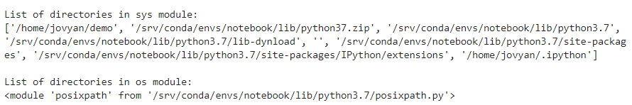

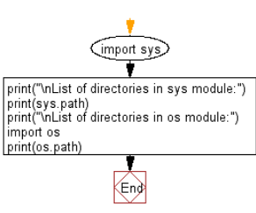
#147 Write a Python function to check whether a number is divisible by another number. Accept two integers values form the user.

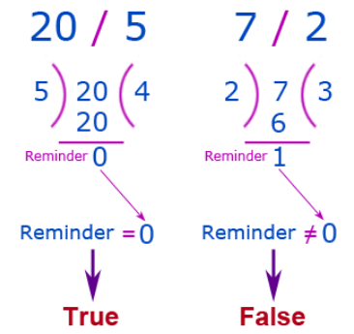
Python Code
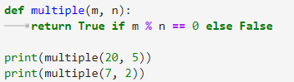
Output
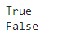

#148 Write a Python function to find the maximum and minimum numbers from a sequence of numbers.
Note: Do not use built-in functions.
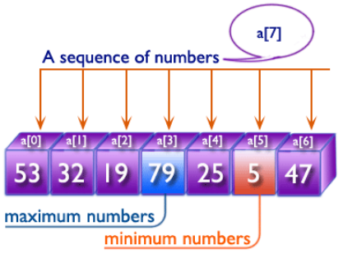
Python Code
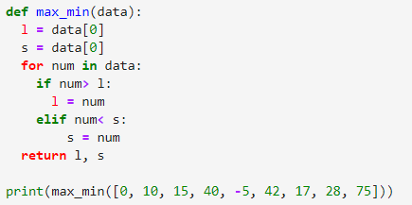
Output

#149 Write a Python function that takes a positive integer and returns the sum of the cube of all the positive integers smaller than the specified number.

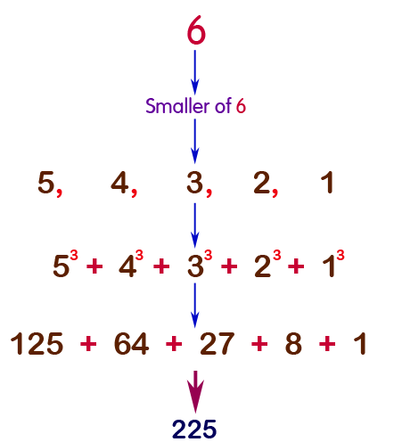

Python Code
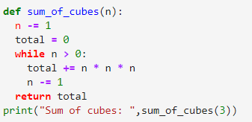
Output


#150 Write a Python function to find a distinct pair of numbers whose product is odd from a sequence of integer values
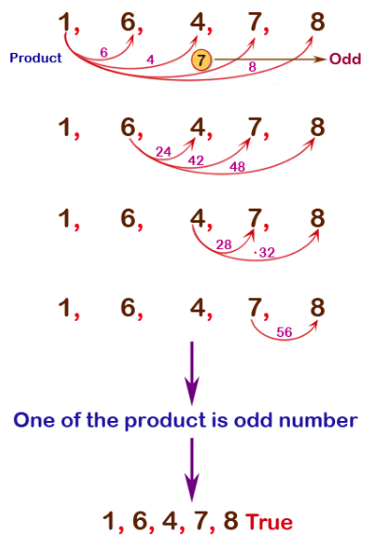
Python Code
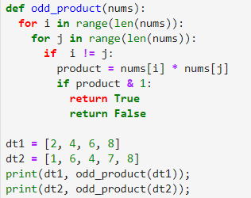
Output
