Python_exercise_session-2

# 1 Write a Python program to print the documents (syntax, description etc.) of Python built-in function(s).

Sample function: abs()

Python Docstring:
A docstring is a string literal that occurs as the first statement in a module, function, class, or method definition. Such a docstring becomes the __doc__ special attribute of that object.
All modules should normally have docstrings, and all functions and classes exported by a module should also have docstrings. Public methods (including the __init__ constructor) should also have docstrings.

Python Code
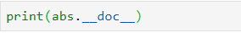
Output

#2 Write a Python program to print the calendar of a given month and year.
Note: Use 'calendar' module.
Python calendar.month(theyear, themonth, w=0, l=0):
The function returns a month’s calendar in a multi-line string using the formatmonth() of the TextCalendar class.
'l' specifies the number of lines that each week will use.
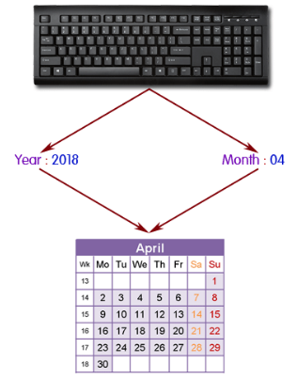
Python Code
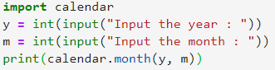
Output
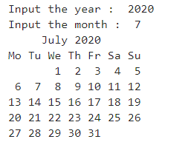

# 3 Write a Python program to print the following 'here document'.
Sample string:
a string that you "don't" have to escape
This
is a ....... multi-line
heredoc string --------> example

Python Code
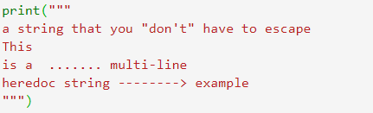
Output
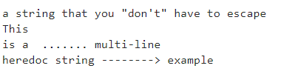

#4 Write a Python program to calculate number of days between two dates.
Python datetime.date(year, month, day) :
The function returns date object with same year, month and day. All arguments are required. Arguments may be integers, in the following ranges:
- MINYEAR <= year <= MAXYEAR
- 1 <= month <= 12
- 1 <= day <= number of days in the given month and year
If an argument outside those ranges is given, ValueError is raised.
- Note: The smallest year number allowed in a date or datetime object. MINYEAR is 1.
- The largest year number allowed in a date or datetime object. MAXYEAR is 9999.
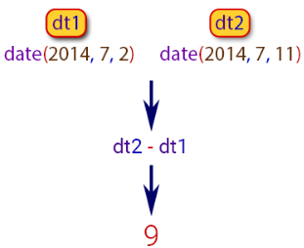
Python Code
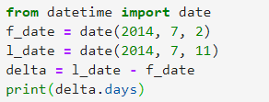
Output

# 5 Write a Python program to get the the volume of a sphere with radius 6.

Python: Volume of a Sphere
A sphere is a three-dimensional solid with no face, no edge, no base and no vertex. It is a round body with all points on its surface equidistant from the center. The volume of a sphere is measured in cubic units.
The volume of the sphere is : V = 4/3 × π × r3 = π × d3/6.
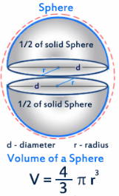

Python Code
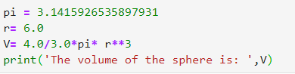
Output

# 6 Write a Python program to get the difference between a given number and 17, if the number is greater than 17 return double the absolute difference.
These statement blocks can have any number of statements, and can include about any kind of statement.
Pictorial Presentation:
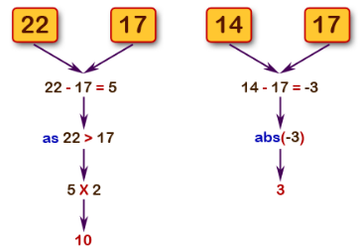
Python Code
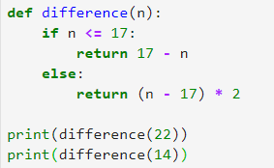
Output
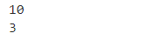

# 7 Write a Python program to test whether a number is within 100 of 1000 or 2000.

Python abs(x) function:
The function returns the absolute value of a number. The argument may be an integer or a floating point number. If the argument is a complex number, its magnitude is returned.
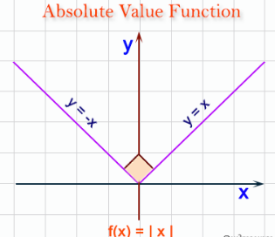
Python Code
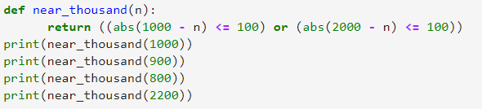
Output
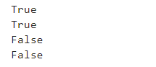

# 8 Write a Python program to calculate the sum of three given numbers, if the values are equal then return thrice of their sum.

Pictorial Presentation:
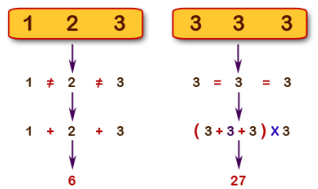
Python Code
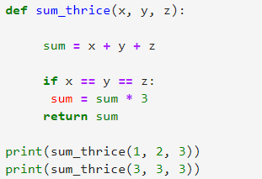
Output
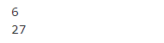

# 9 Write a Python program to get a new string from a given string where "Is" has been added to the front. If the given string already begins with "Is" then return the string unchanged.
Pictorial Presentation:
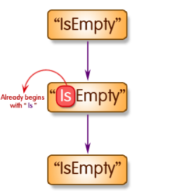
Python Code
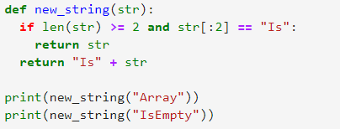
Output
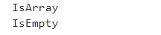

# 10 Write a Python program to get a string which is n (non-negative integer) copies of a given string.

Pictorial Presentation:
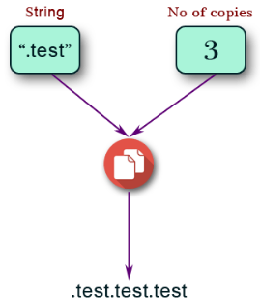

Python Code
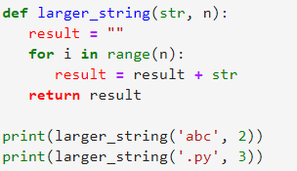
Output
