Python_exercise_session-3

#1 Write a Python program to find whether a given number (accept from the user) is even or odd, print out an appropriate message to the user.
Pictorial Presentation of Even Numbers: Pictorial Presentation of Odd Numbers:

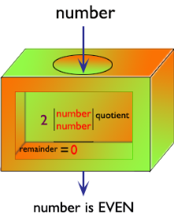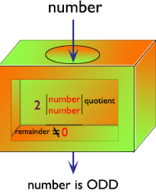
Python Code
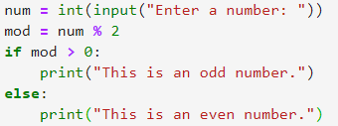
Output
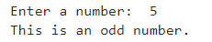

# 2 Write a Python program to count the number 4 in a given list.
Pictorial Presentation:
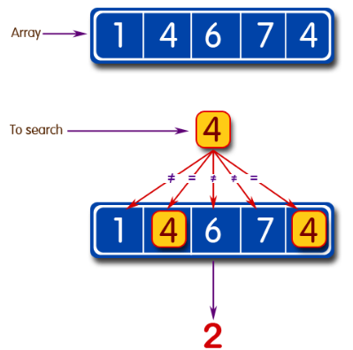
Python Code
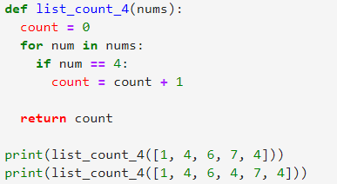
Output
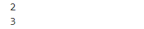

# 3 Write a Python program to get the n (non-negative integer) copies of the first 2 characters of a given string. Return the n copies of the whole string if the length is less than 2.
Pictorial Presentation:
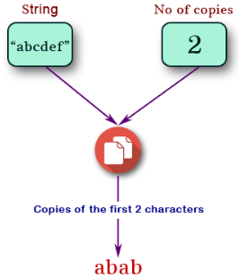
Python Code
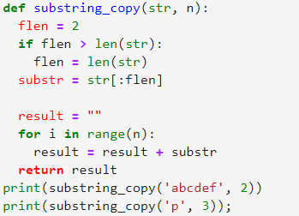
Output
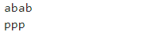

# 4 Write a Python program to test whether a passed letter is a vowel or not.
Pictorial Presentation:

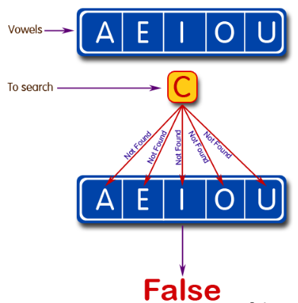

Python Code
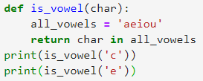
Output
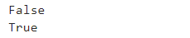

#5 Write a Python program to check whether a specified value is contained in a group of values.
Test Data:
3 -> [1, 5, 8, 3] : True
-1 -> [1, 5, 8, 3] : False
Pictorial Presentation:
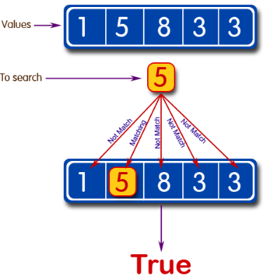
Python Code
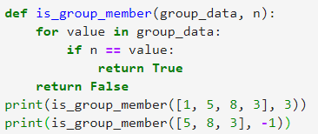
Output
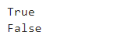

#6 Write a Python program to create a histogram from a given list of integers.
Pictorial Presentation:

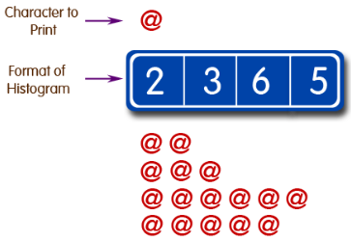
Python Code
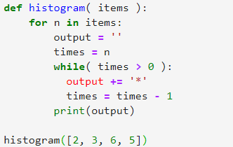
Output
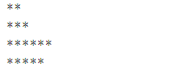

#7 Write a Python program to concatenate all elements in a list into a string and return it.
Pictorial Presentation:
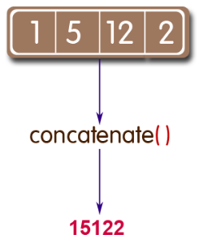
Python Code
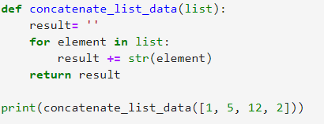
Output
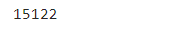

#8 Write a Python program to print out all even numbers from a given numbers list in the same order and stop the printing if any numbers that come after 237 in the sequence.
Sample numbers list:
numbers = [
386, 462, 47, 418, 907, 344, 236, 375, 823, 566, 597, 978, 328, 615, 953, 345,
399, 162, 758, 219, 918, 237, 412, 566, 826, 248, 866, 950, 626, 949, 687, 217,
815, 67, 104, 58, 512, 24, 892, 894, 767, 553, 81, 379, 843, 831, 445, 742, 717,
958,743, 527
]
Python Code
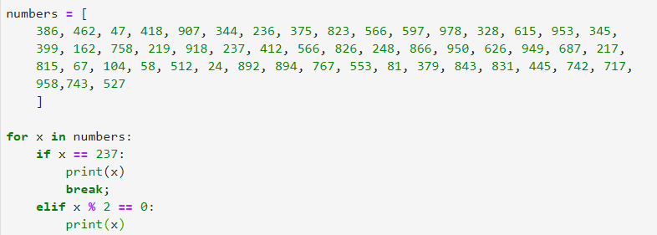
Output
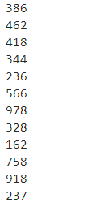

# 9 Write a Python program to print out a set containing all the colors from color_list_1 which are not present in color_list_2.
Test Data:
color_list_1 = set(["White", "Black", "Red"])
color_list_2 = set(["Red", "Green"])
Expected Output :
{'Black', 'White'}

Pictorial Presentation:
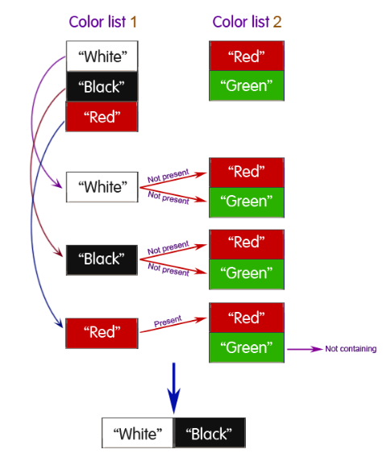

Python Code
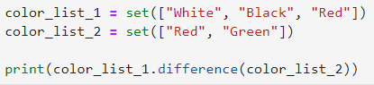
Output
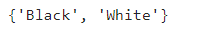

# 10 Write a Python program that will accept the base and height of a triangle and compute the area.

Python: Area of a triangle
A triangle is a polygon with three edges and three vertices. It is one of the basic shapes in geometry. A triangle with vertices A, B, and C is denoted triangle ABC.
- Vertex of a triangle: The point at which two sides of a triangle meet.
- Altitude of a triangle: The perpendicular segment from a vertex of a triangle to the line containing the opposite side.
- Base of a triangle: The side of a triangle to which an altitude is drawn.
- Height of a triangle: The length of an altitude.

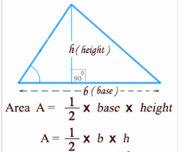

Python Code
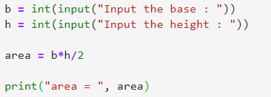
Output
