Python_exercise_session-4

#1 Write a Python program to compute the greatest common divisor (GCD) of two positive integers.
Pictorial Presentation:
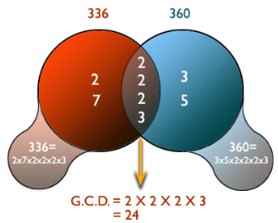
Python Code
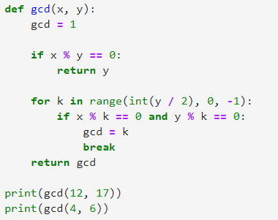
Output


#2 Write a Python program to get the least common multiple (LCM) of two positive integers.
Pictorial Presentation:
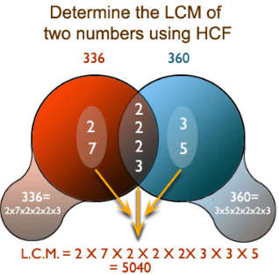

Python Code
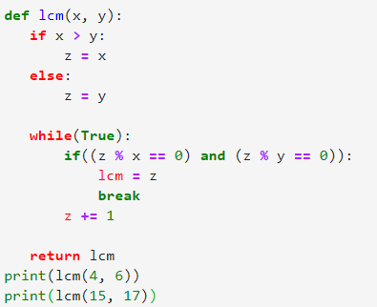
Output
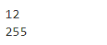

# 3 Write a Python program to sum of three given integers. However, if two values are equal sum will be zero.
Pictorial Presentation:
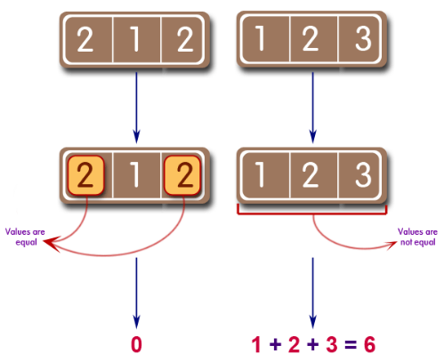
Python Code
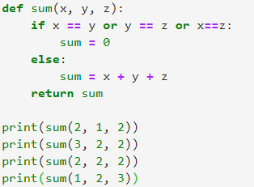
Output
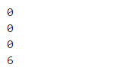

#4 Write a Python program to sum of two given integers. However, if the sum is between 15 to 20 it will return 20.
Pictorial Presentation:
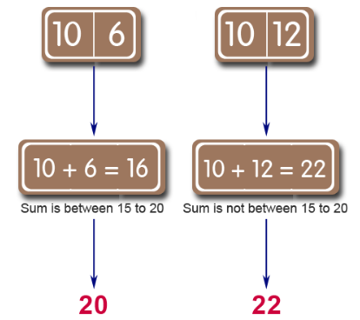
Python Code
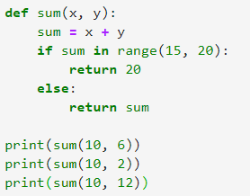
Output


#5 Write a Python program which will return true if the two given integer values are equal or their sum or difference is 5.
Pictorial Presentation:
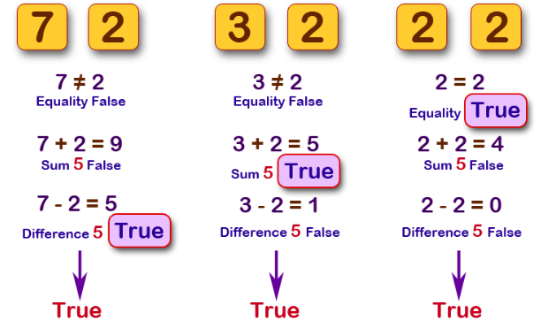
Python Code
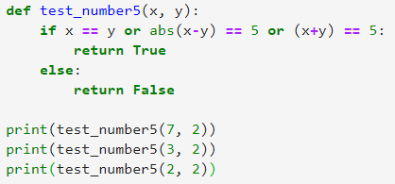
Output
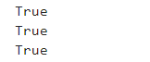

#6 Write a Python program to add two objects if both objects are an integer type.

Python Code
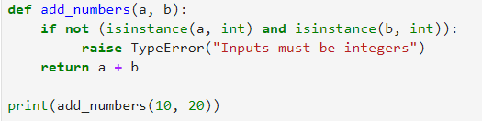
Output

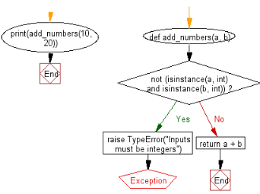

#7 Write a Python program to display your details like name, age, address in three different lines.
Pictorial Presentation:



Python Code
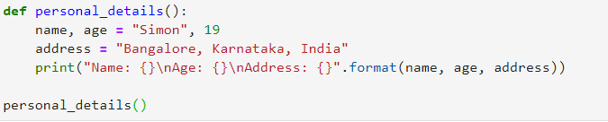
Output
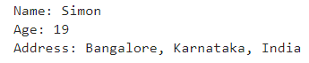

#8 Write a Python program to solve (x + y) * (x + y).

Python Code
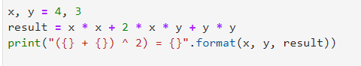
Output
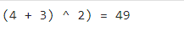

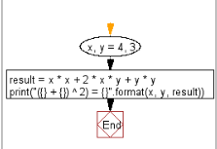

#9 Write a Python program to compute the future value of a specified principal amount, rate of interest, and a number of years.

Python Code
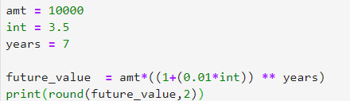
Output

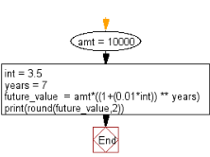

#10 Write a Python program to compute the distance between the points (x1, y1) and (x2, y2).

Pictorial Presentation:
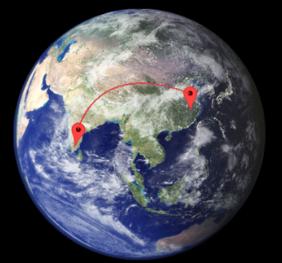

Python Code
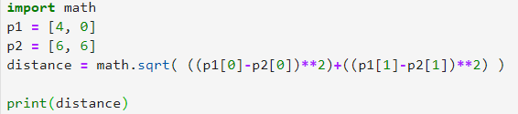
Output
