We_Python_exercises_session-5

#41 Write a Python program to check whether a file exists.

Python Code
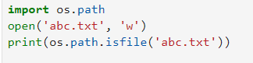
Output

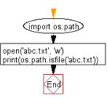

#42 Write a Python program to determine whether a Python shell is executing in 32bit or 64bit mode on OS?

Python Code
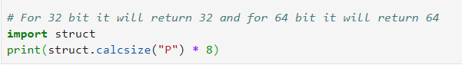
Output

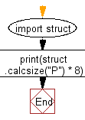
#43 Write a Python program to get OS name, platform and release information.

Python Code
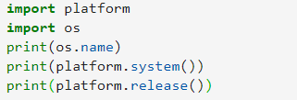
Output
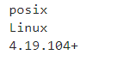

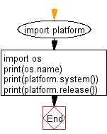

# 44 Write a Python program to locate Python site-packages.

Python Code
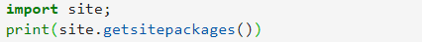
Output

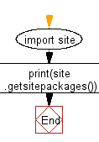

#45 Write a python program to call an external command in Python.

Python Code
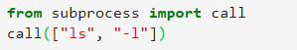
Output


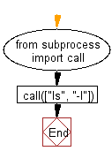
#46 Write a python program to get the path and name of the file that is currently executing.

Python Code
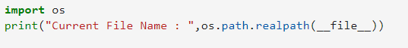
Output

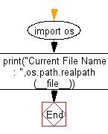

#47 Write a Python program to find out the number of CPUs using

Python Code
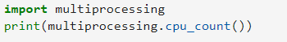
Output
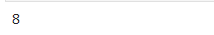

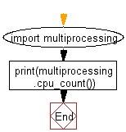
# 48 Write a Python program to parse a string to Float or Integer.

Python Code
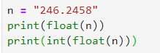
Output
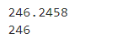

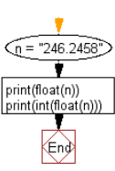
# 49 Write a Python program to list all files in a directory in Python.

Python Code
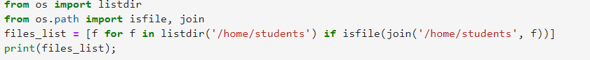
Output

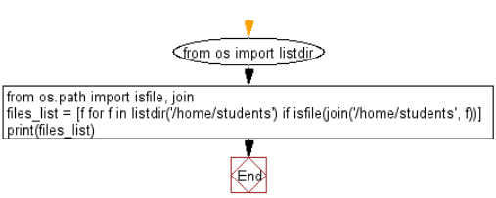
#50 Write a Python program to print without newline or space?

Python Code
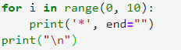
Output


