We_Python_exercise_session-6
#51 Write a Python program to determine profiling of Python programs.
Note: A profile is a set of statistics that describes how often and for how long various parts of the program executed. These statistics can be formatted into reports via the pstats module.
Python Code
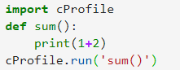
Output
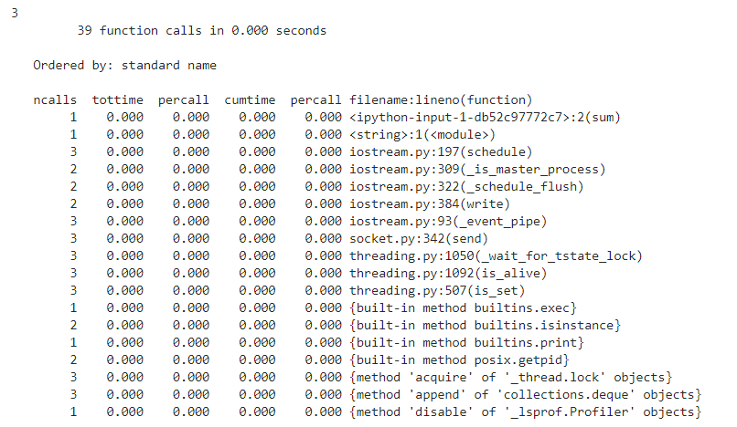
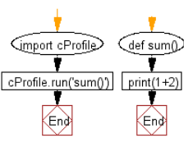

#52 Write a Python program to print to stderr.

Python Code
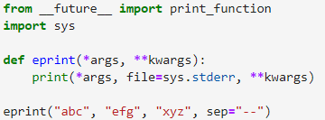
Output

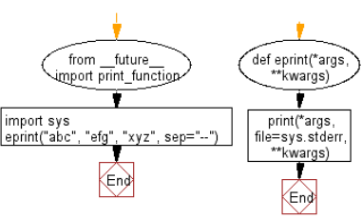

#53 Write a python program to access environment variables.

Python Code
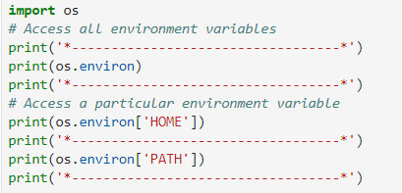
Output
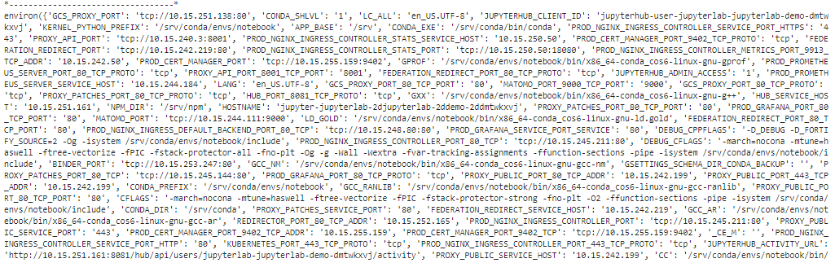
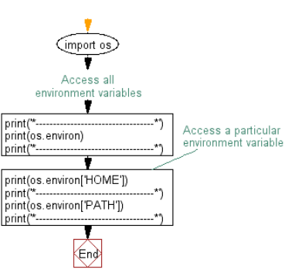

#54 Write a Python program to get the current username.

Note: Output might be differetn name.

Python Code
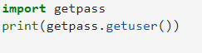
Output

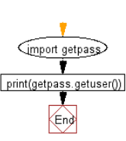

#55 Write a Python to find local IP addresses using Python's stdlib.

Python Code
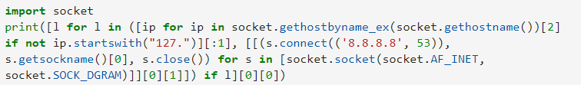
Output

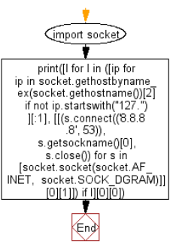

#56 Write a Python program to get height and the width of console window.

Python Code
Output

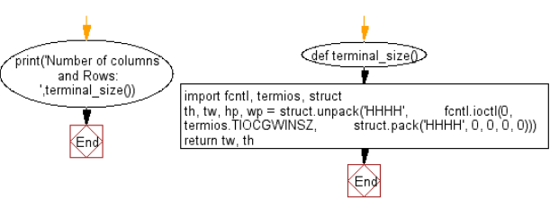

#57 Write a program to get execution time (in seconds) for a Python method.

Python Code
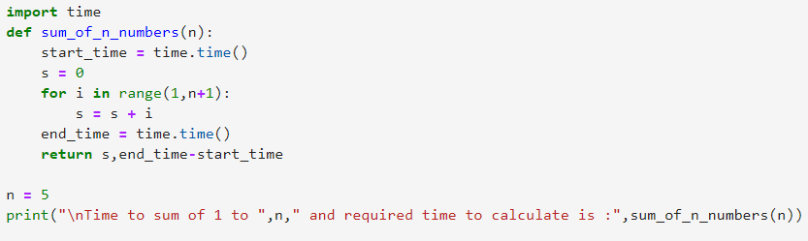
Output
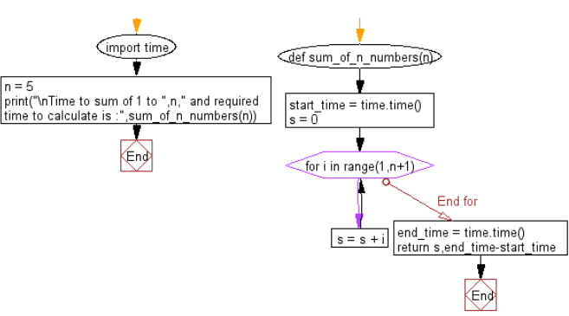

#58 Write a python program to find the sum of the first n positive integers.

Pictorial Presentation:
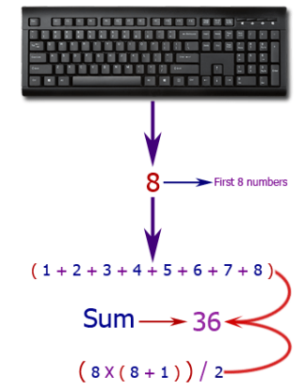

Python Code
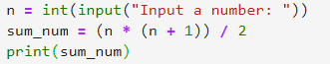
Output
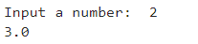

#59 Write a Python program to convert height (in feet and inches) to centimeters.
Pictorial Presentation:
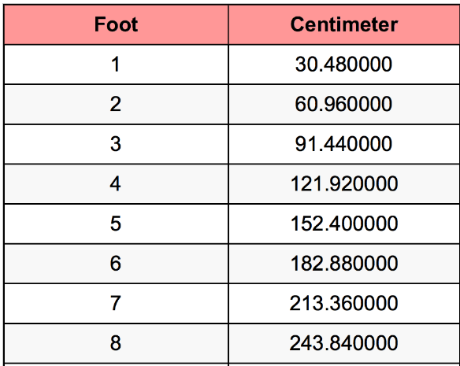

Python Code
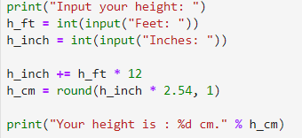
Output
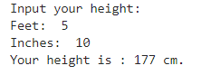

#60 Write a Python program to calculate the hypotenuse of a right angled triangle.

Pictorial Presentation:
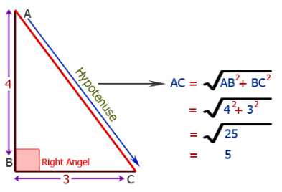
Python Code
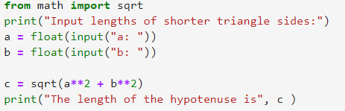
Output
