We_Python_exercise_session-7

#61 Write a Python program to convert the distance (in feet) to inches, yards, and miles.
Pictorial Presentation:
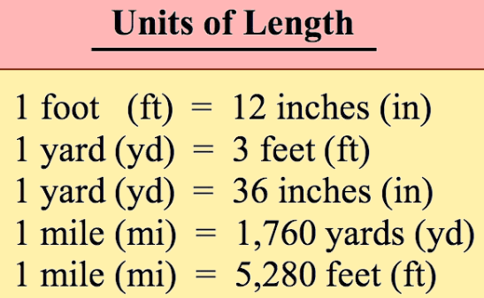
Python Code
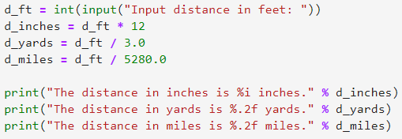
Output
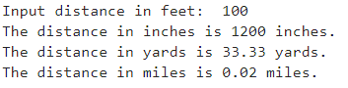

#62 Write a Python program to convert all units of time into seconds.

Pictorial Presentation:

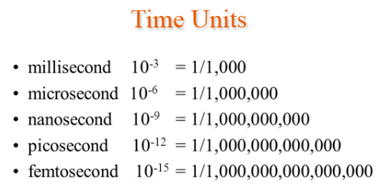
Python Code
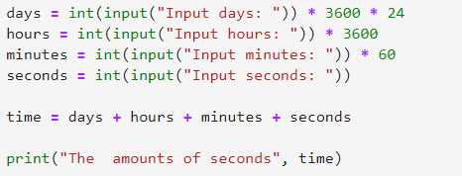
Output
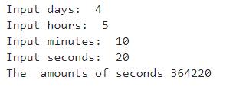

#63 Write a Python program to get an absolute file path.

Note: Your output may vary

Python Code
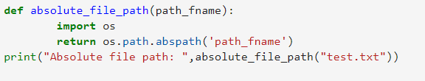
Output

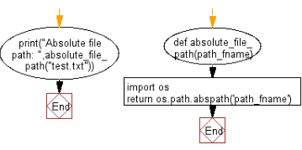

#64 Write a Python program to get file creation and modification date/times.

Python Code
Output

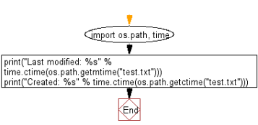

# 65Write a Python program to convert seconds to day, hour, minutes and seconds.

Pictorial Presentation:

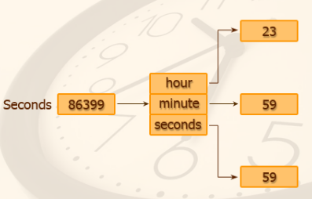

Python Code
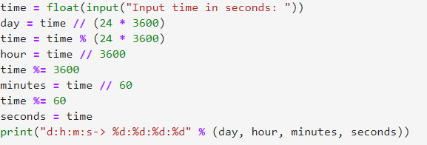
Output
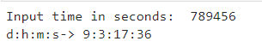

#66 Write a Python program to calculate body mass index.

Pictorial Presentation:

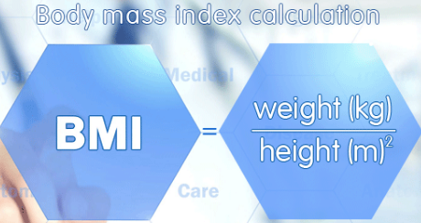

Python Code
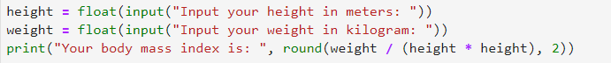
Output
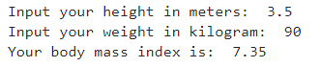

# 67 Write a Python program to convert pressure in kilopascals to pounds per square inch,a millimeter of mercury (mmHg) and atmosphere pressure.
Pictorial Presentation:
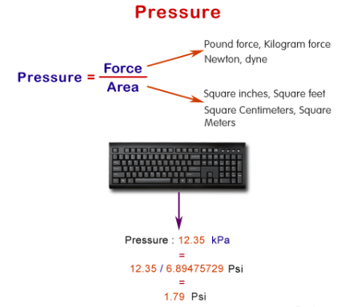

Python Code
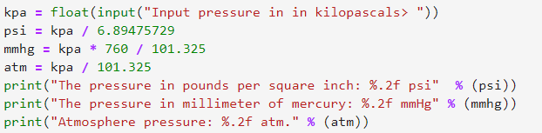
Output
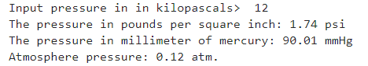

#68 Write a Python program to calculate the sum of the digits in an integer.

Pictorial Presentation:
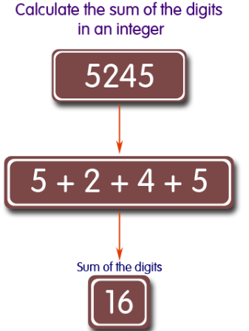
Python Code
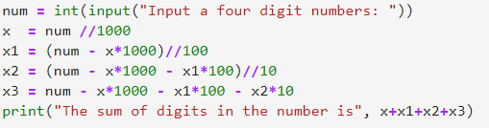
Output
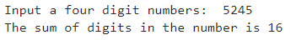

#69 Write a Python program to sort three integers without using conditional statements and loops.

Pictorial Presentation:
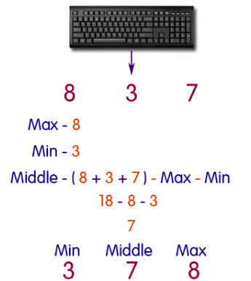

Python Code
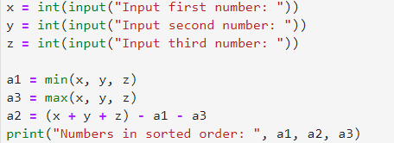
Output
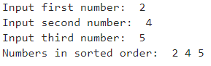

#70 Write a Python program to sort files by date.
Python Code
Output

