8_We_Python_session

#71 Write a Python program to get a directory listing, sorted by creation date.

Python Code
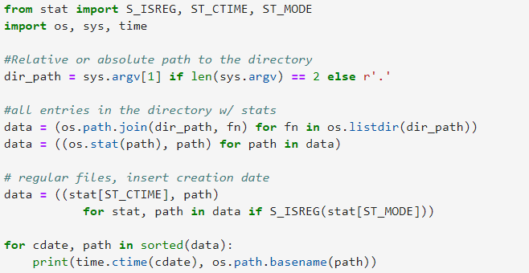
Output
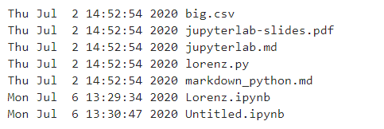

#72 Write a Python program to get the details of math module.

Python Code
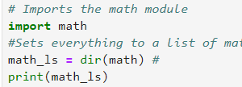
Output
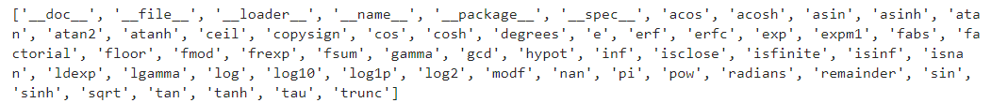

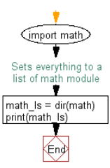

#73 Write a Python program to calculate midpoints of a line.
Pictorial Presentation:
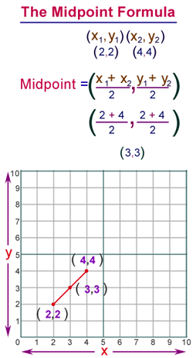
Python Code
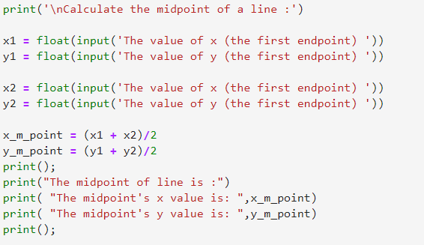
Output
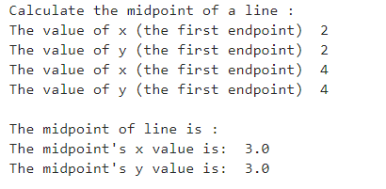

#74 Write a Python program to hash a word.

Python Code
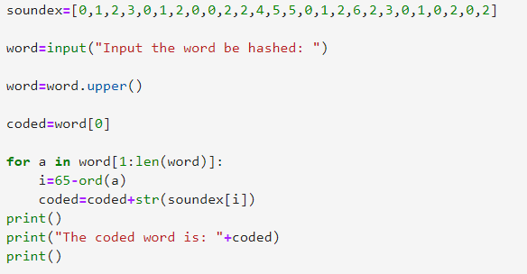
Output
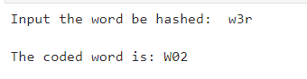

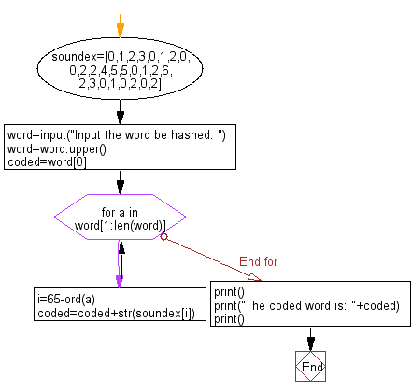

#75 Write a Python program to get the copyright information.

Pictorial Presentation:


Python Code
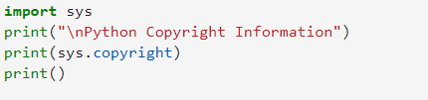
Output
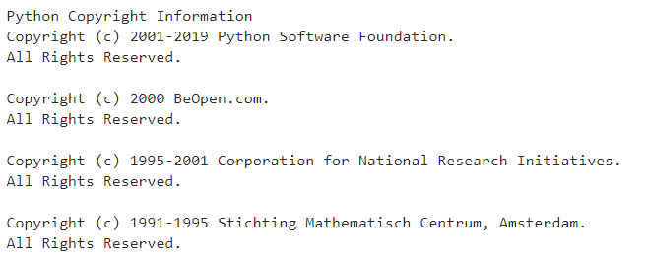

#76 Write a Python program to get the command-line arguments (name of the script, the number of arguments, arguments) passed to a script.

Python Code
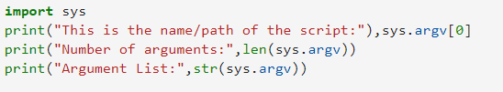
Output

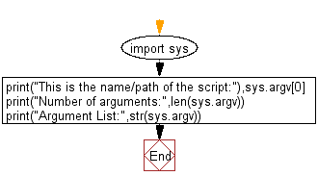

#77 Write a Python program to test whether the system is a big-endian platform or little-endian platform.

Python Code
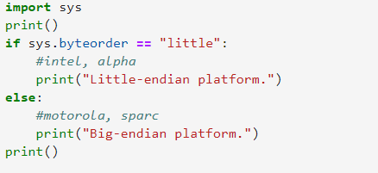
Output
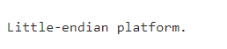

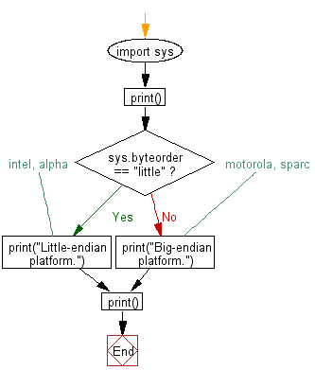

#78 Write a Python program to find the available built-in modules.

Python Code
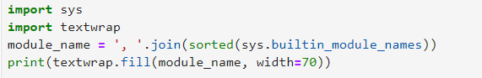
Output
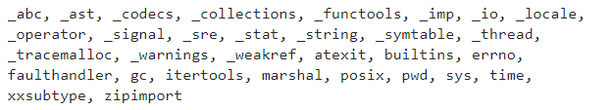

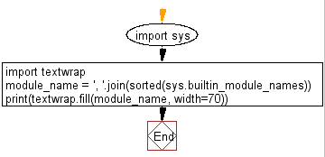

#79 Write a Python program to get the size of an object in bytes.

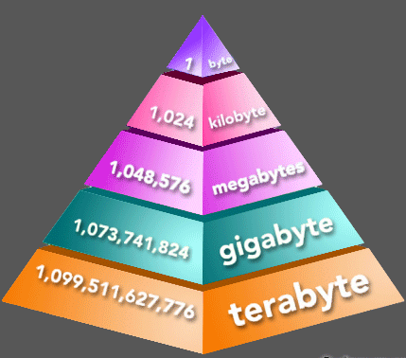
Python Code
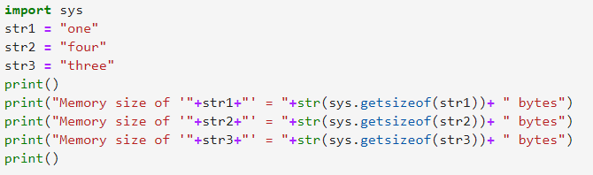
Output
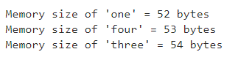

#80 Write a Python program to get the current value of the recursion limit.

Python Code
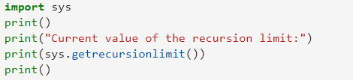
Output
