9_We_Python_session

#81 Write a Python program to concatenate N strings.

Pictorial Presentation:

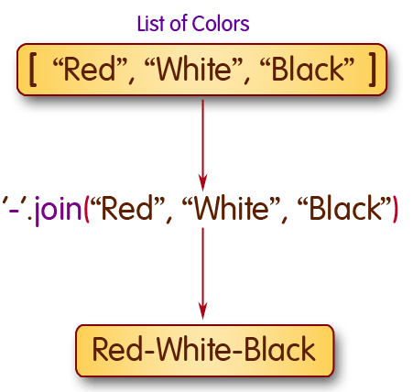
Python Code
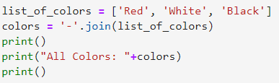
Output
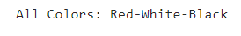

#82 Write a Python program to calculate the sum over a container.

Pictorial Presentation:

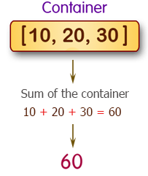

Python Code
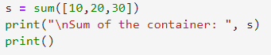
Output


#83 Write a Python program to test whether all numbers of a list is greater than a certain number.
Pictorial Presentation:
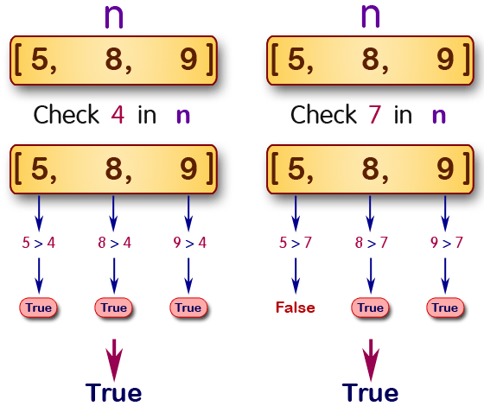
Python Code
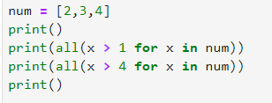
Output
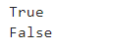

#84 Write a Python program to count the number of occurrence of a specific character in a string.
Pictorial Presentation:
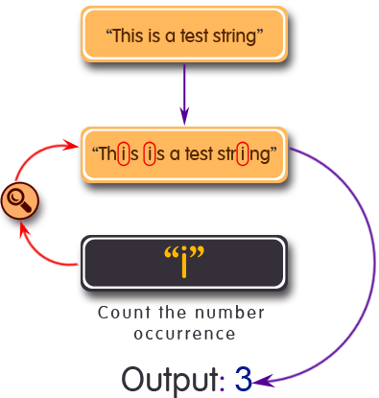

Python Code
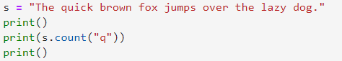
Output

#85 Write a Python program to check whether a file path is a file or a directory.
Python Code
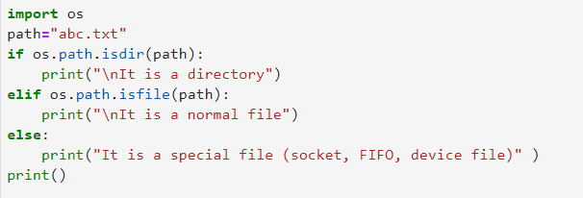
Output

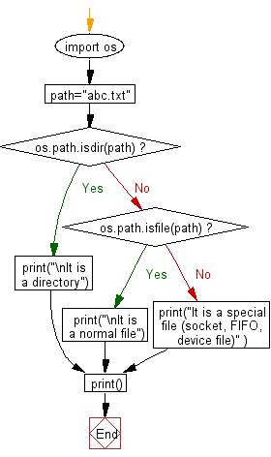

#86 Write a Python program to get the ASCII value of a character.
ASCII (Listeni/ˈæski/ ass-kee), abbreviated from American Standard Code for Information Interchange, is a character encoding standard. ASCII codes represent text in computers, telecommunications equipment, and other devices. Most modern character-encoding schemes are based on ASCII, although they support many additional characters.
Pictorial Presentation:
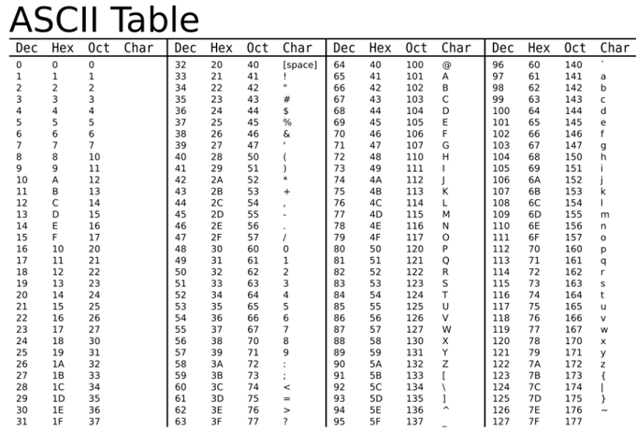

Python Code
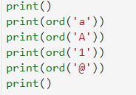
Output
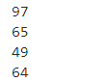

#87 Write a Python program to get the size of a file.

Python Code
Output

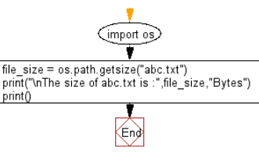
#88 Given variables x=30 and y=20, write a Python program to print "30+20=50".
Pictorial Presentation:
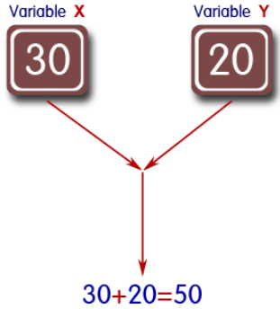
Python Code
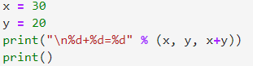
Output
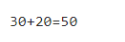

#89 Write a Python program to perform an action if a condition is true.

Given a variable name, if the value is 1, display the string "First day of a Month!" and do nothing if the value is not equal.

Python Code
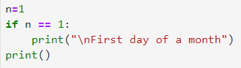
Output
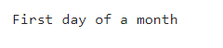

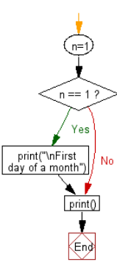
#90 Write a Python program to create a copy of its own source code.

Pictorial Presentation:

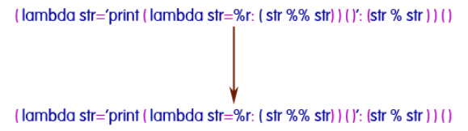
Python Code
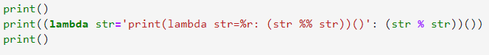
Output

