Python_Exercise_Session-1

#1 Write a Python program to print the following string in a specific format (see the output).
Sample String : "Twinkle, twinkle, little star, How I wonder what you are! Up above the world so high, Like a diamond in the sky. Twinkle, twinkle, little star, How I wonder what you are" Output :
Twinkle, twinkle, little star,
How I wonder what you are!
Up above the world so high,
Like a diamond in the sky.
Twinkle, twinkle, little star,
How I wonder what you are

Python Code
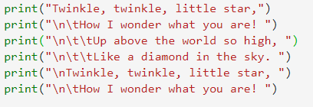
Output
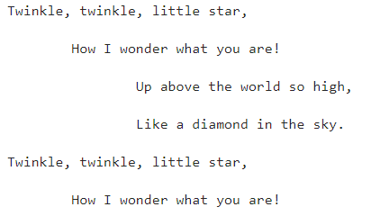

#2 Write a Python program to get the Python version you are using.
A string containing the version number of the Python interpreter plus additional information on the build number and compiler used. This string is displayed when the interactive interpreter is started.
Version info:
A tuple containing the five components of the version number: major, minor, micro, releaselevel, and serial. All values except releaselevel are integers; the release level is 'alpha', 'beta', 'candidate', or 'final'. The version_info value corresponding to the Python version 2.0 is (2, 0, 0, 'final', 0). The components can also be accessed by name, so sys.version_info[0] is equivalent to sys.version_info.major and so on.
Note : 'sys' module provides access to some variables used or maintained by the interpreter and to functions that interact strongly with the interpreter.

Python Code
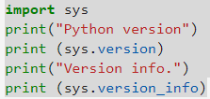
Output
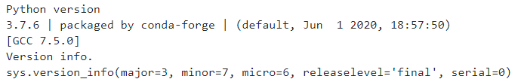

# 3 Write a Python program to display the current date and time.

Python datetime:
The datetime module supplies classes for manipulating dates and times in both simple and complex ways. datetime.now(tz=None) returns the current local date and time. If optional argument tz is None or not specified, this is like today().
date.strftime(format) returns a string representing the date, controlled by an explicit format string. Format codes referring to hours, minutes or seconds will see 0 values.

Python Code
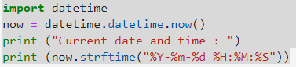
Output
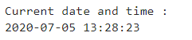

# 4 Write a Python program which accepts the user's first and last name and print them in reverse order with a space between them.
Python has two functions designed for accepting data directly from the user:
Python 2.x. -> raw_input() Python 3.x. -> input() raw_input():
raw_input() asks the user for a string of data and simply returns the string, the string data ended with a newline). It can also take an argument, which is displayed as a prompt before the user enters the data.
print raw_input('Input your name: ') prints out
Input your name: To assign the user's name to a variable "x" you can use following command :
x = raw_input('Input your name: ') input():
In 3.x .raw_input() is renamed to input(). input() function reads a line from sys.stdin and returns it with the trailing newline stripped.
To assign the user's name to a variable "y" you can use following command :
y = input('Input your name: ')

Python Code
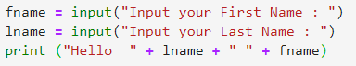
Output
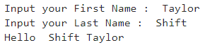

#5 Write a Python program which accepts the radius of a circle from the user and compute the area.

Python: Area of a Circle
In geometry, the area enclosed by a circle of radius r is πr2. Here the Greek letter π represents a constant, approximately equal to 3.14159, which is equal to the ratio of the circumference of any circle to its diameter.
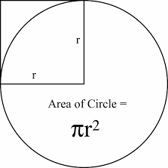
Sample Solution:-
Python Code:
Output

# 6 Write a Python program which accepts a sequence of comma-separated numbers from user and generate a list and a tuple with those numbers.
Sample data: 3, 5, 7, 23
Python list:
A list is a container which holds comma separated values (items or elements) between square brackets where items or elements need not all have the same type. In general, we can define a list as an object that contains multiple data items (elements). The contents of a list can be changed during program execution. The size of a list can also change during execution, as elements are added or removed from it.
Python tuple:
A tuple is container which holds a series of comma separated values (items or elements) between parentheses such as an (x, y) co-ordinate. Tuples are like lists, except they are immutable (i.e. you cannot change its content once created) and can hold mix data types.

Python code
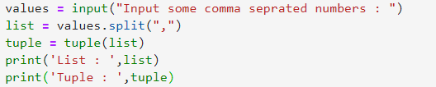
Output
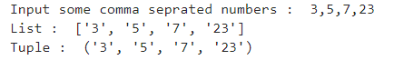

#7 Write a Python program to accept a filename from the user and print the extension of that.
Sample filename: abc.java
Python str.rsplit(sep=None, maxsplit=-1) function:
The function returns a list of the words of a given string using a separator as the delimiter string.
- If maxsplit is given, the list will have at most maxsplit+1 elements.
- If maxsplit is not specified or -1, then there is no limit on the number of splits.
- If sep is given, consecutive delimiters are not grouped together and are deemed to delimit empty strings.
- The sep argument may consist of multiple characters.
- Splitting an empty string with a specified separator returns [''].

Python code
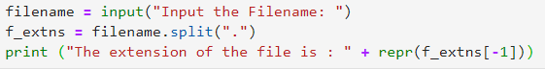
Output
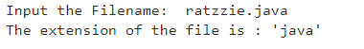

#8 Write a Python program to display the first and last colors from the following list.

color_list = ["Red","Green","White" ,"Black"]
Pictorial Presentation:
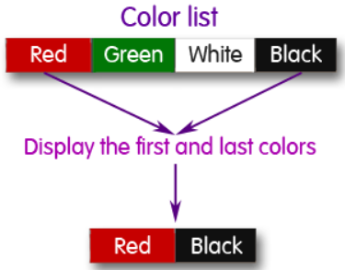

Python Code
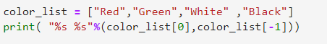
Output
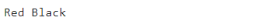

#9 Write a Python program to display the examination schedule. (extract the date from exam_st_date).

exam_st_date = (11, 12, 2014)
Sample Output: The examination will start from : 11 / 12 / 2014

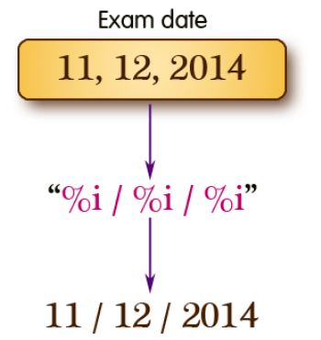

Python Code
Output

#10 Write a Python program that accepts an integer (n) and computes the value of n+nn+nnn.
Sample value of n is 5
Python int(x, base=10):
The function returns an integer object constructed from a number or string x, or return 0 if no arguments are given. If x is a number, return x.__int__(). For floating point numbers, this truncates towards zero.
- If x is not a number or if base is given, then x must be a string, bytes, or bytearray instance representing an integer literal in radix base
- The literal can be preceded by + or - (with no space in between) and surrounded by whitespace
- A base-n literal consists of the digits 0 to n-1, with a to z (or A to Z) having values 10 to 35. The default base is 10.
- The allowed values are 0 and 2-36. Base-2, -8, and -16 literals can be optionally prefixed with 0b/0B, 0o/0O, or 0x/0X, as with integer literals in code.
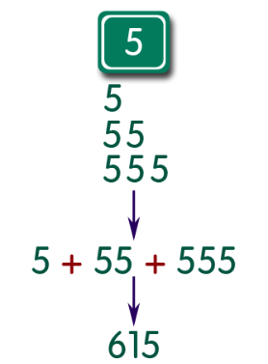

Python Code
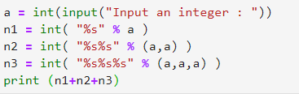
Output
