Executive summary

We developed a compartmental SEIR model to forecast the progression of the West Africa EVD epidemic using a flexible mathematical model (previously used in predicting a Marburg hemorrhagic fever outbreak) that allowed the reproductive number to change every 58 days.

Average times spent in each compartment/transition rates were taken from the recently published WHO Ebola Response Team model. The reporting quotient on 2014-08-25 was established as 1/2.5=40% by the US Centers for Disease Control and Prevention’s (CDC) report. We assumed that reporting quotient on 2014-03-22 was 1/1.5=67%. We then fit an exponentially decreasing time-dependent curve between the two points and extrapolated forward.

The CDC’s widely reported model estimated that to stem the tide of the epidemic 25% of all patients must be placed in Ebola Treatment Units (ETUs) and 45% must be at home or in a community setting such that there is a reduced risk for disease transmission. As of today (2014-10-22), we estimate that there are 1807 (1576, 2038) EVD active cases in treatment, with an additional 13153 (11071, 15236) EVD cases unreported and untreated. To reach the CDC targets, we need 3740 (3216, 4261) cases in ETUs and 6732 (5789, 7675) at home or in a community setting such that there is a reduced risk for disease transmission. In 28 days (2014-11-19), we will need 7639 (5715, 9563) EVD cases in ETUs and 13750 (10287, 17214) EVD cases at reduced risk of transmission. In a further 28 days (2014-12-17) we will need 15567 (9735, 21399) EVD cases in ETUs and 28021 (17522, 38519) cases at reduced risk of transmission.

With every month the CDC’s 70% target grows exponentially while the healthcare workers needed to reverse this epidemic continue to die. Urgent action is needed by the international community to reverse this crisis.

The study has a number of limitations. Firstly, we have no evidence that our exponentially decreasing reporting quotient is accurate. Furthermore, we assume that it is consistent across countries, which we know is not true. We modeled the outbreaks at the national level, while it is well known that the outbreaks are heterogeneous within each country. We assumed that all reported cases came from people who were then immediately treated and not infectious. We did not account for variations between healthcare workers and non-healthcare workers, nor did we account for infectious corpses.

Introduction

West Africa is currently in the grips of the worst Ebola Virus Disease (EVD) epidemic in history. It has reached nearly 10,000 reported cases and is reported to have claimed nearly 5000 lives. Schools have been closed down, air traffic has been restricted, and tourism and trade has been decimated - the cost to these developing countries will most likely be felt for years to come.

The international response to this crisis has been widely criticized as slow and underwhelming. Recently, the US Centers for Disease Control and Prevention (CDC) published a widely reported model, estimating that 25% of all patients must be placed in Ebola Treatment Units (ETUs) and 45% must be at home or in a community setting such that there is a reduced risk for disease transmission, to stem the tide of the epidemic.

While multiple efforts have been made to model and forecast the epidemic, none have explicitly quantified the number of treatment places necessary to achieve the 70% target set by the CDC. We use a flexible mathematical model (previously used to model Marburg hemorrhagic fever) to estimate the number of treatment places needed to obtain the 70% target set by the CDC over the next two months (from 2014-10-21 to 2014-12-16). We hope that these estimates will provide firmer targets for the international response.

Methods

Outbreak Data

As has been common with previous EVD models, we used the public data released by the World Health Organization. For the purposes of our models, we considered all “confirmed, suspected, or probable cases” to be EVD cases. We used cases from Guinea (2014-03-22 to 2014-10-17), Liberia (2014-03-27 to 2014-10-17), and Sierra Leone (2014-05-27 to 2014-10-17).

Model

We developed a compartmental model to describe the outbreaks in the three affected countries. Briefly, the population is divided into six compartments, with average rates and average time periods taken from the recently published WHO Ebola Response Team model.

Susceptible individuals (S) may become Exposed (E) after contact with infectious material. After an average of 11.4 days ($τ_{a}$), Exposed persons (E) then transition into non-reported Infected persons (I). Infected persons (I) may become Treated (T) after an average of 5 days ($τ_{I→T}$) (in which case they are registered as an EVD case and become non-infectious), or they may Recover (R) after an average of 5+11.8 days ($τ_{I→R}$), or Die (D) after an average of 5+4.2 days ($τ_{I→D}$). Treated (T) persons may either Recover (TR) after an average of 11.8 days ($τ_{T→TR}$) or Die (TD) after an average of 4.2 days ($τ_{T→TD}$). The case fatality rate was taken to be 70%.

Probability of Infected persons (I) becoming Treated (T) ${(P_{T})}_{}$ was time dependent: on 2014-03-22, the reporting quotient was set to 1/1.5=67%. Taken from the recently published CDC model, the reporting quotient was set to 1/2.5=40%. These percentages were then transformed into logit form, squared, and a linear regression was fit to estimate an exponentially decreasing reporting quotient over time.

A separate model was fit for each of the three countries.

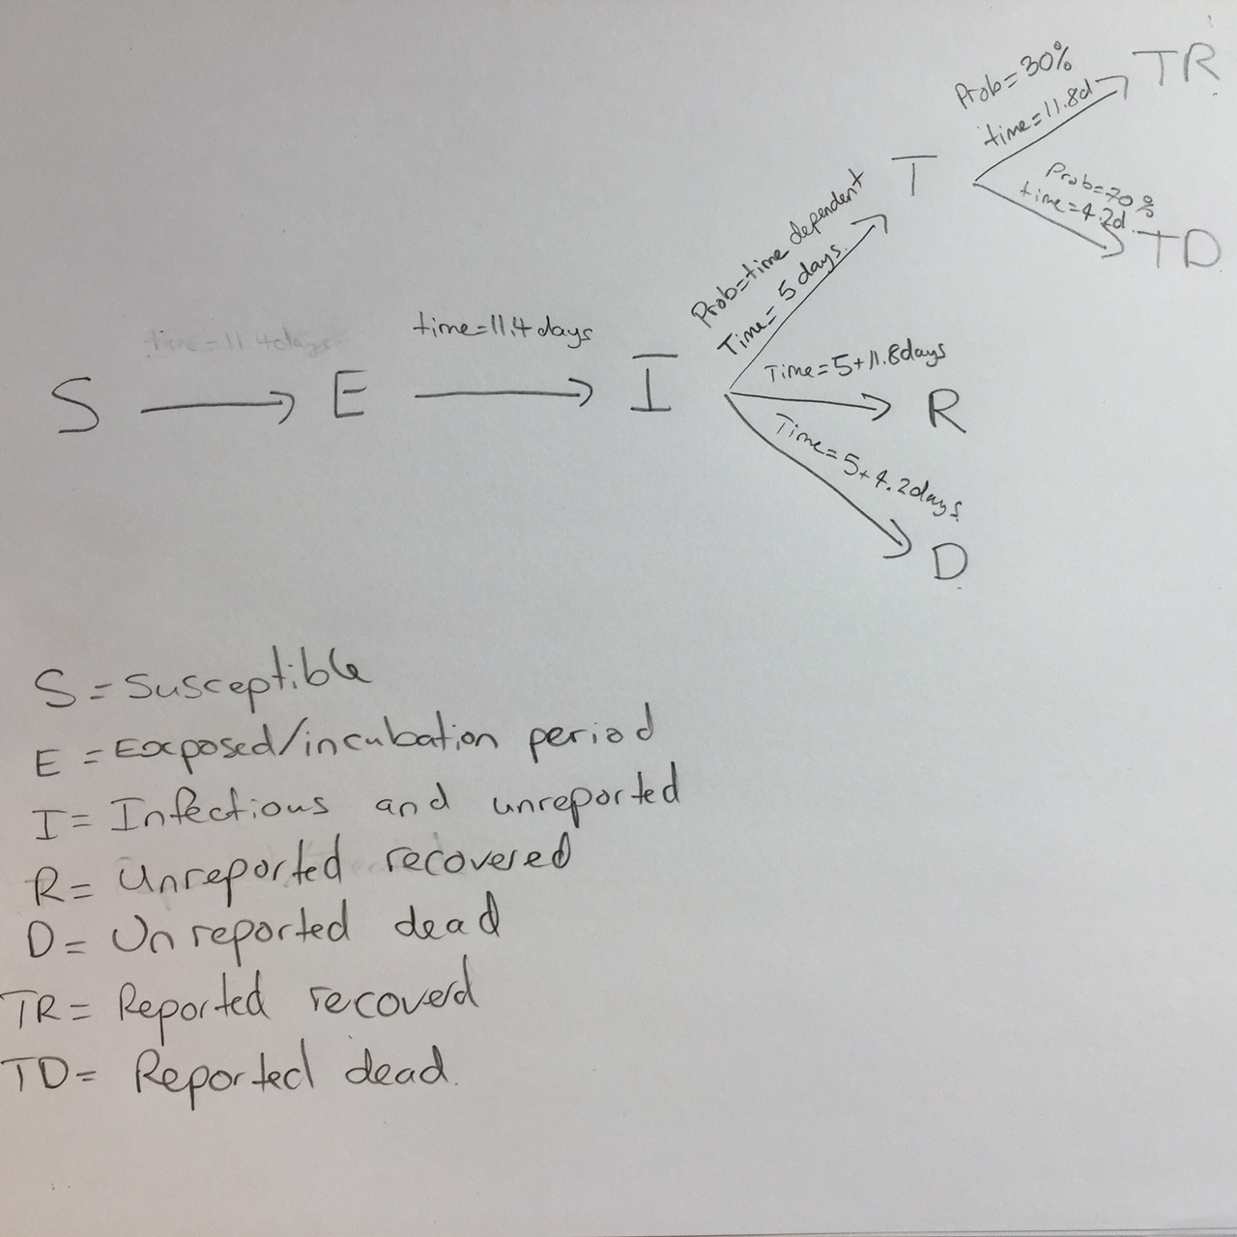

In mathematical terms, the transition equations describing the model are given as:

$$\frac{dS}{dt}=\frac{-βIS}{N}$$

$$\frac{dE}{dt}=\frac{βIS}{N}-aE$$

$$\frac{dI}{dt}=aE-({γ_{I→R}}_{}{+γ}_{I→D}{+γ}_{I→T})I$$

$$\frac{dR}{dt}={γ_{I→R}}_{}I$$

$$\frac{dD}{dt}=γ_{I→D}I$$

$$\frac{dT}{dt}=γ_{I→T}I-(γ_{T→TR}+γ_{T→TD})T$$

$$\frac{dTR}{dt}=γ_{T→TR}T$$

$$\frac{dTD}{dt}=γ_{T→TD}T$$

Where

$$a=\frac{1}{τ_{a}}$$

$$τ_{I→}={(1-P_{T})×0.3τ}_{I→R}+{(1-P_{T})×0.7τ}_{I→D}{+P_{T}τ}_{I→T}$$

$${γ_{I→}}_{}=\frac{1}{τ_{I→}}$$

$${γ_{I→}}_{R}={γ_{I→}}_{}\frac{{(1-P_{T})×0.3τ}_{I→R}}{τ_{I→}}$$

$${γ_{I→}}_{D}={γ_{I→}}_{}\frac{{(1-P_{T})×0.7τ}_{I→D}}{τ_{I→}}$$

$${γ_{I→}}_{T}={γ_{I→}}_{}\frac{P_{T}τ_{I→T}}{τ_{I→}}$$

$$τ_{T→}={0.3τ}_{T→TR}+{0.7τ}_{T→TD}$$

$${γ_{T→}}_{}=\frac{1}{τ_{T→}}$$

$${γ_{T→}}_{TR}={γ_{T→}}_{}\frac{{0.3τ}_{T→TR}}{τ_{T→}}$$

$${γ_{T→}}_{TD}={γ_{T→}}_{}\frac{0.7τ_{T→TD}}{τ_{T→}}$$

$$β=R0{γ_{I→}}_{}$$

Model Fitting

To estimate R0 and beginning starting values for the number of persons in compartments E and I, we implemented an ensemble trajectory model with parameters allowed to change every 2\*28=56 days. Briefly, a matrix of plausible parameter values were generated (R0=1.2, 1.3, …, 2.4; E=2, 12, …, 82; I=2, 12, …, 82). For each parameter combination ($Γ$), the above model was fitted for the first 56 days. We then evaluated the fit of the model using the following formula:

$$ldpp(Γ)=\frac{1}{N}\sum_{i=1}^{N}{}\left|{Obs}_{i}-{Est}_{i}\right|$$

Where ${Obs}_{i}$ was the observed cumulative number of cases at data point i, and ${Est}_{i}$ was the estimated cumulative number of cases at data point i.

From this, we calculated the probability that the outbreak was caused by each parameter combination:

$$P(outbreak was caused by Γ) = \frac{1}{C}exp(-\frac{lddp(Γ)-min(lddp(Γ)}{2{σ^{2}}^{}})$$

Where C was a normalisation constant, and $σ=sqrt(0.2×(lddp(Γ)-min(lddp(Γ)))$

For each parameter combination that had a non-zero probability in the first 58 days of the outbreak, we fitted another 13 models (R0=1.2, 1.3, …, 2.4) and repeated the same procedure. This algorithm was run until it reached the end of the reported data, at which point the probability of the outbreak being caused by each trajectory was calculated. Each trajectory was then forecast to the present day (2014-10-21) and 58 days beyond, with estimated probabilities assigned.

To obtain estimates for each compartment, the differential equations listed above were solved using the “lsoda” function in R (version 3.1.1). From the compartmental model, we extracted the number of estimated cases, new estimated cases each day, estimated reported cases, new estimated reported cases each day, exposed persons currently in the incubation period, EVD cases currently in treatment and non-infectious, and EVD cases currently unreported and infectious in the community.

Results

Model Fit

From a visual observation, the model fit is sufficient. There is some uncertainty and lackluster fit at the beginning (especially for Guinea), but the model can be considered to fit well in the last two months of data, which is the most crucial area.

Reproductive number

Using the last 56 days of data of the outbreak, we estimated that the current effective reproductive number is 1.43 (1.34, 1.52) in Guinea, 2.4 (2.4, 2.4) in Liberia, and 2.10 (1.71, 2.50) in Sierra Leone.

Predictions

Per today (2014-10-22), we have estimated that there are 1699 new cases every day. In 28 days (2014-11-19) this number will increase to 3489 new cases every day, corresponding to a total of 139469 (116629, 162310) cumulative total cases. In a further 28 days (2014-12-17) this will increase to 7001 new cases every day, corresponding to a total of 283622 (205447, 361796) cumulative total cases.

Achieving CDC targets for 70% containment

As of today (2014-10-22), we estimate that there are 1807 (1576, 2038) EVD active cases in treatment, with an additional 13153 (11071, 15236) EVD cases unreported and untreated. To reach the CDC targets, we need 3740 (3216, 4261) cases in ETUs and 6732 (5789, 7675) at home or in a community setting such that there is a reduced risk for disease transmission. In 28 days (2014-11-19), we will need 7639 (5715, 9563) EVD cases in ETUs and 13750 (10287, 17214) EVD cases at reduced risk of transmission. In a further 28 days (2014-12-17) we will need 15567 (9735, 21399) EVD cases in ETUs and 28021 (17522, 38519) cases at reduced risk of transmission.

Conclusion

Our numbers are not incongruent with those given by the WHO model, who predicted approximately 80000 cases by the end of November. Our model explicitly models a decrease in the reporting quotient, whereas the WHO model did not. Thus, our reported estimates of approximately 24000 should lie below, and our corrected estimates of approximately 185000 should lie above. Our aggregate estimates of the countries are similar to a recent model by independent researchers, who predicted approximately 170000 cases by the end of December 2014 in Libera, 45000 cases by the end of December 2014 in Sierra Leone, and an overall R0 of 2.22. However, we predicted that the majority of cases will come from Sierra Leone (148472) instead of Liberia (75249). This is primarily due to our use of later data, where the underreporting in Liberia has severe impacts on our model. As we apply a universal underreporting correction across all countries, we are not able to quantify this.

(<http://currents.plos.org/outbreaks/article/obk-14-0043-modeling-the-impact-of-interventions-on-an-epidemic-of-ebola-in-sierra-leone-and-liberia/>).

This study has a number of limitations. First and foremost, we model at the country level. This masks many geographical variations that may be happening at a more discrete level. Secondly, we assume that registered cases are in treatment and thus non-infectious. While it was assumed by the WHO model that hospitalised cases were non-infectious, it is well documented that healthcare workers are continually being infected (although it has been noted that the majority of the healthcare workers were infected at home or in their local community). We are also uncertain as to our assumption that registered cases are in treatment; considering the overwhelmed nature of the West African health system. It is entirely likely that a great number of the new cases come from counting dead bodies. In addition, this model is based on reported case data, which has significant underreporting that varies over time and geographical region. Our model attempts to correct for underreporting, however, it is not possible to validate how accurately we have done so. Finally, our model assumes that the outbreak will continue growing as it has in the past - while unlikely, the recent international efforts may have had some effect that will take place in the near future.

Currently we need to treat 10472 cases to achieve the CDC’s target. In one month, 21389 cases. In two months, 43588 cases. With every month the CDC’s 70% target grows exponentially, while the healthcare workers needed to reverse this epidemic continue to die. Urgent action is needed by the international community to reverse this crisis.

