# Abstract

Background:

Methods:

Results:

Conclusions:

We developed a compartmental SEIR model to forecast the progression of the West Africa EVD epidemic using a flexible mathematical model (previously used in predicting a Marburg hemorrhagic fever outbreak) that allowed the reproductive number to change every 58 days. For the purposes of our models, we considered all confirmed, suspected, or probable cases to be EVD cases. We used case data from Guinea (2014-03-22 to 2014-10-17), Liberia (2014-03-27 to 2014-10-17), and Sierra Leone (2014-05-27 to 2014-10-17), and implemented different models for each country.

Average times spent in each compartment/transition rates were taken from the recently published WHO Ebola Response Team model. The reporting quotient on 2014-08-25 was established as 1/2.5=40% by the US Centers for Disease Control and Prevention's (CDC) report. We assumed that reporting quotient on 2014-03-22 was 1/1.5=67%. We then fit an exponentially decreasing time-dependent curve between the two points and extrapolated forward.

The CDC's widely reported model estimated that to stem the tide of the epidemic 25% of all patients must be placed in Ebola Treatment Units (ETUs) and 45% must be at home or in a community setting such that there is a reduced risk for disease transmission. As of today (2014-10-28), we estimate that there are 2048 (95% CI=1726 to 2369) EVD active cases in treatment, with an additional 15615 (95% CI=12679 to 18551) EVD cases unreported and untreated. To reach the CDC targets today, we need 4416 (95% CI=3677 to 5154) cases in ETUs and 7948 (95% CI=6619 to 9277) at home or in a community setting such that there is a reduced risk for disease transmission. In 28 days (2014-11-25), we will need 9523 (95% CI=6736 to 12311) EVD cases in ETUs and 17142 (95% CI=12125 to 22159) EVD cases at reduced risk of transmission. In a further 28 days (2014-12-23) we will need 21958 (95% CI=11930 to 31986) EVD cases in ETUs and 39524 (95% CI=21474 to 57575) cases at reduced risk of transmission.

With every month the CDC's 70% target grows exponentially while the healthcare workers needed to reverse this epidemic continue to die. Urgent action is needed by the international community to reverse this crisis.

The study has a number of limitations. Firstly, we have no evidence that our exponentially decreasing reporting quotient is accurate. Furthermore, we assume that it is consistent across countries, which we know is not true. We modeled the outbreaks at the national level, while it is well known that the outbreaks are heterogeneous within each country. We assumed that all reported cases came from people who were then immediately treated and not infectious. We did not account for variations between healthcare workers and non-healthcare workers, nor did we account for infectious corpses.

# Tables

Table 1. Reported cases per day

|  |  |  |  |
| --- | --- | --- | --- |
| Variable | 2014-10-28 | 2014-11-25 | 2014-12-23 |
| Days from today | 0 | 28 | 56 |
| Cases (reported) | 12707 | 22414 | 40630 |
| (11748, 13667) | (19116, 25712) | (29931, 51329) |
| New daily cases (reported) | 253 | 457 | 880 |
| Cases (total) | 80316 | 167345 | 365819 |
| (72089, 88543) | (134004, 200686) | (241125, 490514) |
| New daily cases (total) | 2027 | 4453 | 10402 |
| Incubation period | 23423 | 51507 | 120444 |
| (18264, 28582) | (32691, 70323) | (54380, 186507) |
| Infectious and unreported | 15615 | 34379 | 80652 |
| (12679, 18551) | (23279, 45479) | (40666, 120638) |
| Undergoing treatment | 2048 | 3714 | 7180 |
| (1726, 2369) | (2670, 4758) | (3997, 10362) |
| CDC 25% ETU target | 4416 | 9523 | 21958 |
| (3677, 5154) | (6736, 12311) | (11930, 31986) |
| CDC 45% reduced transmission target | 7948 | 17142 | 39524 |
| (6619, 9277) | (12125, 22159) | (21474, 57575) |
| Reporting quotient | 30% | 26% | 22% |

Table 2. Number of international personnel needed

|  |  |  |  |
| --- | --- | --- | --- |
| Variable | 2014-10-28 | 2014-11-25 | 2014-12-23 |
| Days from today | 0 | 28 | 56 |
| Caseload | 12364 | 26665 | 61482 |
| Administrator (coordination) | 14 | 29 | 68 |
| Doctor (ETU) | 28 | 60 | 138 |
| Doctor (coordination) | 7 | 15 | 34 |
| Epidemiologist (contact tracing) | 15 | 33 | 77 |
| Epidemiologist (coordination) | 20 | 44 | 101 |
| Lab scientist (laboratories) | 41 | 89 | 206 |
| Logistician (burials) | 20 | 44 | 101 |
| Logistician (ETU) | 55 | 119 | 274 |
| Logistician (coordination) | 20 | 44 | 101 |
| Nurse (ETU) | 110 | 237 | 547 |
| Public health specialist (Social mobilization) | 32 | 68 | 157 |
| Public health specialist (coordination) | 14 | 29 | 68 |
| Data management (coordination) | 17 | 37 | 86 |
| Total personnel | 393 | 848 | 1958 |

Table 3. Number of supplies needed each day

|  |  |  |  |
| --- | --- | --- | --- |
| Variable | 2014-10-28 | 2014-11-25 | 2014-12-23 |
| Days from today | 0 | 28 | 56 |
| PPE (m3) | 302.5 | 652.4 | 1504.2 |
| PPE (tons) | 62.9 | 135.6 | 312.6 |
| Body bags (m3) | 0.8 | 1.8 | 4 |
| Body bags (tons) | 0.1 | 0.2 | 0.4 |
| Chlorine (m3) | 0.3 | 0.7 | 1.6 |
| Chlorine (tons) | 0.3 | 0.7 | 1.6 |
| Medical supplies (m3) | 4.7 | 10.1 | 23.2 |
| Medical supplies (tons) | 2.3 | 5 | 11.6 |
| Lab supplies (m3) | 0.5 | 1.1 | 2.5 |
| Lab supplies (tons) | 0.2 | 0.5 | 1.2 |
| Total (m3) | 308.8 | 666 | 1535.6 |
| Total (tons) | 65.8 | 142 | 327.4 |

# 

# Figures

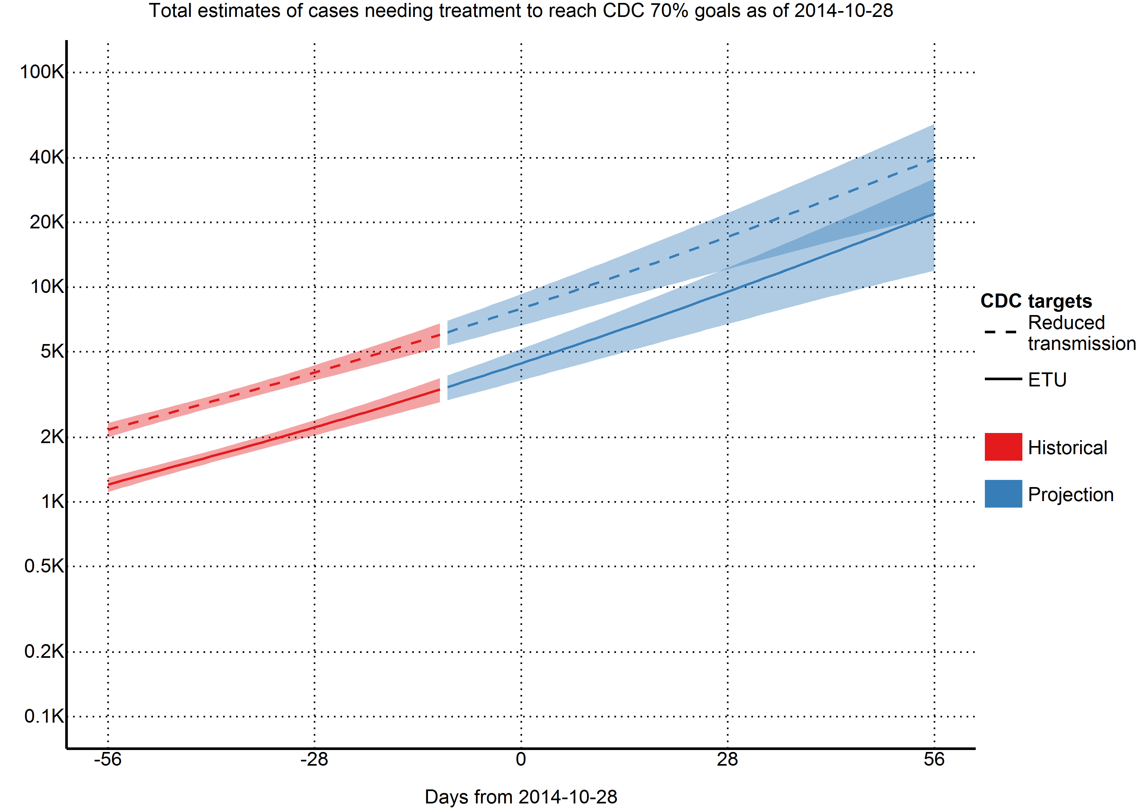

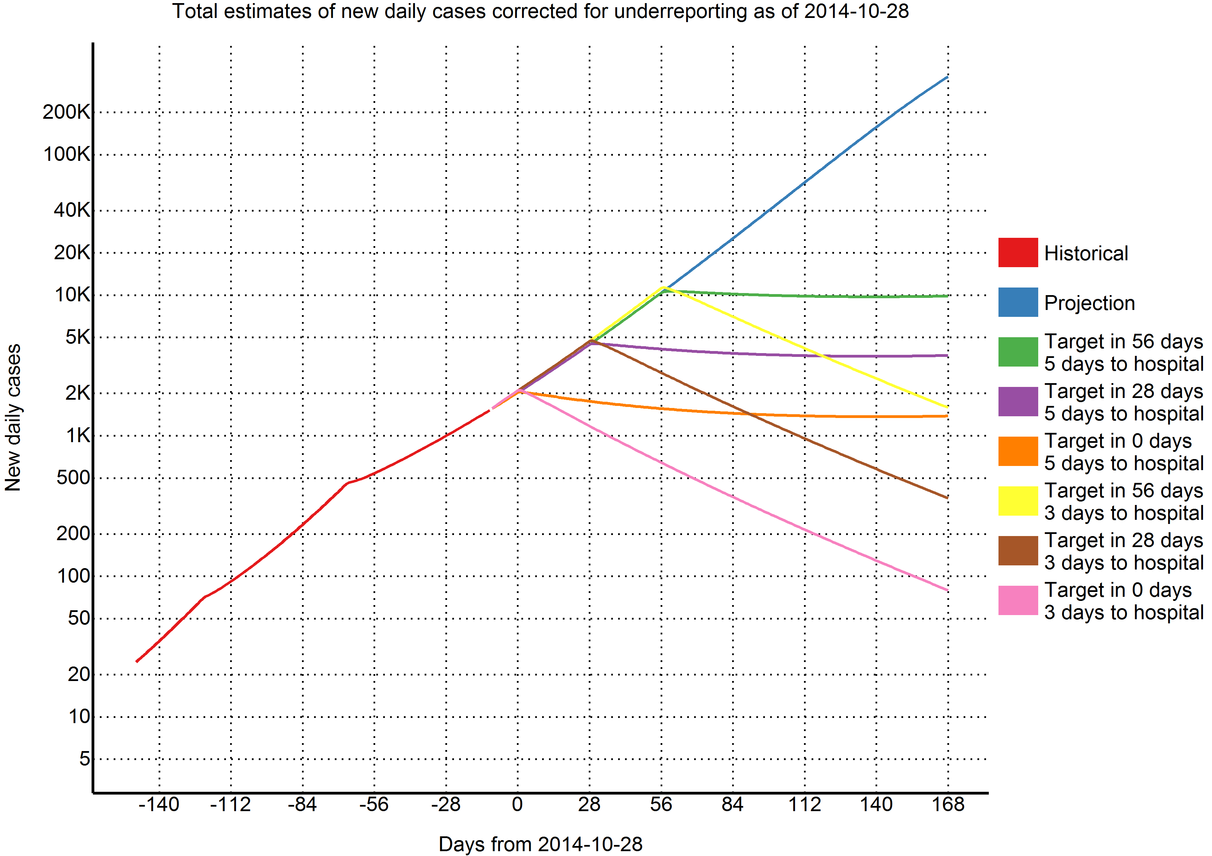

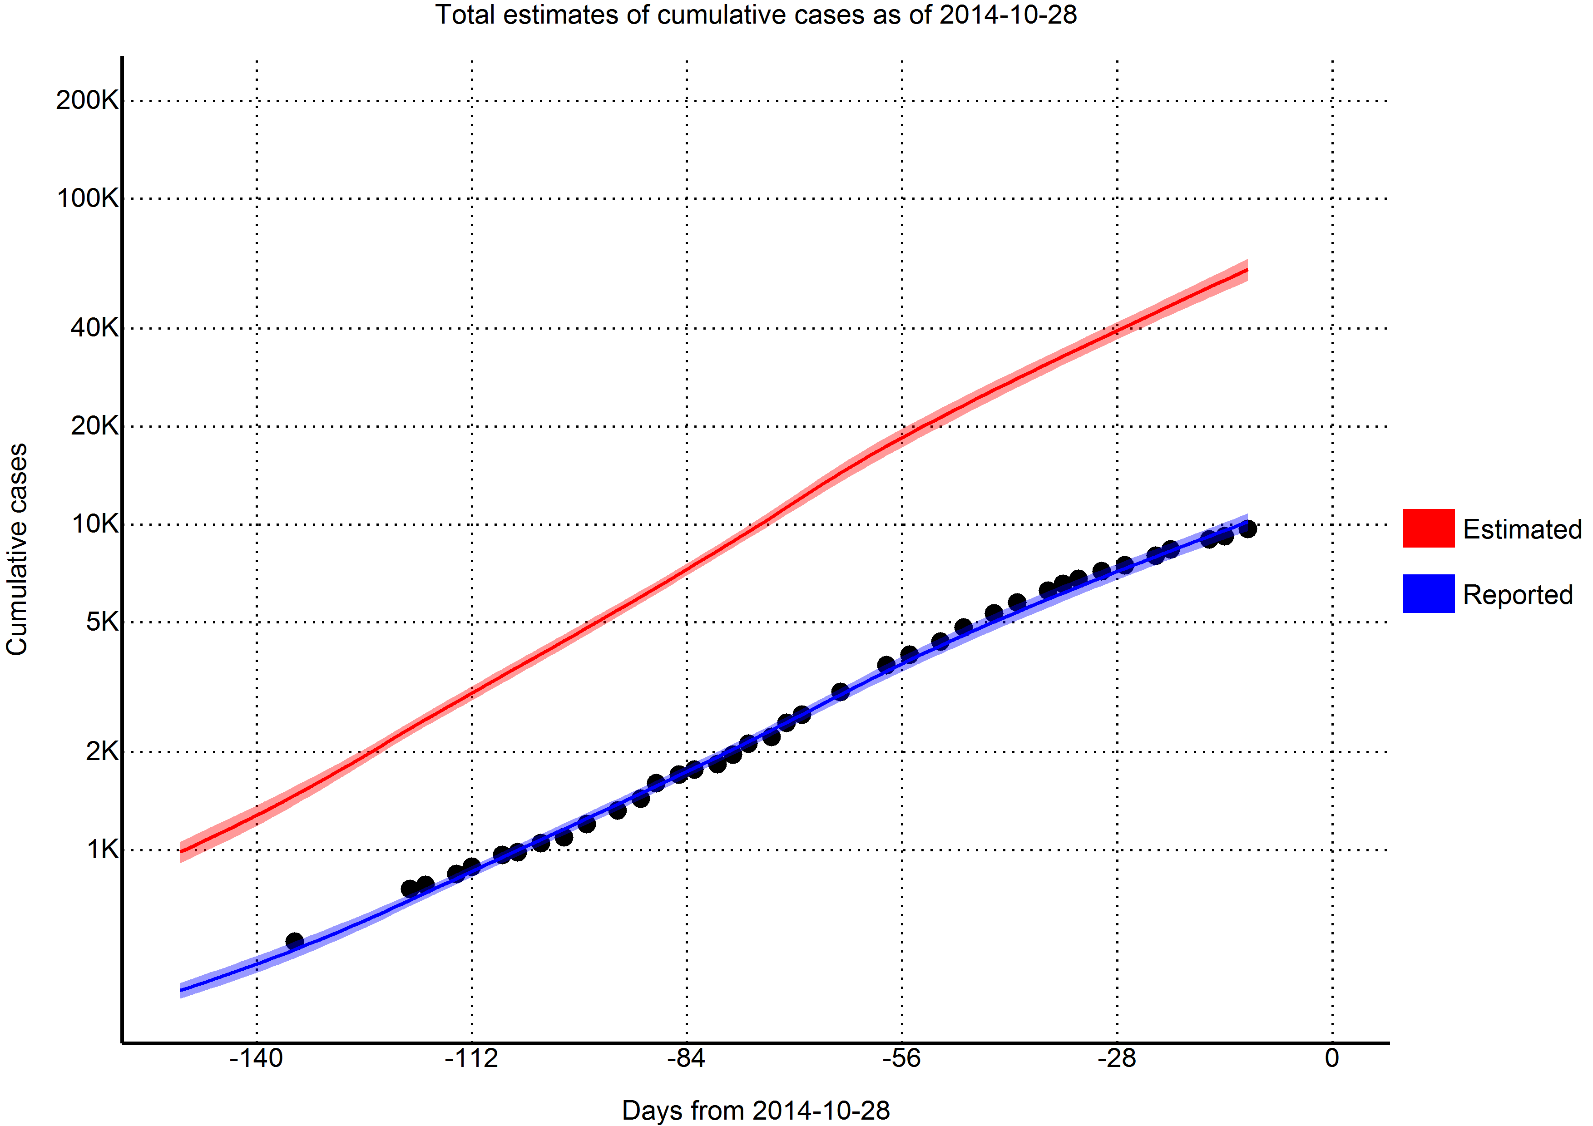

# Funding statement

This research received no specific grant from any funding agency, commercial or not-for-profit sectors. The authors have declared that no competing interests exist.

# Background

Since December 2013, an outbreak of Ebola virus disease (EVD) of unprecedented size and geographic extent has been ongoing in West Africa. As of 28 October 2014, over 10 000 cases and 5 000 deaths have been reported to the World Health Organization by the three most affected countries, Guinea, Liberia and Sierra Leone.

[[1](#_ENREF_1" \o "Meltzer, 2014 #1)]

On 8 August 2014, the World Health Organization declared the outbreak to be a Public Health Emergency of International Concern [2] . On 18 September the UN Security Council determined that the outbreak is a "threat to international peace and security" and announced the United Nations Mission for Ebola Emergency Response (UNMEER) [3]. This is the first time in history that the UN has created a mission for a public health.

Schools have been closed down, air traffic has been restricted, and tourism and trade has been decimated - the cost to these developing countries will most likely be felt for years to come.

[[1](#_ENREF_1" \o "Meltzer, 2014 #1)]

While multiple efforts have been made to model and forecast the epidemic, none have explicitly quantified the number of treatment places necessary to achieve the 70% target set by the CDC. We use a flexible mathematical model (previously used to model Marburg hemorrhagic fever) to estimate the number of treatment places needed to obtain the 70% target set by the CDC over the next two months (from 2014-10-28 to 2014-11-25). We hope that these estimates will provide firmer targets for the international response.

# Methods

## Outbreak Data

As has been common with previous EVD models, we used the public data released by the World Health Organization . For the purposes of our models, we considered all confirmed, suspected, or probable cases to be EVD cases. We used case data from Guinea (2014-03-22 to 2014-10-17), Liberia (2014-03-27 to 2014-10-17), and Sierra Leone (2014-05-27 to 2014-10-17).

## Model

We developed a compartmental model to describe the outbreaks in the three affected countries. Briefly, the population is divided into six compartments, with average rates and average time periods taken from the recently published WHO Ebola Response Team model.

Susceptible individuals (S) may become Exposed (E) after contact with infectious material. After an average of 11.4 days ($τ_{a}$), Exposed persons (E) then transition into non-reported Infected persons (I). Infected persons (I) may become Treated (T) after an average of 5 days ($τ_{I→T}$) (in which case they are registered as an EVD case and become non-infectious), or they may Recover (R) after an average of 5+11.8 days ($τ_{I→R}$), or Die (D) after an average of 5+4.2 days ($τ_{I→D}$). Treated (T) persons may either Recover (TR) after an average of 11.8 days ($τ_{T→TR}$) or Die (TD) after an average of 4.2 days ($τ_{T→TD}$). The case fatality rate was taken to be 70%.

Probability of Infected persons (I) becoming Treated (T) ($P_{T}$) was time dependent: on 2014-03-22, the reporting quotient was set to 1/1.5=67%. Taken from the recently published CDC model, the reporting quotient was set to 1/2.5=40%. These percentages were then transformed into logit form, squared, and a linear regression was fit to estimate an exponentially decreasing reporting quotient over time.

A separate model was fit for each of the three countries.

In mathematical terms, the transition equations describing the model are given as:

$$\frac{dS}{dt}=-\frac{βIS}{N}$$

$$\frac{dE}{dt}=\frac{βIS}{N}-aE$$

$$\frac{dI}{dt}=aE-(γ_{I→R}I)$$

$$\frac{dR}{dt}=γ_{I→R}I$$

$$\frac{dD}{dt}=γ_{I→D}I$$

$$\frac{dT}{dt}=γ_{I→T}I-(γ_{T→TR}+γ_{T→TD})T$$

$$\frac{dTR}{dt}=γ_{T→TR}T$$

$$\frac{dTD}{dt}=γ_{T→TD}T$$

Where

$$a=\frac{1}{τ_{a}}$$

$$τ_{I→}=(1-P_{T})×0.3×τ_{I→R}+(1-P_{T})×0.7×τ_{I→D}+P_{T}τ_{I→T}$$

$$γ_{I→}=\frac{1}{τ_{I→}}$$

$$γ_{I→R}=γ_{I→}\frac{(1-P_{T})×0.3×τ_{I→R}}{τ_{I→}}$$

$$γ_{I→D}=γ_{I→}\frac{(1-P_{T})×0.7×τ_{I→D}}{τ_{I→}}$$

$$γ_{I→T}=γ_{I→}\frac{P_{T}τ_{I→T}}{τ_{I→}}$$

$$τ_{T→}=0.3τ_{T→TR}+0.7τ_{T→TD}$$

$$γ_{T→}=\frac{1}{τ_{T→}}$$

$$γ_{T→TR}=γ_{T→}\frac{0.3τ_{T→TR}}{τ_{T→}}$$

$$γ_{T→TD}=γ_{T→}\frac{0.7τ_{T→TD}}{τ_{T→}}$$

$$β=R0γ_{I→}$$

## Model Fitting

To estimate R0 and beginning starting values for the number of persons in compartments E and I, we implemented an ensemble trajectory model with parameters allowed to change every 2*28=56 days. Briefly, a matrix of plausible parameter values were generated (R0=1.2, 1.3, ..., 2.4; E=2, 12, ..., 82; I=2, 12, ..., 82). For each parameter combination ($Γ$), the above model was fitted for the first 56 days. We then evaluated the fit of the model using the following formula:

$$ldpp(Γ)=\frac{1}{N}\sum_{i=1}^{N}{∣}Obs_{i}-Est_{i}∣$$

Where $Obs_{i}$ was the observed cumulative number of cases at data point i, and $Est_{i}$ was the estimated cumulative number of cases at data point i.

From this, we calculated the probability that the outbreak was caused by each parameter combination:

$$P(outbreakwascausedbyΓ)=\frac{1}{C}exp\left(-\frac{lddp(Γ)-min(lddp(Γ)}{2σ^{2}}\right)$$

Where C was a normalisation constant, and $σ=sqrt(0.2×(lddp(Γ)-min(lddp(Γ)))$

For each parameter combination that had a non-zero probability in the first 58 days of the outbreak, we fitted another 13 models (R0=1.2, 1.3, ..., 2.4) and repeated the same procedure. This algorithm was run until it reached the end of the reported data, at which point the probability of the outbreak being caused by each trajectory was calculated. Each trajectory was then forecast to the present day (2014-10-28) and 58 days beyond, with estimated probabilities assigned.

To obtain estimates for each compartment, the differential equations listed above were solved using the "lsoda" function in R (version 3.1.1). From the compartmental model, we extracted the number of estimated cases, new estimated cases each day, estimated reported cases, new estimated reported cases each day, exposed persons currently in the incubation period, EVD cases currently in treatment and non-infectious, and EVD cases currently unreported and infectious in the community.

## Intervention

We implemented a simpler version of the CDC's recommendations to test their efficacy; we investigated the impact of 70% of infectious EVD cases receiving treatment after 5 and 3 days on average, with this scenario occurring today (2027), in 28 days (2014-11-25), and in 56 days (2014-12-23). This is in contrast to the baseline projection where a time-dependent proportion of EVD cases ($P_{T}$) are treated after an average of 5 days.

# Results

## Model Fit

From a visual observation, the model fit is sufficient. There is some uncertainty and lackluster fit at the beginning (especially for Guinea), but the model can be considered to fit well in the last two months of data, which is the most crucial area.

## Reproductive number

Using the last 56 days of outbreak data, we estimated that the effective reproductive number for 2027 was 1.81 (95% CI=1.37 to 2.25) in Guinea, 1.27 (95% CI=1.14 to 1.41) in Liberia, and 1.81 (95% CI=1.65 to 1.96) in Sierra Leone.

## Predictions

Per today (2014-10-28), we have estimated that there are 2027 new cases every day. In 28 days (2014-11-25) this number will increase to 4453 new cases every day, corresponding to a total of 139469 (116629, 162310) cumulative total cases. In a further 28 days (2014-12-23) this will increase to 10402 new cases every day, corresponding to a total of 283622 (205447, 361796) cumulative total cases.

## Achieving CDC targets for 70% containment

As of today (2014-10-28), we estimate that there are 2048 (95% CI=1726 to 2369) EVD active cases in treatment, with an additional 15615 (95% CI=12679 to 18551) EVD cases unreported and untreated. To reach the CDC targets today, we need 4416 (95% CI=3677 to 5154) cases in ETUs and 7948 (95% CI=6619 to 9277) at home or in a community setting such that there is a reduced risk for disease transmission. In 28 days (2014-11-25), we will need 9523 (95% CI=6736 to 12311) EVD cases in ETUs and 17142 (95% CI=12125 to 22159) EVD cases at reduced risk of transmission. In a further 28 days (2014-12-23) we will need 21958 (95% CI=11930 to 31986) EVD cases in ETUs and 39524 (95% CI=21474 to 57575) cases at reduced risk of transmission.

## Intervention

Due to the high effective reproductive number in Guinea, we found that 70% containment/treatment after 5 days was not sufficient to contain the epidemic; rather, 70% containment/treatment after three days was required. In Sierra Leone, 70% containment/treatment after 5 days produced a minimal reduction of new daily cases, while an average time-to-treatment of three days offered a dramatic reduction of new daily cases. In Liberia, both scenarios were considered to be sufficient.

# Discussion

Our numbers are not incongruent with those given by the WHO model, which predicted approximately 80000 cases by the end of November. Our model explicitly models a decrease in the reporting quotient, whereas the WHO model did not. Thus, our reported estimates of 24861 should lie below, and our corrected estimates of 191686 should lie above. However, we predicted that the majority of cases will come from Sierra Leone (94723) instead of Liberia (61792). This is primarily due to our use of later data, where the underreporting in Liberia has severe impacts on our model. As we apply a universal underreporting correction across all countries, we are not able to quantify this.

This study has a number of limitations. First and foremost, we model at the country level. This masks many geographical variations that may be happening at a more discrete level. Secondly, we assume that registered cases are in treatment and thus non-infectious. While it was assumed by the WHO model that hospitalised cases were non-infectious, it is well documented that healthcare workers are continually being infected (although it has been noted that the majority of the healthcare workers were infected at home or in their local community). We are also uncertain as to our assumption that registered cases are in treatment; considering the overwhelmed nature of the West African health system. It is entirely likely that a great number of the new cases come from counting dead bodies. In addition, this model is based on reported case data, which has significant underreporting that varies over time and geographical region. Our model attempts to correct for underreporting, however, it is not possible to validate how accurately we have done so. Finally, our model assumes that the outbreak will continue growing as it has in the past - while unlikely, the recent international efforts may have had some effect that will take place in the near future.

Currently we need to treat 12364 cases to achieve the CDC's target. In one month, 26665 cases. In two months, 61482 cases. With every month the CDC's 70% target grows exponentially, while the healthcare workers needed to reverse this epidemic continue to die. Urgent action is needed by the international community to reverse this crisis.

References

1. Meltzer MI, Atkins CY, Santibanez S, Knust B, Petersen BW, Ervin ED, Nichol ST, Damon IK, Washington ML: **Estimating the future number of cases in the ebola epidemic --- liberia and sierra leone, 2014--2015**. *Morbidity and mortality weekly report Surveillance summaries* 2014, **63**:1-14.

2. **WHO Statement on the Meeting of the International Health Regulations Emergency Committee Regarding the 2014 Ebola Outbreak in West Africa** [<http://www.who.int/mediacentre/news/statements/2014/ebola-20140808/en/>]

3. **UN Mission for Ebola Emergency Response (UNMEER)** [<http://www.un.org/ebolaresponse/mission.shtml>]