# Projected treatment capacity needs in Sierra Leone

Richard A White ${}^{1,2*}$, Emily MacDonald ${}^{1*}$, Birgitte de Blasio ${}^{1,3}$, Karin Nygard ${}^{1}$, Line Vold ${}^{1}$, John-Arne Rottingen ${}^{4}$

1. Department of Infectious Disease Epidemiology, Norwegian Institute of Public Health, Oslo, Norway
2. Department of Health Statistics, Norwegian Institute of Public Health, Oslo, Norway
3. Oslo Centre for Biostatistics and Epidemiology, Department of Biostatistics, Institute of Basic Medical Sciences, University of Oslo, Norway
4. Division of Infectious Disease Control, Norwegian Institute of Public Health, Oslo, Norway

$*$ Indicates joint first authorship

**Corresponding author:**

**Mailing address:**

Department of Infectious Disease Epidemiology

Norwegian Institute of Public Health

Postboks 4404 Nydalen

NO-0403 Oslo, Norway

**Phone number:**

**Fax number:** +47 2107 6513

**Phone number:**

**Email address:**

# Abstract

**Background:** The ongoing outbreak of Ebola Virus Disease in West Africa is the largest in history and requires immediate and sustained input from the international community in order to curb transmission. The CDC has produced a model that concluded that to end the outbreak by pushing the reproductive number below one, 25% of the patients must be placed in an Ebola Treatment Unit (ETC) and 45% isolated in a community setting in which risk of disease transmission is reduced and safe burials are provided. We estimate the national and international personnel and treatment capacity that may be required in Sierra Leone to reach these percentages in order to provide firmer targets for the international response.

**Methods:** We developed a compartmental SEIR model that was fitted to WHO data and local data allowing the reproductive number to change every 8 weeks to forecast the progression of the EVD epidemic in Sierra Leone. We used the previously estimated 2.5x correction factor estimated by the CDC to correct for underreporting. Number of personnel required to provide treatment for the predicted number of cases was estimated using UNMEER and UN OCHA requests for resources required to meet the CDC targets.

**Results:** As of today (2014-12-01), we estimate that there are 852 (95% CI=760 to 945) EVD active cases in treatment, with an additional 4048 (95% CI=3468 to 4627) EVD cases unreported and untreated. To reach the CDC targets today, we need 1225 (95% CI=1078 to 1372) cases in ETCs and 2205 (95% CI=1941 to 2469) at home or in a community setting with a reduced risk for disease transmission. In 28 days (2014-12-29), we will need 1521 (95% CI=1193 to 1849) EVD cases in ETCs and 2738 (95% CI=2147 to 3328) EVD cases at reduced risk of transmission. If the current transmission rate is not reduced, up to 3972 personnel in total will be required in 56 days (2015-01-26) to operate ETCs according to our model.

**Conclusions:** The current outbreak will require massive input from the international community in order to curb the outbreak by traditional containment mechanisms by breaking the chains of transmission in Sierra Leone. If sufficient treatment facilities, healthcare workers and support personnel are not rapidly deployed, the increasing number of cases will be overwhelming. In addition to traditional isolation and treatment mechanisms, other viable control options, such as the development of an effective vaccine, should be supported.

# Funding statement

This research received no specific grant from any funding agency, commercial or not-for-profit sectors. The authors have declared that no competing interests exist.

# Background

Since December 2013, an outbreak of Ebola virus disease (EVD) of unprecedented size and geographic extent has been ongoing in West Africa. As of 12 November 2014 , over 14 000 cases and 5 000 deaths have been reported to the World Health Organization by the three most affected countries, Guinea, Liberia and Sierra Leone. Cases have also been reported in Nigeria, Senegal, the United States, Spain and, most recently, Mali (ref). Since its first case was reported on DATE, Sierra Leone has reported 5368 cases and 1129 deaths. In order to interrupt the chains of transmission and prevent further spread, a number of control measures have been implemented, including establishing Ebola Treatment Centres, increasing case ascertainment and contact tracing, and promoting safe burial practices (ref). Although these approaches have been used to successfully curb previous outbreaks of EVD in Central and Eastern Africa, for the first time, EVD has spread throughout densely populated urban areas among highly mobile populations who have no previous knowledge of the disease. the current outbreak will therefore require a sustained, innovative and flexible approach to achieve containment.

The international response to this crisis has been widely criticized as slow and insufficient (ref). As early as DATE, Medecins Sans Frontieres (MSF), an organization which has been involved in providing treatment from the early stages of the outbreak, have been requesting large-scale and sustained support from the international community. Despite these requests, the response has been slow to materialize. However, on 8 August 2014, the World Health Organization declared the outbreak to be a Public Health Emergency of International Concern (PHEIC) [1]. On 18 September the UN Security Council determined that the outbreak was a "threat to international peace and security" and announced the creation of the United Nations Mission for Ebola Emergency Response (UNMEER) [2]. This is the first time in history that the UN has created a mission for a public health concern. Despite these actions the outbreak continued to grow in magnitude and the potential for spread to neighbouring countries is of serious concern.

Several models have been developed to forecast the progression of the outbreak, with and without intervention options. A model produced by the WHO's Ebola Response Team, published September 2014, aimed to document trends in the epidemic and project expected case numbers for the coming weeks. Based on data reported to the WHO from Guinea, Liberia, and Sierra Leone until 14 September 2014, this model concluded that there was a possibility that for the medium term EVD may become endemic among the human population of West Africa [3]. A model produced by the CDC using data from Liberia and Sierra Leone until 29 August 2014 aimed to galvanize support for multinational intervention by demonstrating the large long-term costs of delay and giving estimates of the size of the control interventions needed [4]. The CDC model concluded that to end the outbreak by pushing the reproductive number below one, 25% of the patients must be placed in an Ebola Treatment Centre (ETC) and 35% isolated in a community setting in which risk of disease transmission is reduced and safe burials are provided [4]. This model reinforced that the cost of delay is devastating - the number of cases doubles every 20 days, making the 70% target even harder to achieve.

Since the creation of UNMEER, the international community has committed extensive resources to controlling the outbreak, including establishing Ebola Treatments Centres (ETC) in order to ensure patients are isolated. Although only a fraction of the centres are operational at this time, the ETCs are designed to provide care to suspected and confirmed cases while preventing infection of healthcare workers and members of the community. UNMEER has a 60 day target of having that capacity to isolate at least 70% of patients and ensure 70% of cases who die from EVD are safely buried by 1 December 2014. These targets are based on the assumption that 25% of cases will be isolated in ETCs while 45% will be isolated in Community Care Centres (CCCs). The overall goal is to ensure isolation of 100% of cases and provide safe burials to 100% of patients who die from EVD by 1 January 2015 (90-day target). As of 13 November 2014, UNMEER reports that of the 53 ETCs that are planned, only 19 are operational with a bed capacity that can accommodate 1129 patients the three affected countries. Data from an ETC status overview from 30 October shows that the WHO calculates that seventeen ETCs are required in Sierra Leone, of which seven are operational and ten are planned to open soon. All seventeen have identified field medical teams responsible for the operation of the facilities.

While multiple efforts have been made to model and forecast the epidemic, few have explicitly quantified the number of treatment places necessary to achieve the 70% target set by the CDC. Lewnard et al. developed a transmission model to assess the effectiveness of expanding EVD treatment centres, increasing case ascertainment and allocating protective household kits in Montserrado County, Liberia.

We use a flexible mathematical model to estimate the number of treatment places, personnel and equipment needed to obtain the 70% target set by the CDC in Sierra Leone over the next two months (from 2014-12-01 to 2014-12-29) in order to provide firmer targets for the international response. We also reexamine what targets for treatment or isolation within a specified time frame are necessary to acheive a reproductive number below one.

# Methods

## Outbreak Data

To fit our model, we used the public data released by the World Health Organization (ref) from 2014-03-22 until 2014-08-13, after which we obtained approximately daily counts from the public press releases from the Sierra Leonean Ministry of Health (2014-05-27 to 2014-11-30). For the purposes of our models, we considered all confirmed, suspected, or probable cases to be EVD cases.

## Model

We developed a compartmental model to describe the outbreaks in Sierra Leone (Figure 1). Briefly, the population is divided into six compartments, with average rates and average time periods taken from the recently published WHO Ebola Response Team model (ref).

Susceptible individuals (S) may become Exposed (E) after contact with infectious material. After an average of 11.4 days ($τ_{a}$), Exposed persons (E) then transition into non-reported Infected persons (I). Infected persons (I) may become Treated (T) after an average of 5 days ($τ_{I→T}$) (in which case they are registered as an EVD case and become non-infectious), or they may Recover (R) after an average of 5+11.8 days ($τ_{I→R}$), or Die (D) after an average of 5+4.2 days ($τ_{I→D}$). Treated (T) persons may either Recover (TR) after an average of 11.8 days ($τ_{T→TR}$) or Die (TD) after an average of 4.2 days ($τ_{T→TD}$). The case fatality rate was taken to be 70% (ref). The recently published CDC model estimated that the reporting quotient was set to 1/2.5=40% (on 2014-08-25). We used this number to crudely assume that 40% of the population have been reported, and then treated in some fashion (either submission to an ETC or isolated in a community setting or at home). Therefore, we estimated probability of Infected persons (I) becoming Treated (T) ($P_{T}$) to be 40%. Due to poor data quality, we considered that all cases were non-infectious after being reported (as we could not assign a certain proportion to ETCs versus community isolation versus home isolation).

**Figure 1. SEIR model**

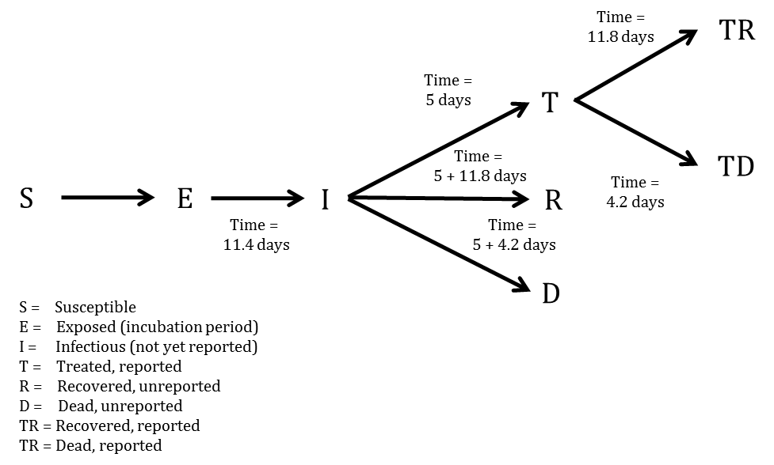

In mathematical terms, the transition equations describing the model are given as:

$$\frac{dS}{dt}=-\frac{βIS}{N}$$

$$\frac{dE}{dt}=\frac{βIS}{N}-aE$$

$$\frac{dI}{dt}=aE-γ_{I→}I$$

$$\frac{dR}{dt}=γ_{I→R}I$$

$$\frac{dD}{dt}=γ_{I→D}I$$

$$\frac{dT}{dt}=γ_{I→T}I-(γ_{T→TR}+γ_{T→TD})T$$

$$\frac{dTR}{dt}=γ_{T→TR}T$$

$$\frac{dTD}{dt}=γ_{T→TD}T$$

Where

$$a=\frac{1}{τ_{a}}$$

$$τ_{I→}=(1-P_{T})×0.3×τ_{I→R}+(1-P_{T})×0.7×τ_{I→D}+P_{T}τ_{I→T}$$

$$γ_{I→}=\frac{1}{τ_{I→}}$$

$$γ_{I→R}=γ_{I→}\frac{(1-P_{T})×0.3×τ_{I→R}}{τ_{I→}}$$

$$γ_{I→D}=γ_{I→}\frac{(1-P_{T})×0.7×τ_{I→D}}{τ_{I→}}$$

$$γ_{I→T}=γ_{I→}\frac{P_{T}τ_{I→T}}{τ_{I→}}$$

$$τ_{T→}=0.3τ_{T→TR}+0.7τ_{T→TD}$$

$$γ_{T→}=\frac{1}{τ_{T→}}$$

$$γ_{T→TR}=γ_{T→}\frac{0.3τ_{T→TR}}{τ_{T→}}$$

$$γ_{T→TD}=γ_{T→}\frac{0.7τ_{T→TD}}{τ_{T→}}$$

$$β=R0γ_{I→}$$

More concisely, the above average times, rates, and probabilities are clearly defined in Tables 1-3, with sources listed.

**Table 1. Probabilities, proportions, and populations in the SEIR model**

|  |  |  |
| --- | --- | --- |
| Variable | Value | Source |
| Case fatality rate | 0.7 | WHO model |
| Probability of treatment/reported | $P_{t}=1/2.5=0.40$ on 2014/08/25 | CDC model |
| Population of Sierra Leone | 6,319,000 | UNPOP 2012 |

**Table 2. Average days spent in first compartment of the SEIR model when transitioning**

|  |  |  |
| --- | --- | --- |
| Transition | Average days spent in first compartment | Source |
| $$E→I$$ | $$τ_{a}=11.4$$ | WHO model |
| $$I→T$$ | $$τ_{I→T}=5$$ | WHO model |
| $$I→R$$ | $$τ_{I→R}=5+11.8$$ | Constructed |
| $$I→D$$ | $$τ_{I→D}=5+4.2$$ | Constructed |
| $$I→T,R,D$$ | $$τ_{I→}=(1-0.4)×0.3×τ_{I→R}+(1-0.4)×0.7×τ_{I→D}+0.4τ_{I→T}=8.9$$ | Constructed |
| $$T→TR$$ | $$τ_{T→TR}=11.8$$ | WHO model |
| $$T→TD$$ | $$τ_{T→TD}=4.2$$ | WHO model |
| $$T→TR,TD$$ | $$τ_{T→}=0.3×τ_{T→TR}+0.7×τ_{T→TD}=6.5$$ | Constructed |

**Table 3. Rates used in the SEIR model**

|  |  |  |
| --- | --- | --- |
| Transition | P(transition) | Rate |
| $$E→I$$ | 1 | $$a=\frac{1}{τ_{a}}=0.088$$ |
| $$I→T,R,D$$ | 1 | $$γ_{I→}=\frac{1}{τ_{I→}}=0.112$$ |
| $$I→R$$ | $$(1-0.4)×0.3$$ | $$γ_{I→R}=γ_{I→}\frac{(1-0.4)×0.3×τ_{I→R}}{τ_{I→}}=0.038$$ |
| $$I→D$$ | $$0.4×0.7$$ | $$γ_{I→D}=γ_{I→}\frac{(1-0.4)×0.7×τ_{I→D}}{τ_{I→}}=0.049$$ |
| $$I→T$$ | $$0.4$$ | $$γ_{I→T}=γ_{I→}\frac{0.4τ_{I→T}}{τ_{I→}}=0.025$$ |
| $$T→TR,TD$$ | 1 | $$γ_{T→}=\frac{1}{τ_{T→}}=0.154$$ |
| $$T→TR$$ | 0.3 | $$γ_{T→TR}=γ_{T→}\frac{0.3τ_{T→TR}}{τ_{T→}}=0.084$$ |
| $$T→TD$$ | 0.7 | $$γ_{T→TD}=γ_{T→}\frac{0.7τ_{T→TD}}{τ_{T→}}=0.070$$ |

## Model Fitting

To estimate R0 and beginning starting values for the number of persons in compartments E and I, we implemented an ensemble trajectory model with parameters allowed to change every 2*28=56 days. The choice of 56 days was made based on preliminary simulations. When investigating the effect of varying the time interval with fixed transmissibility, we found that allowing the parameters to change every 28 days was too flexible and gave poor forward projections, while 72 days was not flexible enough and gave a poor model fit. Briefly, a matrix of plausible parameter values were generated (R0=0.7, 0.8, ..., 2.4; E=2, 12, ..., 82; I=2, 12, ..., 82). For each parameter combination ($Γ$), the above model was fitted for the first 56 days. We then evaluated the fit of the model using the following formula ( $lddp$ is the least deviation per datum):

$$ldpp(Γ)=\frac{1}{N}\sum_{i=1}^{N}{|}Obs_{i}-Est_{i}|$$

Where $Obs_{i}$ was the observed cumulative number of cases at data point i, and $Est_{i}$ was the estimated cumulative number of cases at data point i.

From this, we calculated the probability that the outbreak was caused by each parameter combination:

$$P(outbreakwascausedbyΓ)=\frac{1}{C}exp\left(-\frac{lddp(Γ)-min(lddp(Γ)}{2σ^{2}}\right)$$

Where C was a normalisation constant, and $σ=sqrt(0.2×(lddp(Γ)-min(lddp(Γ)))$. Ref: Real-Time Modeling and Prediction of Unfolding Epidemics. LMA Bettencourt.

For each parameter combination that had support in the first 56 days of the outbreak, we fitted another 18 models (R0=0.7, 0.8, ..., 2.4) and repeated the same procedure. This algorithm was run until it reached the end of the reported data, at which point the probability of the outbreak being caused by each trajectory was calculated. Each trajectory was then forecast to the present day (2014-12-01) and 56 days beyond, with estimated probabilities assigned.

To obtain estimates for each compartment, the differential equations listed above were solved using the "lsoda" function in R (version 3.1.1). From the compartmental model, we extracted the number of estimated cases, new estimated cases each day, estimated reported cases, new estimated reported cases each day, exposed persons currently in the incubation period, EVD cases currently in treatment and non-infectious, and EVD cases currently unreported and infectious in the community.

## Intervention

We implemented a simpler version of the CDC's recommended proportions (25% to ETCs and 45% in community centres) of isolated cases to test their efficacy: due to poor data quality, we considered that all cases were grouped together in a single non-infectious state after being reported (as we could not assign a certain proportion to ETCs versus community isolation versus home isolation). We investigated the impact of 0, 10, ..., 90, 100% of infectious EVD cases receiving treatment or being isolated after 0, 1, ..., 10 days on average. This is in contrast to the baseline projection where 40% are treated (i.e. considered reported and non-infectious) after an average of 5 days. We observed which of the interventions resulted in a reproductive number below one, which is necessary for ending the epidemic.

## Quantification of resources needed

In order to estimate the required number of personnel per ETC and CCC, figures for optimal staffing were obtained from UNMEER (ref) and UN OCHA (ref). Several sources, including UN OCHA, calculate that 110 healthcare personnel, including doctors, nurses and nurses' aids, and 100 other personnel, including logistics, water and sanitation, waste teams, cooks, laundry and cleaners, drivers and security are required for a 100-bed ETC (ref). For estimating staff required for CCCs, we used...

Our estimates were then compared to data on planned and existing bed capacity as of 30 October 2014 obtained from the Humanitarian Data Exchange platform hosted by the United Nations (ref).

# Results

## Model Fit

From a visual observation, the model fit is sufficient (Figure 2). We also performed a goodness of fit test by regressing the new case residuals (new daily predicted cases minus new daily observed cases) against time, and found there to be no significant slope nor intercept.

**Figure 2. Total estimates of cumulative cases (per 2014-12-01)**

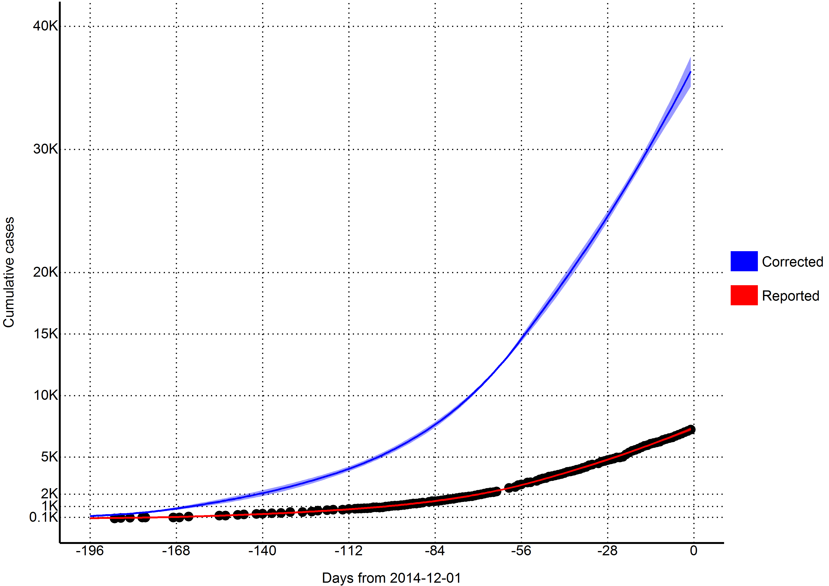

## Reproductive number

Using the last 56 days of outbreak data (2014-10-06 to 2014-11-30), we estimated that the effective reproductive number was 1.16 (95% CI=1.07 to 1.26) in Sierra Leone. Reporting for the entire outbreak, the reproductive number was estimated to be 2.15 from 2014-05-19 to 2014-06-15, 1.37 from 2014-06-16 to 2014-08-10, 1.54 from 2014-08-11 to 2014-10-05, and 1.16 from 2014-10-06 to 2014-11-30.

**Table 4. Model estimates**

|  |  |  |  |
| --- | --- | --- | --- |
| Variable | 2014-12-01 | 2014-12-29 | 2015-01-26 |
| Days from today | 0 | 28 | 56 |
| Cases (reported) | 7383 | 10586 | 14565 |
| (7210, 7555) | (9784, 11388) | (12525, 16606) |
| New daily cases (reported) | 102 | 127 | 158 |
| (88, 117) | (94, 159) | (101, 215) |
| Cases (corrected for underreporting) | 36833 | 52045 | 70952 |
| (35534, 38132) | (47213, 56878) | (59629, 82276) |
| New daily cases (corrected for underreporting) | 485 | 602 | 749 |
| (399, 570) | (429, 775) | (455, 1042) |
| Incubation period | 5547 | 6890 | 8567 |
| (4560, 6534) | (4894, 8887) | (5188, 11946) |
| Infectious and unreported | 4048 | 5026 | 6247 |
| (3468, 4627) | (3734, 6317) | (3974, 8520) |
| Undergoing treatment | 852 | 1058 | 1315 |
| (760, 945) | (822, 1295) | (878, 1752) |
| Beds for CDC target of 25% cases in ETC | 1225 | 1521 | 1891 |
| (1078, 1372) | (1193, 1849) | (1312, 2469) |
| Beds for CDC target of 45% cases in reduced transmission | 2205 | 2738 | 3403 |
| (1941, 2469) | (2147, 3328) | (2361, 4444) |
| Reporting (treatment) quotient | 40% | 40% | 40% |

## Predictions

Per today (2014-12-01), we estimate that there are 852 (95% CI=760 to 945) EVD active cases in treatment, with an additional 4048 (95% CI=3468 to 4627) EVD cases unreported and untreated (Table 4). Furthermore, we have estimated that there are 485 new symptomatic cases every day (Table 4).

If the outbreak continues with a reproductive number of 1.16 (95% CI=1.07 to 1.26), in 28 days (2014-12-29) this number will increase to 602 new cases every day, corresponding to a total of 52045 (95% CI=47213 to 56878) cumulative total cases (Table 4). In a further 28 days (2015-01-26) this will increase to 749 new cases every day, corresponding to a total of 70952 (95% CI=59629 to 82276) cumulative total cases (Table 4).

## Achieving CDC targets for 70% containment

To reach the CDC targets today, we need 1225 (95% CI=1078 to 1372) cases in ETCs and 2205 (95% CI=1941 to 2469) at home or in a community setting such that there is a reduced risk for disease transmission through effective isolation (Table 4 and Figure 3). If the outbreak continues with a reproductive number of 1.16 (95% CI=1.07 to 1.26), in 28 days (2014-12-29), we will need 1521 (95% CI=1193 to 1849) EVD cases in ETCs and 2738 (95% CI=2147 to 3328) EVD cases at reduced risk of transmission (Table 4 and Figure 3). In a further 28 days (2015-01-26) we will need 1891 (95% CI=1312 to 2469) EVD cases in ETCs and 3403 (95% CI=2361 to 4444) cases at reduced risk of transmission (Table 4 and Figure 3).

**Figure 3. Estimates of needed capacity corresponding to the CDC goals of 25% of cases in ETCs and 45% of cases in reduced transmission settings (per 2014-12-01)**

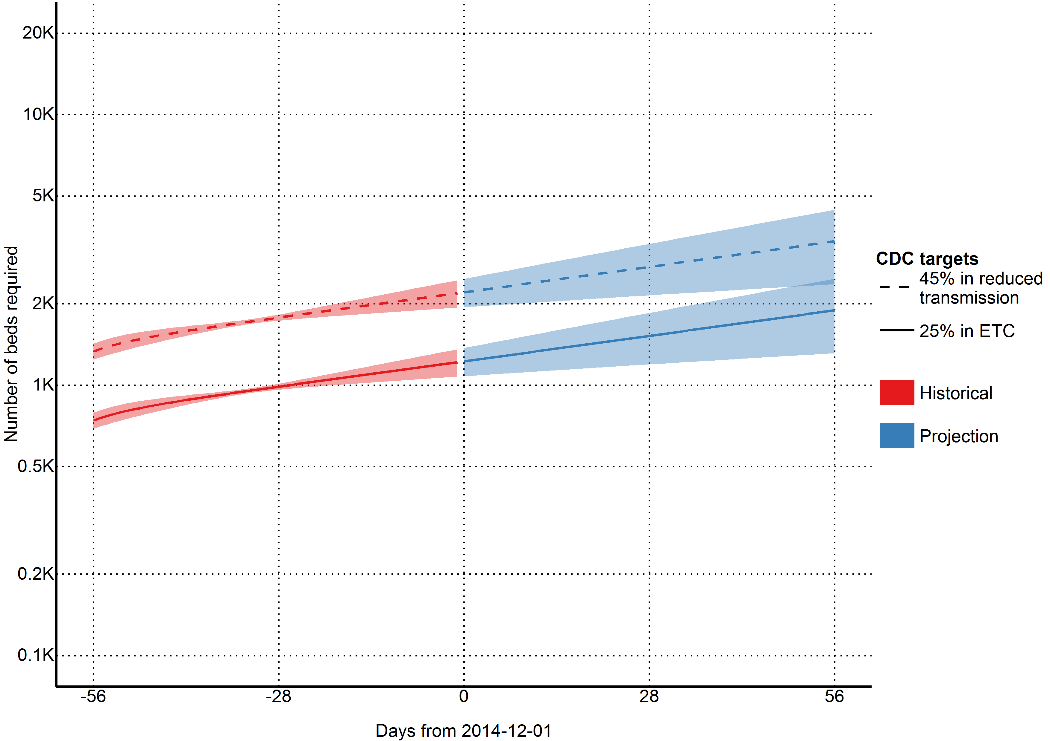

## Quantification of resources needed

**Figure 4. Estimates of personnel needed to operate ETUs with CDC goal of 25% of cases in ETCs (per 2014-12-01)**

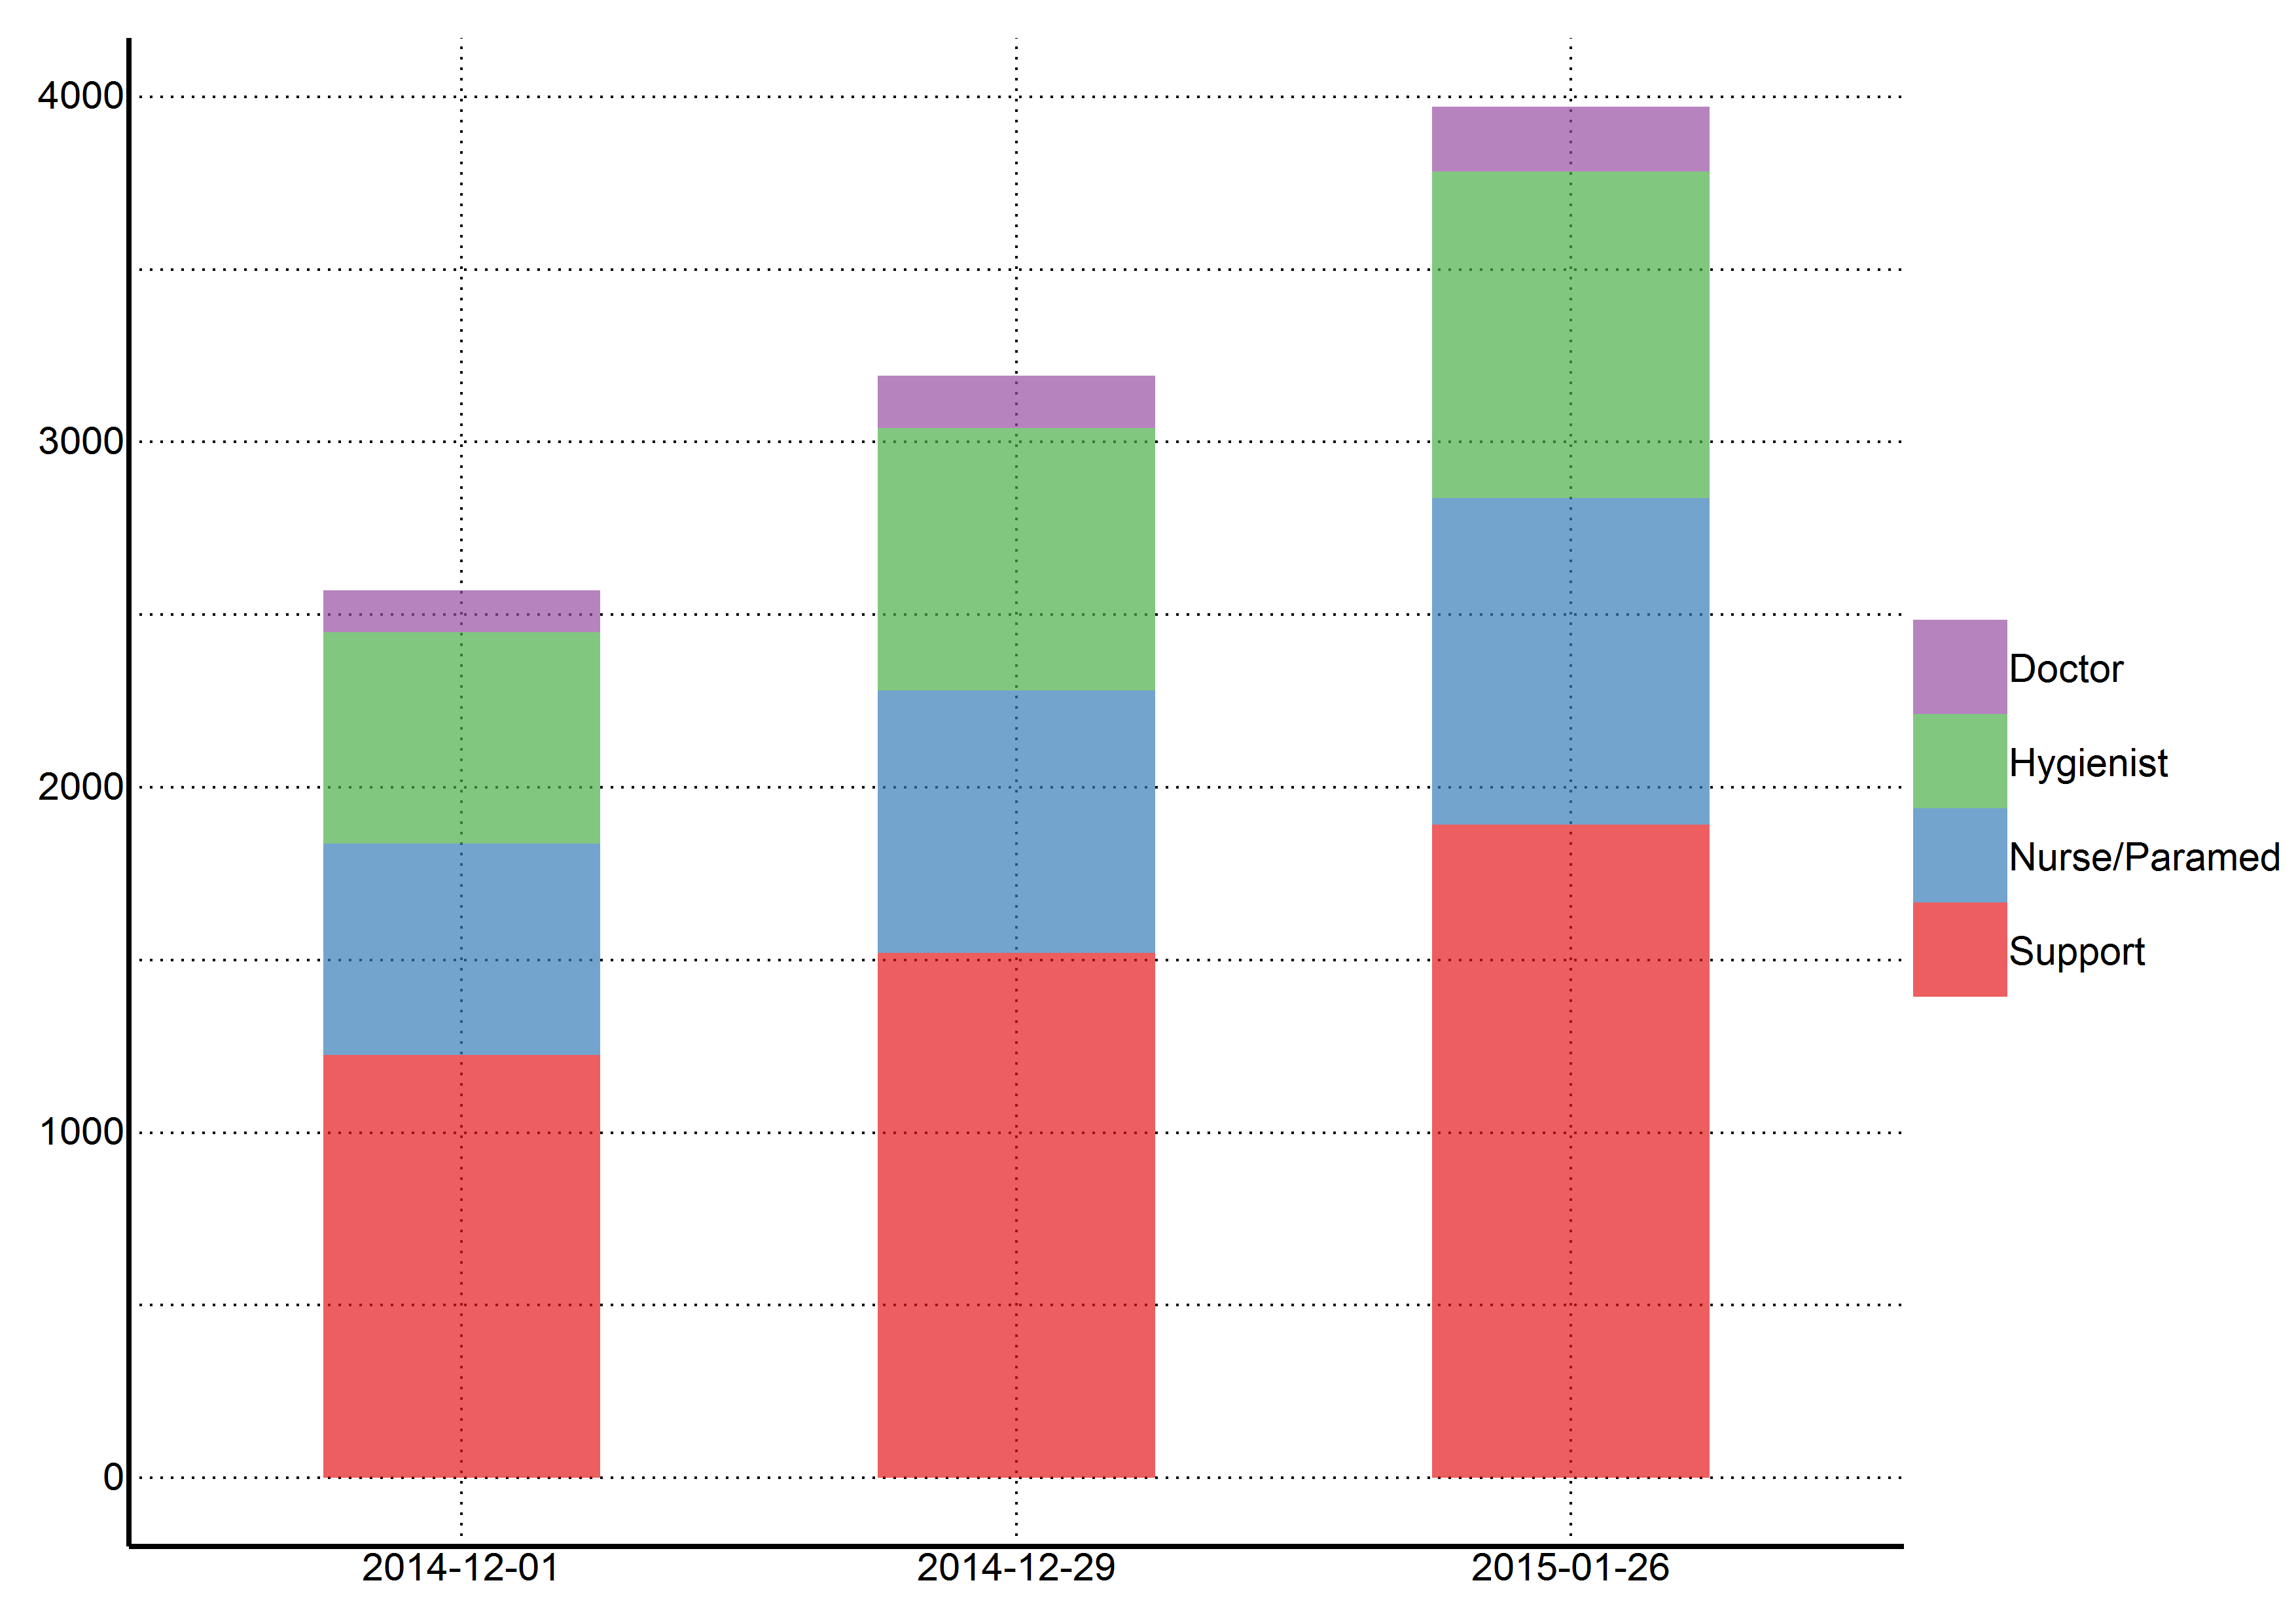

As of today (2014-12-01), we estimate that 2571 staff members are needed to operate ETCs that cover 25% of cases in Sierra Leone (Figure 4). This includes 122 doctors, 612 hygienists, 612 nurses/paramedics, and 1225 support staff. If this incidence of cases increases as projected and the targets of 25% of cases in ETCs is maintained, 3193 staff members will be required in 28 days (2014-12-29), and 3972 staff members will be required in an additional 28 days (2015-01-26).

## Intervention

We found that 70% containment/treatment after the five days baseline was sufficient to contain the epidemic. More specifically, 40% containment/treatment after one day, 50% after three days, 60% after five days, 70% after six days, and 90% after seven days were all sufficient scenarios (Figure 5). However, these numbers are based upon the uncertain estimate that currently 40% of cases are non-infectious, which may not be applicable.

**Figure 5. Ability of different intervention scenarios to achieve a reproductive number below one (per 2014-12-01)**

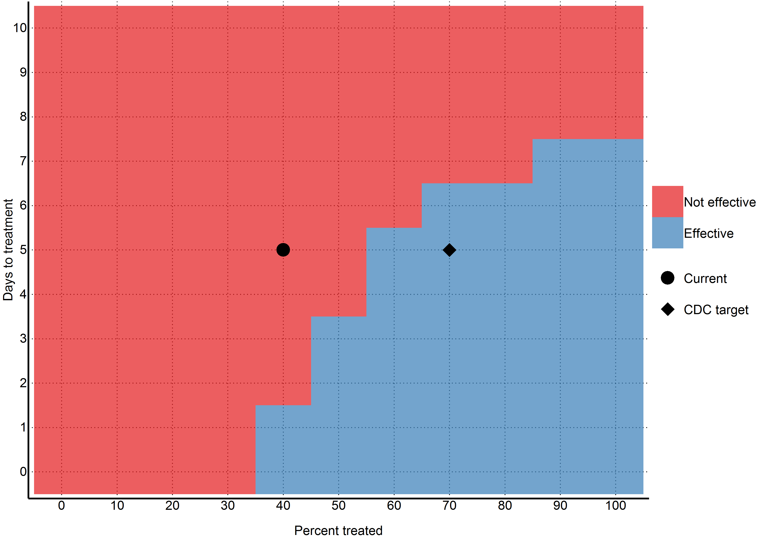

## Longevity of Model

One problem with outbreak models is that they become outdated very quickly as the outbreak progresses. We therefore present today's numbers (1225 (95% CI=1078 to 1372) cases in ETCs and 2205 (95% CI=1941 to 2469) cases in reduced transmission) as the minimum needed to reverse the outbreak. This is because even if the outbreak slows, today's numbers will still need to be achieved to push the reproductive number below one, unless another way of reducing transmission is found. Thus in the absence of effective vaccines or other preventative measures, 1225 (95% CI=1078 to 1372) cases in ETCs and 2205 (95% CI=1941 to 2469) cases in reduced transmission should remain as firm minimum targets for the international community, and will likely need to be exceeded given the growing context of the outbreak.

## Issues with assumption of 40% of treatment of cases

One flaw of this model is that it assumes that after five days, 40% of the cases will be non-infectious due to some sort of treatment. If this assumption is incorrect, then our reproductive number estimate and Figure 5 will also be incorrect. However, our estimates for the number of cases (and thus the number of beds needed to reach the CDC targets) will still be correct, as this assumption only affects the relationship between the number of currently infectious cases and how they infect the susceptible. It does not affect the overall number of cases currently alive. These unaffected numbers are then multiplied against the 25%/45% CDC numbers and we obtain our estimates, independent of whether our treatment proportion or reproductive number are correctly estimated.

Because of this, we do not place too much emphasis on the interpretation of our reproductive number nor Figure 5 in this manuscript.

## Detailed results and projections

More detailed results (including daily projections for the next six months) can be found in the supplemental materials.

# Discussion

Points to include in the Discussion:

* Outbreak is ongoing - although the overall trend is unclear at this time, there is still a profound need for treatment capacity in Sierra Leone.
* Gap between planned ETCs and estimated need for ETCs if outbreak is not contained
  + Delays in intervention will lead to substantial increases in the required treatment capacity and manpower
  + Comparison between existing treatment capacity, WHO-reported planned treatment capacity and projected treatment capacity
  + WHO existing ETC in Sierra Leone: 29% of required beds (of the 1209 needed), 3% of required CCC beds (of the 1208 needed) in place
  + Only 37% of cases are currently being isolated
  + Model suggests that 1344 ETC beds and 2420 CCC beds are required today to achieve 70% coverage - in 28 days this will increase to 2284 and 4112 beds, respectively
  + Best treatment option: ETCs or CCCs? Outbreak trend is unclear at this point - if overall incidence is decreasing but hot spots are still appearing rapid, flexible response will be required.
  + CCCs used for isolation of patients who are awaiting Ebola diagnostic test results and for provision of basic care (e.g., oral rehydration salts solutions) to patients confirmed to have Ebola who are awaiting transfer to ETCs
  + CCCs often have less bed capacity than ETCs and are frequently placed in areas not served by ETCs; if built rapidly enough and in sufficient quantity, CCCs will allow Ebola-related health measures to reach a larger proportion of the population.
  + Staffing requirements for CCCs are frequently lower than for ETCs because CCCs are often designed such that basic patient needs such as food are provided for by friends and family of patients rather than by CCC staff.
* ETCs operating at capacity or not? Need to ensure resources are distributed in areas with most need - one of the challenges in establishing semi-permanent structures as the epicenter of the outbreak changes. Reports of some ETCs with empty beds in some areas while ETCs in other areas are over capacity
* Mention Norwegian-run ETC?
* WHO reporting on 10 November that a more flexible approach is needed as the overall number appears to be declining, but hot spots continue to appear throughout the affected countries (ref). MSF's 250-bed facility in Monrovia is only 20% full and in Foya, Northern Liberia, no new cases have been reported since 30 October.
* Other models find that the importance of sufficient resources to provide case isolation for infected individuals within 4 days of symptom onset - more effort directed towards expanding the capacity of hospitalized case isolation (Yamin et al.)
* Window for action is closing - if widespread transmission continues, the number of cases will overwhelm existing resources and sufficient international resources to treat upwards of 100 00020000 cases in Sierra Leone will be difficult to acquire
* If the urgent need for isolation and treatment is not met, other control measures must be available, including vaccination, as sufficient resources, particularly healthcare workers, will be difficult, if not impossible to mobilize.
* Underreporting
  + Used estimates that others have used
  + Not known whether underreporting is improving due to increased awareness and more systematic application of control measures?

This study has a number of limitations. First and foremost, we model at the country level and only include data from Sierra Leone. This masks many geographical variations that may be happening at a more discrete level. Secondly, we assume that registered cases are in treatment and thus non-infectious. While it was assumed by the WHO model that hospitalised cases were non-infectious, it is well documented that healthcare workers are continually being infected (although it has been noted that the majority of the healthcare workers were infected at home or in their local community). We are also uncertain as to our assumption that registered cases are in treatment; considering the overwhelmed nature of the West African health system. It is entirely likely that a great number of the new cases come from counting dead bodies. In addition, this model is based on reported case data, which has significant underreporting that varies over time and geographical region. Our model attempts to correct for underreporting, however, it is not possible to validate how accurately we have done so. Finally, our model assumes that the outbreak will continue growing as it has in the past - while unlikely, the recent international efforts may have had some effect that will take place in the near future.

Currently we need to treat 3400 cases to achieve the CDC's target. In one month, 4300 cases. In two months 5300 cases will need to be treated, requiring up to 4000 personnel. With every month the CDC's 70% target grows exponentially, while the healthcare workers needed to reverse this epidemic continue to die. Urgent action is needed by the international community to reverse this crisis.