PROJECT DOCUMENTATION
PCOS EARLY CHECK
A QUESTIONNAIRE-BASED MACHINE-LEARNING AND GUIDELINE SYSTEM FOR THE EARLY SCREENING OF POLYCYSTIC OVARY SYNDROME (PCOS/PCOD) IN ADOLESCENT GIRLS AND ADULT WOMEN

Prepared by
Mohammed Irfan
Version 1.0
October 2026
Educational screening tool. Not a medical device and not a diagnosis.
ABSTRACT
Polycystic ovary syndrome (PCOS), widely called PCOD in India, affects an estimated 10–13% of women of reproductive age, yet up to 70% of them remain undiagnosed, and many wait more than two years for a diagnosis. Its earliest signs (irregular periods, excess hair growth, acne, scalp hair thinning, dark skin patches and weight gain) can be reported by the person herself, which makes a structured questionnaire a natural first screen. This document describes PCOS Early Check, an end-to-end system that turns a five-step questionnaire of about 25 questions into an explained, guideline-aware risk result for teenage girls and adult women.
The system combines two components. A rule engine encodes the 2023 International Evidence-based Guideline, including its adolescent rules, in which the definition of an irregular cycle depends on the years since the first period and both irregular cycles and androgen excess are required for a diagnosis. A machine-learning model, trained on 1,135 real records harmonised from four independent Indian sources (a clinical cohort from ten Kerala hospitals and three questionnaire surveys), estimates a calibrated probability. Six model families were compared with nested, repeated cross-validation and leave-one-source-out external validation. An elastic-net logistic regression with per-source fixed effects was selected. It reached a cross-validated ROC-AUC of 0.879 (95% CI 0.857–0.898), a mean AUC of 0.782 on unseen sources and 0.824 on the held-out clinical cohort, with a calibration slope of 1.02. Lifestyle and wellbeing answers were removed from the score after an ablation showed that they reduced accuracy on new populations.
The system is delivered as a privacy-respecting FastAPI web application with an accessible, mobile-first questionnaire, plain-language explanations, red-flag warnings and educational content. It is verified by 107 automated tests, ten reference personas and manual browser testing. The results show that a short questionnaire can triage PCOS risk well enough to prompt a timely clinical visit, while blood tests and ultrasound, which raise accuracy to an AUC of 0.957, remain essential for diagnosis.
Keywords: Polycystic Ovary Syndrome, PCOD, Early Screening, Adolescent Health, Clinical Prediction Model, Logistic Regression, External Validation, Explainable AI, Web Application.
INDEX
CHAPTER 1: INTRODUCTION 9
1.1 PROBLEM DEFINITION & DESCRIPTION 9
1.2 OBJECTIVES OF THE PROJECT 10
1.3 SCOPE OF THE PROJECT 11
1.4 PROJECT DEVELOPMENT APPROACH 11
CHAPTER 2: SYSTEM ANALYSIS 14
2.1 EXISTING SYSTEM 14
2.1.1 BACKGROUND AND LITERATURE SURVEY 14
2.1.2 LIMITATIONS OF EXISTING SYSTEM 16
2.2 PROPOSED SYSTEM 16
2.2.1 ADVANTAGES OF PROPOSED SYSTEM 17
2.3 HARDWARE AND SOFTWARE REQUIREMENTS 17
2.3.1 SOFTWARE REQUIREMENTS 17
2.3.2 HARDWARE REQUIREMENTS 18
2.4 FEASIBILITY STUDY 18
CHAPTER 3: ARCHITECTURAL DESIGN 20
3.1 MODULES DESIGN 20
3.1.1 NUMBER OF MODULES AS PER ANALYSIS 20
3.1.2 METHODOLOGY 21
3.2 PROJECT ARCHITECTURE 24
3.2.1 COMPLETE ARCHITECTURE 25
3.2.2 DATA FLOW DIAGRAM 26
3.2.3 CLASS DIAGRAM 27
3.2.4 USE CASE DIAGRAM 28
3.2.5 SEQUENCE DIAGRAM 29
3.2.6 ACTIVITY DIAGRAM 30
3.2.7 MACHINE-LEARNING PIPELINE 31
CHAPTER 4: IMPLEMENTATION 32
4.1 CODING BLOCKS 32
4.2 SAMPLE CODE 33
CHAPTER 5: TESTING & RESULTS 35
5.1 RESULTING SCREENS 35
5.2 RESULTING GRAPHS 42
5.3 RESULTS & ANALYSIS 47
CHAPTER 6: CONCLUSION & FUTURE SCOPE 50
6.1 CONCLUSION 50
6.2 FUTURE SCOPE 50
BIBLIOGRAPHY 52

LIST OF DIAGRAMS
Figure 1.1 Project development roadmap 12
Figure 3.1 Complete architecture 25
Figure 3.2 Data flow diagram (one screening) 26
Figure 3.3 Class diagram 27
Figure 3.4 Use case diagram 28
Figure 3.5 Sequence diagram (one screening request) 29
Figure 3.6 Activity diagram (deciding the result level) 30
Figure 3.7 Machine-learning training pipeline 31

LIST OF SCREENSHOTS
Screenshot 5.1 Home page 36
Screenshot 5.2 Questionnaire, step 2: periods 36
Screenshot 5.3 Questionnaire, step 3: hair growth by body region 37
Screenshot 5.4 Result for a symptomatic adult 38
Screenshot 5.5 Explanation of the score 39
Screenshot 5.6 Teenager with no period at 15: “at risk” with a red flag 39
Screenshot 5.7 Learn page 40
Screenshot 5.8 About the model page 41
Screenshot 5.9 Mobile layout: questionnaire and result 42

LIST OF GRAPHS
Graph 5.1 Training data by source 42
Graph 5.2 ROC curves of the six model families (nested 5×5 cross-validation) 43
Graph 5.3 External validation: AUC on a source never seen in training 44
Graph 5.4 Calibration of the selected model 45
Graph 5.5 Adjusted odds ratios of the final model 45
Graph 5.6 What a doctor's tests add (Kerala cohort) 46
Graph 5.7 Automated tests per module 46

LIST OF TABLES
Table 1.1 Design variations considered 12
Table 1.2 Project at a glance 13
Table 2.1 Software requirements 18
Table 2.2 Platform decision matrix (scores from 1 to 5) 19
Table 3.1 Code modules 21
Table 3.2 Data sources used for training 21
Table 3.3 Harmonised questionnaire features 22
Table 3.4 Irregular-cycle rules by years since the first period 23
Table 3.5 Combination of guideline result and model band 24
Table 4.1 Error handling 33
Table 5.1 Summary of testing 35
Table 5.2 Model comparison (AUC; LOSO = held-out source) 47
Table 5.3 Feature-set ablation (mean LOSO AUC, fixed hyper-parameters) 47
Table 5.4 Reference personas scored by the live server 48
Table 5.5 Issues found by manual testing and their fixes 48

LIST OF ABBREVIATIONS
Abbreviation | Meaning
AMH | Anti-Müllerian hormone
API | Application programming interface
AUC | Area under the ROC curve (ROC-AUC); PR-AUC is the area under the precision–recall curve
BMI | Body-mass index (weight in kg divided by height in m squared)
CI | Confidence interval
CSP | Content-Security-Policy (a browser security header)
CV | Cross-validation
ECE | Expected calibration error
LOSO | Leave-one-source-out validation (train on three datasets, test on the fourth)
mFG | Modified Ferriman–Gallwey hirsutism score
ML | Machine learning
OR | Odds ratio
PCOS / PCOD | Polycystic ovary syndrome / polycystic ovarian disease (common Indian usage)
ROC | Receiver operating characteristic
TPE | Tree-structured Parzen estimator (Optuna's search algorithm)
WCAG | Web Content Accessibility Guidelines

CHAPTER 1: INTRODUCTION

1.1 PROBLEM DEFINITION & DESCRIPTION
Polycystic ovary syndrome (PCOS) is one of the most common hormonal conditions in girls and women. The World Health Organization estimates that it affects 10–13% of women of reproductive age and that up to 70% of affected women are unaware they have it [1]. Prevalence depends on the diagnostic criteria used: a meta-analysis found about 6% under the NIH criteria and about 10% under the broader Rotterdam criteria [2], and studies from India report figures between 3.7% and 22.5% depending on the population and definition [3]. In everyday Indian usage the condition is often called PCOD; this document uses the medical term PCOS throughout.
Diagnosis is frequently slow. In an international survey of 1,385 women with PCOS, 33.6% reported waiting more than two years for a diagnosis and 47.1% saw three or more health professionals before receiving one [4]. The delay matters because PCOS is a lifelong condition with consequences far beyond the ovaries: insulin resistance and a higher risk of type 2 diabetes and gestational diabetes, an adverse cardiometabolic profile, changes in the lining of the womb when periods are very infrequent, reduced fertility, and higher rates of anxiety and depression [5]. Lifestyle changes and treatment work best when they start early.
Teenagers are a special case. Irregular cycles are normal in the first years after the first period (menarche), acne is common in adolescence, and ovarian ultrasound is unreliable in young people. The international guideline therefore applies stricter, age-specific rules to adolescents [6], [7]. Applying adult criteria to a 15-year-old risks over-diagnosis, while dismissing symptoms as “just puberty” risks missing the condition.
At the same time, the earliest signs of PCOS (irregular or missed periods, excess facial or body hair, persistent acne, scalp hair thinning, dark velvety skin patches and difficult weight gain) are things a person can observe and report herself. A carefully designed questionnaire can therefore act as a first screen, long before a blood test or an ultrasound.
The project focuses on five core problems:
- Late and missed diagnosis: many girls and women live with symptoms for years without knowing that they may share a common, manageable cause.
- A confusing picture in adolescence: the line between normal pubertal irregularity and early PCOS depends on the years since menarche, which generic advice ignores.
- Unvalidated online checks: symptom quizzes usually give a yes/no verdict with no evidence base, no calibration and no explanation, and they often collect sensitive data.
- Small, fragmented public data: published machine-learning work mostly uses one hospital dataset and relies on hormone tests and follicle counts, which are only available after a clinical work-up; few studies test their models on a different population.
- Privacy and trust: menstrual and body-hair information is sensitive, especially for minors, so a screening tool must work without accounts or data collection.
When these problems are left unaddressed, the costs are real: years of untreated symptoms and distress, missed opportunities to prevent diabetes and cardiovascular risk, fertility problems discovered late, and mistrust of both online tools and health services.

1.2 OBJECTIVES OF THE PROJECT
The objectives of the project are to:
- Design a short questionnaire of about 25 questions that any girl or woman can answer without tests, in about four minutes.
- Collect, document and harmonise real public PCOS datasets into a single, reproducible training set.
- Train and compare several machine-learning models with nested cross-validation and leave-one-source-out external validation, and select a calibrated, explainable model.
- Encode the 2023 International Evidence-based Guideline, including its adolescent rules, as a transparent rule engine, and combine it safely with the model.
- Explain every result in plain language, with the reasons behind it, the tests a doctor may suggest, warning signs and personalised lifestyle tips.
- Deliver the system as an accessible, mobile-first, privacy-respecting web application with a documented API.
- Verify the whole system with automated tests, reference personas and manual browser testing, and document its data, model and limitations honestly.

1.3 SCOPE OF THE PROJECT
The project delivers a complete, working system: a configurable Python training pipeline, a trained model artifact with its model card, a guideline rule engine, a FastAPI REST service and a web interface with three areas: Check (the questionnaire and results), Learn (education) and About (model accuracy and limitations). It is intended for girls and women aged 10 to 60, and for teachers, school nurses and health workers who run awareness sessions.
The system screens; it does not diagnose. It never states that a person has or does not have PCOS, does not interpret laboratory or ultrasound results, and gives no treatment advice beyond general, guideline-based lifestyle information. No accounts are created and, by default, no answers are stored.
Four limitations are stated up front: all training data comes from India; three of the four datasets use self-reported diagnoses; only 19 of the 1,135 training records are from people under 18; and the system has not yet been tested in a prospective clinical study.

1.4 PROJECT DEVELOPMENT APPROACH
The project followed a four-stage product framework (Figure 1.1). Stage 1, ideation, framed the problem and three user personas: a teenager with irregular periods and acne who is unsure what is normal; a young adult with irregular cycles and weight or skin concerns who may be planning a pregnancy; and an educator or health worker who needs a quick, explainable screener for awareness camps. Three design variations were then compared (Table 1.1).
Stage 2 validated the idea against evidence on prevalence, diagnostic delay and the guideline. It also searched Kaggle, GitHub, Figshare, Zenodo, Mendeley and IEEE DataPort for usable data, which produced four real, individual-level sources, and selected a responsive web application as the form factor (Section 2.4). Stage 3 audited existing systems and fixed the technical requirements. Stage 4 carried out the plan: data harmonisation, a feature-set ablation, nested cross-validated training, the guideline engine, the web application, automated and manual testing, and a final deterministic retraining.
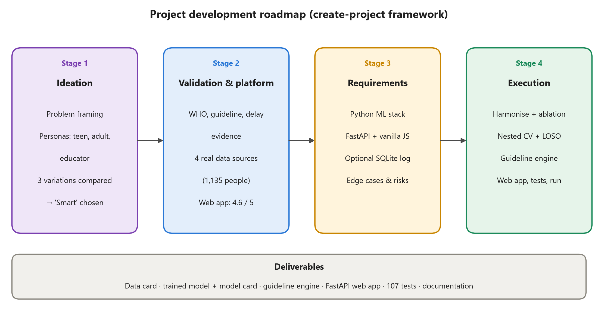
Figure 1.1 Project development roadmap
Table 1.1 Design variations considered
Variation | Description | Strengths | Weaknesses
Lean / minimal | Static rule-based checklist that runs in the browser | No server; fully transparent; nothing leaves the device | No statistical risk estimate; yes/no output; cannot learn from data
Automated / smart (chosen) | ML model on harmonised real data, guideline engine and explanations behind a REST API | Calibrated probability; explainable; age-aware; reproducible training | Needs a backend and a model file; limited by small public datasets
Enterprise / robust | Smart variation plus accounts, consented data store, clinician dashboard, FHIR export and monitoring | Scales to clinics and public-health programmes | Heavy compliance burden; needs clinical validation first

The smart variation was built, with hooks for the enterprise path already in place: configuration-driven paths, an optional anonymous SQLite log that is off by default, a versioned model artifact with model and data cards, and a health-check endpoint. Table 1.2 summarises the delivered project.
Table 1.2 Project at a glance
Aspect | Summary
Users | Teenage girls, adult women, educators and health workers
Input | Five-step questionnaire, about 25 questions, about 4 minutes
Training data | 1,135 people from 4 independent Indian sources; 35.9% with PCOS
Model | Elastic-net logistic regression with per-source fixed effects; 10 features
Accuracy | Cross-validated AUC 0.879; 0.782 on unseen sources (0.824 on the clinical cohort)
Clinical logic | 2023 International Evidence-based Guideline, including the adolescent rules
Output | Low, moderate or high level with reasons, tests to ask about, red flags and tips
Platform | Python 3.13, scikit-learn, FastAPI, HTML/CSS/JavaScript
Quality | 107 automated tests, 10 reference personas, manual browser testing

CHAPTER 2: SYSTEM ANALYSIS
The system must do five things well: collect answers that people can give without tests, apply the clinical criteria correctly for each age group, estimate risk with a calibrated model, explain the result in plain language, and point to sensible next steps. Its non-functional requirements are privacy (no accounts and no stored data by default), explainability, honest reporting of accuracy, generalisation to new populations, accessibility on low-end phones, fast responses on an ordinary CPU and fully reproducible training.

2.1 EXISTING SYSTEM
Today a PCOS diagnosis follows the clinical pathway: a consultation, a physical examination, blood tests for androgens and for conditions that mimic PCOS (thyroid function, prolactin and 17-hydroxyprogesterone) and, for adults, a pelvic ultrasound or an anti-Müllerian hormone (AMH) test [5], [8]. The pathway is accurate but slow to start: people first have to recognise that their symptoms are worth a visit, and stigma, cost and distance delay many of them [4].
Outside the clinic, people turn to online quizzes and period-tracking apps. These are easy to reach but rarely evidence-based: they typically add up symptoms into a yes/no verdict, ignore the age-specific rules for teenagers, report no accuracy figures and often require an account that stores intimate health data.
In research, machine-learning models for PCOS have mostly been built on a single public hospital dataset from Kerala [13] or on electronic health records [12]. They often reach high accuracy, but largely because they use hormone levels and ultrasound follicle counts, information that exists only after a clinical work-up, and they are usually evaluated on random splits of the same dataset rather than on a different population.

2.1.1 BACKGROUND AND LITERATURE SURVEY
[8] The Rotterdam consensus (2004) defined PCOS by any two of three features (oligo- or anovulation, clinical or biochemical hyperandrogenism, and polycystic ovarian morphology) after other causes are excluded. It remains the basis of adult diagnosis.
[5] Teede et al. (2023) published the International Evidence-based Guideline, which defines irregular cycles by the time since menarche, recommends the modified Ferriman–Gallwey score for hirsutism and accepts AMH as an alternative to ultrasound in adults. The rule engine in this project implements these definitions.
[6], [7] Peña et al. (2020, 2025) set out the adolescent recommendations: diagnosis needs both irregular cycles and hyperandrogenism; ultrasound and AMH should not be used within eight years of menarche; and a girl with only one feature is “at risk” and should be followed up. These rules drive the teen pathway.
[2] Bozdag et al. (2016) showed in a meta-analysis that prevalence depends strongly on the criteria used, which helps explain the very different PCOS rates across the datasets used here.
[4] Gibson-Helm et al. (2017) documented long diagnostic delays and dissatisfaction among women with PCOS, the gap an early-screening tool aims to close.
[9], [10] Ferriman and Gallwey (1961) introduced body-region scoring of hair growth, and Bedrick et al. (2020) showed that a self-administered questionnaire, including self-rated hirsutism, can screen for PCOS in adult women. The body-region hair questions in this project follow the same idea.
[11], [12] Denny et al. (2019) proposed i-HOPE, an early machine-learning system for PCOS detection and prediction. Zad et al. (2024) predicted PCOS from the electronic health records of 30,601 women, comparing logistic regression, support vector machines, gradient-boosted trees and random forests with AUCs of roughly 0.80–0.85, and noted that earlier models were built on small samples, mostly from fertility clinics.
[14] Christodoulou et al. (2019) reviewed clinical prediction studies and found no performance benefit of machine learning over logistic regression, which supports giving the simpler model a fair chance during model selection.
[15–21] TRIPOD+AI [15] and the prediction-model literature [16], [17] stress calibration and external validation. Nested cross-validation avoids optimistic bias when hyper-parameters are tuned [18], [19], and leaving one dataset out at a time is an established form of internal–external validation [20], [21].

2.1.2 LIMITATIONS OF EXISTING SYSTEM
- The clinical pathway only starts once a person recognises her symptoms, and the typical delay is long.
- Online quizzes give unexplained yes/no answers, ignore age-specific rules and rarely publish their accuracy.
- Many symptom apps require accounts and store intimate health data, which is a particular concern for minors.
- Published models depend on hormone tests and ultrasound, so they cannot be used before a clinic visit.
- Most models are evaluated on a single dataset, with no evidence that they work on a different population and little attention to calibration.
- Few tools explain what drives a result or what to do next.

2.2 PROPOSED SYSTEM
PCOS Early Check is a web application that turns a short self-report questionnaire into an explained, guideline-aware screening result, without accounts and without storing data by default. It offers six capabilities:
- Check: a five-step adaptive questionnaire (about you, periods, skin and hair, lifestyle and wellbeing, health history) with unit conversion, a live BMI preview and conditional questions.
- Guideline engine: applies the 2023 guideline's cycle rules by years since the first period, assesses signs of excess androgen, selects the adolescent or adult pathway and raises red flags.
- Risk model: a calibrated logistic-regression model trained on 1,135 real records that estimates how often women with similar answers had PCOS.
- Explained results: a low, moderate or high level, the criteria behind it, the answers that raised or lowered the score, tests to ask a doctor about and personalised tips based on WHO activity guidelines [35].
- Learn: plain-language education about PCOS, teenagers, diagnosis, management, warning signs, and myths and facts.
- About: the model's accuracy, data sources and limitations, shown openly to every user.
Five principles guide the design. Evidence first: every rule traces back to the international guideline. Honesty: the tool never says that a person has or does not have PCOS, and a low result is never presented as an all-clear. Adolescent safety: for teenagers the guideline leads and the model supports it. Explainability: every result lists its reasons. Privacy by default: no accounts, no cookies, no third-party scripts and no stored answers unless storage is enabled and the user consents.

2.2.1 ADVANTAGES OF PROPOSED SYSTEM
- Earlier awareness: anyone can check her symptoms in about four minutes, with no test and no appointment.
- Correct for teenagers: cycle rules adapt to the years since the first period, and the “at risk” category avoids both over- and under-diagnosis.
- Validated on unseen populations: accuracy is reported for whole datasets the model never saw, not only for random splits.
- Explainable and calibrated: the probability means what it says (calibration slope 1.02), and each result lists the answers that drove it.
- Private and lightweight: no accounts or tracking; the model file is 5.6 KB, and a screening request takes about 17 ms on an ordinary laptop.
- Reproducible: one command retrains the model from the raw data and regenerates every metric, figure and model card.

2.3 HARDWARE AND SOFTWARE REQUIREMENTS

2.3.1 SOFTWARE REQUIREMENTS
Table 2.1 lists the software stack. All components are open source and run on Windows, macOS or Linux.
Table 2.1 Software requirements
Component | Version
Language | Python 3.13.0
Data processing | pandas 3.0.6, NumPy 2.5.4, openpyxl 3.1.5
Machine learning | scikit-learn 1.9.1, LightGBM 4.7.0, XGBoost 3.4.1
Hyper-parameter search | Optuna 5.0.0
Reporting and model files | matplotlib 3.11.2, joblib
Configuration | PyYAML 6.0.3 and argparse
Web backend | FastAPI 0.143.1, Uvicorn 0.54.0, Pydantic 2.14.1
Web frontend | HTML5, CSS3 and vanilla JavaScript (no third-party libraries)
Storage (optional) | SQLite (Python standard library)
Testing | pytest 9.1.1, httpx 0.28.1 (API test client)

2.3.2 HARDWARE REQUIREMENTS
Development and training were carried out on a Windows 11 laptop with a 12-thread CPU, 16 GB of RAM and no GPU. Because the data is tabular and small, no GPU is needed: the full nested cross-validation (29 parallel fold tasks over six model families) completes in about 21 minutes, and a quick smoke run takes about 2 minutes. Serving the app needs very little: the model file is 5.6 KB, and a screening request takes a median of 17 ms (95th percentile 50 ms) on the same machine. Users need only a modern browser on any phone, tablet or computer.

2.4 FEASIBILITY STUDY
Technical: every component uses mature, well-documented open-source libraries, and the working implementation passes all 107 automated tests. Economic: there are no licence costs, paid services or GPU requirements; a single small server or a laptop can host the app. Operational: the questionnaire takes about four minutes, needs no account and works on phones, so it suits individual use as well as school and community awareness sessions. Legal and ethical: because no personal data is collected by default, compliance with India's Digital Personal Data Protection Act 2023 is simpler [36]; the tool is clearly labelled as educational, includes red-flag guidance and is designed with minors' privacy in mind. Accessibility follows WCAG 2.2 practices such as labelled form controls, keyboard navigation and sufficient contrast [37].
The form factor was chosen with a weighted decision matrix (Table 2.2). A responsive web application scored highest because it reaches users on any device without installation, updates centrally and still works well on phones.
Table 2.2 Platform decision matrix (scores from 1 to 5)
Criterion (weight) | Desktop | Web app | Android
Reach to teens and women on any device (30%) | 1 | 5 | 4
Zero install; use in school or college camps (20%) | 1 | 5 | 2
Seamless model updates (15%) | 2 | 5 | 3
Privacy; no data at rest (15%) | 5 | 4 | 4
Development and maintenance cost (10%) | 3 | 5 | 2
Offline use (10%) | 5 | 2 | 5
Weighted score | 2.35 | 4.55 | 3.35

CHAPTER 3: ARCHITECTURAL DESIGN

3.1 MODULES DESIGN
The code is organised so that data handling, clinical rules, model training, inference and the web layer stay separate, and each can be tested on its own.

3.1.1 NUMBER OF MODULES AS PER ANALYSIS
The project is organised into six functional modules:
- Data harmonisation: loads each raw source, maps its questions onto 14 canonical features, enforces physiological bounds, removes duplicates and keeps a source label.
- Guideline rule engine: implements the 2023 guideline's cycle rules, androgen signs, adolescent and adult pathways, red flags and notes.
- Model training and validation: the model zoo, nested cross-validation, leave-one-source-out validation, model selection, calibration, thresholds and reports.
- Inference and explanation: loads the artifact, clamps inputs to the training range, predicts, explains the score and combines it with the guideline result.
- Web application: the FastAPI service [39] with validation and security headers, and the three-area frontend (Check, Learn, About).
- Quality assurance and storage: 107 automated tests, the persona checker and the optional anonymous SQLite log.
Table 3.1 Code modules
Module | Responsibility
pcos_screen/data.py, schema.py | Source loaders, harmonisation and the canonical feature schema
pcos_screen/questionnaire.py | The Answers data class and the mapping of answers to model features
pcos_screen/guideline.py | 2023 guideline rule engine (cycles, androgen signs, pathway, red flags)
pcos_screen/models.py | Preprocessor, monotone boosting, soft-vote ensemble and search spaces
pcos_screen/train.py, metrics.py, report.py | Nested CV, LOSO, selection, calibration, thresholds, figures and model card
pcos_screen/predict.py, screening.py | Inference, explanations, guideline–model combination and advice
pcos_screen/storage.py | Optional anonymous SQLite log (off by default)
app/main.py, schemas.py, static/ | FastAPI service, request validation and web interface
tests/, scripts/ | Automated tests and the persona checker
config/default.yaml | Paths, sources, features, training and app settings

3.1.2 METHODOLOGY
Data sources. Four individual-level sources were found and kept, each in its own folder (Table 3.2). The Kerala cohort [13], retrieved from a GitHub mirror [43] whose file hash matched a second independent copy, is the only clinically diagnosed source; the three surveys [40]–[42] use self-reported diagnoses. Sources with undocumented labels, aggregate-only tables and synthetic datasets were excluded, because synthetic data would inflate the metrics without adding evidence.
Table 3.2 Data sources used for training
Source | People | PCOS | Label | Main content
Kerala clinics (10 hospitals) | 541 | 32.7% | Clinical diagnosis | Symptoms, body measurements, hormones, ultrasound
India survey 2018 | 161 | 83.2% | Self-reported test result | Symptoms, hair growth by body region, lifestyle
Mumbai survey | 261 | 22.6% | Self-reported diagnosis | Cycle length, hair-growth grades, symptoms
Lifestyle survey | 172 | 22.1% | Self-reported diagnosis | BMI, family history, diet and exercise
Total | 1,135 | 35.9%

Harmonisation. Every source is mapped onto 14 canonical questionnaire features (Table 3.3). Questions a source never asked stay missing rather than being guessed; for example, the Kerala cohort has no question about difficulty conceiving. Hair growth recorded by body region is turned into one “excess hair” flag (moderate growth on the face, chest or abdomen, or heavy growth on the thighs), and cycle-length answers are combined with the “irregular periods” question.
Table 3.3 Harmonised questionnaire features
Feature | Meaning | Use
Age | Age in years | Risk model
BMI, overweight | Body-mass index; BMI of 25 or more | Risk model
Irregular cycle | Irregular or missed periods (guideline definition) | Risk model
Weight gain | Rapid weight gain or difficulty losing weight | Risk model
Excess hair | Moderate or heavy hair in androgen-sensitive areas | Risk model
Acne | Frequent acne or pimples | Risk model
Hair loss | Scalp hair thinning | Risk model
Skin darkening | Dark, velvety skin patches | Risk model
Difficulty conceiving | Trying for 12 months or more without success | Risk model
Fast food, exercise | 3+ fast-food meals; 3+ active days a week | Advice only
Fatigue, mood swings | Tired most of the time; frequent mood swings | Advice only

Confounding control. PCOS prevalence ranges from 22% to 83% across the sources, and each source asked a slightly different set of questions. If this were ignored, a model could learn “which survey is this?” instead of “which symptoms matter?”. The model therefore includes a fixed effect γ for each source:
logit P(PCOS) = β₀ + Σ_{j} β_{j} x_{j} + γ_{source}
This way, symptom effects are estimated within sources. At prediction time the source is set to the Kerala clinical cohort, so probabilities are expressed on the scale of women attending gynaecology clinics with a doctor-confirmed diagnosis.
Feature selection by ablation. Before training, a leave-one-source-out ablation compared feature sets with fixed hyper-parameters. Lifestyle answers (fast food, exercise) and wellbeing answers (fatigue, mood swings) lowered accuracy on unseen sources, and exercise even appeared to raise risk, a sign of reverse causation (women who are diagnosed are advised to exercise). These four answers are still asked, but only to personalise advice. The final model uses 10 features.
Training and validation. Six model families were compared, all implemented with scikit-learn [23] or compatible libraries: elastic-net logistic regression [27], random forest [26], histogram gradient boosting, LightGBM [24], XGBoost [25] and a soft-voting ensemble. Gradient-boosted trees are usually the strongest models for tabular data [22], so they were natural challengers; the three boosted models use monotone constraints, so a symptom can only raise the predicted risk. Each candidate was evaluated with nested, repeated, stratified cross-validation: five repeats of five outer folds, stratified by source and label, with hyper-parameters tuned only in a three-fold inner loop by Optuna's TPE sampler (25 trials, log-loss objective) [28], [18], [19]. In addition, each source was held out completely in turn, giving a leave-one-source-out (LOSO) estimate of performance on a new population [20], [21]. Discrimination is reported as ROC-AUC [31] and PR-AUC with bootstrap confidence intervals [33], and probability accuracy as the Brier score [32], calibration slope and intercept, and expected calibration error [17].
Model selection, calibration and thresholds. The rule fixed before training was to choose the simplest model whose mean LOSO AUC is within 0.01 of the best. Calibration was then chosen by out-of-fold Brier score from three options: no recalibration, Platt scaling [29] and isotonic regression [30]. Finally, two cut-offs were set from out-of-fold probabilities. The “low” cut-off is the highest value that still flags at least 90% of PCOS cases as moderate or high, and the “high” cut-off is the lowest value that keeps at least 80% of non-PCOS cases below it. With the selected model these are 0.198 and 0.320.
Guideline rules. The rule engine applies the 2023 guideline [5]–[7]. The definition of an irregular cycle depends on the years since the first period (Table 3.4). Signs of excess androgen are moderate-to-heavy hair on the face, chest or lower abdomen (or heavy hair on the thighs or back), moderate-to-severe or persistent acne, and, for adults only, scalp hair thinning. The adolescent pathway applies to anyone under 18 or within eight years of her first period, when ultrasound is not used for diagnosis.
Table 3.4 Irregular-cycle rules by years since the first period
Years since first period | Counts as irregular
Less than 1 | Not assessed: irregular cycles are a normal part of puberty
1 to less than 3 | Cycles shorter than 21 or longer than 45 days
3 or more | Cycles shorter than 21 or longer than 35 days
More than 1 | Any single cycle longer than 90 days
Periods not started | Primary amenorrhoea if there is no period by age 15 (also a red flag)

Combining the guideline and the model. The two components are combined with the decision table in Table 3.5, which deliberately keeps the clinical rules in charge where the model is weakest. Any red flag (no period by 15, rapid virilisation, or possible pregnancy with absent periods) changes the advice to “see a doctor soon”, whatever the level.
Table 3.5 Combination of guideline result and model band
Situation | Final level
Irregular cycles and androgen signs both present | High
Teen pathway, one feature present (“at risk”) | Moderate
Teen pathway, no feature, model band high | Moderate
Teen pathway, no feature, model band low or moderate | Low
Adult, one feature present | Moderate, or High if the model band is high
Adult, no feature | Model band, capped at Moderate
Model unavailable | Guideline only: High, Moderate or Low

Explanations and safety at inference. Each answer's contribution is measured by occlusion [34]: the answer is replaced by its symptom-free value (and BMI by 22), and the change in log-odds is reported. The person is therefore compared with someone of the same age without that sign:
Δ_{j} = logit p(x) − logit p(x with x_{j} set to its baseline)
Numeric inputs are clamped to the 1st–99th percentile of the training data (age 16–48 years, BMI 14.6–35.2), so the linear model never extrapolates, and answers given as “not sure” are imputed. For a girl in her first year after menarche, irregular cycles are treated as normal (“absent”) rather than unknown.

3.2 PROJECT ARCHITECTURE
The diagrams that follow describe the system using standard UML and data-flow notation.

3.2.1 COMPLETE ARCHITECTURE
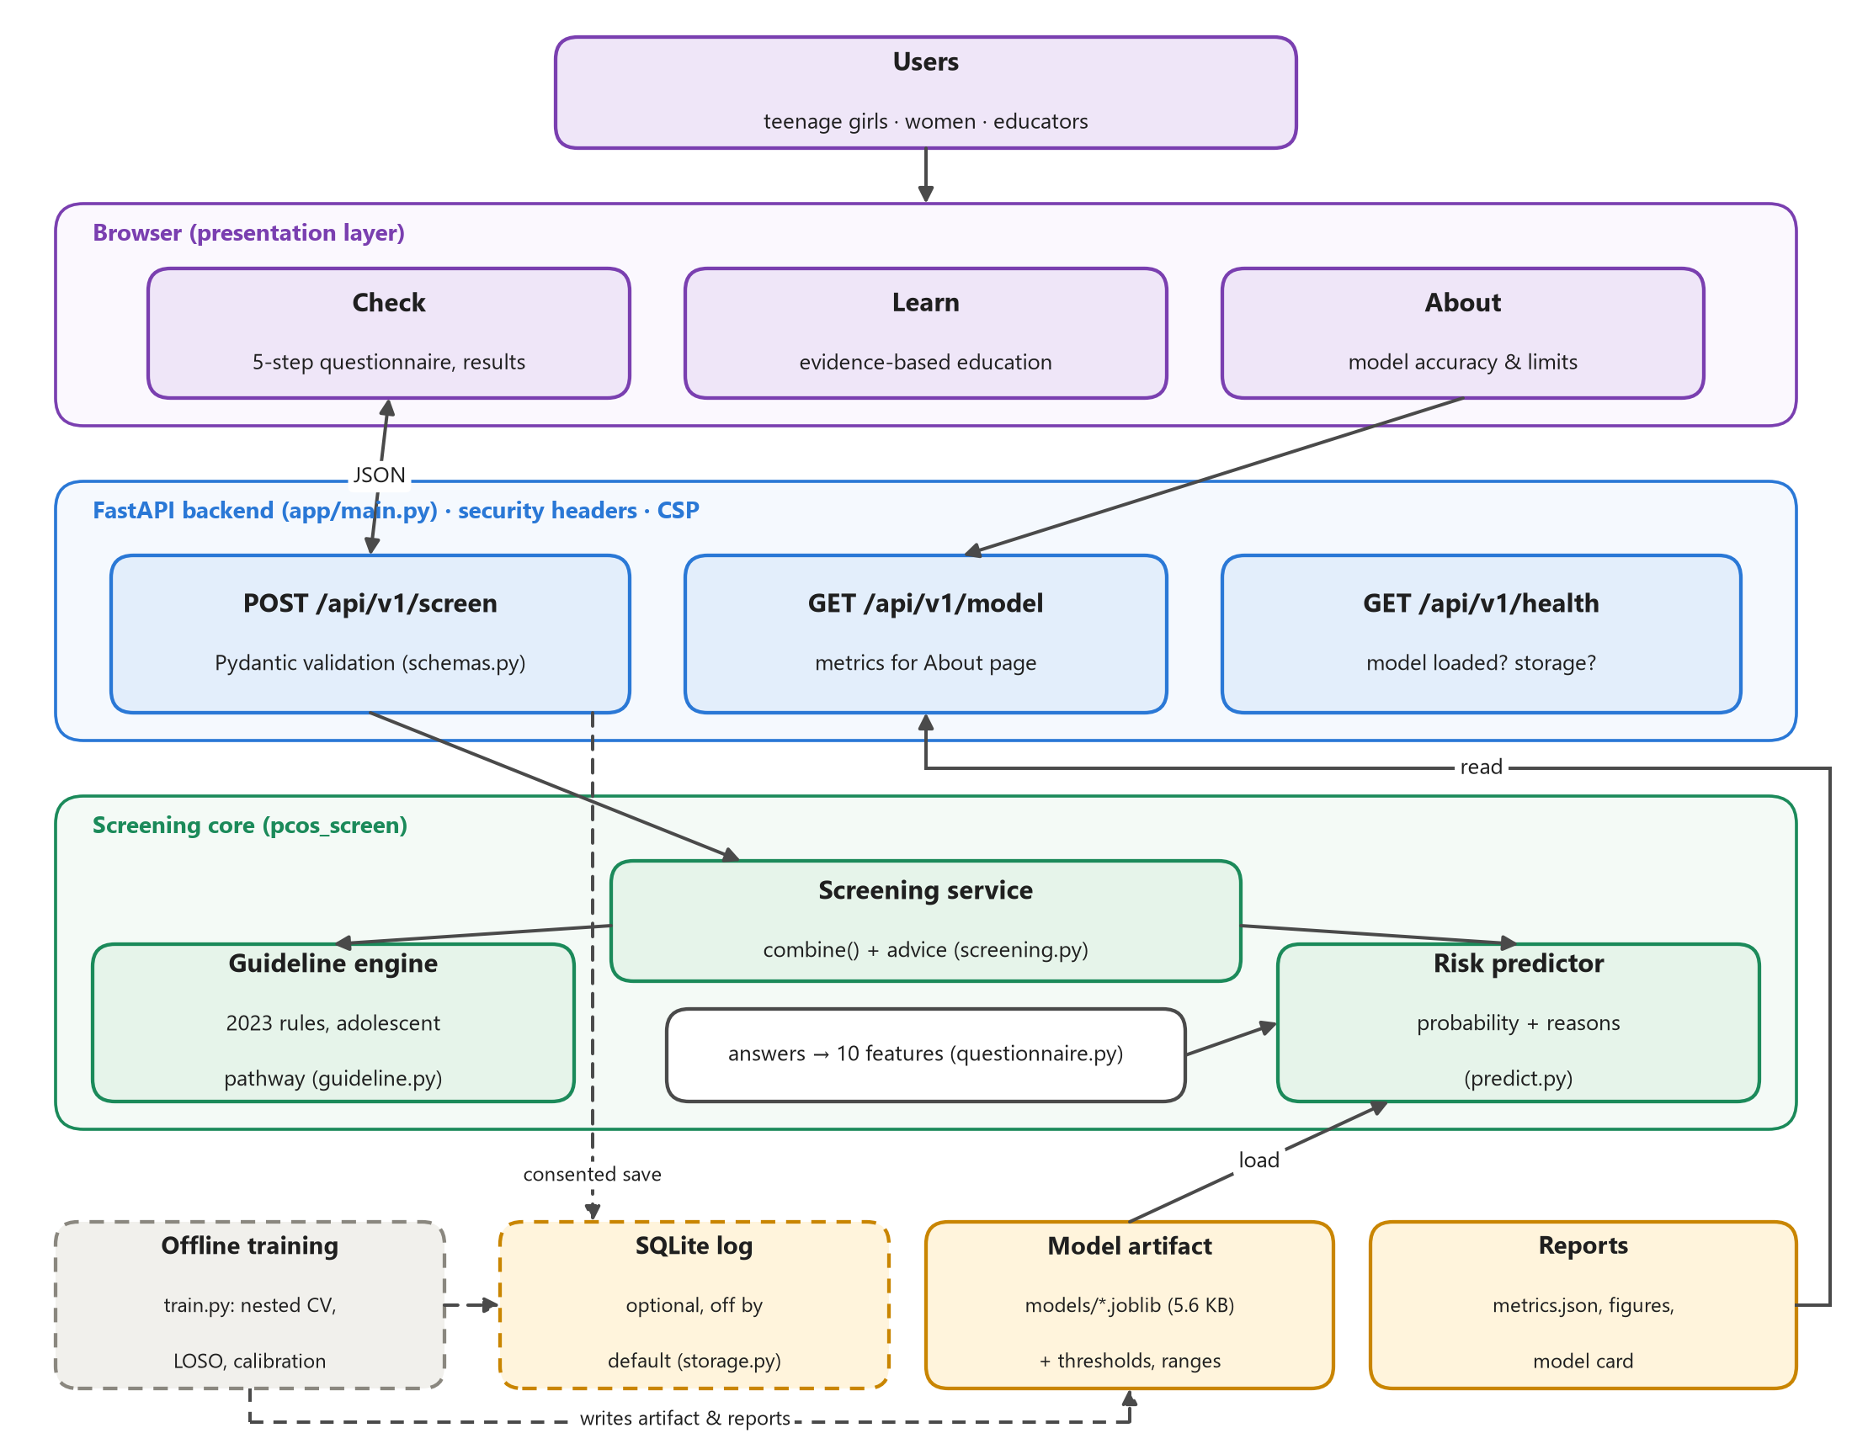
Figure 3.1 Complete architecture
Users interact with the browser presentation layer, which has three areas. The FastAPI backend validates every request with Pydantic, adds security headers including a strict Content-Security-Policy [38], and exposes three endpoints. The screening core combines the guideline engine with the risk predictor, which loads a small model artifact. Training runs offline and writes the artifact, metrics and model card; the optional SQLite log is used only when storage is enabled and the user consents.

3.2.2 DATA FLOW DIAGRAM
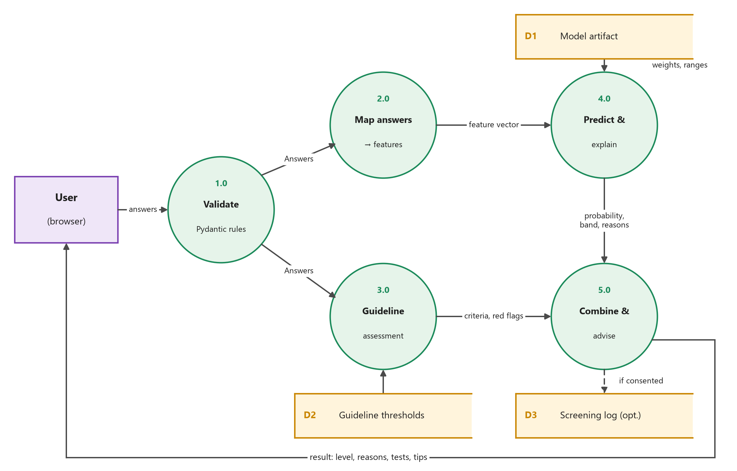
Figure 3.2 Data flow diagram (one screening)
The user's answers are validated (1.0) and then follow two paths: they are mapped to the model's feature vector (2.0) and assessed against the guideline thresholds (3.0). The predictor (4.0) reads the model artifact and returns a probability, band and reasons, and the combination step (5.0) merges both results into the final level and advice. A screening is written to the log only if storage is enabled and the user consents.

3.2.3 CLASS DIAGRAM
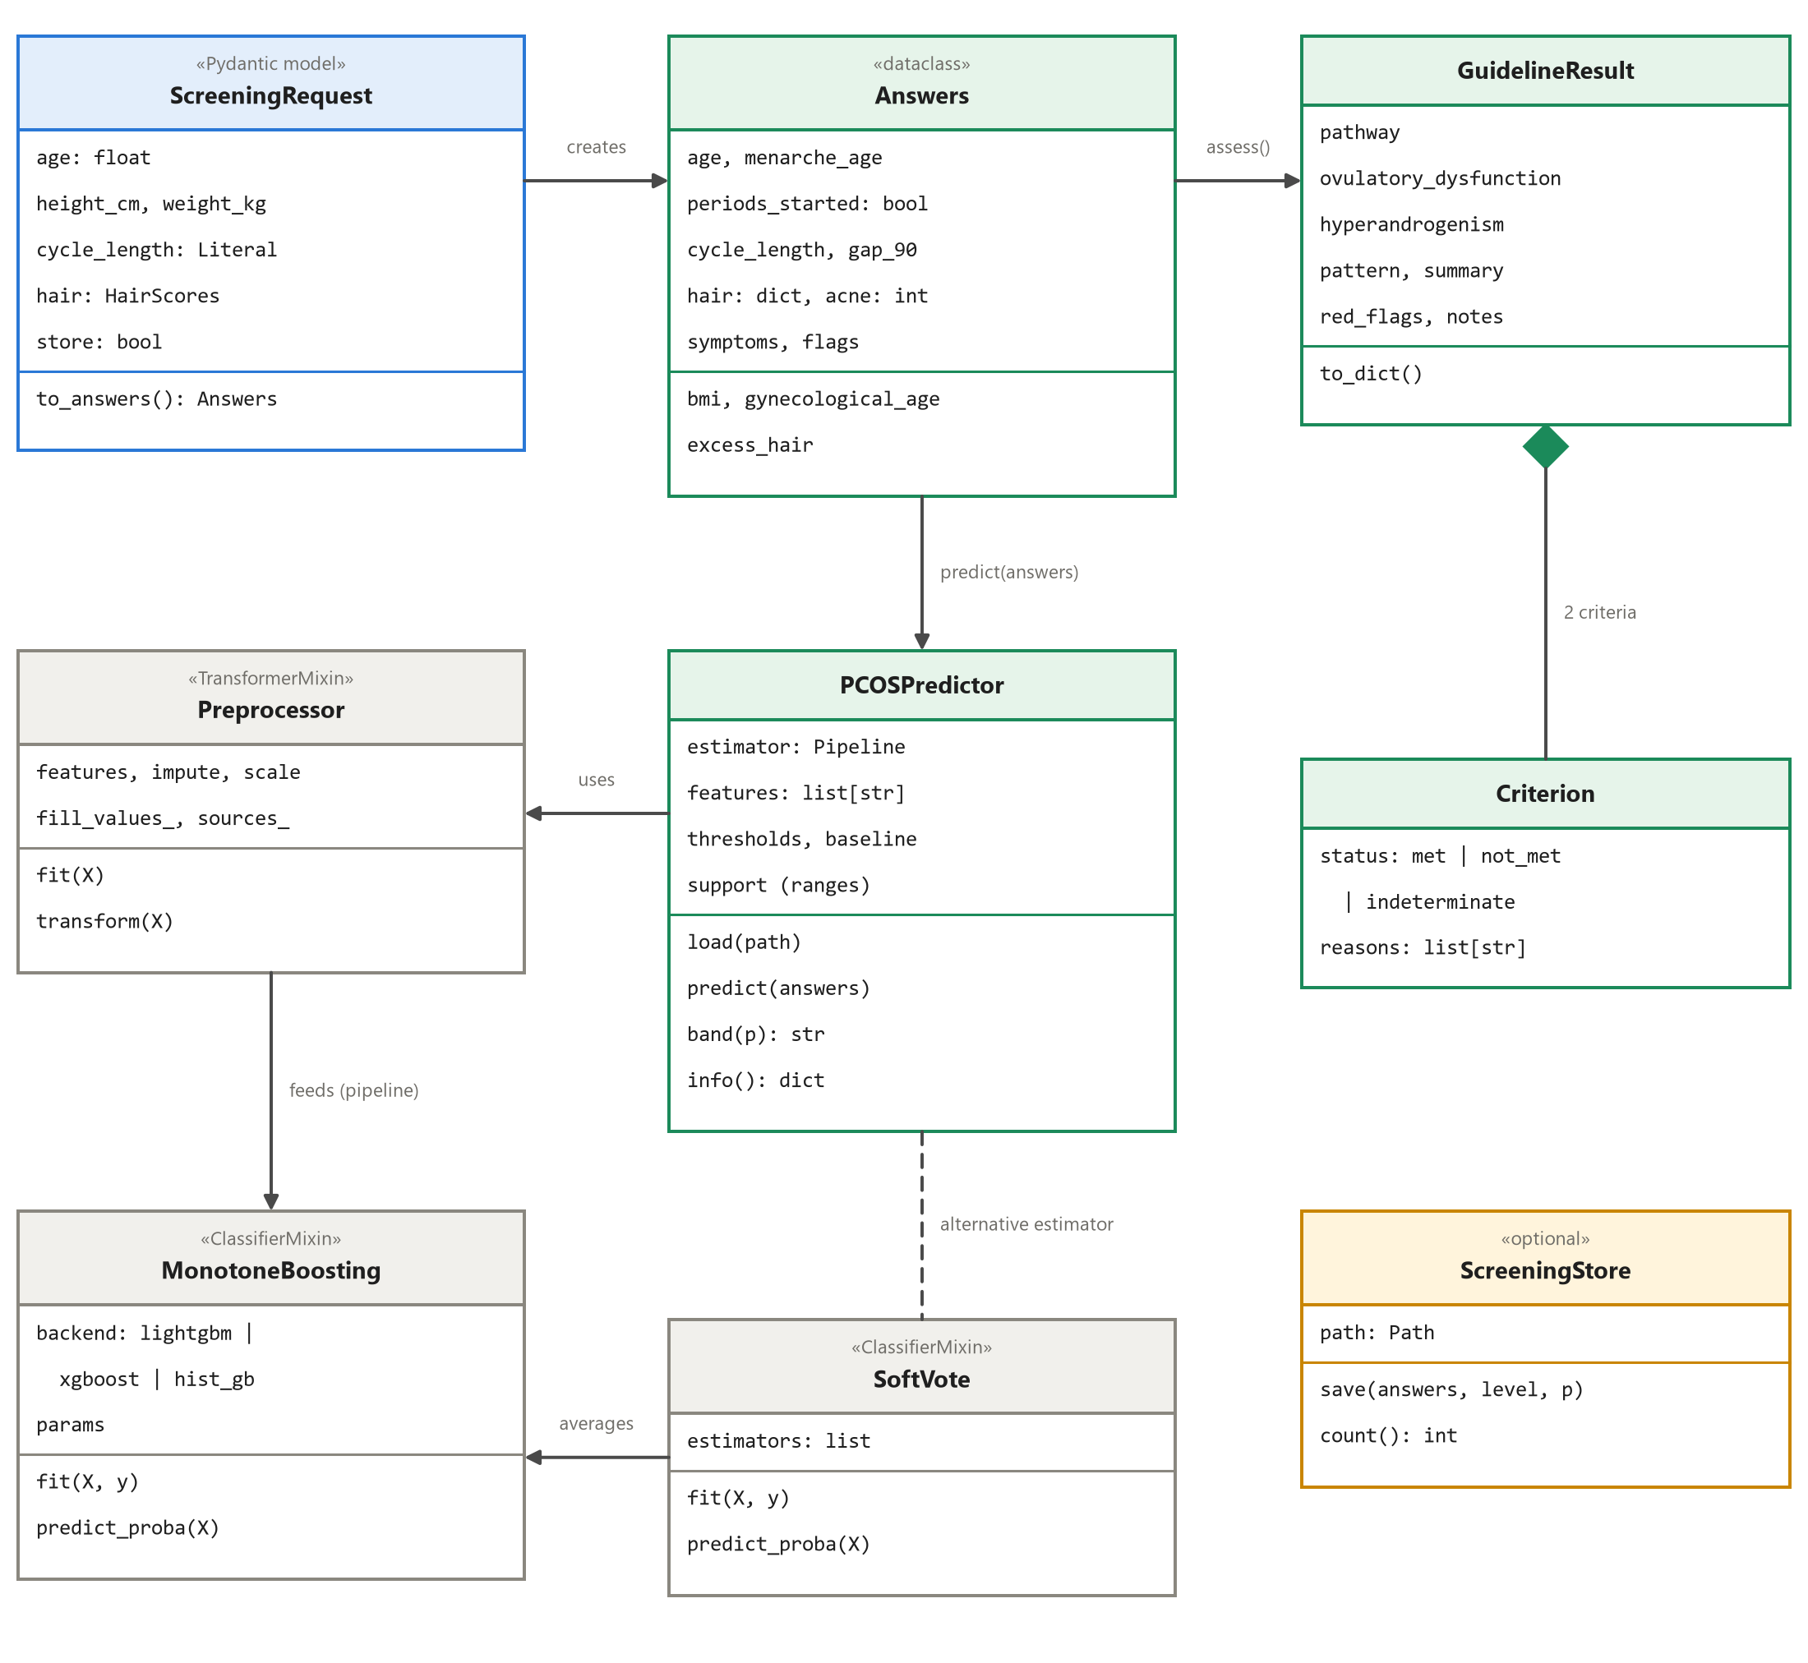
Figure 3.3 Class diagram
ScreeningRequest validates the incoming JSON and creates an Answers object. The guideline engine turns Answers into a GuidelineResult that holds two Criterion objects. PCOSPredictor wraps the trained scikit-learn pipeline, in which a Preprocessor imputes, scales and one-hot encodes the source before a classifier (logistic regression, MonotoneBoosting or SoftVote) makes the prediction. ScreeningStore is the optional log.

3.2.4 USE CASE DIAGRAM
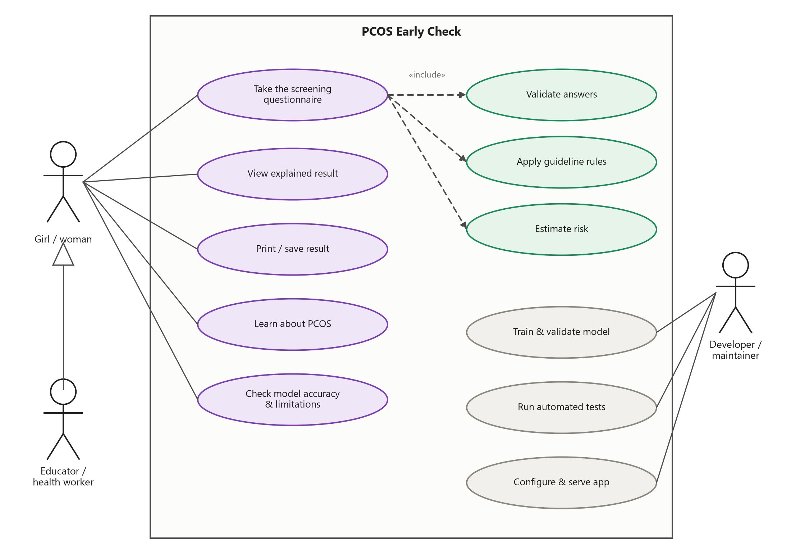
Figure 3.4 Use case diagram
A girl or woman takes the questionnaire, views and prints her explained result, learns about PCOS and checks the model's accuracy. An educator or health worker can do everything a user can. Taking the questionnaire includes validating the answers, applying the guideline rules and estimating risk. The developer trains and validates the model, runs the tests, and configures and serves the app.

3.2.5 SEQUENCE DIAGRAM
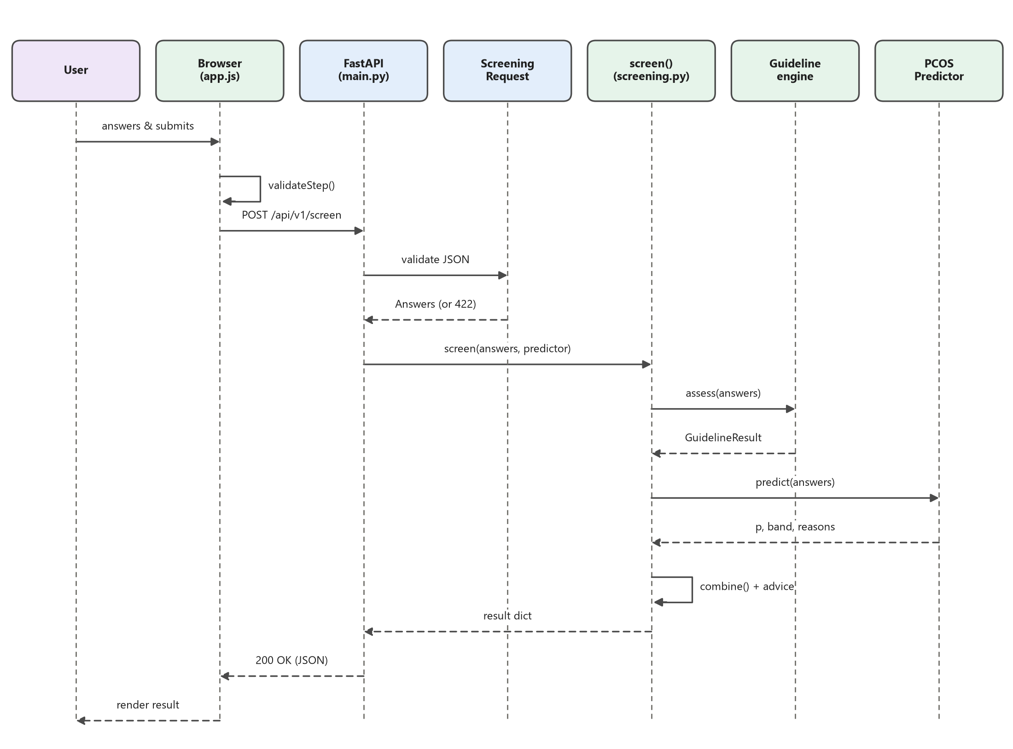
Figure 3.5 Sequence diagram (one screening request)
When the user submits, the browser checks each step and posts the answers to /api/v1/screen. FastAPI validates them, returning a readable 422 error if needed, and then calls screen(), which asks the guideline engine for an assessment and the predictor for a probability before combining the two. The JSON result returns to the browser, which renders the level, criteria, score, reasons and advice.

3.2.6 ACTIVITY DIAGRAM
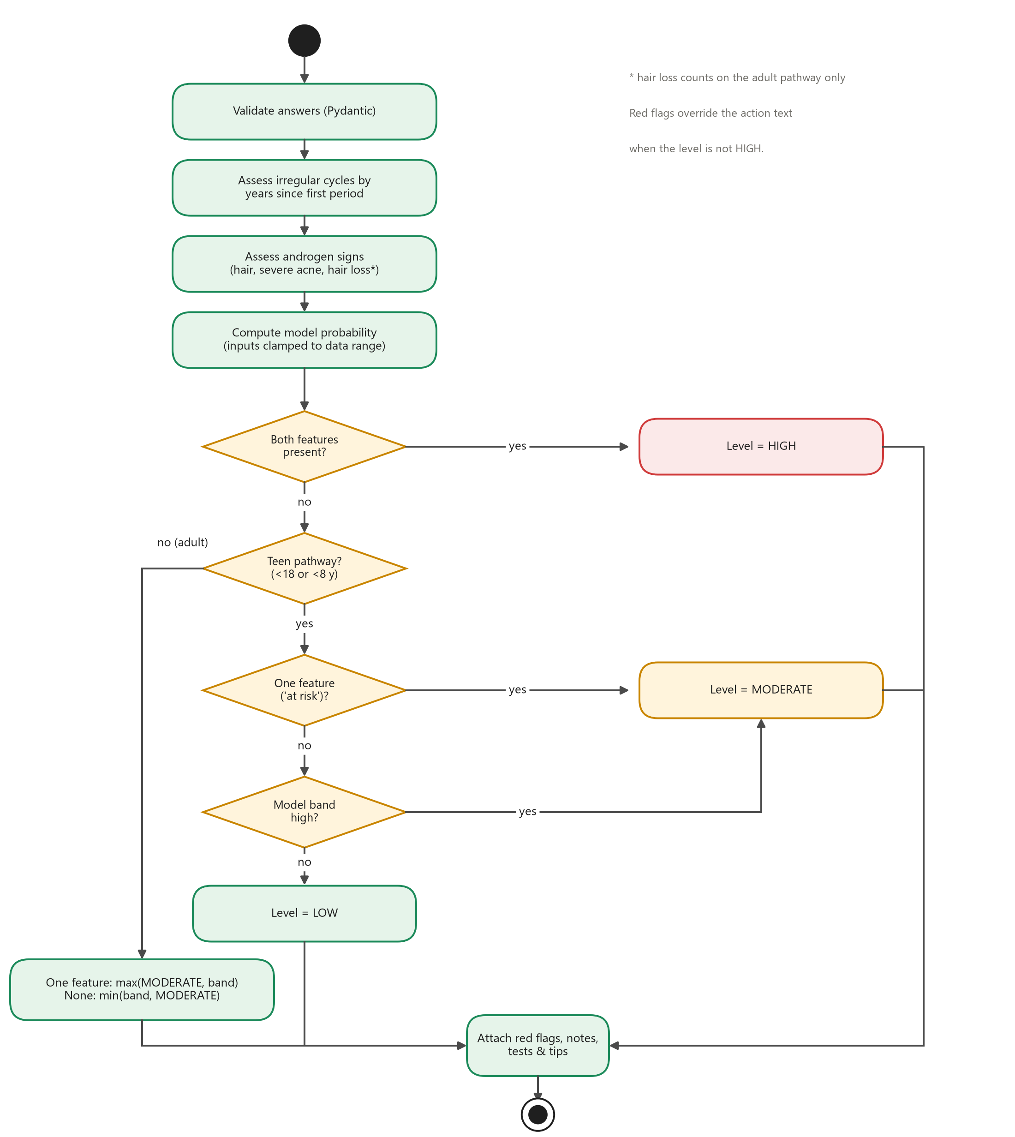
Figure 3.6 Activity diagram (deciding the result level)
The activity diagram shows the decision logic of a single screening, from validation to the final level, including the separate teen and adult branches. The red-flag override and the adult-only use of hair loss are noted beside it.

3.2.7 MACHINE-LEARNING PIPELINE
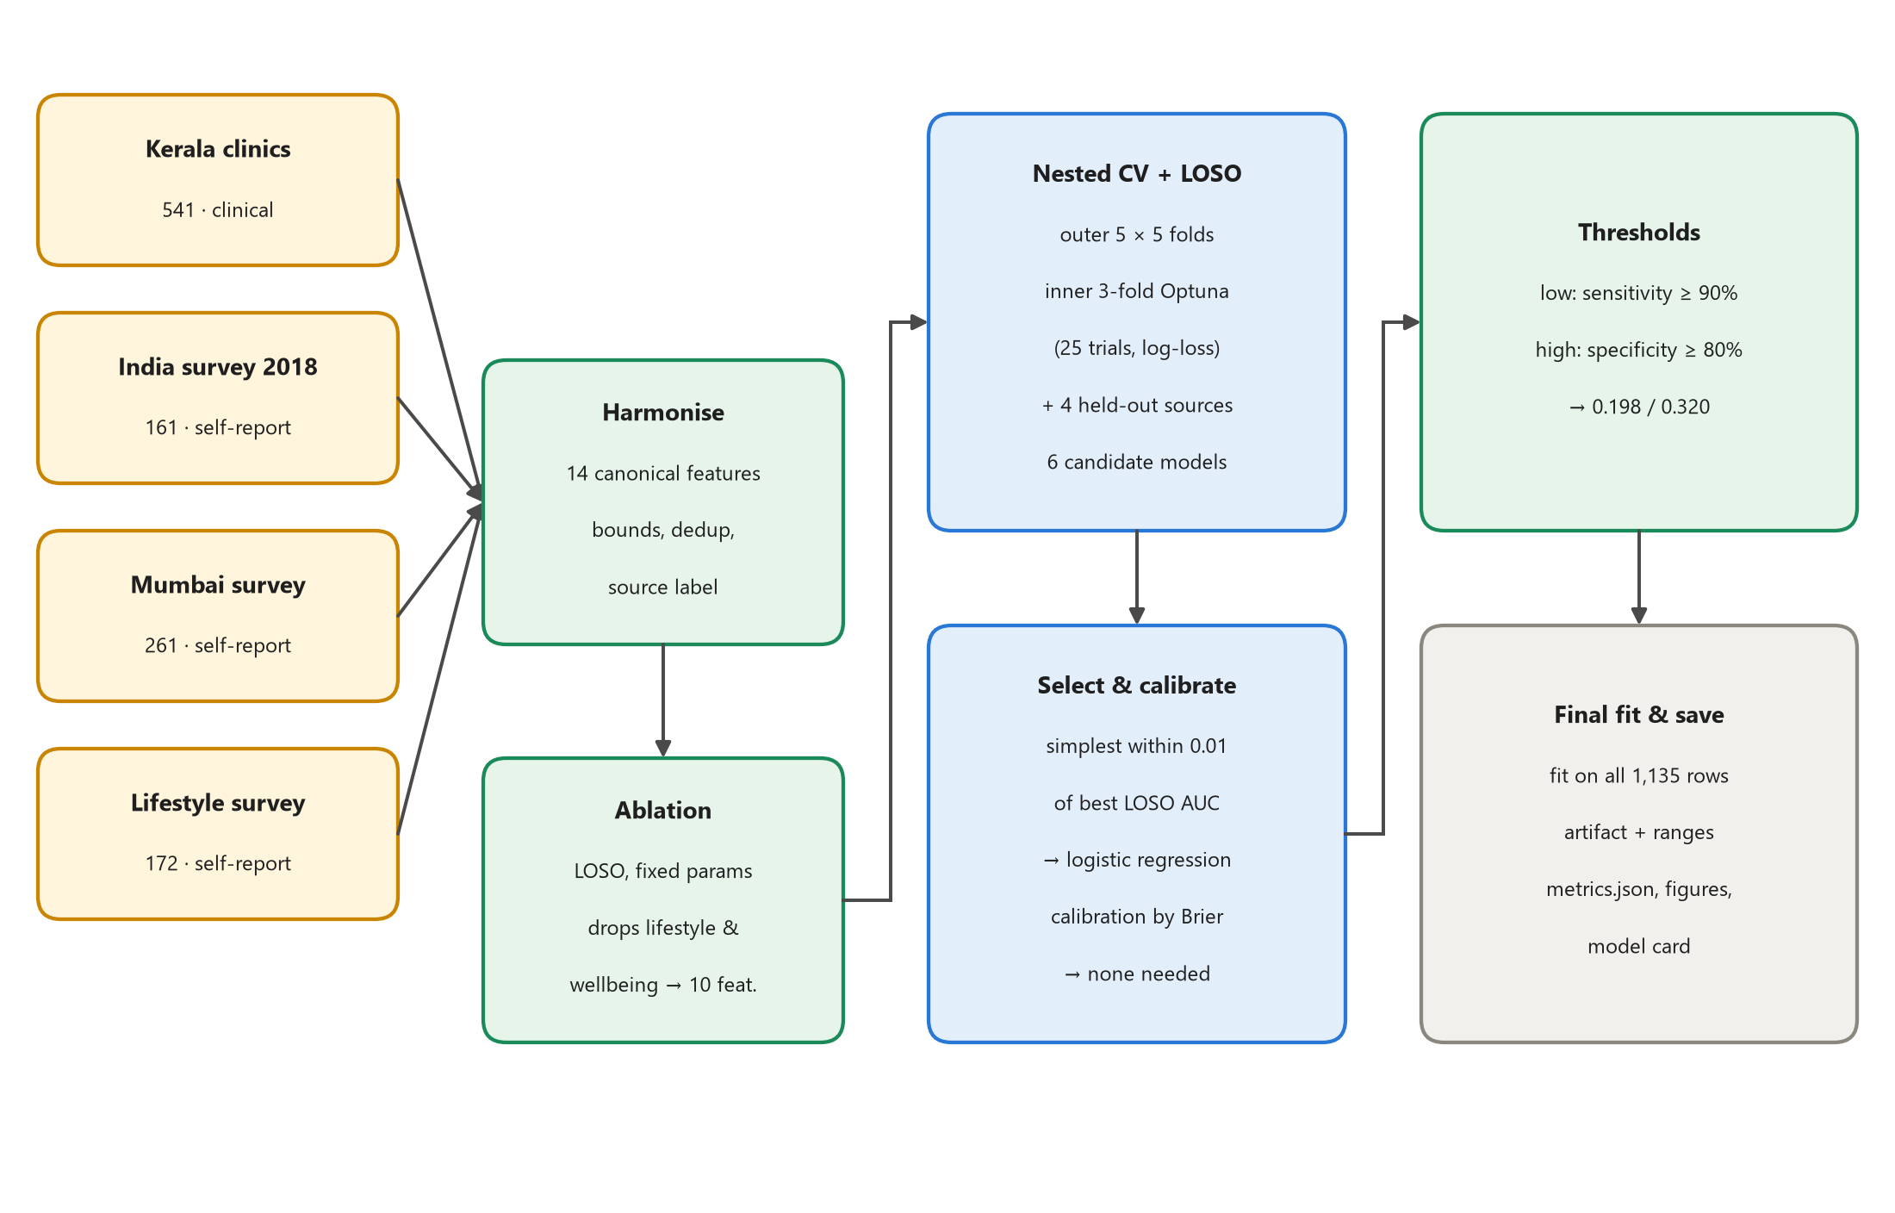
Figure 3.7 Machine-learning training pipeline
The training pipeline runs end to end from a single command. Four raw sources are harmonised; the ablation fixes the feature set; nested cross-validation and LOSO compare six model families; the selection rule and the calibration check choose the final model; thresholds are set; and the final model is fitted on all 1,135 records and saved together with its training ranges, metrics, figures and model card.

CHAPTER 4: IMPLEMENTATION
The system is implemented in Python 3.13 and standard web technologies. The core package (pcos_screen) has about 2,000 lines of code and the web backend about 200; the frontend has about 1,000 lines of HTML, CSS and JavaScript with no third-party libraries; and the tests add about 540 lines. All settings live in a single YAML file and can be overridden from the command line (for example --set training.n_trials=50), and a PowerShell helper wraps the common tasks: setup, train, quick, test and serve.

4.1 CODING BLOCKS
- Data discovery and loaders came first, with each raw source kept unchanged in its own folder.
- The canonical schema, harmonisation and the leave-one-source-out ablation followed, fixing the 10 model features.
- The model zoo and the training pipeline were built next: preprocessing with source fixed effects, monotone boosting, nested cross-validation, LOSO, calibration, thresholds and reports.
- The guideline engine and the questionnaire-to-feature mapping were written as pure functions, so every rule could be unit-tested.
- Inference, occlusion explanations and the guideline–model combination followed.
- The FastAPI service and the three-area frontend were then built on top.
- Automated tests, the persona checker and manual browser testing came next; every issue found was fixed and, where it affected behaviour, covered by a new test.
- Finally, the model was retrained from scratch to confirm that the pipeline is deterministic, and the complete application was run end to end.
Error handling is explicit throughout (Table 4.1), so a failure produces a clear message rather than a crash, and a missing model never takes the app down.
Table 4.1 Error handling
Situation | Behaviour
Missing or malformed data file | DataSourceError naming the file; training exits with code 2
Invalid configuration or unknown model name | ConfigError or a clear message; exit code 2
A model fails in one fold | Logged and excluded from selection; the other models continue
Non-finite predictions (NaN or infinity) | Rejected with an error instead of being used
Out of memory in parallel training | Falls back to sequential execution
Missing or corrupt model artifact | The API reports model_loaded = false and serves guideline-only results
Invalid answers (e.g. first period after the current age) | HTTP 422 with readable, field-level messages
Report generation fails | Logged; the trained model is never lost

4.2 SAMPLE CODE
Two short excerpts show the core logic. The first applies the guideline's cycle rules by years since the first period; the second combines the guideline result with the model band.
guideline.py: irregular-cycle rules (shortened)
def assess_cycles(a: Answers) -> Criterion:
if not a.periods_started:
if a.age >= 15:
return Criterion("met", ["No period by age 15 (primary amenorrhoea)"])
return Criterion("indeterminate", ["Periods have not started yet"])
gyn = a.gynecological_age # years since the first period
if gyn is not None and gyn < 1:
return Criterion("indeterminate", ["Less than 1 year since the first period"])
if gyn is None: # unknown: lenient rule for teens
long_limit = 35 if a.age >= ADOLESCENT_AGE else 45
else:
long_limit = 35 if gyn >= 3 else 45
reasons = []
if a.cycle_length == "lt21":
reasons.append("Cycles are usually shorter than 21 days")
elif a.cycle_length == "36_45" and long_limit == 35:
reasons.append("Cycles are usually longer than 35 days")
elif a.cycle_length in ("46_90", "gt90"):
reasons.append(f"Cycles are usually longer than {long_limit} days")
elif a.cycle_length == "unpredictable":
reasons.append("Cycle length is too unpredictable to say")
if a.gap_over_90_days == "yes":
reasons.append("Went more than 90 days without a period")
...

screening.py: combining the guideline and the model (shortened)
def combine(g: GuidelineResult, ml_band: str | None) -> tuple[str, str]:
if g.pattern == "consistent": # both clinical features
return "high", "Both clinical criteria ... are present."
if ml_band is None: # model unavailable
level = "moderate" if g.pattern in ("at_risk", "possible") else "low"
return level, "Based on the guideline criteria only ..."
if g.pathway == "adolescent": # the guideline leads
if g.pattern == "at_risk":
return "moderate", "One of the two features ... is present ('at risk')."
return ("moderate" if ml_band == "high" else "low"), "..."
if g.pattern == "possible": # adult, one feature
return _max("moderate", ml_band), "..."
return _min(ml_band, "moderate"), "..." # adult, no feature: capped

CHAPTER 5: TESTING & RESULTS
Testing combined three layers: automated tests that run in about a minute, ten reference personas scored against the running server, and manual walkthroughs in a real browser at desktop and phone sizes, in light and dark themes. Table 5.1 summarises the results: all 107 automated tests pass, all ten personas receive the expected level, and all twelve issues found during manual testing were fixed.
Table 5.1 Summary of testing
Level | Tests | Result
Data loading, harmonisation and configuration | 11 | Pass
Guideline rules (all age and cycle edge cases) | 24 | Pass
Questionnaire-to-feature mapping | 5 | Pass
Models, including monotonicity of boosted trees | 12 | Pass
Metrics, thresholds and bootstrap | 7 | Pass
Predictor and explanations | 12 | Pass
Guideline–model combination and advice | 17 | Pass
API: validation, security headers, fallback mode | 17 | Pass
End-to-end training command | 2 | Pass
Reference personas against the live server | 10 | 10 of 10 as expected
Manual browser testing (desktop and 375 px phone) | – | 12 issues found and fixed

5.1 RESULTING SCREENS
The screenshots were taken from the running application in the light theme. The answers belong to example personas, not to real people.
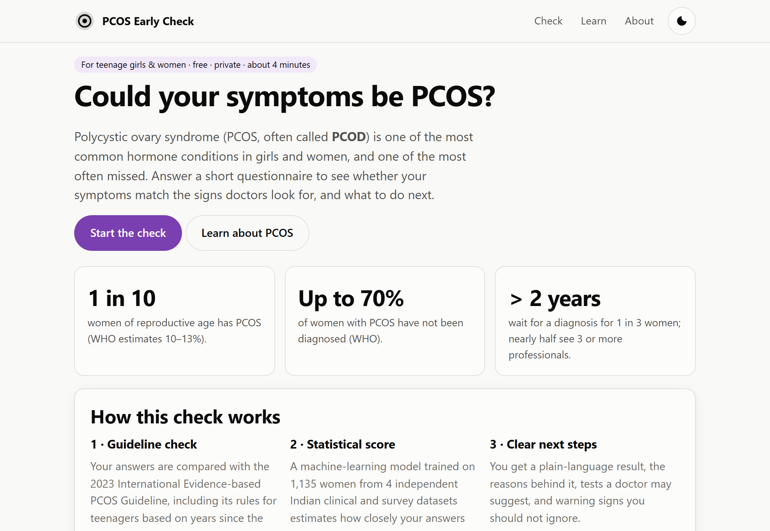
Screenshot 5.1 Home page
The home page explains the purpose of the check, gives key facts about PCOS and states clearly that the tool is educational and private.
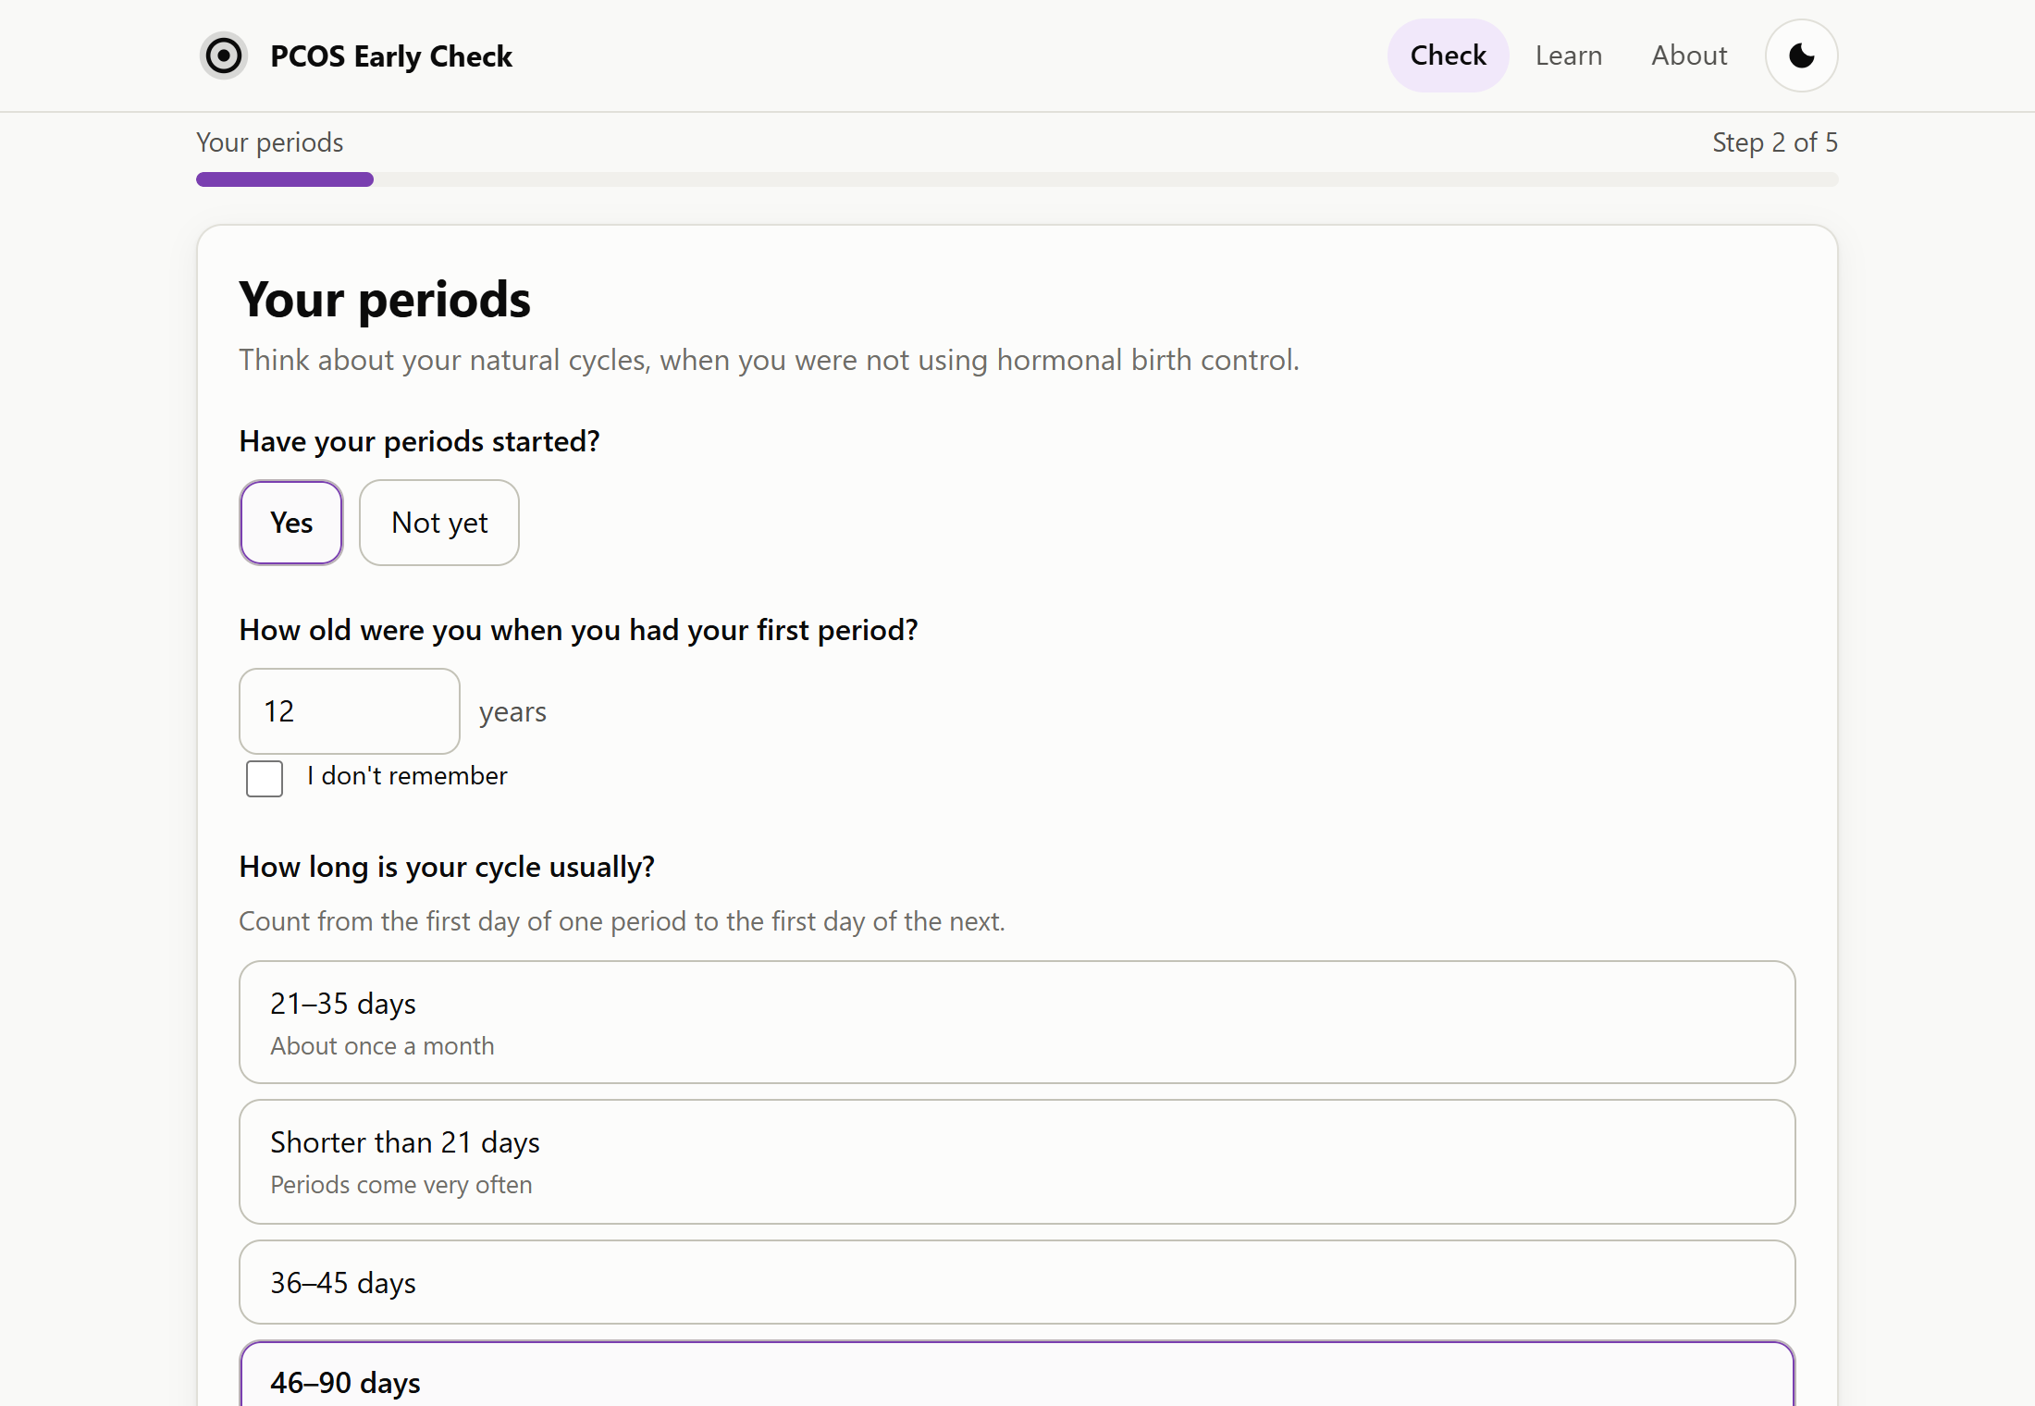
Screenshot 5.2 Questionnaire, step 2: periods
Step 2 asks about periods in everyday language. The questions adapt to the answers: if periods have not started, the cycle questions are hidden, and a pregnancy question appears only when periods have been absent for a long time.
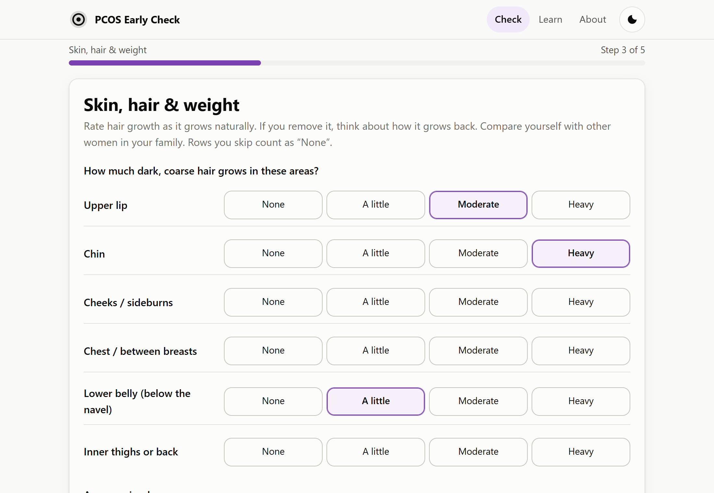
Screenshot 5.3 Questionnaire, step 3: hair growth by body region
Step 3 rates hair growth separately for six body regions, an approach adapted from the Ferriman–Gallwey score [9], followed by questions on acne, scalp hair, skin and weight.
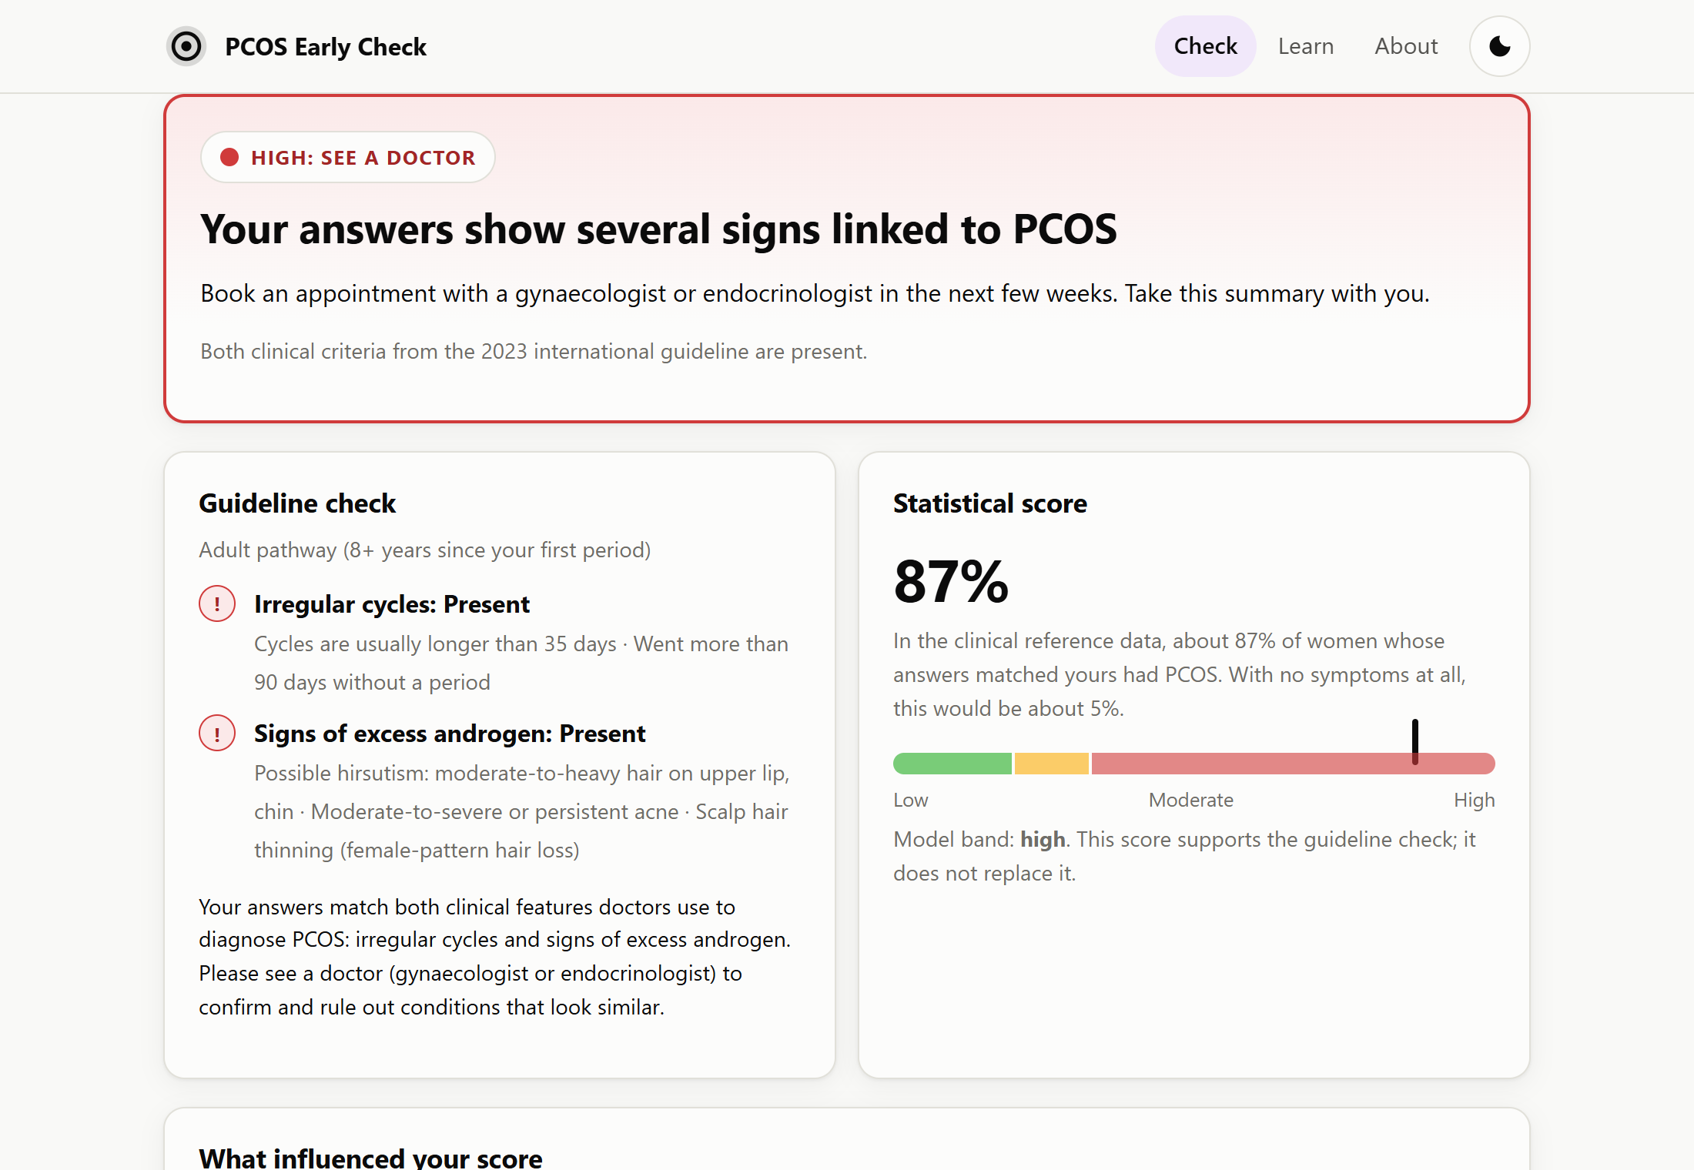
Screenshot 5.4 Result for a symptomatic adult
For this symptomatic adult both guideline criteria are present, so the level is High. The statistical score (87%) sits in the high band of the gauge, and the reasons for each criterion are listed in plain language.
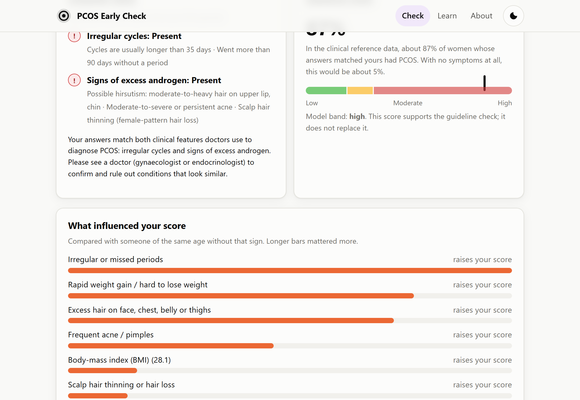
Screenshot 5.5 Explanation of the score
The explanation lists the answers that raised the score, longest bar first. For this person, irregular periods, rapid weight gain and excess hair matter most.
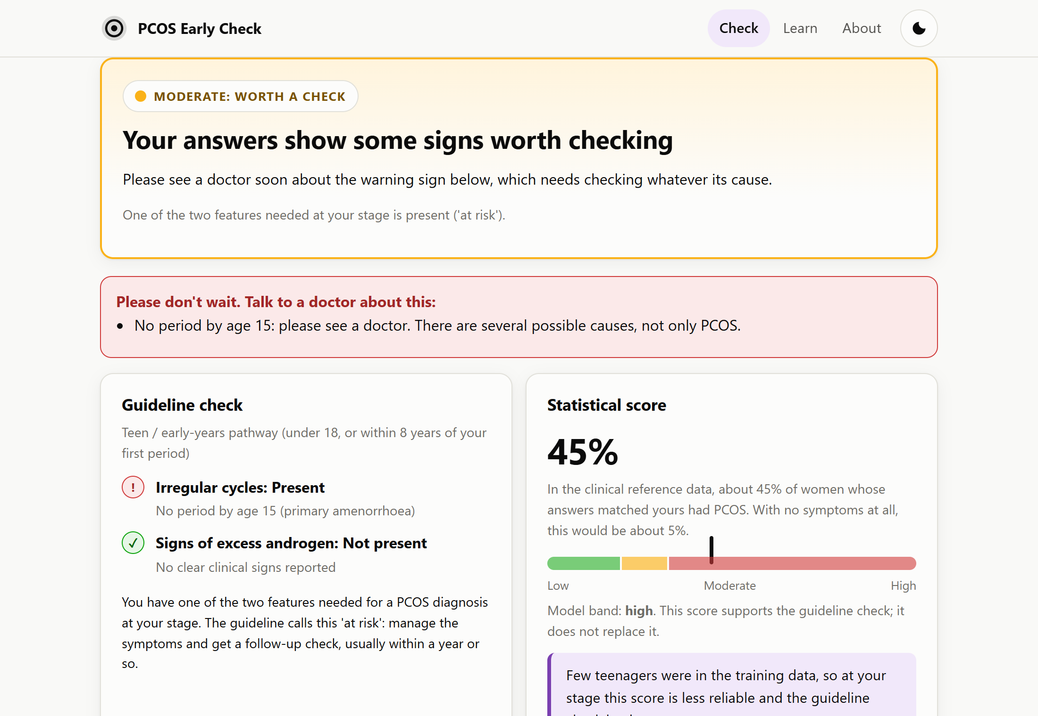
Screenshot 5.6 Teenager with no period at 15: “at risk” with a red flag
For a 15-year-old whose periods have not started, the teen pathway applies. The result is Moderate (“at risk”), but the red-flag box and the action text ask her to see a doctor soon, because primary amenorrhoea needs checking whatever its cause. A note explains that the statistical score is less reliable for teenagers.
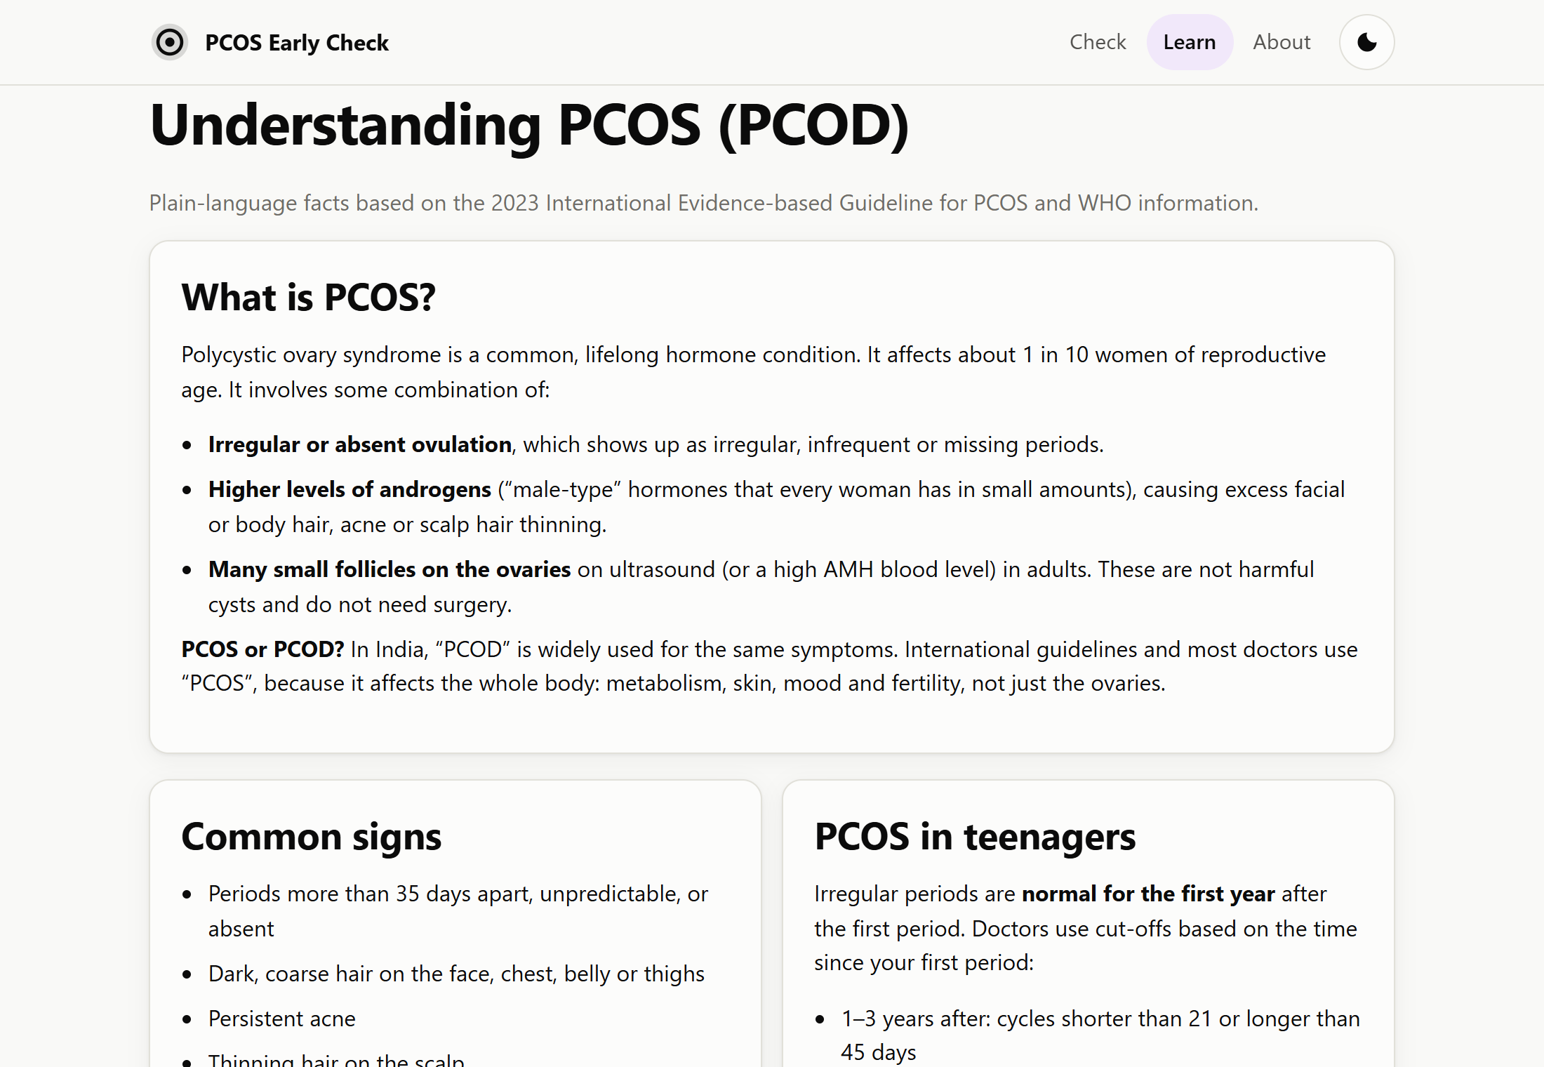
Screenshot 5.7 Learn page
The Learn page explains PCOS, its signs, the rules for teenagers, diagnosis, management, warning signs, and myths and facts.
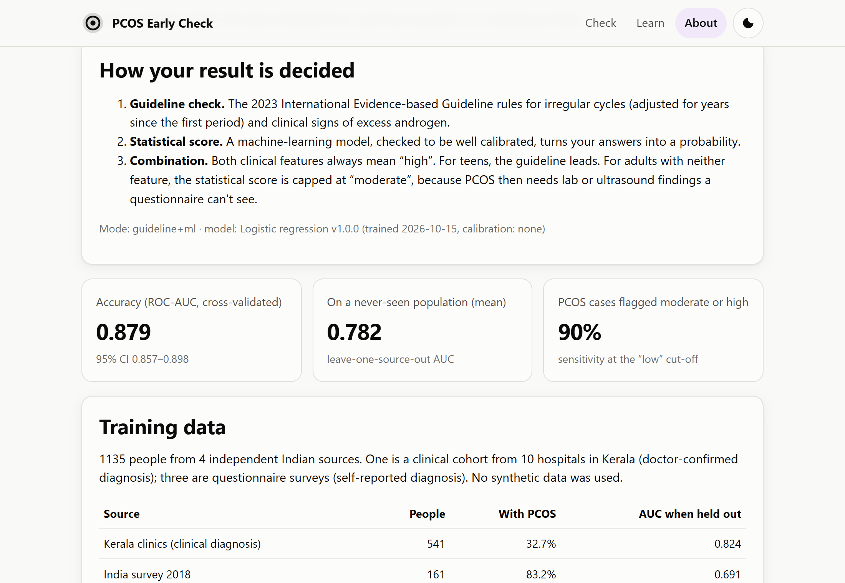
Screenshot 5.8 About the model page
The About page shows how the result is decided, the model's accuracy, the training data and the limitations, so users can judge the tool for themselves.
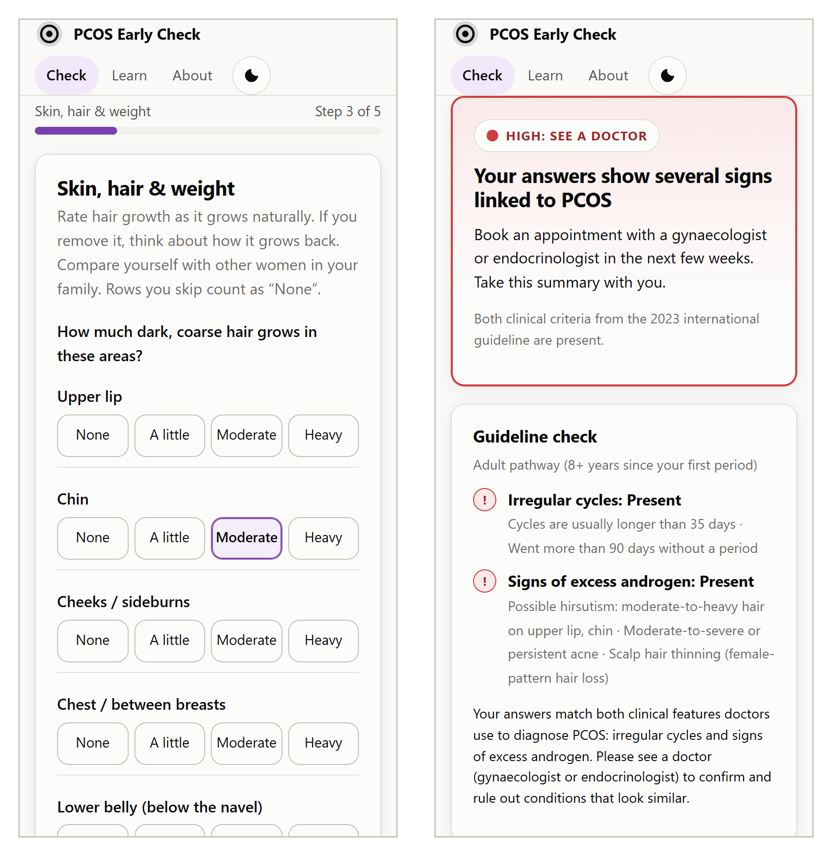
Screenshot 5.9 Mobile layout: questionnaire and result
On a phone, the hair-growth options form a four-column grid and the result cards stack vertically; no page scrolls horizontally at a width of 375 px.

5.2 RESULTING GRAPHS
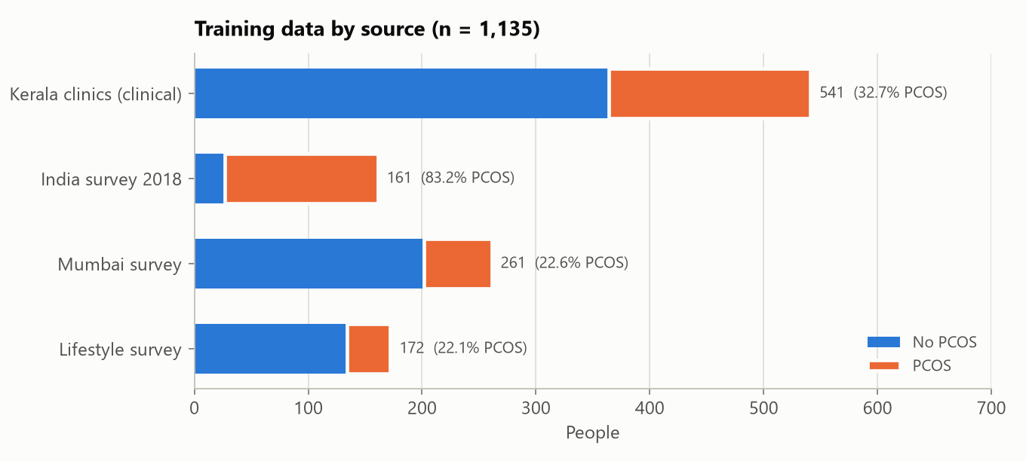
Graph 5.1 Training data by source
The four sources differ strongly in size and PCOS prevalence, from 22% in the two community surveys to 83% in the 2018 survey, which mostly reached women who had already been tested. This variation is why the model includes a source fixed effect and why LOSO validation matters.
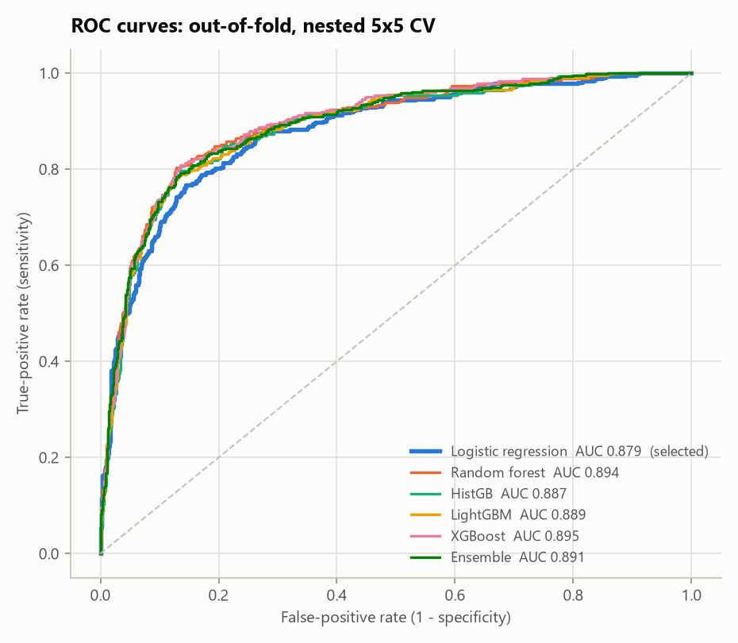
Graph 5.2 ROC curves of the six model families (nested 5×5 cross-validation)
All six model families discriminate well within the training sources, with pooled out-of-fold AUCs between 0.879 (logistic regression) and 0.895 (XGBoost).
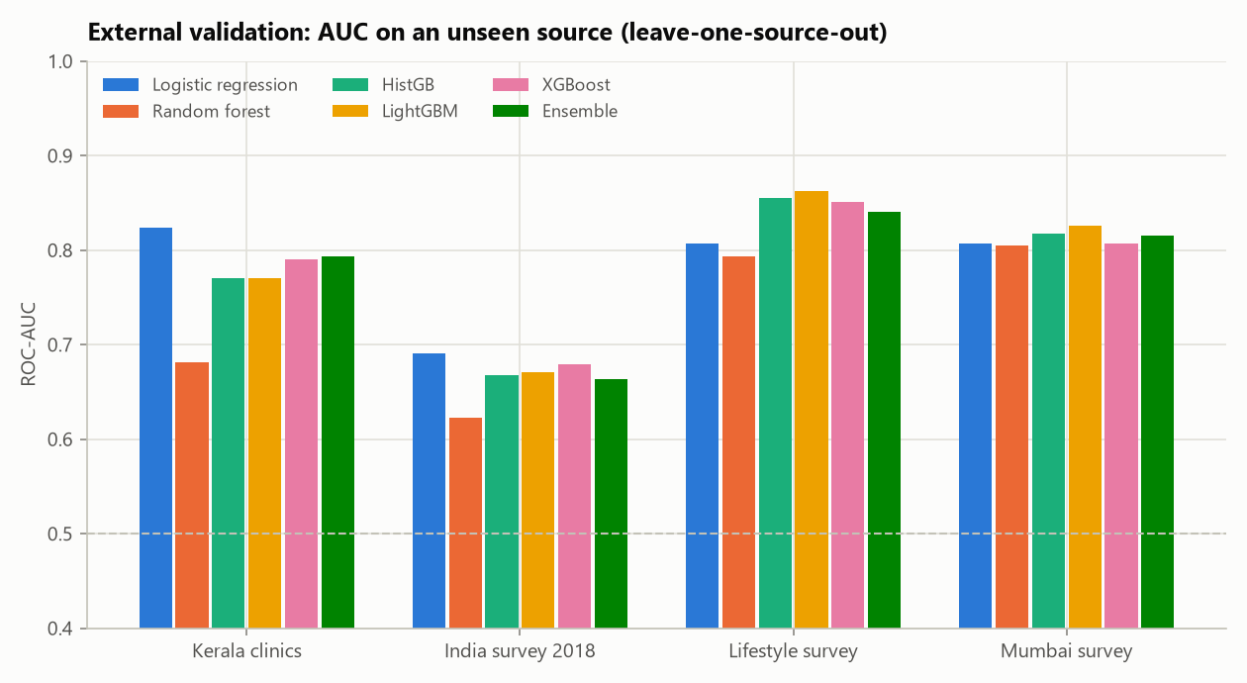
Graph 5.3 External validation: AUC on a source never seen in training
On a source never seen in training, the picture changes. Logistic regression, LightGBM and XGBoost tie at a mean AUC of 0.782, while the random forest drops to 0.726. On the clinically diagnosed Kerala cohort, logistic regression is the best model (0.824). The 2018 survey is the hardest for every model (0.62–0.69): 83% of its respondents had PCOS, and the remaining 27 were women who had been tested because of symptoms, so the two groups are much alike.
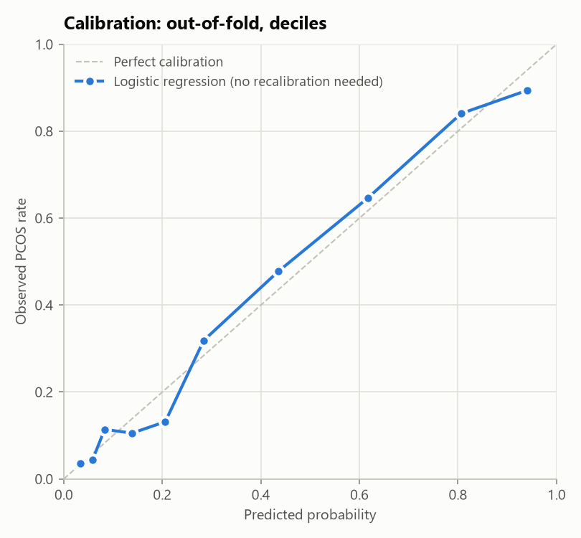
Graph 5.4 Calibration of the selected model
Predicted probabilities closely follow the observed PCOS rates (calibration slope 1.02, intercept 0.01, expected calibration error 0.034), so no recalibration was needed.
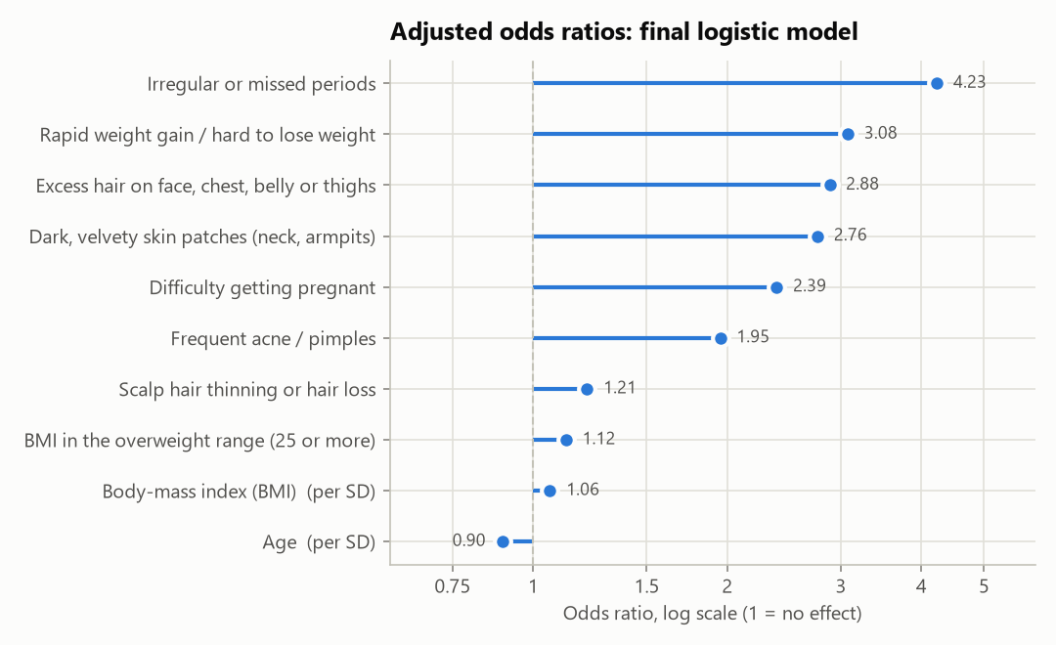
Graph 5.5 Adjusted odds ratios of the final model
Irregular periods have the strongest association (odds ratio 4.2), followed by rapid weight gain (3.1), excess hair (2.9), dark skin patches (2.8), difficulty conceiving (2.4) and acne (2.0). These directions match clinical knowledge.
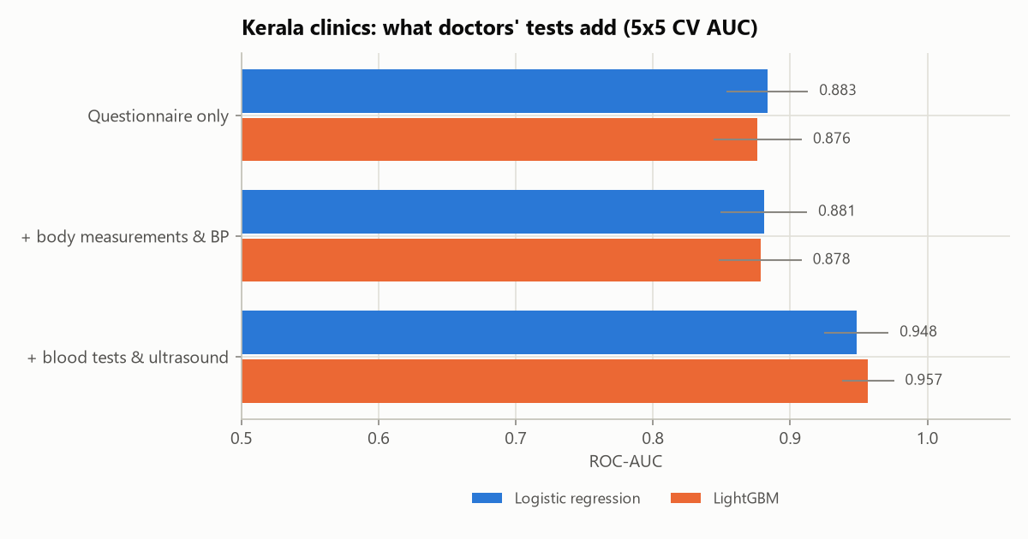
Graph 5.6 What a doctor's tests add (Kerala cohort)
Within the Kerala cohort, the questionnaire alone reaches an AUC of 0.883, adding body measurements and blood pressure changes nothing, and adding blood tests and ultrasound raises the AUC to 0.957. A questionnaire is an effective first filter, but confirmation needs a clinic.
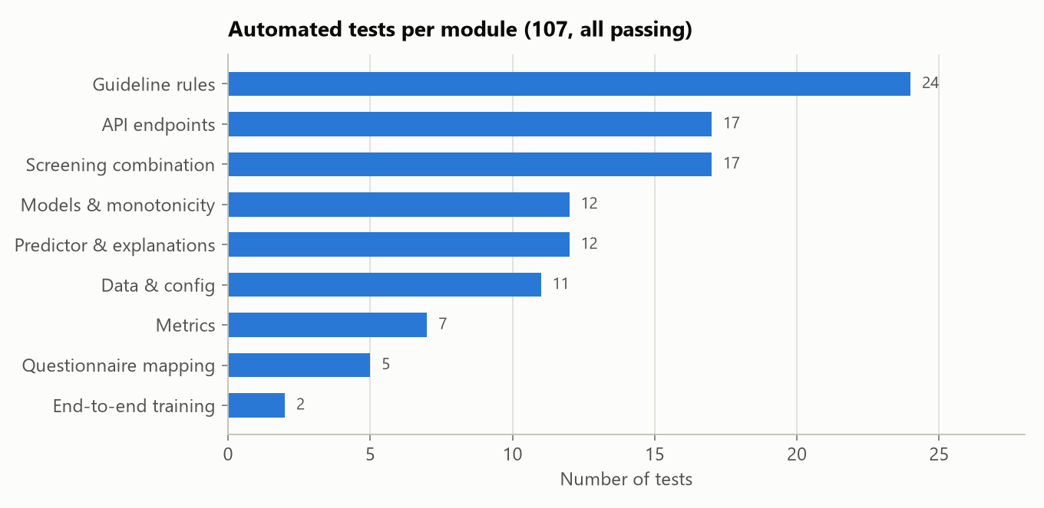
Graph 5.7 Automated tests per module
The guideline rules carry the most tests (24), reflecting the many age and cycle edge cases, followed by the API and the combination logic (17 each).

5.3 RESULTS & ANALYSIS
Table 5.2 compares the six model families. Tree ensembles fit the training sources slightly better: XGBoost's pooled AUC is 0.017 higher than that of logistic regression, a statistically significant difference in a paired bootstrap (95% CI 0.008 to 0.026). However, they did not generalise better to new populations, and the selection rule (the simplest model within 0.01 of the best mean LOSO AUC) chose logistic regression. This agrees with the finding that machine learning rarely beats logistic regression in clinical prediction [14], and it brings two practical benefits: the model is fully interpretable through odds ratios, and its file is only 5.6 KB.
Table 5.2 Model comparison (AUC; LOSO = held-out source)
Model | CV AUC (mean ± SD) | Brier | LOSO mean | Kerala | 2018 | Mumbai | Lifestyle
Logistic regression (selected) | 0.879 ± 0.020 | 0.130 | 0.782 | 0.824 | 0.691 | 0.807 | 0.807
Random forest | 0.893 ± 0.017 | 0.122 | 0.726 | 0.681 | 0.623 | 0.805 | 0.794
HistGB | 0.886 ± 0.018 | 0.124 | 0.777 | 0.770 | 0.667 | 0.817 | 0.855
LightGBM | 0.888 ± 0.017 | 0.124 | 0.782 | 0.770 | 0.671 | 0.826 | 0.862
XGBoost | 0.895 ± 0.016 | 0.120 | 0.782 | 0.791 | 0.679 | 0.807 | 0.851
Ensemble | 0.892 ± 0.017 | 0.123 | 0.778 | 0.794 | 0.664 | 0.816 | 0.840

The selected model has a pooled out-of-fold AUC of 0.879 (95% CI 0.857–0.898), a PR-AUC of 0.816 and a Brier score of 0.130. At the “low” cut-off (0.198) it flags 90.2% of PCOS cases as moderate or high, with a specificity of 61.8%; at the “high” cut-off (0.320), sensitivity and specificity are both 80.1%. This trade-off suits screening: a low result misses few cases, while a high result is right four times out of five on the training populations.
The ablation (Table 5.3) confirmed that removing the lifestyle and wellbeing answers improves accuracy on unseen sources for both logistic regression and LightGBM.
Table 5.3 Feature-set ablation (mean LOSO AUC, fixed hyper-parameters)
Feature set | Features | Logistic regression | LightGBM
All questionnaire features | 14 | 0.761 | 0.721
Without lifestyle (fast food, exercise) | 12 | 0.774 | 0.745
Without lifestyle and wellbeing (selected) | 10 | 0.783 | 0.754

Table 5.4 shows how the complete system behaved for the ten reference personas. Each received the level the guideline logic expects. Two cases show the safeguards at work: a teenager in her first year after menarche is rated Low because irregular cycles are normal at that stage, and an adult with metabolic signs but neither guideline feature is capped at Moderate despite a model probability of 0.58.
Table 5.4 Reference personas scored by the live server
Persona | Model probability | Guideline pattern | Level
Adult, classic PCOS picture | 0.946 | Both features | High
Adult, regular cycles, no signs | 0.042 | Not suggestive | Low
Adult, irregular cycles only | 0.184 | One feature | Moderate
Lean adult, hirsutism and irregular cycles | 0.404 | Both features | High
Teen, first year after menarche | 0.160 | Too early to judge | Low
Teen, 2 years after menarche, 40-day cycles | 0.271 | Not suggestive | Low
Teen, irregular cycles and severe acne | 0.611 | Both features | High
Teen, irregular cycles only | 0.443 | At risk | Moderate
15-year-old with no period yet | 0.446 | At risk, red flag | Moderate
Adult, metabolic signs only | 0.584 | Not suggestive (capped) | Moderate

Manual testing found twelve issues that the automated tests had not caught (Table 5.5). All were fixed, and those that affected behaviour were covered by new tests.
Table 5.5 Issues found by manual testing and their fixes
Issue | Fix
Clicks during smooth scrolling could select the wrong answer | Instant scroll after each step
Focus did not move to the first invalid field | Focus now moves to the first invalid input
Adult activity advice mentioned teen targets | Separate adult and teen advice
“Not applicable” answers listed as unanswered | Listed only when truly unanswered
Red flag shown next to relaxed advice | Red flags override the action text
“Age lowers your score” was confusing | Age is no longer listed as a reason
Model extrapolated for very young users | Inputs clamped to the training range; teen note
Hair-growth options wrapped on phones | Four-column grid on small screens
First-year teen's irregular cycles were imputed | Treated as normal (“absent”)
Overlapping labels in report figures | Figures redrawn (log-scale odds ratios)
HEAD / returned HTTP 405 | HEAD requests supported
Focus outline drawn around step headings | Outline removed from script-focused headings

Limitations of the evaluation:
- All four sources come from India, so performance in other populations is unknown.
- Three sources use self-reported diagnoses, and women who are already diagnosed may notice and report symptoms more often.
- Only 19 training records are from people under 18, so the guideline leads for teenagers.
- Hirsutism is self-rated rather than scored by a clinician.
- There has been no prospective study with real users, and the tool is not a medical device.

CHAPTER 6: CONCLUSION & FUTURE SCOPE

6.1 CONCLUSION
PCOS Early Check shows that a short, self-reported questionnaire can screen for PCOS in a way that is evidence-based, explainable, honest about its accuracy and respectful of privacy. Built on 1,135 real records from four independent sources, its logistic-regression model reaches a cross-validated AUC of 0.879 and keeps an AUC of 0.782 on populations it never saw, with well-calibrated probabilities.
By putting the 2023 international guideline in charge of the clinical logic, especially for teenagers, whose normal cycle irregularity is easily mistaken for disease, and letting the model support it, the system avoids both false reassurance and needless alarm. A rigorous process (nested cross-validation, leave-one-source-out validation, a pre-declared selection rule and a feature ablation) led to a model that is simpler, smaller and more transparent than the alternatives, without losing accuracy where it matters.
The application turns this into a four-minute experience with plain-language reasons, red-flag warnings and clear next steps, verified by 107 automated tests, ten reference personas and manual testing. Just as important, the project is open about its limits: blood tests and ultrasound still add a great deal (AUC 0.957 in the clinical cohort), so the tool's job is to send the right people to a doctor sooner, not to replace the doctor.

6.2 FUTURE SCOPE
- Validating the tool prospectively in clinics, colleges and school health programmes.
- Testing on datasets from outside India and recalibrating the model for new populations.
- Translating the questionnaire and results into Hindi and regional languages such as Tamil, Malayalam and Telugu.
- Adding picture-based guidance for rating hair growth, closer to the modified Ferriman–Gallwey chart.
- Offering an optional clinician mode that accepts laboratory results (androgens, AMH) to move towards the clinical-ceiling model.
- Importing cycle data from period-tracking apps, with consent, instead of asking for a typical cycle length.
- Building an installable offline web app and exporting a clinician summary as a PDF or a FHIR QuestionnaireResponse.
- With consent and ethics approval, collecting anonymous outcomes to recalibrate the model and monitor drift.
- Running a formal accessibility audit with screen readers against WCAG 2.2 [37].

BIBLIOGRAPHY
[1] World Health Organization. (2026). Polycystic ovary syndrome [Fact sheet]. Retrieved October 15, 2026, from https://www.who.int/news-room/fact-sheets/detail/polycystic-ovary-syndrome
[2] Bozdag, G., Mumusoglu, S., Zengin, D., Karabulut, E., & Yildiz, B. O. (2016). The prevalence and phenotypic features of polycystic ovary syndrome: A systematic review and meta-analysis. Human Reproduction, 31(12), 2841–2855.
[3] Ganie, M. A., Vasudevan, V., Wani, I. A., Baba, M. S., Arif, T., & Rashid, A. (2019). Epidemiology, pathogenesis, genetics & management of polycystic ovary syndrome in India. Indian Journal of Medical Research, 150(4), 333–344.
[4] Gibson-Helm, M., Teede, H., Dunaif, A., & Dokras, A. (2017). Delayed diagnosis and a lack of information associated with dissatisfaction in women with polycystic ovary syndrome. Journal of Clinical Endocrinology & Metabolism, 102(2), 604–612.
[5] Teede, H. J., Tay, C. T., Laven, J. J. E., Dokras, A., Moran, L. J., Piltonen, T. T., et al. (2023). Recommendations from the 2023 International Evidence-based Guideline for the Assessment and Management of Polycystic Ovary Syndrome. Journal of Clinical Endocrinology & Metabolism, 108(10), 2447–2469.
[6] Peña, A. S., Witchel, S. F., Hoeger, K. M., et al. (2020). Adolescent polycystic ovary syndrome according to the international evidence-based guideline. BMC Medicine, 18, 72.
[7] Peña, A. S., Witchel, S. F., Boivin, J., Burgert, T. S., Ee, C., Hoeger, K. M., Lujan, M. E., Mousa, A., Oberfield, S., Tay, C. T., & Teede, H. (2025). International evidence-based recommendations for polycystic ovary syndrome in adolescents. BMC Medicine, 23, 151. https://doi.org/10.1186/s12916-025-03901-w
[8] Rotterdam ESHRE/ASRM-Sponsored PCOS Consensus Workshop Group. (2004). Revised 2003 consensus on diagnostic criteria and long-term health risks related to polycystic ovary syndrome. Fertility and Sterility, 81(1), 19–25.
[9] Ferriman, D., & Gallwey, J. D. (1961). Clinical assessment of body hair growth in women. Journal of Clinical Endocrinology & Metabolism, 21(11), 1440–1447.
[10] Bedrick, B. S., Eskew, A. M., Chavarro, J. E., & Jungheim, E. S. (2020). Self-administered questionnaire to screen for polycystic ovarian syndrome. Women's Health Reports, 1(1), 566–573. https://doi.org/10.1089/whr.2020.0073
[11] Denny, A., Raj, A., Ashok, A., Ram, C. M., & George, R. (2019). i-HOPE: Detection and prediction system for polycystic ovary syndrome (PCOS) using machine learning techniques. TENCON 2019 – IEEE Region 10 Conference, 673–678.
[12] Zad, Z., Jiang, V. S., Wolf, A. T., Wang, T., Cheng, J. J., Paschalidis, I. C., & Mahalingaiah, S. (2024). Predicting polycystic ovary syndrome with machine learning algorithms from electronic health records. Frontiers in Endocrinology, 15, 1298628. https://doi.org/10.3389/fendo.2024.1298628
[13] Kottarathil, P. (n.d.). Polycystic ovary syndrome (PCOS) [Data set]. Kaggle. https://www.kaggle.com/datasets/prasoonkottarathil/polycystic-ovary-syndrome-pcos
[14] Christodoulou, E., Ma, J., Collins, G. S., Steyerberg, E. W., Verbakel, J. Y., & Van Calster, B. (2019). A systematic review shows no performance benefit of machine learning over logistic regression for clinical prediction models. Journal of Clinical Epidemiology, 110, 12–22.
[15] Collins, G. S., Moons, K. G. M., Dhiman, P., Riley, R. D., Beam, A. L., Van Calster, B., et al. (2024). TRIPOD+AI statement: Updated guidance for reporting clinical prediction models that use regression or machine learning methods. BMJ, 385, e078378.
[16] Steyerberg, E. W. (2019). Clinical prediction models: A practical approach to development, validation, and updating (2nd ed.). Springer.
[17] Van Calster, B., McLernon, D. J., van Smeden, M., Wynants, L., & Steyerberg, E. W. (2019). Calibration: The Achilles heel of predictive analytics. BMC Medicine, 17, 230.
[18] Varma, S., & Simon, R. (2006). Bias in error estimation when using cross-validation for model selection. BMC Bioinformatics, 7, 91.
[19] Cawley, G. C., & Talbot, N. L. C. (2010). On over-fitting in model selection and subsequent selection bias in performance evaluation. Journal of Machine Learning Research, 11, 2079–2107.
[20] Royston, P., Parmar, M. K. B., & Sylvester, R. (2004). Construction and validation of a prognostic model across several studies, with an application in superficial bladder cancer. Statistics in Medicine, 23(6), 907–926.
[21] Debray, T. P. A., Vergouwe, Y., Koffijberg, H., Nieboer, D., Steyerberg, E. W., & Moons, K. G. M. (2015). A new framework to enhance the interpretation of external validation studies of clinical prediction models. Journal of Clinical Epidemiology, 68(3), 279–289.
[22] Grinsztajn, L., Oyallon, E., & Varoquaux, G. (2022). Why do tree-based models still outperform deep learning on typical tabular data? Advances in Neural Information Processing Systems, 35 (Datasets and Benchmarks Track).
[23] Pedregosa, F., Varoquaux, G., Gramfort, A., Michel, V., Thirion, B., Grisel, O., et al. (2011). Scikit-learn: Machine learning in Python. Journal of Machine Learning Research, 12, 2825–2830.
[24] Ke, G., Meng, Q., Finley, T., Wang, T., Chen, W., Ma, W., Ye, Q., & Liu, T.-Y. (2017). LightGBM: A highly efficient gradient boosting decision tree. Advances in Neural Information Processing Systems, 30, 3146–3154.
[25] Chen, T., & Guestrin, C. (2016). XGBoost: A scalable tree boosting system. Proceedings of the 22nd ACM SIGKDD International Conference on Knowledge Discovery and Data Mining, 785–794.
[26] Breiman, L. (2001). Random forests. Machine Learning, 45(1), 5–32.
[27] Zou, H., & Hastie, T. (2005). Regularization and variable selection via the elastic net. Journal of the Royal Statistical Society: Series B, 67(2), 301–320.
[28] Akiba, T., Sano, S., Yanase, T., Ohta, T., & Koyama, M. (2019). Optuna: A next-generation hyperparameter optimization framework. Proceedings of the 25th ACM SIGKDD International Conference on Knowledge Discovery & Data Mining, 2623–2631.
[29] Platt, J. C. (1999). Probabilistic outputs for support vector machines and comparisons to regularized likelihood methods. In A. J. Smola, P. Bartlett, B. Schölkopf, & D. Schuurmans (Eds.), Advances in Large Margin Classifiers (pp. 61–74). MIT Press.
[30] Zadrozny, B., & Elkan, C. (2002). Transforming classifier scores into accurate multiclass probability estimates. Proceedings of the 8th ACM SIGKDD International Conference on Knowledge Discovery and Data Mining, 694–699.
[31] Hanley, J. A., & McNeil, B. J. (1982). The meaning and use of the area under a receiver operating characteristic (ROC) curve. Radiology, 143(1), 29–36.
[32] Brier, G. W. (1950). Verification of forecasts expressed in terms of probability. Monthly Weather Review, 78(1), 1–3.
[33] Efron, B., & Tibshirani, R. J. (1993). An introduction to the bootstrap. Chapman & Hall.
[34] Zeiler, M. D., & Fergus, R. (2014). Visualizing and understanding convolutional networks. European Conference on Computer Vision (ECCV 2014), Lecture Notes in Computer Science 8689, 818–833.
[35] Bull, F. C., Al-Ansari, S. S., Biddle, S., Borodulin, K., Buman, M. P., Cardon, G., et al. (2020). World Health Organization 2020 guidelines on physical activity and sedentary behaviour. British Journal of Sports Medicine, 54(24), 1451–1462.
[36] Government of India. (2023). The Digital Personal Data Protection Act, 2023 (Act No. 22 of 2023). Ministry of Law and Justice.
[37] World Wide Web Consortium. (2023). Web Content Accessibility Guidelines (WCAG) 2.2. https://www.w3.org/TR/WCAG22/
[38] Mozilla. (n.d.). Content Security Policy (CSP). MDN Web Docs. https://developer.mozilla.org/en-US/docs/Web/HTTP/CSP
[39] Ramírez, S. (n.d.). FastAPI [Computer software]. https://fastapi.tiangolo.com
[40] manika1430. (n.d.). PCOS detection using classification techniques (2018 PCOS survey data) [Source code and data]. GitHub. https://github.com/manika1430/PCOS-detection-using-classifiation-techniques
[41] Sathwikapaturi. (n.d.). PCOD-Prediction (Mumbai menstrual-health survey data) [Source code and data]. GitHub. https://github.com/Sathwikapaturi/PCOD-Prediction
[42] Caspal26. (n.d.). pcos-risk-prediction (lifestyle and diet PCOS survey) [Source code and data]. GitHub. https://github.com/Caspal26/pcos-risk-prediction
[43] aryashah2k. (n.d.). Prediction of PCOS using optimized ML classifiers (mirror of the Kerala dataset [13]) [Source code and data]. GitHub. https://github.com/aryashah2k/Prediction-Of-PCOS-Using-Optimized-ML-Classifiers

