Roam Energy
Products Projects About Contact

Products Projects About Contact

Powering the Future with Solar
High-quality, reliable, and scalable solar solutions designed for African homes, businesses, and communities.
Explore Products Get a Quote

Sustainable Energy Solutions
Energy and mobility go hand in hand. Roam Energy delivers integrated, scalable energy solutions that work seamlessly with our mobility ecosystem. From charging your Roam Air at home to powering businesses and communities, we're here to make clean energy accessible for all.

Cutting-Edge Technology
Our solar solutions incorporate the latest innovations for maximum efficiency and reliability.

Sustainable Future
Designed to be affordable, sustainable, and future-ready for African homes and businesses.

Seamless Integration
Works perfectly with our electric mobility solutions for complete energy independence.

Our Premium Products
High-quality components that form the backbone of reliable solar energy systems

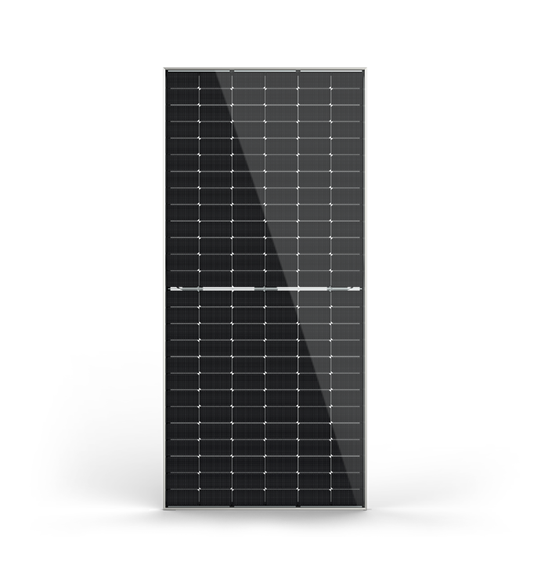

Jinko Bifacial Solar Panels
585W / 620W
Tier 1 panels with dual-sided power generation and advanced N-Type TOPCon cell technology for maximum efficiency.
- 30-year linear performance warranty
- Higher energy yield from same sunlight
- Built to last a lifetime

Dyness Lithium Battery
5.12kWh
The LiFePO4 Dyness Battery brings reliable power with over 6,000 cycles at 90% DoD, scalable up to 50 units in parallel.
- Modular design for flexible installation
- Wall or floor mounting options
- Combines power with sleek design

Deye Hybrid Inverters
Single & Three Phase
All-in-one hybrid inverter supporting both on-grid and off-grid modes with built-in MPPT charge controller.
- Parallel operation for bigger systems
- Ensures uninterrupted energy flow
- Ideal for homes and businesses
Request Quote

Reference Projects
See how we're powering businesses and communities across Africa

Roam Park
Nairobi, Kenya
At Roam Park, Roam Energy installed a 55.78kWp grid-tied solar PV system, featuring Jinko 575W solar panels and SMA Sunny Tripower Core inverters.
Completed: August 2021

Emboo River 2
Maasai Mara, Kenya
In the heart of the Maasai Mara National Park, Narok County, Roam Energy implemented a 64.31kWp off-grid solar PV system with 153.6kWh lithium-ion battery storage.
Completed: January 2023

Sekanani Camp
Maasai Mara, Kenya
Roam Energy installed a 10.34 kWp off-grid solar PV system with 25.6 kWh battery storage at Sekanani Camp in the Maasai Mara National Park, Narok County.
Completed: November 2022
View All Projects

Frequently Asked Questions
Get answers to common questions about solar energy solutions

How much does a solar system cost?

The cost of a solar system depends on several factors including your energy needs, the size of the system, and whether you need battery storage. Residential systems typically start from $2,000 for a basic setup, while commercial systems can range from $10,000 to $100,000+. Contact us for a free customized quote based on your specific requirements.

What warranties do you offer?

We offer comprehensive warranties on all our products and installations:
- Solar panels: 25-30 years performance warranty
- Batteries: 10 years warranty
- Inverters: 5 years warranty
- Installation workmanship: 1 year warranty

How long does installation take?

Installation time varies depending on the system size and complexity:
- Residential systems: 1-3 days
- Commercial systems: 1-6 weeks
- Large-scale projects: 4-12 weeks
After your initial consultation and system design approval, we'll provide a detailed timeline for your specific project.

Do solar panels require maintenance?

Solar systems require minimal maintenance. We recommend:
- Visual inspection every 6 months
- Cleaning panels 2-4 times per year (more in dusty areas)
- Professional system check every 2-3 years
We offer affordable maintenance packages to keep your system performing at its best.

Can I go completely off-grid?

Yes, with the right system design and battery storage capacity, you can achieve complete energy independence. However, going completely off-grid requires:
- Accurate assessment of your energy needs
- Sufficient battery storage for night-time and cloudy days
- Possible backup generator for extended bad weather
- Energy-efficient appliances to minimize consumption
Our experts can help design an off-grid solution tailored to your specific requirements.

What Our Clients Say

"Roam Energy transformed our manufacturing facility with their solar solution. Our energy bills dropped by 60% and we've had zero downtime since installation."

James Mwangi
CEO, Carton Manufacturers

"The solar installation at our camp has been flawless. No more generator noise, just clean reliable power that impresses our guests and protects the environment."

Loic Amado
Manager, Emboo Camp

"Our health clinic can now operate 24/7 thanks to Roam Energy's reliable solar solution. Critical equipment never loses power, and we've seen improved patient outcomes."

Dr. Peter Omondi
Medical Director, Rural Health Clinic

Our Location

Ready to Power Your World Sustainably?
Discover how Roam Energy can provide reliable, affordable solar solutions for your home, business, or community.
Get a Free Consultation Call Us Now

Get In Touch
Have questions about our solar solutions? Our team is ready to help you find the perfect energy solution for your needs.

Our Office
National Park East Gate Rd, Nairobi

Email Us
energy@roam-electric.com

Call Us
+254 704 612 435

Send Us a Message
Send Message

Powering the future with sustainable solar solutions for African homes, businesses, and communities.

Quick Links
- Products
- Projects
- About Us
- Contact

Products
- Solar Panels
- Batteries
- Inverters
- Complete Systems

Newsletter
Subscribe to get updates on our latest products and projects.
Subscribe

© 2025 Roam Energy. All rights reserved.
Privacy Policy Terms of Service

