DEEP LEARNING
PROJECT REPORT


Submitted by
Umara Maqsood 2022-EE-254
Muhammad Rauf 2022-EE-273

Submitted To : Dr. Umar Rashid
Department of Electrical, Electronics & Telecommunication
Engineering
University of Engineering and Technology, Lahore

AI-Based Intrusion Detection System for Network Traffic Classification

Abstract
With the rapid growth of internet technologies, network security has become a critical concern for organizations and individuals. Cyber attacks such as denial-of-service, unauthorized access, and malware attacks can severely impact network performance and data confidentiality. Traditional intrusion detection systems rely on signature-based detection, which cannot effectively detect unknown or evolving attacks.
This project proposes an AI-Based Intrusion Detection System for Network Traffic Classification using deep learning techniques. A deep neural network model is developed to classify network traffic into different categories of attacks. The dataset contains multiple network traffic features that represent various connection properties.
The model is trained using a deep learning architecture implemented in Python using TensorFlow and Keras. Data preprocessing, feature selection, and model evaluation techniques are applied to improve performance. The system evaluates the model using performance metrics such as accuracy, precision, recall, and F1-score.
A user-friendly Gradio interface is developed to allow users to input network traffic parameters and receive predictions about potential attacks. The experimental results demonstrate that deep learning models can effectively detect and classify network intrusions with high accuracy.

Introduction

1.1 Background
Computer networks have become an essential part of modern society. Businesses, government organizations, and individuals rely heavily on internet-based systems for communication, data storage, and online services. However, the increased use of networks has also led to a rise in cyber attacks.
Cyber attacks can target systems in many ways, including unauthorized access, malware injection, denial-of-service attacks, and data theft. These attacks can cause financial losses, data breaches, and service disruptions.
To protect networks from such threats, Intrusion Detection Systems (IDS) are used. IDS monitor network traffic and identify suspicious activities.

1.2 Traditional Intrusion Detection Systems
Traditional IDS systems are generally divided into two categories:

Signature-Based Detection
This method detects attacks by comparing network traffic patterns with a database of known attack signatures. Although effective for known threats, it fails to detect new or unknown attacks.

Anomaly-Based Detection
This method identifies unusual behavior by comparing network traffic with normal patterns. However, it often produces high false alarms.
Because of these limitations, researchers have started using Artificial Intelligence and Machine Learning techniques for intrusion detection.

1.3 Role of Artificial Intelligence in Cybersecurity
Artificial Intelligence (AI) enables systems to learn patterns from large datasets and automatically detect anomalies. AI-based intrusion detection systems can analyze complex network traffic patterns and identify both known and unknown attacks.
Deep learning models are particularly effective because they can automatically extract important features from data and improve detection accuracy.

Literature Review
Several researchers have applied machine learning and deep learning techniques for intrusion detection.
Recent studies have shown that deep learning models such as Deep Neural Networks (DNN), Convolutional Neural Networks (CNN), and Recurrent Neural Networks (RNN) can significantly improve intrusion detection accuracy.
Many intrusion detection studies use datasets such as:
- KDD Cup 99
- NSL-KDD
- CICIDS2017
These datasets contain network traffic records labeled with attack types.
Recent research indicates that deep learning models achieve better performance compared to traditional machine learning algorithms such as decision trees and support vector machines.
However, challenges such as data imbalance and feature complexity still exist in intrusion detection systems.

Dataset Description
The dataset used in this project contains network traffic records used for intrusion detection.
Each record consists of
- 42 input features
- 1 output label
The features represent different properties of network connections, such as:
- Protocol type
- Service type
- Duration of connection
- Number of bytes transferred
- Number of connections
- Error rates
The label column represents the attack category or normal traffic.

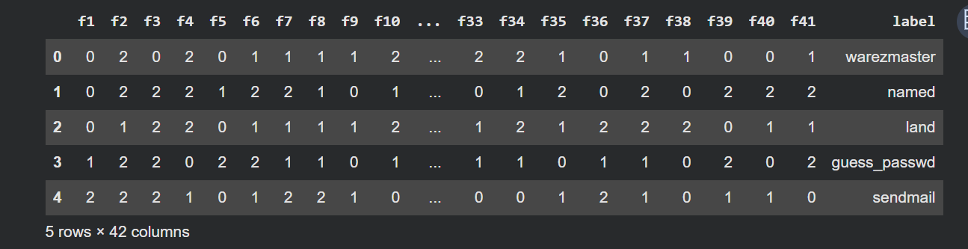Proposed Methodology
The proposed system follows several steps to detect network intrusions.

4.1 Data Preprocessing
Before training the model, the dataset is cleaned and prepared.
Steps include:
Removing unnecessary columns
Converting categorical values into numerical format
Normalizing numerical features
Splitting the dataset into training and testing sets
The dataset is divided into:
- 80% training data
- 20% testing data

4.2 Deep Learning Model
A Deep Neural Network (DNN) model is used to classify network traffic.

Model Architecture
- Input Layer
41 input features
- Hidden Layers
- Dense Layer – 128 neurons (ReLU activation)
Dropout Layer – 0.3
- Dense Layer – 64 neurons (ReLU activation)
Dropout Layer – 0.3
- Dense Layer – 32 neurons (ReLU activation)
- Output Layer
- Softmax activation for attack classification.

4.3 Model Training
The model is trained using:
Optimizer
Adam
Loss Function
Categorical Crossentropy
Epochs
50
Batch Size
32

Performance Evaluation
The model performance is evaluated using the following metrics.

Accuracy
Accuracy measures the percentage of correctly predicted samples.
Accuracy = (Correct Predictions / Total Predictions)

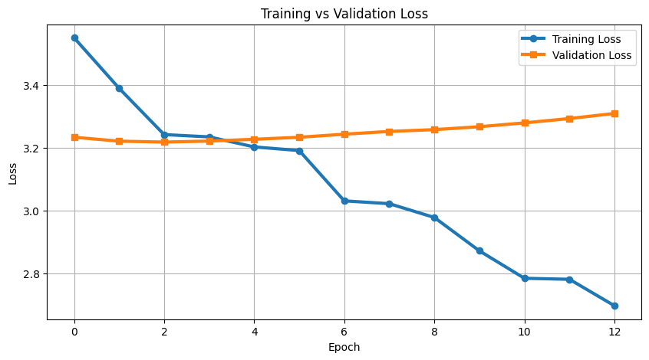Precision
Precision measures how many predicted attacks were actually attacks.

Recall
Recall measures how many actual attacks were correctly detected.

F1 Score
F1 Score is the harmonic mean of precision and recall.

Confusion Matrix
The confusion matrix shows the number of correct and incorrect predictions for each class.

System Implementation
The project is implemented using Python programming language on Google Colab.
Libraries used include:
- TensorFlow
- Keras
- Pandas
- NumPy
- Matplotlib
- Seaborn
- Scikit-learn
- Gradio
The system performs:
1 Data loading
2 Data preprocessing
3 Model training
4 Performance evaluation
5 Attack prediction using user input

User Interface
A Gradio interface is developed to allow users to interact with the intrusion detection model.
The interface allows users to input network traffic features and receive predictions about the type of attack.
The interface includes:
- Input fields for network features
- Predict button
- Display of predicted attack type
This makes the system easier to use without writing code.

Results and Discussion
After training the deep learning model, the system achieved high performance in detecting network attacks.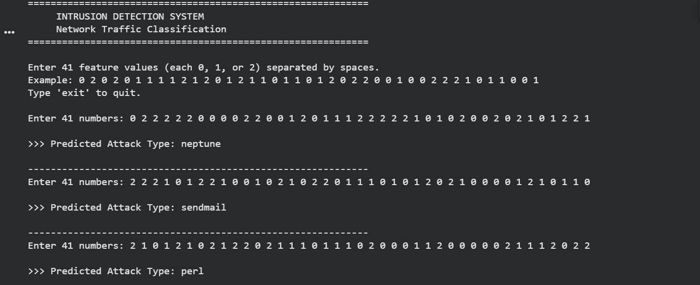The model was evaluated using testing data and produced good results for accuracy and classification metrics.
- Performance graphs such as:
- Training accuracy graph
- Loss graph
- Confusion matrix were generated to analyze model performance.
The results demonstrate that deep learning models are effective for network intrusion detection.

Conclusion
This project presented an AI-Based Intrusion Detection System for Network Traffic Classification using deep learning techniques.
The system uses a deep neural network model trained on network traffic data to detect and classify cyber attacks. Experimental results show that deep learning models can effectively detect intrusions with high accuracy.
The addition of a Gradio interface makes the system user-friendly and suitable for practical use.

Future Work
- Future improvements may include:
- Using larger and more diverse datasets
- Implementing advanced deep learning models such as CNN or LSTM
- Developing a real-time intrusion detection system
- Integrating the system with network monitoring tools

