FORGE FITNESS
Term 2 Final Deliverable: Business Rules, ERDs, Wireframes, and Self-Reflection
Prepared by: Imaad Petersen

Table of Contents
1. Business Rules ............................................................... 2
1.1 User Authentication and Registration ..................................... 2
1.2 Membership Management .................................................... 2
1.3 Packages Tier Architecture ............................................... 2
1.4 Courses and Content Library .............................................. 3
1.5 Personal Trainers Information & Allocation ............................... 3
1.6 Payments and Future Billings ............................................. 3
1.7 Admin Controls ........................................................... 3
1.8 System Management & Infrastructure ....................................... 4
2. Entity Relationship Diagrams (ERD) ........................................... 5
2.1 Main Group ERD Blueprint ................................................. 5
2.2 Course Enrollment Sub-Module ERD ......................................... 6
2.3 Training Plan & Progress Sub-Module ERD .................................. 6
3. Interface Wireframe Artifacts ................................................ 7
3.1 Training Courses Landing Page ............................................ 7
3.2 Video Library & Instructional Module Interface ........................... 8
4. Project Self-Reflection ...................................................... 9

1. Business Rules
This section outlines the operational frameworks, systemic constraints, and functional mandates governing the Forge Fitness digital application ecosystem. These rules establish clear database specifications, authorization boundaries, and core system functionality.
1.1 User Authentication and Registration
1.1 A new member should provide their ID for verification and create a password.
1.2 Password must meet the system's security requirements (minimum length/character complexity).
1.3 A user may only get access to member-only features when their membership is active and verified.
1.4 The system should verify login credentials before giving access.
1.5 Users are only allowed to edit their own profile when they are logged in.
1.2 Membership Management
2.1 User must be a registered and verified member of the gym to access membership tiers.
2.2 Memberships are provided in various ways depending on the type of member (Student, normal citizen, or elderly).
2.3 Memberships automatically expire at the end of the package duration.
2.4 Members may upgrade their package at any time; however, downgrading is only permitted at the end of the current billing cycle.
2.5 A member may terminate their membership through their profile settings; their data will be systematically archived into the database and active system access will be revoked.
1.3 Packages Tier Architecture
3.1 Only verified and registered members can purchase packages.
3.2 Each package must have a defined price, description, and duration.
3.3 A member can only have one active package at any single point in time.
1.4 Courses and Content Library
4.1 Course content should be rigorously evaluated and approved before being published to users.
4.2 Each course should have a unique title and a structured description.
1.5 Personal Trainers Information & Allocation
5.1 Trainer profiles should be thoroughly provided with a name, professional qualification, and background.
5.2 Only registered trainers may edit their own profile settings.
5.3 Trainer profiles are universally visible to all users (registered or unregistered guests) to promote engagement.
5.4 Each trainer has a maximum capacity of assigned members to ensure high quality of service.
5.5 Trainers and members can communicate exclusively through the system's internal messaging feature to ensure absolute data privacy and structured record-keeping.
[COMPLETED BY IMAAD PETERSEN — MODULE 5]
1.6 Payments and Future Billings
6.1 Users pay a baseline registration fee when signing up for the platform.
6.2 All package purchases must be strictly recorded in the secure billing system.
6.3 Users should receive an automated email receipt when registration and initial payment are successful.
6.4 System Administrators may generate and review comprehensive billing and revenue reports.
1.7 Admin Controls
7.1 Only system administrators are allowed to manually add, update, or delete member accounts.
7.2 Only system administrators may update structural packages, courses, or specific trainer details.
7.3 Administrators possess enhanced system privileges across all application levels.
7.4 All changes made by administrators must be immutably logged for comprehensive audit purposes.
[COMPLETED BY IMAAD PETERSEN — MODULE 7]
1.8 System Management & Infrastructure
8.1 The system must securely store all user and membership transactional information in the relational database.
8.2 The system must back up data regularly to prevent the risk of catastrophic data loss.

2. Entity Relationship Diagrams (ERD)
The database schema design maps the structural relationships defined within the business rules. Primary keys (PK) use robust UUID data types to allow scalability, and Foreign Keys (FK) manage relational dependencies seamlessly.
2.1 Main Group ERD Blueprint
The main comprehensive group ERD maps out the holistic database design across all system operations including Users, Student Profiles, Transactions, Locations, Trainers, Courses, and Exercises.
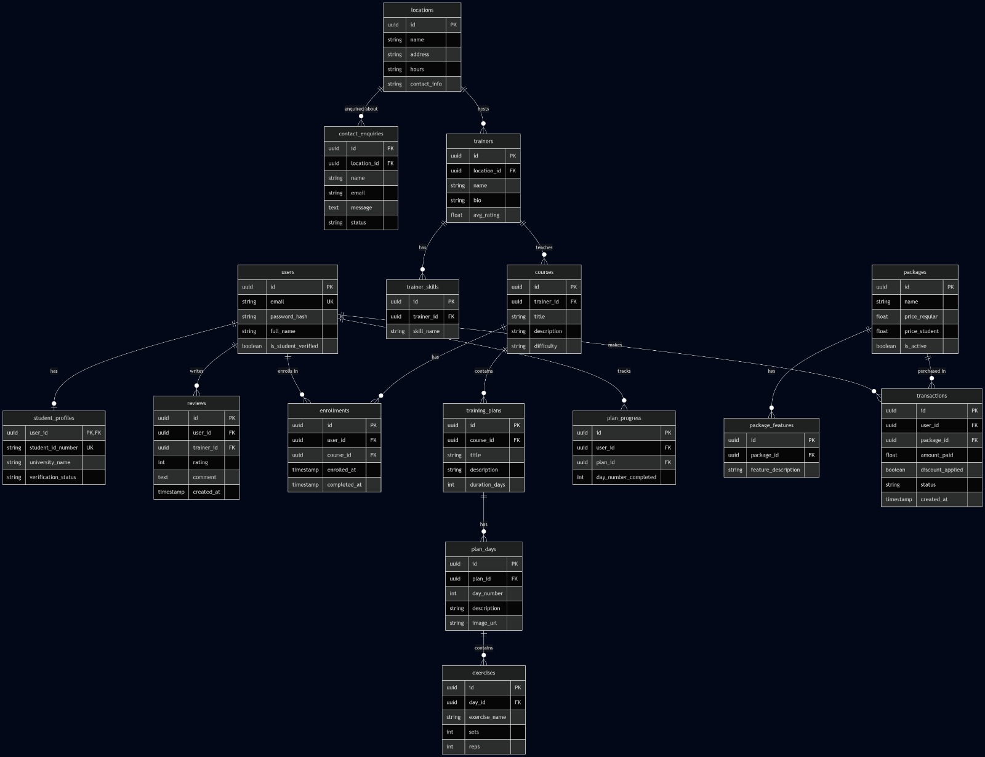
2.2 Course Enrollment Sub-Module ERD
This sub-module visualizes how users enroll into courses, mapping the many-to-many link table. Links to Users (Module 1) since users enroll. Links to Packages (Module 6) because package tier determines course access.
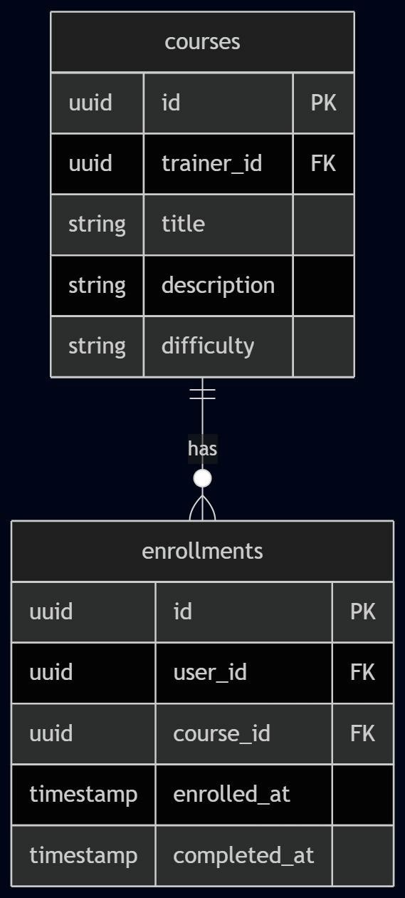
2.3 Training Plan & Progress Sub-Module ERD
Links to Courses (Module 4) where each training plan lives inside a course. Links to Users (Module 1) where progress is tracked per user down to the exact daily exercises completed.
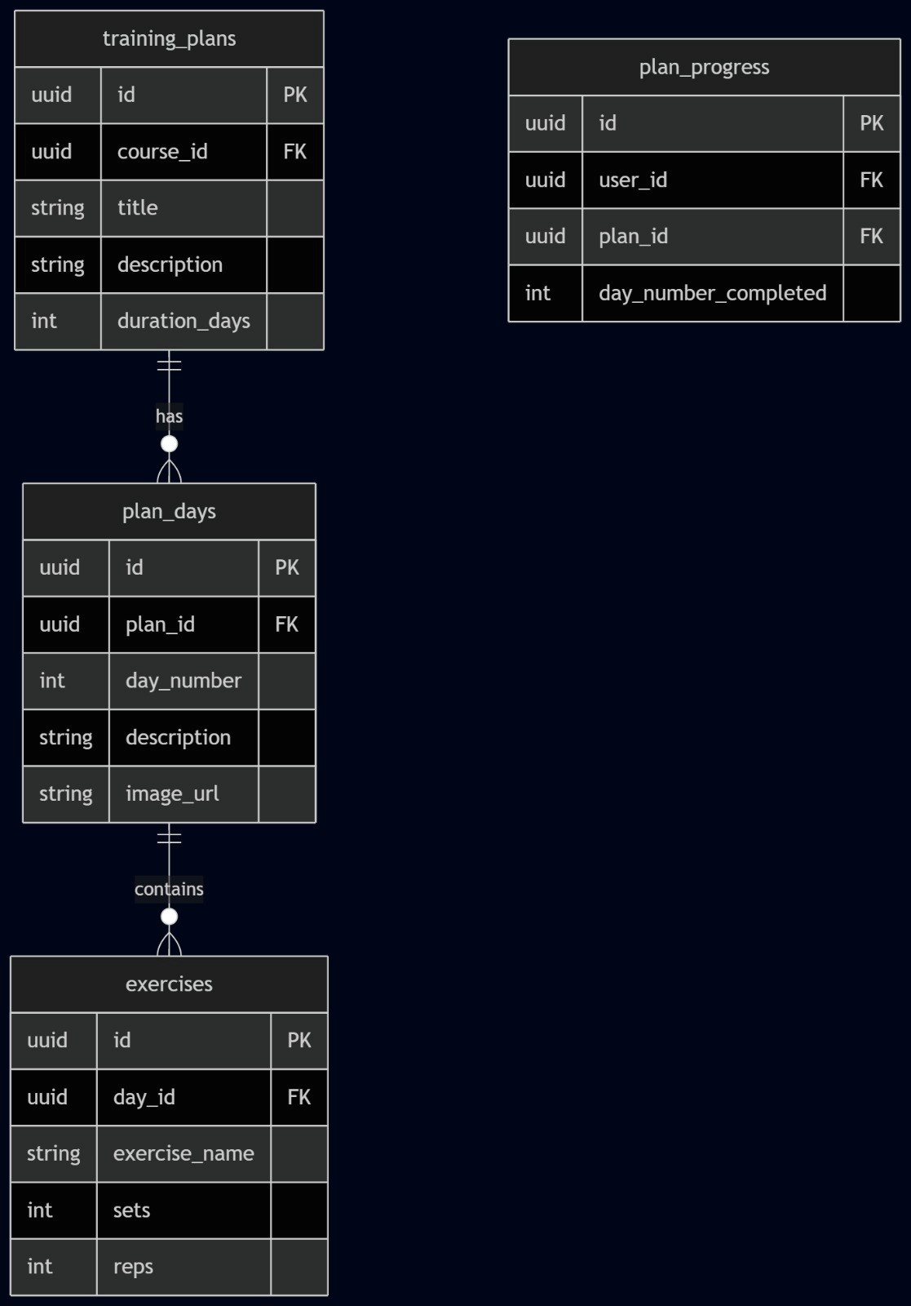

3. Interface Wireframe Artifacts
The user experience layout for Forge Fitness prioritizes sleek, uncluttered text presentation, accessible course navigation, and progress visibility across training routines.
3.1 Training Courses Landing Page
Figure 1: Training Courses Landing Page — Showcasing program categories like Hyrox, Strength, and Mobility. Includes descriptions, bullet points highlighting key deliverables, and 'Learn More' action prompts for individual courses.

3.2 Video Library & Instructional Module Interface
Figure 2: Video Library Interface — Displaying individual mastery courses and instructional media modules. This screen provides video cards with precise time-duration stamps, video titles, and difficulty parameters.

4. Project Self-Reflection
Forge Fitness Digital Transformation — Imaad Petersen Reflection
Introduction :
In this term final project for Forge Fitness, I was personally responsible for designing and documenting key components of the system's infrastructure and user experience. My focus centered on the core fitness offerings, specifically the structural creation of training plans and the video/course library. This reflection outlines my strategic technical contributions and the valuable collaborative efforts that shaped our final team deliverable.
Key Contributions :
- My primary technical contribution involved the core development of the Training Plans and Course/Video Library modules. This required a deep logical dive into how users interact with modern digital fitness content. I focused on:
• Structural Design: Defining how training plans are granularly broken down into daily routines and specific exercises, ensuring a completely logical flow from a high-level course description to individual sets and reps.
• User Interface (Wireframes) : Conceptualizing and designing the structural visual layout for the 'Training Courses' and 'Video Library' application interfaces to ensure top-tier accessibility and visual clarity for gym members.
• Business Rules & UML: I contributed significantly to the business rules engine, specifically mapping out the rigid structural specifications for course publication workflows (Rule 4.1) and administrative trainer profile parameters (Section 5 and Section 7).
• Relational Modeling: I collaborated on the Entity Relationship Diagram (ERD) blueprints to guarantee that the database architecture correctly maps multi-layered courses to physical trainers, locations, and active users.
Collaboration :
Software engineering and business systems analysis are rarely solitary tasks. Throughout this deliverable, I worked in close synchronization with my teammate Anas to rigorously refine the behavioral logic for the training plans and video modules. This collaboration was absolutely vital in ensuring that the course access permissions (linked heavily to paid membership tiers) remained perfectly consistent across both the abstract business rules and the technical ERD schemas. Together, we ensured that the application flow from a coarse overview down to a specific workout exercise video felt completely seamless for the end user.
Conclusion :
Contributing to the Forge Fitness project has allowed me to bridge the critical gap between high-level business operational requirements and low-level technical system implementation. By taking ownership of the training architecture, authoring Sections 5 and 7 of our business rules, and collaborating closely on the system's foundational schemas, I have helped build a professional framework that is highly scalable for gym administrators and exceptionally engaging for gym members.

