Project Self-Reflection
Forge Fitness Digital Transformation
Introduction
In this project for Forge Fitness, I was responsible for designing and documenting key components of the system's infrastructure and user experience. My focus centered on the core fitness offerings, specifically the training plans and the video/course library. This reflection outlines my contributions and the collaborative efforts that shaped the final deliverable.

Key Contributions
My primary technical contribution involved the development of the Training Plans and Course/Video Library modules. This required a deep dive into the logic of how users interact with fitness content. I focused on:
- Structural Design: Defining how training plans are broken down into daily routines and specific exercises, ensuring a logical flow from a high-level course description to individual sets and reps.
- User Interface (Wireframes): Designing the visual layout for the "Training Courses" and "Video Library" pages to ensure accessibility and clarity for members.
- Business Rules & UML: I contributed significantly to the business rules, specifically regarding course publication (Rule 4.1) and trainer assignments (Rule 5.4). I also worked on the Entity Relationship Diagram (ERD) to ensure the database correctly links courses to trainers and users.

Collaboration
Software development is rarely a solitary task. I worked closely with Anas to refine the logic for the training plans and video modules. This collaboration was vital in ensuring that the course access logic (linked to membership tiers) was consistent across both the business rules and the technical ERD. Together, we ensured that the transition from a course overview to a specific workout video felt seamless for the end user.

Wireframe Artifacts
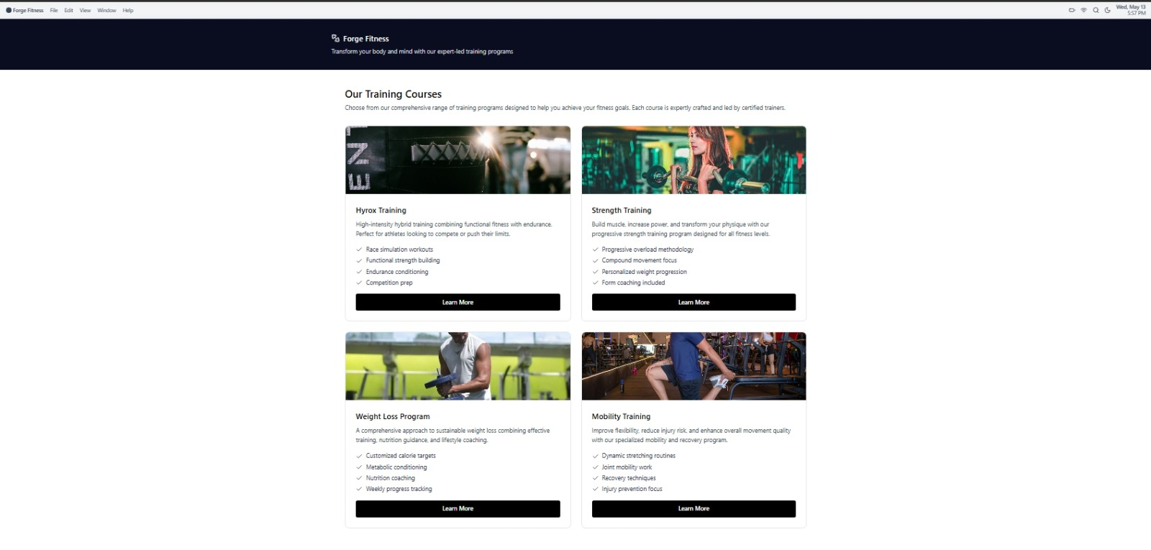
Training Courses Wireframe
Figure 1: Training Courses Landing Page - Showcasing program categories like Hyrox, Strength, and Mobility.

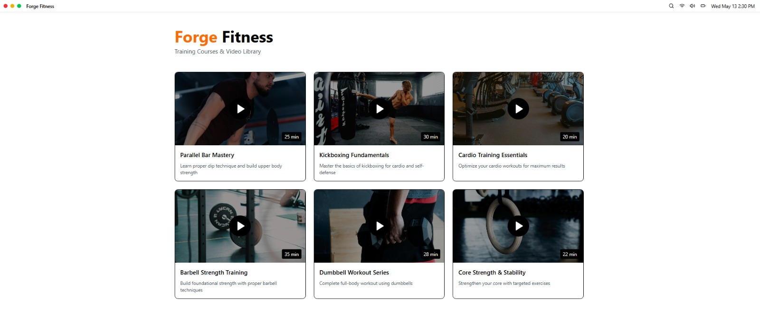
Video Library Wireframe
Figure 2: Video Library Interface - Displaying individual mastery courses and instructional modules.

Conclusion
Contributing to the Forge Fitness project has allowed me to bridge the gap between business requirements and technical implementation. By focusing on the training architecture and collaborating on the system's foundational rules, I helped create a framework that is both scalable for administrators and engaging for gym members.

Prepared by Imaad Petersen | Forge Fitness Project Deliverable

