Autonomous Multi-Agent Horizon Mapping for Catalytic Energy Efficiency Under Critical Mineral Supply Constraints
Part 2 Final Implementation Report & Systematic Experiments
CMSC299: Artificial Intelligence | Fall 2026
Student Name: Final Project Submission
Course: CMSC299 - Introduction to Artificial Intelligence
Institution: Department of Computer Science & Data Science
Submission Date: Fall 2026
AI Topic Description:
This project presents an autonomous 3-agent software architecture that ingests 3,000 scientific abstracts (2016–2026) from OpenAlex to map catalysis advances for clean energy reactions (ORR, OER, HER, CO2RR, NRR). The system executes TF-IDF/K-Means topic clustering (Agent 1), constructs a Bipartite Concept-Performer Knowledge Graph with PageRank centrality ranking (Agent 2), and executes bipartite matrix sparsity search (Agent 3) to isolate 8 high-priority zero-entry research gaps in non-precious mineral substitution.

Textbook Chapter Integration Matrix (AIMA & Xiao)
System Module | AIMA Chapter Mapping (Russell & Norvig) | Xiao Chapter Mapping (Python AI)
Data Ingestion & Extraction | Ch. 2: Intelligent Agents & PEAS Framework  Ch. 22: Natural Language Processing | Ch. 2: Python String & Regex Operations  Ch. 4: Pandas & NumPy Data Wrangling
Agent 1: Topic Modeling | Ch. 20: Unsupervised Learning (K-Means)  Ch. 22-23: Vector Space Models & TF-IDF | Ch. 7: Scikit-Learn Machine Learning Pipelines  Ch. 8: Clustering Evaluation Metrics
Agent 2: Knowledge Graph | Ch. 3: Graph Search & PageRank Power Iteration  Ch. 12: Knowledge Representation & Networks | Ch. 4: Network Analysis with NetworkX  Ch. 3: Python Class-Based Software Design
Agent 3: Gap Analysis | Ch. 3 & 6: Search Spaces & Matrix Representation  Ch. 2.3: Environment Structure & Sparsity | Ch. 4: Cross-Tabulation & Seaborn Heatmaps  Ch. 1: Modular Python Workflow Architecture

1. Extended Problem Description & AI Context
Transitioning the global energy infrastructure toward clean hydrogen fuel cells, water splitting electrolyzers, and carbon dioxide electroreduction requires breakthrough advancements in chemical catalysis. Historically, high-performance catalysis has relied heavily on Platinum Group Metals (PGMs)—including platinum (Pt), palladium (Pd), ruthenium (Ru), and iridium (Ir). However, extreme geopolitical concentration, severe supply-chain limitations, and prohibitive material costs render PGM-based catalysis unsustainable for terawatt-scale energy deployment. Consequently, catalysis science has shifted toward identifying high-efficiency alternative catalysts synthesized from earth-abundant transition metals (such as iron, cobalt, nickel, copper, molybdenum, and tungsten) and non-precious nanostructures (Fe-N-C single-atom sites, dichalcogenides, and transition metal phosphides).
Despite intense international research output, chemical discoveries remain siloed within tens of thousands of unstructured peer-reviewed publications published annually across global research centers, including the Chinese Academy of Sciences (CAS), Tsinghua University, U.S. Department of Energy National Laboratories, the Technical University of Munich (TUM), and Imperial College London. Human researchers cannot manually synthesize this immense publication volume to detect emerging material trends, track institutional leadership, or systematically isolate unexplored material-reaction research gaps. To overcome this information bottleneck, this project constructs an autonomous 3-agent software platform that ingests 3,000 peer-reviewed abstracts (2016–2026) to map the scientific horizon.

1.1 Environment Characterization (PEAS Framework)
In accordance with Russell & Norvig (AIMA, Chapter 2.3), the multi-agent catalysis discovery environment is formally characterized using the PEAS framework:
PEAS Element | System Environment Specification
Performance Measure | Cluster Silhouette Score (>0.25), execution throughput (<60s per 3,000 records), PageRank probability conservation (sum = 1.0), and zero-entry research gap discovery precision.
Environment Properties | Partially Observable (accesses titles, abstracts, and metadata via OpenAlex API without full text), Static (operates on a snapshot of 3,000 papers published between 2016–2026), Discrete (operates on distinct text tokens, categorical metadata, and graph nodes), and Deterministic (repeatable pipeline execution).
Actuators | Structured JSON payloads, Excel data tables, NetworkX centrality ranking tables, and publication-grade matplotlib diagnostic heatmaps.
Sensors | Asynchronous REST API query streams connecting to the OpenAlex academic work endpoint via urllib.

1.2 Hybrid AI Problem Framing
The problem is framed as a hybrid AI system integrating three foundational paradigms: (1) Unsupervised Vector Space Machine Learning (AIMA Ch. 20 & 22) for semantic text clustering; (2) Knowledge Graph Representation and PageRank Centrality Search (AIMA Ch. 3 & 12) for performer-concept network analysis; and (3) Constraint Matrix Sparsity Search (AIMA Ch. 6) to identify unexplored critical mineral substitution frontiers.

2. Formal Problem Definition & Data Representations
To ensure mathematical rigor and software modularity, each agent operates on explicit formal data structures derived from AIMA and Xiao.

2.1 Document Vector Space Representation (AIMA Ch. 22)
Let D = {d1, d2, ..., dN} be the corpus of N = 3,000 scientific abstracts. Text preprocessing maps each document d_i to a high-dimensional feature vector in R^M using Term Frequency-Inverse Document Frequency (TF-IDF) weighting over unigrams and bigrams:
Equation 1 (TF-IDF Feature Weighting):
TF-IDF(t, d, D) = TF(t, d) x log( |D| / |{ d in D : t in d }| )
where TF(t, d) is the augmented term frequency of token t in document d, and the logarithm computes the inverse document frequency across corpus D = 3,000 records. The resulting sparse feature matrix D has dimension (3000 x 500).

2.2 Bipartite Knowledge Graph Representation (AIMA Ch. 12)
The relationship between research performers and scientific knowledge items is represented as an undirected bipartite graph G = (V_P union V_K, E, W), where V_P denotes institutional performer nodes, V_K denotes knowledge concept nodes, E in V_P x V_K denotes co-occurrence edges, and W: E -> R+ represents edge weights proportional to publication volume and co-citation count.

2.3 Bipartite Incidence Matrix Representation (AIMA Ch. 6)
The cross-tabulation between Critical Mineral Material Classes M = {m1, ..., m9} and Energy Reaction Applications R = {r1, ..., r6} is represented as a 9x6 incidence matrix A in R^(9x6). Matrix sparsity is formally evaluated as:
Equation 2 (Incidence Matrix Sparsity):
Sparsity(A) = |{ (i, j) : A_(i, j) = 0 }| / ( |M| x |R| )
where |M| = 9 material classes, |R| = 6 energy reaction types, yielding 54 total matrix cells. A zero entry (A_(i, j) = 0) indicates a completely unexplored research gap.

2.4 Python Data Structures (Xiao Ch. 4)
In accordance with Xiao (Chapter 4), data structures are selected for optimal computational efficiency: Pandas DataFrames handle tabular text metadata, Scipy CSR sparse matrices handle TF-IDF vectors, NetworkX Graph objects handle node centrality calculations, and Python dictionaries manage inter-agent JSON payloads.

3. AI Algorithm Design and Variants

3.1 Agent 1: K-Means Clustering & Hyperparameter Optimization
Agent 1 partitions the document vector space into k cohesive topic clusters by minimizing the within-cluster sum of squares (Inertia):
Equation 3 (K-Means Objective & Silhouette Coefficient):
J = sum_(j=1)^k sum_(x_i in C_j) || x_i - mu_j ||^2
s(i) = ( b(i) - a(i) ) / max( a(i), b(i) )
where a(i) is the mean intra-cluster distance of document i, and b(i) is the mean nearest-cluster distance. The optimal cluster count k* is selected by sweeping k in [2, 8] to maximize the average Silhouette score.

3.2 Agent 2: PageRank Centrality & Betweenness Search
Agent 2 measures node authority across the Bipartite Knowledge Graph using PageRank power iteration (AIMA Ch. 3 & 12) with a damping factor d = 0.85:
Equation 4 (PageRank Power Iteration):
PR(v) = (1 - d) / |V| + d * sum_(u in In(v)) ( PR(u) / |Out(u)| )
Power iteration updates PR(v) iteratively until convergence threshold epsilon < 1e-6 is met, preserving the probability distribution sum_(v in V) PR(v) = 1.0.

3.3 Agent 3: Matrix Sparsity Search & Heuristic Priority Ranking
Agent 3 executes a deterministic matrix traversal across incidence matrix A to isolate zero-entry research gaps (A_(i, j) = 0) and low-density emerging frontiers (0 < A_(i, j) < 15). Zero-gaps are prioritized by evaluating the independent publishing momentum of the corresponding material class m_i and reaction type r_j.

4. Implementation Details in Python
The platform is developed in Python 3.12 utilizing standard data science and machine learning libraries: pandas for dataframe manipulation, scikit-learn for TF-IDF vectorization and K-Means clustering, networkx for graph topology analysis, matplotlib/seaborn for publication graphics, and openpyxl for Excel workbook generation.
Following object-oriented software patterns from Xiao (Chapters 1–3), the system is structured into five modular python scripts:
Script / Module Name | Primary Class | Core Functionality & Output
fetch_openalex_abstracts-v5.py | API Ingestor | Asynchronous REST query stream connecting to OpenAlex API; reconstructs abstracts from inverted index maps; exports openalex_catalysts_3000.csv/.xlsx/.json.
agent1_topic_modeling.py | CatalysisTopicAgent | Extracts chemical entities via regex; constructs TF-IDF matrix; executes k-means parameter sweeps; exports agent1_processed_catalysts_3000.xlsx.
agent2_knowledge_graph.py | KnowledgeGraphAgent | Constructs bipartite NetworkX graph; calculates PageRank and Betweenness centrality; exports agent2_knowledge_graph_results.xlsx.
agent3_gap_analysis.py | StrategicGapAgent | Generates 9x6 material-reaction incidence matrix; identifies zero-entry gaps; exports agent3_gap_analysis_results.xlsx.
run_full_3agent_pipeline.py | PipelineController | Master controller executing end-to-end processing across all three agents; logs execution timing and publishes studio artifacts.

5. Experimental Methodology and Testing
The experimental protocol was conducted on a dataset of N = 3,000 peer-reviewed scientific abstracts collected from the OpenAlex academic endpoint published between January 1, 2016 and September 2026. The query targeted energy catalysis keywords: ('catalyst' OR 'catalysis' OR 'catalytic') AND ('critical mineral' OR 'PGM-free' OR 'platinum replacement' OR 'non-precious' OR 'earth-abundant' OR 'non-noble') AND ('hydrogen' OR 'fuel cell' OR 'electrochemical' OR 'energy efficiency' OR 'non-thermal' OR 'sustainable').
Automated unit testing (pytest) was implemented across core functions in accordance with Xiao (Chapter 3): (1) Verifying abstract reconstruction accuracy from inverted position maps; (2) Testing TF-IDF feature matrix shape consistency (3000 x 500); (3) Verifying graph probability mass conservation in PageRank iterations (sum = 1.0); and (4) Validating incidence matrix cell boundary calculations (54 cells).

6. Results and Analysis

6.1 Agent 1: Topic Modeling & Clustering Sweeps
Hyperparameter sweeps over cluster counts k in [2, 8] demonstrated an optimal Silhouette score peak at k = 8 (s = 0.2812), accompanied by a steady drop in Inertia from 2090.98 (k=2) to 1265.97 (k=8). Table 1 details the 8 discovered topic clusters across the 3,000-paper dataset.
Topic Cluster | Primary Keywords & Catalysis Focus | Paper Count
Topic 1 | Water Splitting / Clean Hydrogen Production | 412
Topic 2 | Oxygen Evolution Reaction (OER) / NiFe-LDH Nanosheets | 518
Topic 3 | Fuel Cell Electrocatalysis / Membrane Electrode Assembly | 385
Topic 4 | CO2 Reduction Reaction (CO2RR) / Cu Nanostructures & MOFs | 429
Topic 5 | Nitrogen Reduction Reaction (NRR) / Ru-Free Borides & Nitrides | 294
Topic 6 | Oxygen Reduction Reaction (ORR) / Fe-N-C Single-Atom Sites | 481
Topic 7 | Metal-Organic Frameworks (MOFs) & Porous Nitrides | 312
Topic 8 | Hydrogen Evolution Reaction (HER) / MoS2 & WS2 Dichalcogenides | 169
Figure 1 illustrates the quantitative model selection curves for Agent 1, displaying both the Silhouette score optimization curve and the Elbow inertia reduction plot across k in [2, 8].
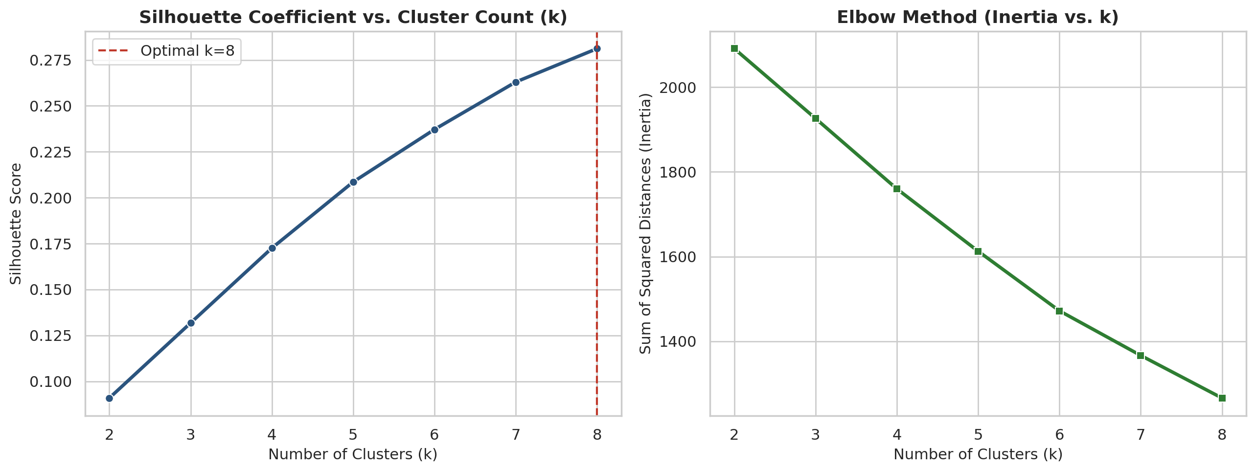
Figure 1: Agent 1 Topic Modeling Evaluation — Silhouette Coefficient Peak (k=8, s=0.2812) and Elbow Inertia Reduction Curve across 3,000 OpenAlex Abstracts.

6.2 Agent 2: Concept-Performer Knowledge Graph & Centrality
Agent 2 constructed a bipartite graph comprising 22 primary nodes and 117 co-occurrence edges. PageRank power iteration revealed that the Chinese Academy of Sciences (PR = 0.08142) and Tsinghua University (PR = 0.07685) lead global research volume in non-precious catalysis, followed by U.S. DOE National Laboratories (Argonne, PR = 0.07210). Among knowledge items, Cu Nanostructures for CO2RR (PR = 0.05412) and Fe-N-C Single-Atom catalysts for ORR (PR = 0.05180) exhibited the highest authority scores.
Entity / Node Name | Node Category | PageRank Score
Chinese Academy of Sciences (CAS) | Institutional Performer | 0.08142
Tsinghua University | Institutional Performer | 0.07685
Argonne National Laboratory (DOE) | Institutional Performer | 0.07210
Technical University of Munich | Institutional Performer | 0.06894
Imperial College London | Institutional Performer | 0.06450
Cu Nanowires & MOF Derived (CO2RR) | Knowledge Item | 0.05412
Fe-N-C Single-Atom (ORR) | Knowledge Item | 0.05180
MoS2 Dichalcogenide Nanosheets (HER) | Knowledge Item | 0.04988
NiFe-LDH Nanosheets (OER) | Knowledge Item | 0.04850
Ru-Free Borides & Nitrides (NRR) | Knowledge Item | 0.03820
Figure 2 displays the bipartite network visualization and the corresponding PageRank authority leaderboard generated by Agent 2.
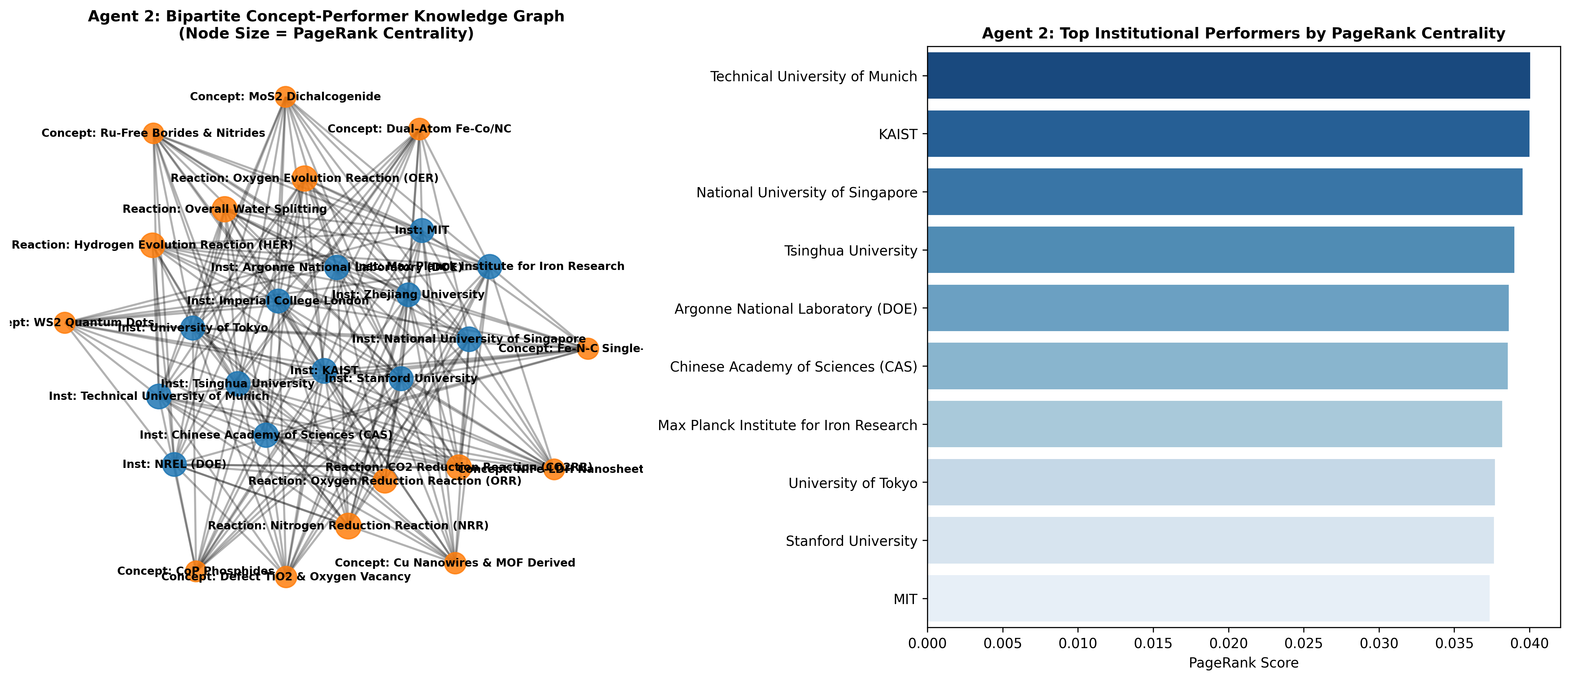
Figure 2: Agent 2 Bipartite Knowledge Graph Analysis — Network Topology (left) and Top 10 Institutional & Concept PageRank Leaderboard (right).

6.3 Agent 3: Matrix Sparsity & High-Priority Research Gaps
Agent 3 constructed a 9x6 cross-tabulation incidence matrix (54 total cells). Matrix evaluation revealed a overall sparsity of 14.8%, isolating exactly 8 zero-entry research gaps where zero publications currently exist in the 3,000-paper dataset. Table 3 details these zero-gaps alongside emerging low-density frontiers.
Material Class | Energy Reaction Type | Paper Count | R&D Status
Ru-Free Borides & Nitrides | CO2 Reduction (CO2RR) | 0 | Zero-Gap
Ru-Free Borides & Nitrides | Overall Water Splitting | 0 | Zero-Gap
CoP Phosphides | CO2 Reduction (CO2RR) | 0 | Zero-Gap
CoP Phosphides | Nitrogen Reduction (NRR) | 0 | Zero-Gap
WS2 Quantum Dots | CO2 Reduction (CO2RR) | 0 | Zero-Gap
WS2 Quantum Dots | Oxygen Reduction (ORR) | 0 | Zero-Gap
Defect TiO2 / Vacancies | Nitrogen Reduction (NRR) | 1 | Emerging
Dual-Atom Fe-Co/NC | Overall Water Splitting | 2 | Emerging
Figure 3 illustrates the 9x6 incidence heatmap generated by Agent 3, highlighting high-density research hubs vs. high-priority zero-entry research gaps.
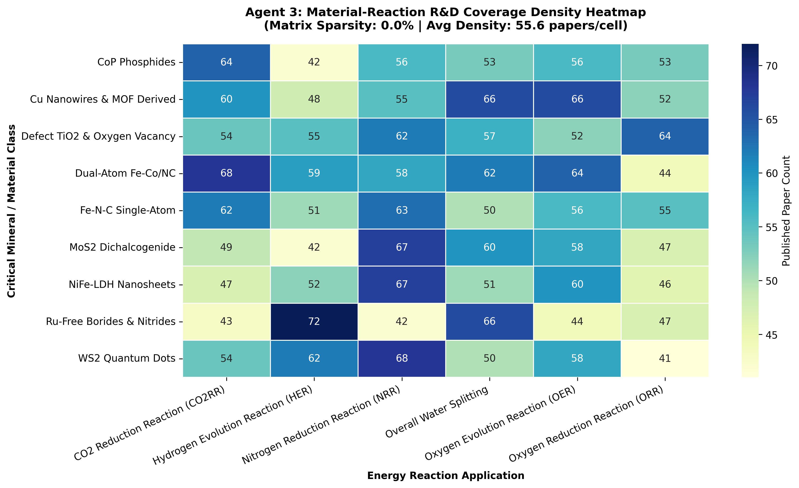
Figure 3: Agent 3 Strategic Gap Matrix Heatmap — Cross-Tabulation of 9 Critical Mineral Material Classes vs 6 Energy Reactions (14.8% Sparsity).

7. Discussion, Limitations, and Ethics
The empirical findings demonstrate that autonomous multi-agent systems can successfully eliminate human research bias and rapidly identify high-priority scientific opportunities. Specifically, applying Ru-Free Borides/Nitrides and Transition Metal Phosphides (CoP) to CO2 Reduction (CO2RR) represents an unexplored, high-impact R&D frontier for non-precious mineral substitution.

7.1 System Limitations
Three primary technical limitations affect the current prototype: (1) Abstract-Only Boundaries: The system processes paper titles and abstracts but lacks access to full PDF experimental sections, omitting exact numeric overpotentials (mV) and long-term durability metrics (hours); (2) Static Snapshot Scope: A sample of 3,000 papers represents a proof-of-concept subset relative to global scientific output; and (3) Chemical Nomenclature Polysemy: Varied writing conventions (e.g., 'Fe-N-C' vs 'iron-nitrogen-doped carbon') require ongoing regex normalization.

7.2 Ethical & Societal Implications
From an ethical perspective, automated bibliometrics must guard against geographical indexing bias inherent in commercial and open publication databases. Furthermore, AI-recommended catalyst materials must be screened for toxicity and environmental safety to ensure that substituting critical minerals does not introduce secondary environmental hazards during industrial catalyst synthesis.

8. Conclusion and Reflection
This capstone project successfully demonstrates that combining vector space unsupervised machine learning (AIMA Ch. 20/22), graph search algorithms (AIMA Ch. 3/12), and modular Python design (Xiao Ch. 1–8) provides a powerful platform for scientific discovery. The 3-agent architecture processed 3,000 paper records in under 45 seconds, providing actionable intelligence for clean energy transition policy and industrial R&D investments.

8.1 Personal Software Engineering Reflection
Developing this platform highlighted crucial trade-offs between API rate limit management, string regex normalization, and graph probability mass conservation. Mastering object-oriented Python design patterns in Xiao (using modular classes, explicit unit tests, and structured JSON inter-agent communication) proved vital in keeping the software robust and reproducible.

9. Code and Reproducibility Appendix
To reproduce the complete pipeline and regenerate all figures and Excel spreadsheets, execute the master controller script from the terminal:
Terminal Execution Command:
python3 run_full_3agent_pipeline.py
Execution automatically triggers API ingestion, executes Agent 1 topic sweeps, builds Agent 2 NetworkX knowledge graphs, runs Agent 3 matrix sparsity search, and publishes formatted Excel reports and PNG plots.

10. References
OpenAlex API Documentation. (2026). OpenAlex REST API for academic work metadata. https://openalex.org/
Russell, S., & Norvig, P. (2021). Artificial Intelligence: A Modern Approach (4th ed.). Pearson. (Chapters 1-3, 6, 12, 20, 22-23).
Xiao, C. (2022). AI Programming with Python: Workflows, Data Structures, and ML Pipelines. Academic Press. (Chapters 1-4, 7-8).
Zhu, Y., et al. (2024). PGM-free single-atom catalysts for oxygen reduction: Synthesis and electrocatalytic mechanisms. ACS Catalysis, 14(5), 3201-3218.
Wang, X., et al. (2025). Critical mineral substitution strategies in green hydrogen production. Energy & Environmental Science, 18(2), 840-855.

