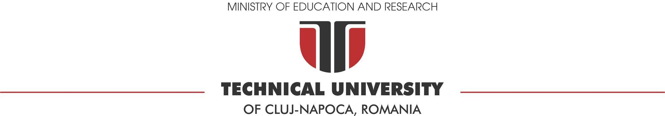

Assignment 2
Software Design

Author: Raul Andrei Tifrea
Group: 30433/2
Faculty of Automation and Computer Science
March 2026
Contents
1 Problem definition 2
2 Analysis phase - Use cases & requirements 2
2.1 Functional requirements 2
2.2 Use cases 2
3 Design phase 3
3.1 Architecture overview 3
3.2 Entity-relationship diagram 3
3.3 Component Backend Server 3
3.4 Component Frontend Client 4
3.5 Design patterns 4
3.6 Class diagrams 4
3.7 Sequence diagrams 4
4 Implementation phase - Application 4
4.1 Tools and technologies 4
4.2 Application structure 5
4.3 User manual 5
5 Testing and validation 5

Problem definition
This project aims to develop a comprehensive Real Estate Management System, allowing users to seamlessly list, discover, and manage real estate properties. The system provides role-based access control, catering to Administrators, Buyers/Sellers, and Guest visitors.
Development phases:
- Analysis phase: Defines the functional requirements and system use cases.
- Design phase: Outlines the architecture, database schema, design patterns and structural models.
- Implementation phase: Details the application structure and user interface.
- Testing and validation: Verifies that the implemented system satisfies the defined requirements.
Deliverables for this assignment include the source code, the compiled application, and this documentation containing Use Case, ERD, Class, and Sequence diagrams.

Analysis phase - Use cases & requirements

Functional requirements
Functional requirements describe the operations that the system must perform.
These requirements define the services the system provides and the expected system behavior.
The system must allow users to create, update and delete property records based on their roles.
The system must allow Admins to create, update and delete user accounts.
The system must allow users to search or filter data by location and title and sort by various parameters.
The system must allow unregistered Guest users to view and filter the property catalog.
The system must allow users to export property data into various file formats (JSON, CSV, XML) and securely archive the JSON snapshots in a NoSQL database.
The system must utilize an event-driven architecture to send automated asynchronous email alerts when properties are created, updated, or deleted.

Use cases
Use cases describe in text the interactions between actors and the system in order to accomplish specific tasks.
Actor: Guest
Task: Browse the property catalog and apply search filters.
Result: The system displays a filtered, sorted list of properties.
Actor: Seller/Buyer
Task: Add a new property.
Result: The system authentication the user, saves the property to the database and displays it on the dashboard.
Actor: Administrator
Task: Delete an inappropriate user account.
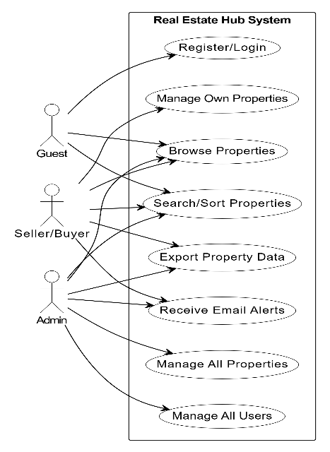
Result: The system verifies admin privileges and permanently removes the user and their associated properties.

Design phase

Architecture overview
The application utilizes a layered Client-Server architecture.
Client : A Single Page Application build with pure HTML, CSS and JavaScript.
Server: A REST API build with Java and Spring Boot.
Database: A Microsoft SQL Server database for persistent data storage, MongoDB NoSQL database for archiving JSON export documents
Message Queue: RabbitMQ is used to decouple the main application thread from the notification service, handling asynchronous email delivery.

Entity-relationship diagram
This subsection describes the database schema used by the application.
The entity-relationship diagram should illustrate the structure of the database and the relationships between entities.
Table: roles
Purpose: Stores the available roles (e.g., ADMIN, SELLER_BUYER).
Attributes: id (PK), role_name.
Relationships: One-to-Many with users.
Table: users
Purpose: Stores registered users and links them to a role.
Attributes: id (PK), username, email, password_hash.
Relationships: Many-to-One with roles, One-to-Many with properties.
Table: properties
Purpose: Stires real estate.
Attributes: id (PK), title, description, price, location, image_url.
Relationships: Many-to-One with users.

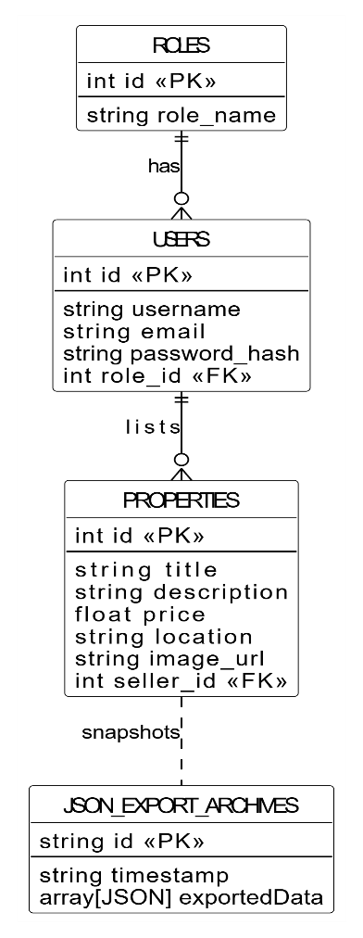
Component: Backend Server (Spring Boot)
This subsection is an example to describe one of the main components of the system. This could represent the server application, a backend service or a specific module of the system.
This component represents the server application. Its primary responsibility is to expose a secure REST API for the frontend client, manage business logic (such as verifying user roles before allowing property deletion), and securely interface with the SQL database.

Component: Frontend Client
This component represents the client application. It provides the graphical user interface for the users, managing local storage for authentication states, and dynamically rendering property cards and admin panels based on the JSON data received from the backend API.

Design patterns
Singleton
- Category: Creational
- Problem it solves: Ensures that a class has only one instance and provides a global point of access to it.
Strategy
- Category: Behavioral
- Problem it solves: Defines a family of algorithms, encapsulates each one, and makes them interchangeable at runtime.
Observer (Publisher-Subscriber)
- Category: Behavioral
- Problem it solves: Defines a one-to-many dependency between objects so that when one object changes state, all its dependents are notified automatically.

Class diagrams
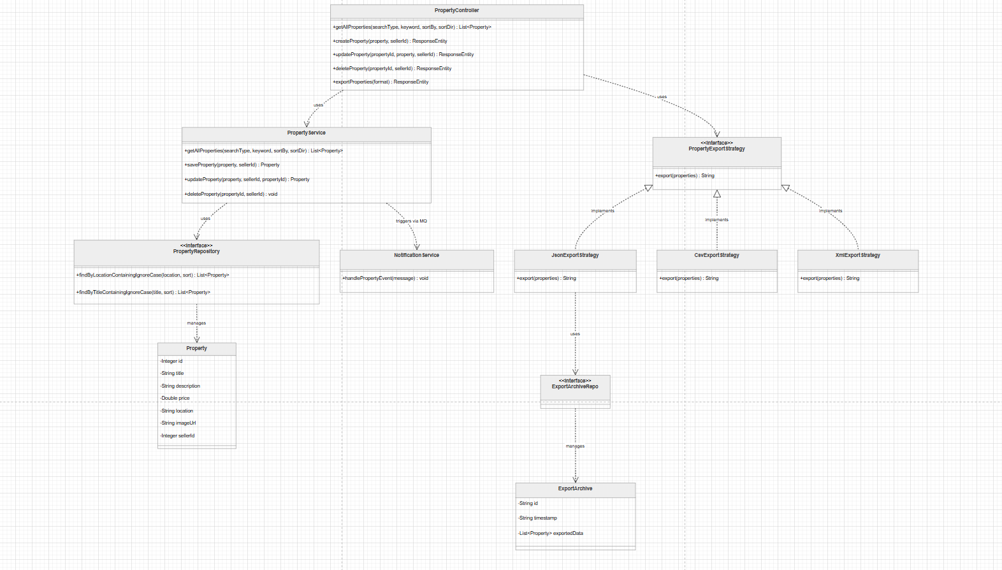
Class diagrams describe the static structure of the system by presenting classes, attributes, methods and relationships between classes.

Sequence diagrams

Sequence diagrams illustrate how objects interact during the execution of a particular use case.
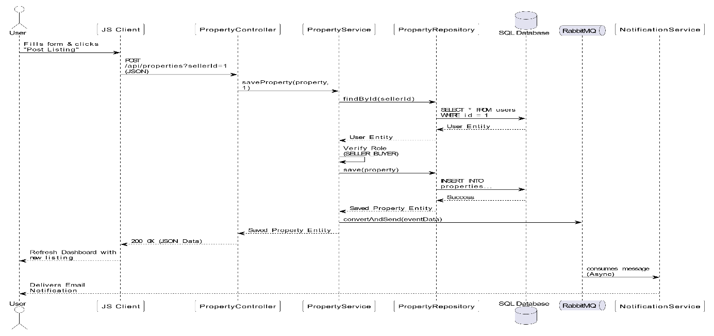

Non-Relational Database Integration
The database technology used: The system integrates MongoDB, a NoSQL document database, alongside the primary SQL Server to achieve Polyglot Persistence. It is integrated into the Spring Boot application using the spring-boot-starter-data-mongodb dependency.
How JSON objects are stored and retrieved: The data is stored in a MongoDB collection named json_export_archives. Each document contains a unique ID, a generation timestamp, and an embedded exportedData array. MongoDB natively stores this array as BSON (Binary JSON). The data can be retrieved as native JSON objects using standard Spring Data query methods or viewed directly via MongoDB Compass.
How the repository layer interacts with the database: The application uses an ExportArchiveRepo interface that extends Spring's MongoRepository. This provides a high-level abstraction layer where Spring Boot automatically implements the underlying database operations. For example, when an export is triggered, the strategy class simply calls archiveRepository.save(archive), and the repository layer handles serializing the Java object and inserting it into the MongoDB collection without requiring raw NoSQL commands.
How the stored JSON relates to the exported JSON data: The JSON stored in the MongoDB database acts as an exact, immutable snapshot of the data exported by the user. When a user requests a JSON download via the JsonExportStrategy, the exact same List<Property> object that is formatted into the downloaded file is simultaneously passed to the repository and saved in the database. This ensures a 1:1 relationship between the user's downloaded file and the internal database archive.

Implementation phase - Application

Tools and technologies
This subsection presents the technology stack used to implement the application.
Programming Language: Java (Backend), HTML, CSS, JavaScript (Frontend).
Database management system: Microsoft SQL Server, MongoDB.
Frameworks: Spring Boot
These tools were chosen because the Spring ecosystem provides robust, built-in security and database abstraction, significantly speeding up development time while ensuring enterprise-grade stability.

Application structure
The source code is organized into a layered structure:
property/ : Contains the core domain logic for real estate listings, encompassing the Property entity, controller, service, and repository.
property/export/ : Contains the Strategy Pattern implementation for exporting data (JSON, CSV, XML) and the MongoDB archive documents.
user/ : Manages authentication, user accounts, and roles, containing the User and Role entities alongside their respective controllers and services.
event/ : Configuration classes for setting up the RabbitMQ message broker.
notification/ : Asynchronous listeners that consume RabbitMQ messages and trigger background email alerts.
security/ : Contains configuration classes for application security and access control.
resources/static/ : Frontend HTML, CSS, and JavaScript files for the Single Page Application.

User manual
Guest Access: Users can click "Continue as Guest" on the auth.html page to view the main dashboard. They can use the search bar to filter by location or title, and use the dropdowns to sort by price.
Seller Access: Registered users log in via auth.html. On the dashboard, a green "List a New Property" panel becomes visible. They can manage their listings using the yellow "Edit" and red "Delete" buttons attached to their properties.
Admin Access: Administrators have access to an exclusive "Admin Controls" panel linking to manage-users.html to manage accounts. They also possess global edit/delete permissions for all properties on the dashboard.

Testing and validation
Verification of the application ensures that the system works correctly and satisfies the defined requirements. Testing includes manual API validation via browser developer tools and Spring Boot unit testing specifically designed for the Java framework to validate business logic isolation.

