Function in Hardware
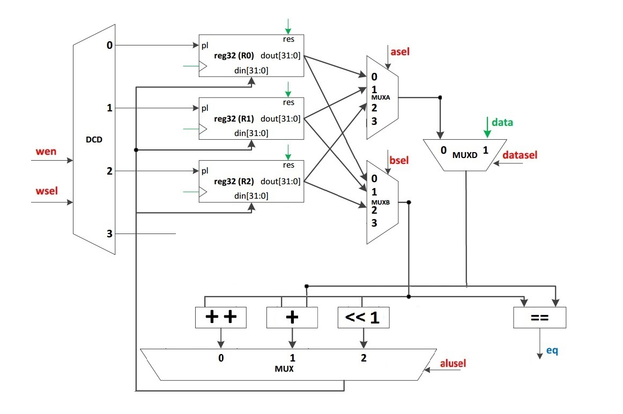
11. xn = xn-1 + 15*n, x0 = 0

#include <iostream>
using namespace std;

int main(void) {
int sum = 0, n;
cout << "N = ";
cin >> n;
for (int i = 0; i <= n; i++)
sum = sum + 15 * i;
cout << "Rez = " << sum << endl;
return 0;
}

