Emp-nangeng-Web

都是GET请求 无参

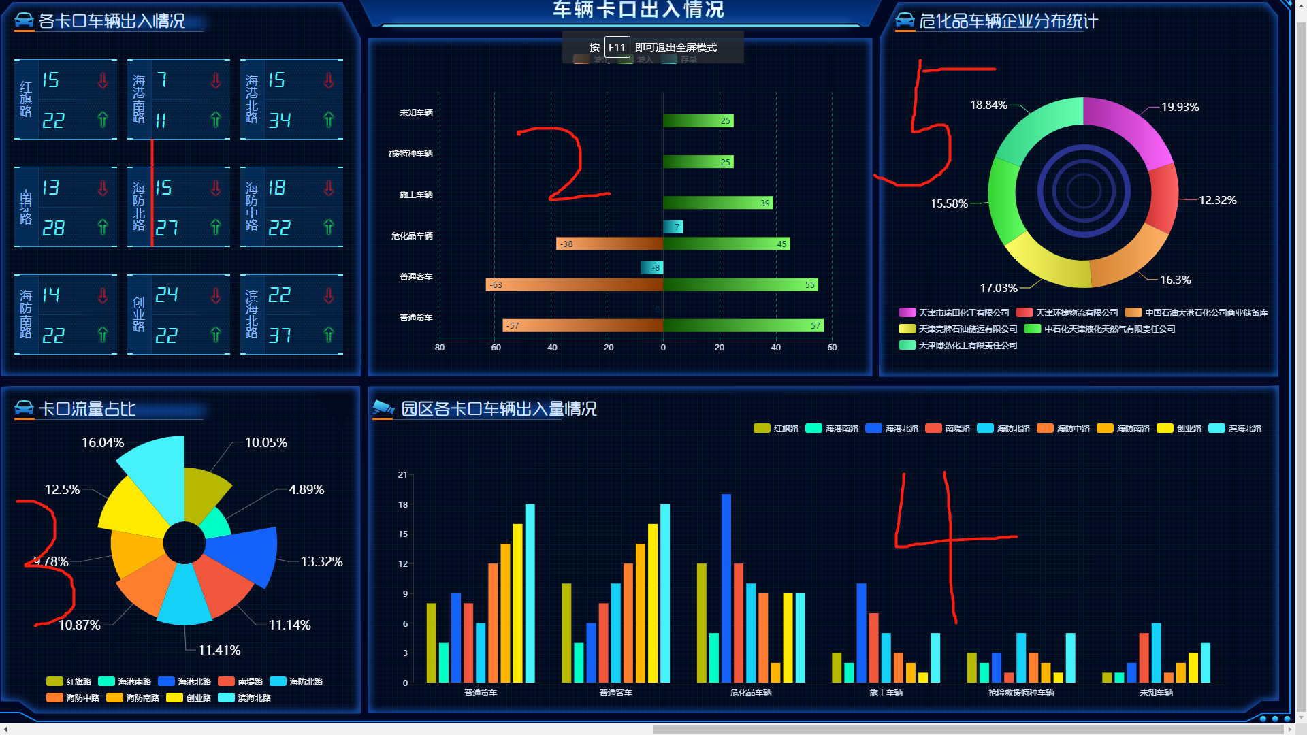

**1 url: web-emp-nangang/passRecordVehicles/getBayonetVehiclePassState**

{

"code": 2000,

"msg": "操作成功",

"data": [

{

"bayonetName": "红旗路",

"inNumber": "1",

"outNumber": "1"

},

{

"bayonetName": "海港南路",

"inNumber": "2",

"outNumber": "2"

},

{

"bayonetName": "海港北路",

"inNumber": "3",

"outNumber": "3"

},

{

"bayonetName": "南堤路",

"inNumber": "4",

"outNumber": "4"

},

{

"bayonetName": "海防北路",

"inNumber": "5",

"outNumber": "5"

},

{

"bayonetName": "海防中路",

"inNumber": "6",

"outNumber": "6"

},

{

"bayonetName": "海防南路",

"inNumber": "7",

"outNumber": "7"

},

{

"bayonetName": "创业路",

"inNumber": "8",

"outNumber": "8"

},

{

"bayonetName": "滨海北路",

"inNumber": "9",

"outNumber": "9"

}

]

}

**2 url: web-emp-nangang/passRecordVehicles/getVehicleTypeAndFlow**

{

"code": 2000,

"msg": "操作成功",

"data": {

"legendData": [

"驶出",

"驶入",

"存量"

],

"totalNumber": [

"0",

"0",

"0",

"0",

"0",

"0"

],

"comeInNum": [

"9",

"9",

"9",

"9",

"9",

"9"

],

"goOutNum": [

"9",

"9",

"9",

"9",

"9",

"9"

],

"yaxisData": [

"普通货车",

"普通客车",

"危化品车辆",

"施工车辆",

"抢险救援特种车辆",

"未知车辆"

]

}

}

**3 url: web-emp-nangang/passRecordVehicles/getBayonetFlowProportion**

{

"code": 2000,

"msg": "操作成功",

"data": [

{

"bayonetName": "红旗路",

"flow": "11.11"

},

{

"bayonetName": "海港南路",

"flow": "11.11"

},

{

"bayonetName": "海港北路",

"flow": "11.11"

},

{

"bayonetName": "南堤路",

"flow": "11.11"

},

{

"bayonetName": "海防北路",

"flow": "11.11"

},

{

"bayonetName": "海防中路",

"flow": "11.11"

},

{

"bayonetName": "海防南路",

"flow": "11.11"

},

{

"bayonetName": "创业路",

"flow": "11.11"

},

{

"bayonetName": "滨海北路",

"flow": "11.11"

}

]

}

**4 url: web-emp-nangang/passRecordVehicles/getVehicleTypeAndBayonetFlow**

{

"code": 2000,

"msg": "操作成功",

"data": {

"series": [

{

"bayonetName": "红旗路",

"type": "bar",

"data": [

"2",

"2",

"2",

"2",

"2",

"2"

]

},

{

"bayonetName": "海港南路",

"type": "bar",

"data": [

"2",

"2",

"2",

"2",

"2",

"2"

]

},

{

"bayonetName": "海港北路",

"type": "bar",

"data": [

"2",

"2",

"2",

"2",

"2",

"2"

]

},

{

"bayonetName": "南堤路",

"type": "bar",

"data": [

"2",

"2",

"2",

"2",

"2",

"2"

]

},

{

"bayonetName": "海防北路",

"type": "bar",

"data": [

"2",

"2",

"2",

"2",

"2",

"2"

]

},

{

"bayonetName": "海防中路",

"type": "bar",

"data": [

"2",

"2",

"2",

"2",

"2",

"2"

]

},

{

"bayonetName": "海防南路",

"type": "bar",

"data": [

"2",

"2",

"2",

"2",

"2",

"2"

]

},

{

"bayonetName": "创业路",

"type": "bar",

"data": [

"2",

"2",

"2",

"2",

"2",

"2"

]

},

{

"bayonetName": "滨海北路",

"type": "bar",

"data": [

"2",

"2",

"2",

"2",

"2",

"2"

]

}

],

"xaxis": [

"普通货车",

"普通客车",

"危化品车辆",

"施工车辆",

"抢险救援特种车辆",

"未知车辆"

]

}

}

**5 url: web-emp-nangang/passRecordVehicles/getVehicleByCompany**

{

"code": 2000,

"msg": "操作成功",

"data": [

{

"name": "天津市滨海新区公安局交管分局大港支队港南交警大队",

"total": "8"

},

{

"name": "中国南海工程有限公司",

"total": "3"

},

{

"name": "天津林献石化有限公司",

"total": "3"

},

{

"name": "天津杰士电池有限公司",

"total": "2"

},

{

"name": "天津泰达绿化集团有限公司",

"total": "2"

},

{

"name": "汇辰融资租赁有限公司",

"total": "2"

},

{

"name": "天津荣航机电科技有限公司",

"total": "2"

},

{

"name": "其他企业",

"total": "4"

}

]

}