**An electronic structure descriptor for oxygen reactivity at metal and metal-oxide surfaces**

*Colin F. Dickens,1,2 Joseph H. Montoya,3 Ambarish R. Kulkarni,1,4 Michal Bajdich,2 and Jens K. Nørskov1,2,5\**

1SUNCAT Center for Interface Science and Catalysis, Department of Chemical Engineering, Stanford University, Shriram Center, 443 Via Ortega, Stanford, California, 94305, USA.

2SUNCAT Center for Interface Science and Catalysis, SLAC National Accelerator Laboratory 2575 Sand Hill Road, Menlo Park, California, 94025, USA.

3Energy Technologies Area, Lawrence Berkeley National Laboratory, Berkeley, California, 94720, USA.

4Department of Chemical Engineering, University of California, Davis, California, 95616, USA.

5Department of Physics, Technical University of Denmark, 2800, Kongens Lyngby, Denmark.

*Correspondence to: [jkno@dtu.dk](mailto:jkno@dtu.dk)

**Supplementary Information**

Computational Details

All DFT calculations in this work were performed using Quantum Espresso through the Atomic Simulation Environment interface.[1,2] Calculation parameters and optimization routines vary by dataset, so each will be explained separately in the following.

FCC metal calculations were performed using the BEEF-vdW exchange-correlation functional[3] with plane-wave/density-wave cutoffs of 600/6000 eV. Ultrasoft pseudopotentials from the GBRV library were used.[4] Spin-polarization was neglected. The lattice constant for each metal was obtained by minimizing the energy of a bulk primitive cell with a 12 × 12 × 12 Monkhorst-Pack sampling of reciprocal space. Surface calculations were performed in a 3 × 3 × 3 cell of the (111) facet with the lower two layers fixed to their bulk positions and a 4 × 4 × 1 Monkhorst-Pack sampling of reciprocal space. A total vacuum region of 14 Å was added between periodic surfaces and a dipole correction was used. Local structural relaxations of surfaces were performed with a maximum force tolerance of 0.05 eV/Å. Additional structural constraints were applied to some of the FCC data points in Figure 1. For the cases of circles, diamonds, and triangles, the in-plane coordinates of oxygen in either adsorbed O or OH were fixed at an on-top, bridge, or FCC site, respectively. Star symbols indicate O and OH were relaxed at their most stable site without any constraints applied. For the structures in Figures 3, 5 and 6 the in-plane coordinates of oxygen and hydrogen were fixed at an on-top site and the perpendicular coordinate of oxygen was fixed at a particular value.

Rutile metal-oxide calculations were performed using the BEEF-vdW exchange-correlation functional with plane-wave/density-wave cutoffs of 600/6000 eV. Ultrasoft pseudopotentials from the GBRV library were used. Spin-polarization was neglected. The bulk lattice for each rutile metal-oxide from which the surface was cut was obtained by minimizing the energy of a bulk primitive cell (two formula units) with a 7 × 7 × 10 Monkhorst-Pack sampling of reciprocal space. Specifically, this minimization was performed with respect to the two lattice constants, *a* and *c*, and the reduced oxygen coordinate (often referred to as *u*). Surface calculations were performed in a 1 × 2 × 4 cell of the (110) facet with the lower two layers fixed to their bulk positions and a 4 × 4 × 1 Monkhorst-Pack sampling of reciprocal space. A total vacuum region of 12 Å was added between periodic surfaces and a dipole correction was used. Local structural relaxations of surfaces were performed with a maximum force tolerance of 0.05 eV/Å. For the rutile points in Figure 1, three oxygen sites were considered (as illustrated in the main text) and the stoichiometric surface (oxygen adsorbed at bridge and three-fold sites; nothing adsorbed at CUS) was always used as a starting point. Explicitly stated, the average O 2*p*-state energy of rutile circles is calculated from the DOS projected onto oxygen adsorbed at the CUS with nothing resting on the neighboring CUS and Δ*E*O–Δ*E*OH is calculated as the negative energy of adding a hydrogen atom to the same adsorbed oxygen. The average 2*p*-state energy of rutile diamonds and triangles is calculated from the DOS projected onto either the bridge or three-fold oxygen of a stoichiometric surface and Δ*E*O–Δ*E*OH is calculated as the negative energy of adding a hydrogen atom to the same either bridge or three-fold oxygen. The structure in Figure 7 is identical to the “CUS single-kink” from our previous work.[5]

The majority of perovskite data in Figure 1 directly utilize the calculations performed previously by Montoya *et al*. and the reader is directed to the original paper for details of those calculations.[6] Notable differences with the above data include the use of the RPBE exchange-correlation functional[7] and lower plane-wave/density-wave cutoffs of 400/4000 eV. We have reoptimized the structures of adsorbed OH and O for six surfaces with plane-wave/density-wave cutoffs of 600/6000 eV and saw negligible changes in the average O 2*p*-state energy and Δ*E*O–Δ*E*OH. In the perovskite calculations performed by Montoya *et al*., some distortions in the surface structure arose upon relaxation with adsorbates. We have not necessarily omitted cases where distortions arose, but in cases where there were significant relative distortions between adsorbed O and adsorbed OH, we re-relaxed the structures in an attempt to make the distortions more similar between states. Specifically, we removed hydrogen from the structure with adsorbed OH and performed a local relaxation using the same parameters as the original calculation. Ultimately, perovskite structures (both original calculations and those re-relaxed) were excluded from the dataset if the root-mean-square-displacement of all atoms between the structure with adsorbed O and the structure with adsorbed OH was greater than 0.15 Å. Perovskites in the final data-set that were re-relaxed by us as described above are indicated as such in Table S1.

Reference for O chemisorption

As mentioned in the main text, oxygen chemisorption energies (Δ*E*O) were calculated with respect to oxygen gas (in a triplet state). For the perovskite data set (which relies on RPBE), a standard +0.7 eV correction applied to the gas-phase reference (resulting in 0.35 eV stronger binding oxygen chemisorption energies) such that the energetics of water formation match experimental values. For the BEEF-vdW functional, it is somewhat ambiguous whether or not a correction should be applied because the functional was trained to experimental data using an uncorrected O2 reference. In this work we have chosen not to apply a correction to Δ*E*O for the datasets that rely on BEEF (rutile and FCC). This choice only affects the relative shift between perovskite data and rutile/FCC data, and correcting both RPBE and BEEF in the same manner results in a negligible change to the overall fit (no change in MAE to two decimal places).

Naturally, this choice of reference implies that OH chemisorption energies (Δ*E*OH) are with respect to oxygen gas and hydrogen gas.

Free energy correction for Δ*E*O–Δ*E*­OH

The conventional descriptor for OER activity is Δ*G*O–Δ*G*­OH at standard conditions (300 K, 1 bar of hydrogen gas), which differs from Δ*E*O–Δ*E*­OH by vibrational energy and entropy of the surface and translational, rotational, and vibrational energy and entropy of hydrogen gas:



Using the IdealGasThermo class in the thermochemistry module of the Atomic Simulation Environment (ASE), we calculate the free energy correction for ½H2 gas to be -0.02 eV, and using the HarmonicThermo class in (ASE), we have calculated the free energy corrections for either adsorbed O or OH and the difference between them for 178 of the data points in Figure 1, as shown in the histogram in Figure S8. The mean +/- one standard deviation for the free energy corrections of O, OH, and O-OH are 0.05 +/- 0.02 eV, 0.32 +/- 0.04 eV, -0.27 +/- 0.03 eV, respectively. Therefore, the average total free energy correction to be applied to Δ*E*O–Δ*E*OH is -0.27 – 0.02 = -0.29 eV.

Iterative scheme to determine most stable surface coverage

It is often desirable to calculate catalytic properties with the appropriate coverage under reaction conditions. In principle, the most energetically stable coverage (considering either adsorbed OH or O) could be predicted based on the of each oxygen (which yields an estimate of Δ*E*O–Δ*E*OH) given the chemical potential of hydrogen. However, if adsorbate-adsorbate interactions are significant, then the reactivity of each oxygen may change upon addition of hydrogen to the surface. The change in reactivity could of course be estimated by performing an additional self-consistent DFT calculation of the new surface coverage and extracting of each oxygen site, and the process could be iterated on until the convergence is achieved. We show preliminary evidence in Figure S7 that suggests of oxygen in adsorbed OH could be used to predict the energetics of its deprotonation, which would be necessary in such a scheme.

Numerical Methods

Integration of the DOS spectra was performed via the trapezoidal rule as implemented in the python package NumPy.

Raw Data

All structures and DOS considered in this study are available in a zip file. Structures are provided either in CUBE or ASE-Trajectory formats (the latter includes some calculation information including structural constraints), and DOS is provided in a csv with up to three columns: energy relative to the Fermi level, DOS projected onto 2*p*-states of the oxygen atom of interest, total DOS. Each data point in this study is represented by 2-3 structures (one for O adsorbed, one for OH adsorbed and in some cases, one for an empty site) and a DOS spectrum projected onto O. The naming scheme for the structures used in Figures 1, S2, and S3 is chemical_formula-coordination-adsorbate. For example, LaOsO3-2c-OH.traj represents OH adsorbed with two-fold coordination to Os (*i.e.* in the OsO2 plane) on LaOsO3, LaOsO3-2c-s.traj has the same structure with the OH removed (leaving an oxygen vacancy), and LaOsO3-2c-O.traj replenishes the vacancy with an oxygen atom. Analogously, the DOS projected onto the adsorbed oxygen for the latter structure is contained in LaOsO3-2c-O.csv. The naming scheme for data in Figure 3 is metal-bond_length-species (e.g. Ag-2.60-O.traj) where the M-O bond length is in units of Å. The naming scheme for data in Figure 7 is RuO2_kink-atom_index-adsorbate (e.g. RuO2_kink-6-OH.traj) where atom_index is the index of the oxygen site of interest (zero-based indexing).

Structures and energies are also available for viewing at CatalysisHub.org.[8]

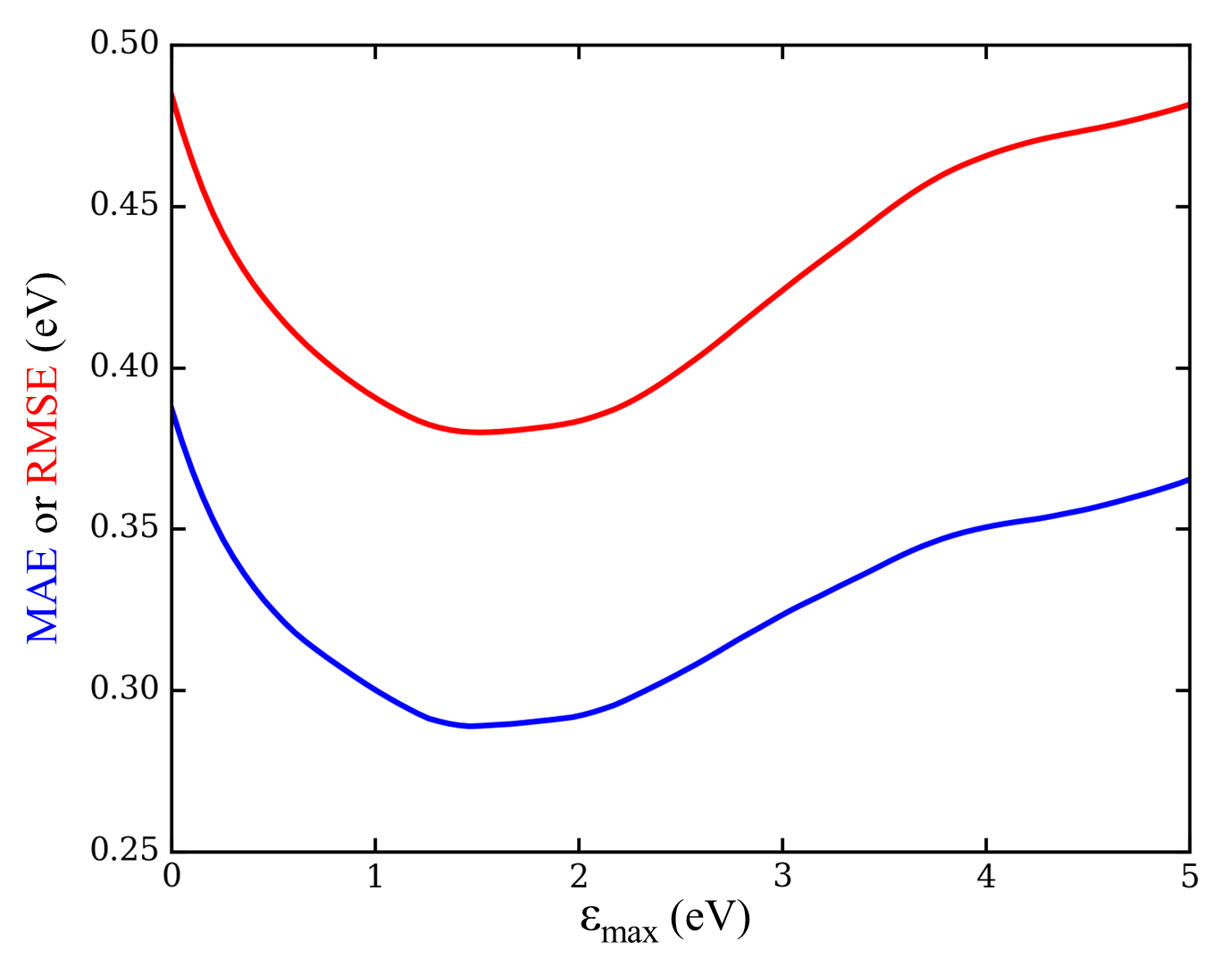

Figure S1. Sensitivity of Figure 1 correlation with respect to the integration upper bound. MAE and RMSE are the mean absolute error and root mean absolute error, respectively, of the linear model.

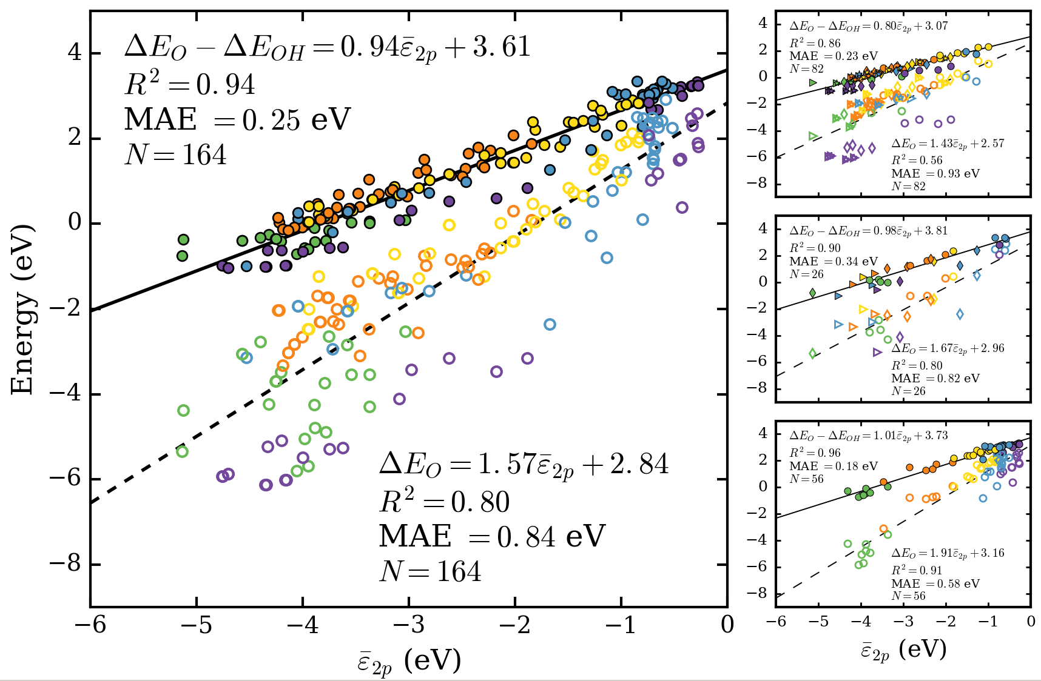

Figure S2. Analogous to Figure 1 of the main text but including the oxygen chemisorption energy relative to O2(g). Note that the perovskite structures in this study are taken from ref. [6], where calculations of bridge-site oxygen vacancies were not performed (necessary for calculating oxygen chemisorption at bridge sites). This accounts for the smaller data set analyzed in this figure compared to Figure 1.

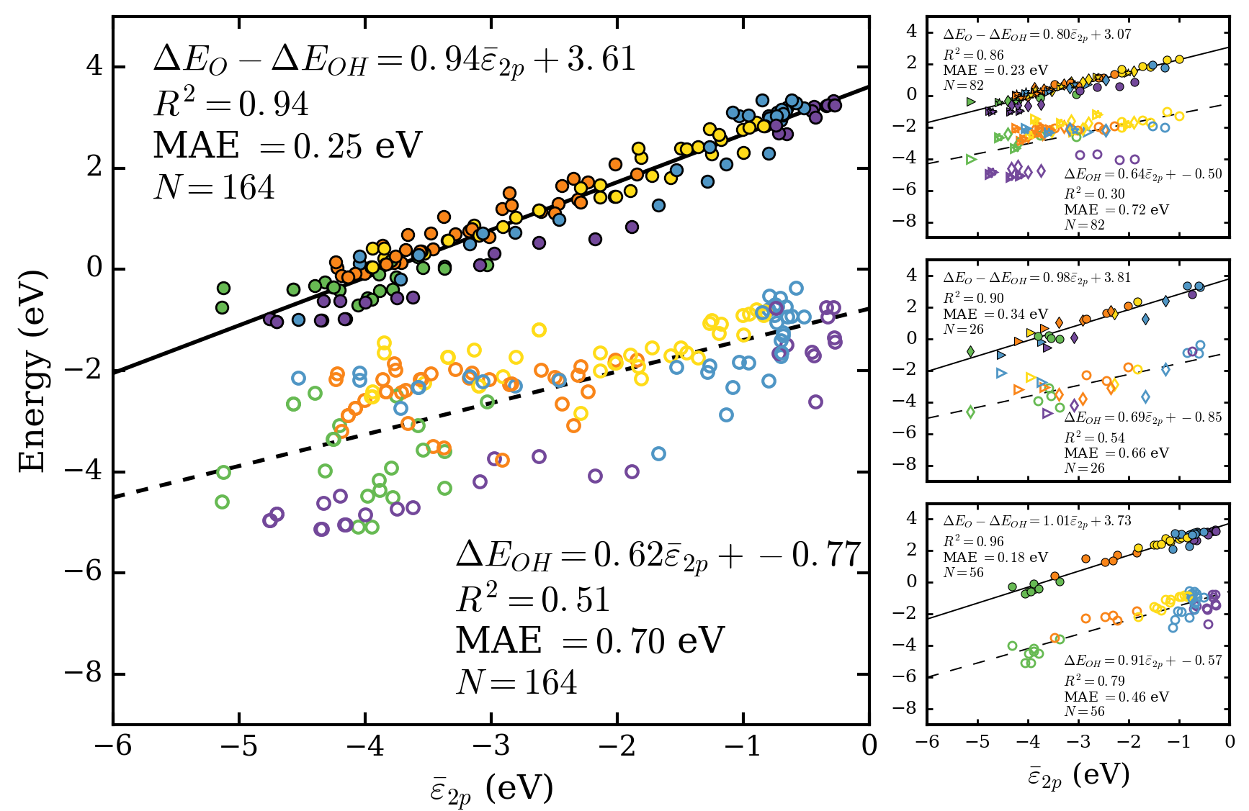

Figure S3. Analogous to Figure 1 of the main text but including the OH chemisorption energy relative to O2(g) and H2(g).

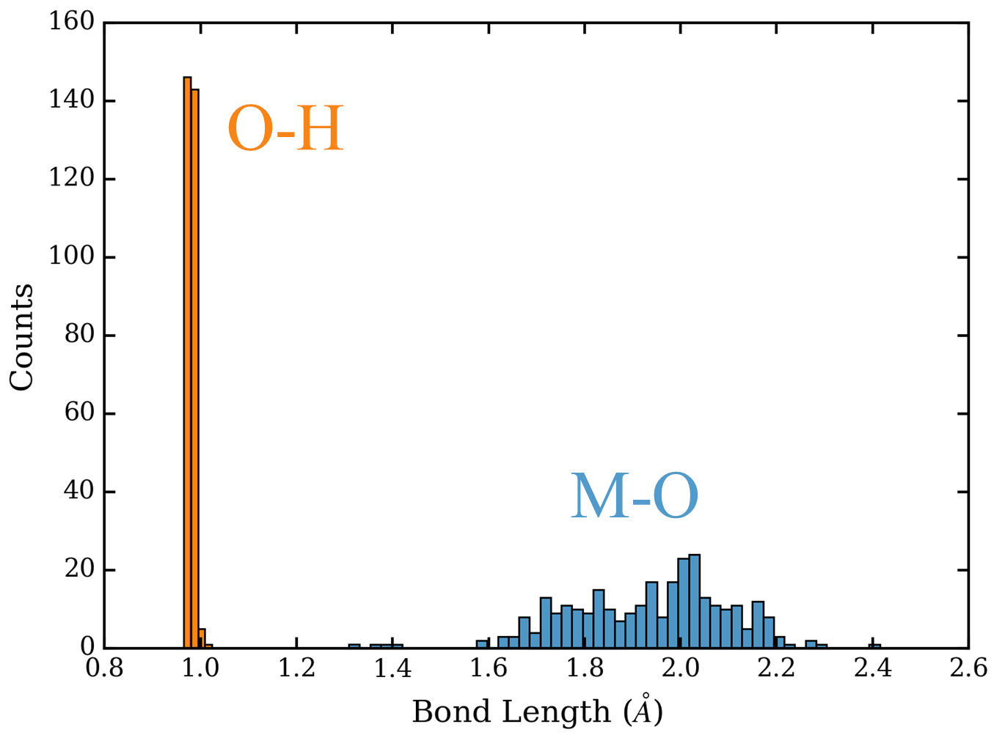

Figure S4. O-H and M-O bond lengths for the data in Figure 1 of the main text. M-O bond lengths correspond to the structure after deprotonation (O adsorbed).

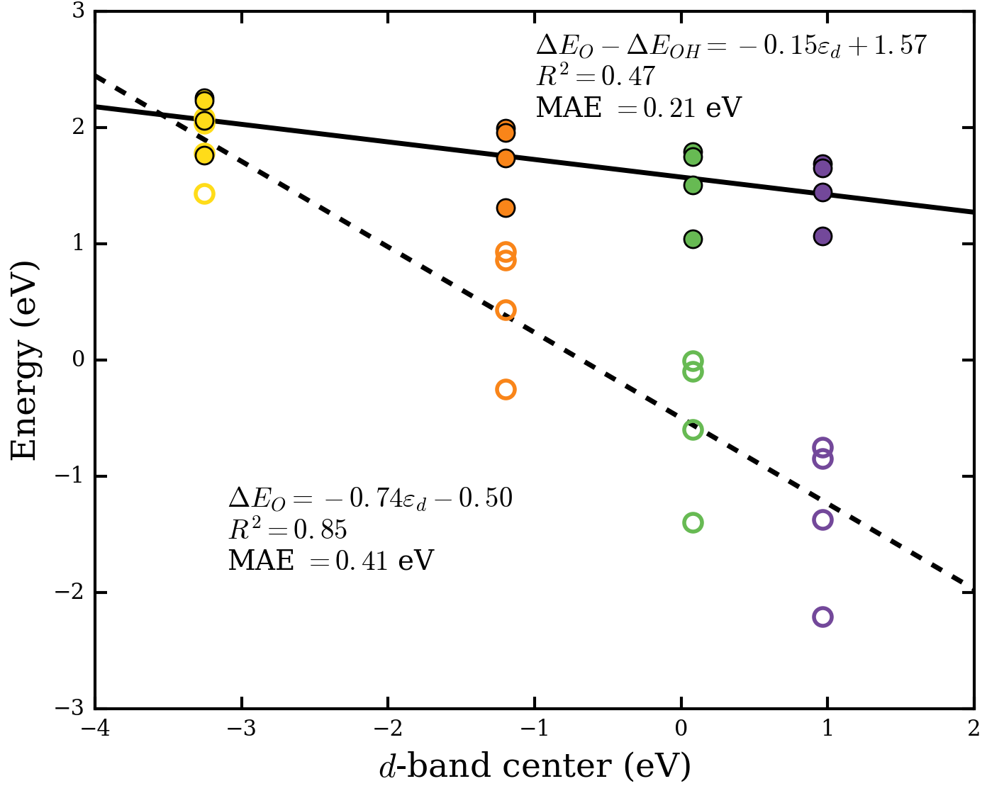

Figure S5. Correlation between the d-band center and either the oxygen chemisorption energy (unfilled) or the energy required to deprotonate surface OH (filled) for surfaces in Figure 3.

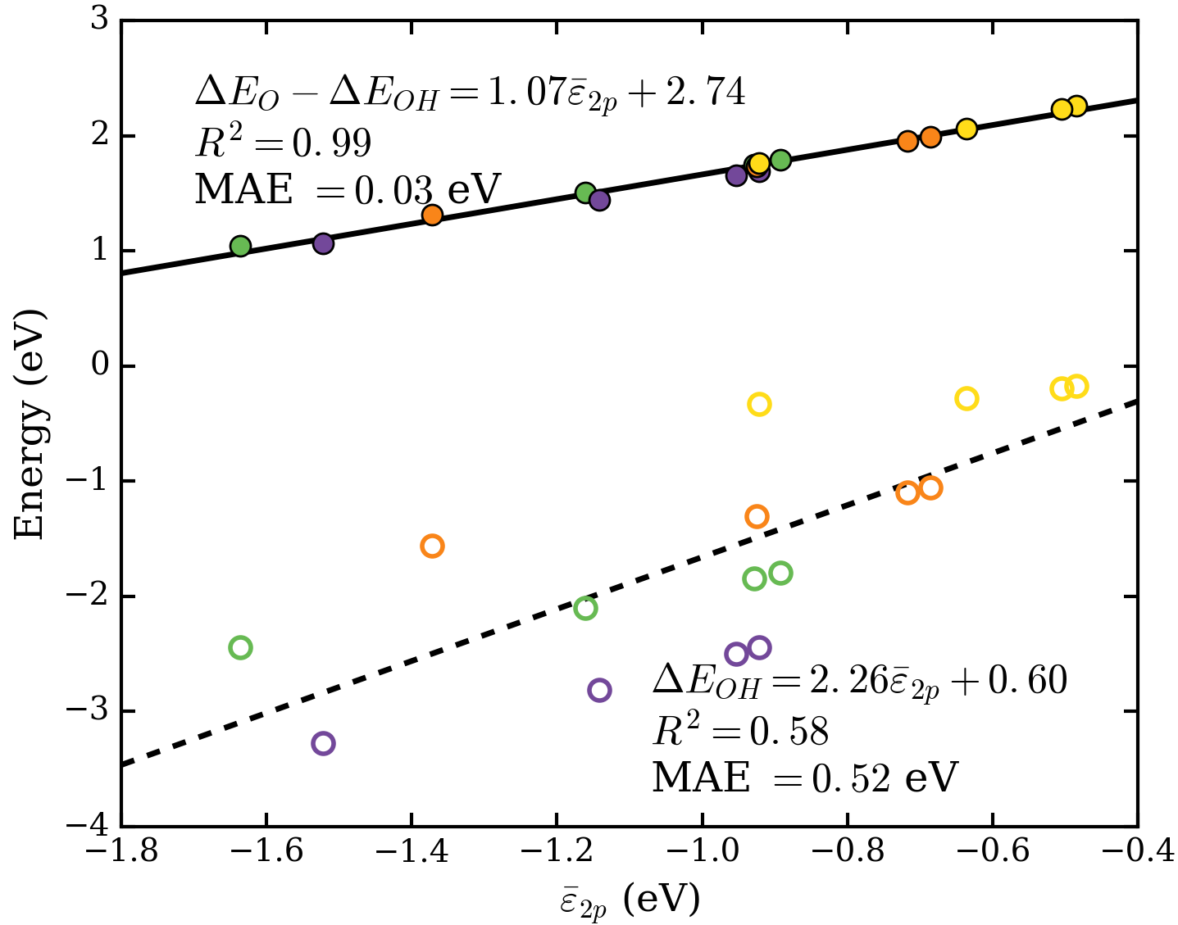

Figure S6. Correlation between either ΔEO–ΔEOH (filled) or ΔEOH (unfilled) and for all grid elements in Figure 3 of the main text.

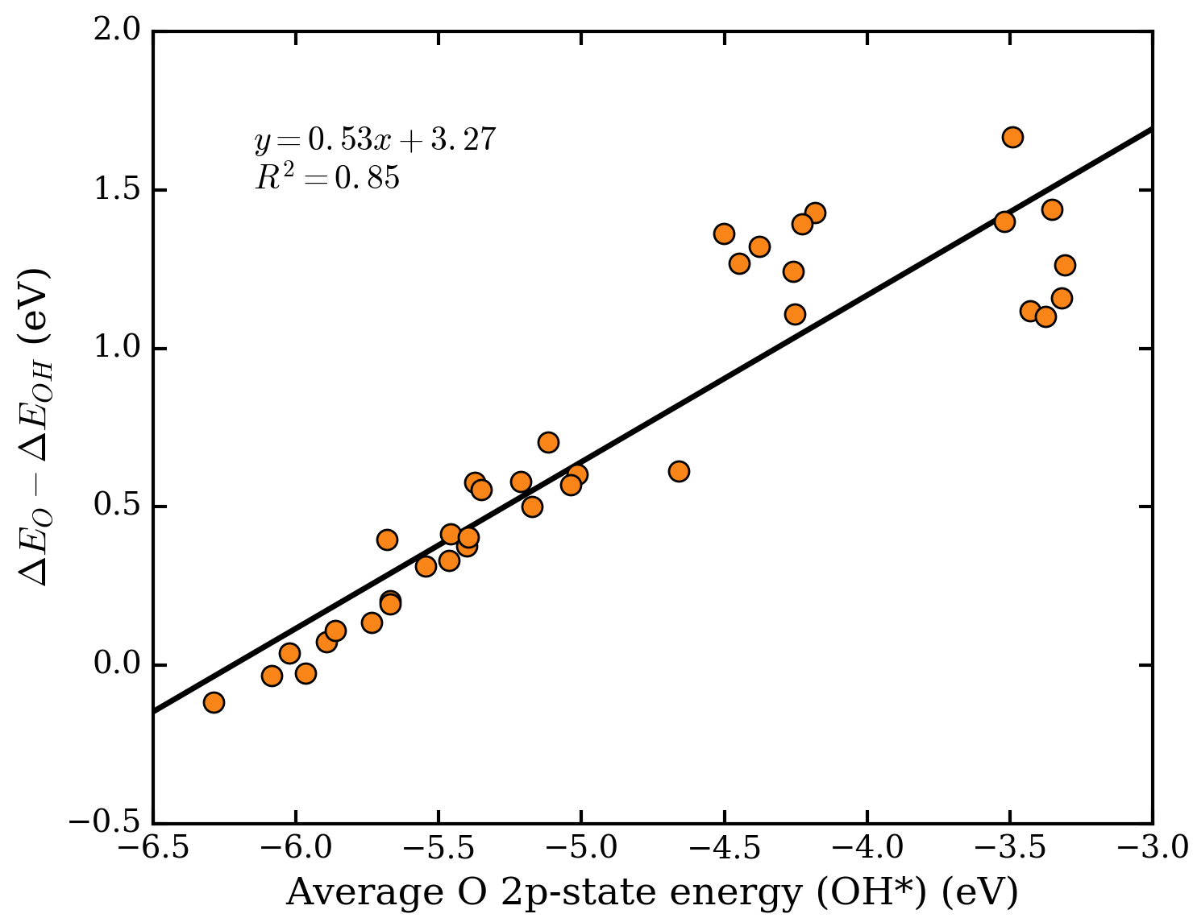

Figure S7. Correlation between the energy required to deprotonate adsorbed OH and the average 2p-state energy of oxygen in adsorbed OH for each site considered in Figure 7.

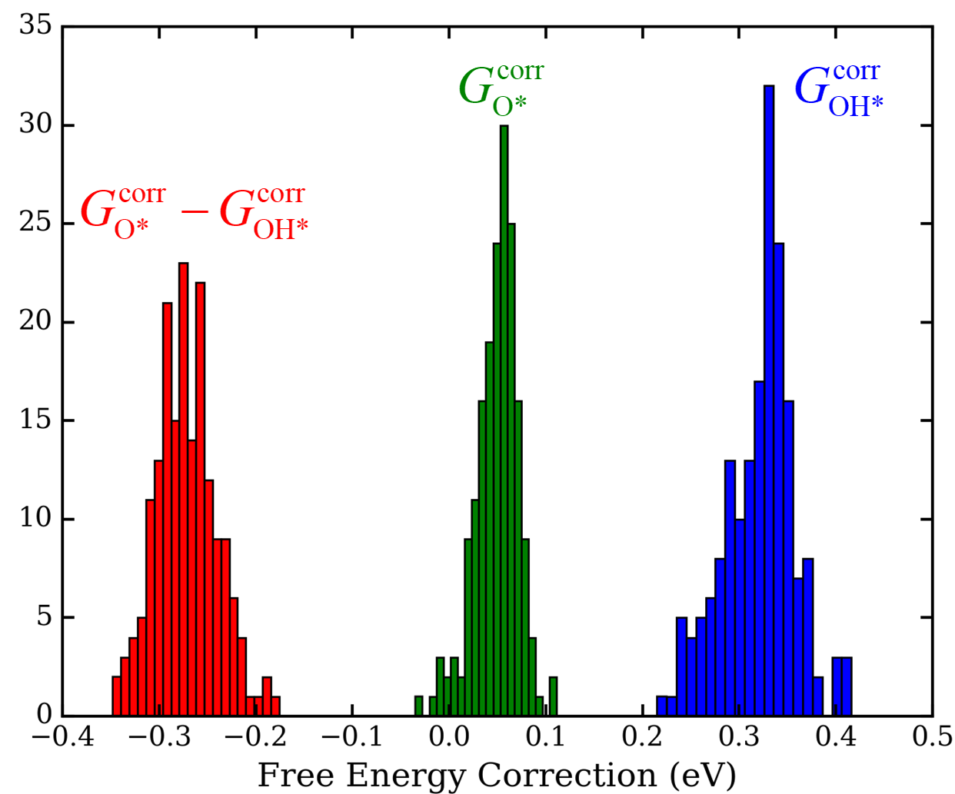

Figure S8. Histogram of free energy corrections for 178 of the data points in Figure 1 of the main text.

|  |  |  |  |  |  |
| --- | --- | --- | --- | --- | --- |
| Table S1. Raw data from Figures 1, S2, and S3. Asterisks (*) next to perovskite names indicate they were re-relaxed as explained above. FCC entries without coordination numbers indicate that O and OH were relaxed without constraints on their most stable respective sites. All energies are in units of eV. | | | | | |
| Formula | Coordination |  | Δ*E*O–Δ*E*OH | Δ*E*O | Δ*E*OH |
| Ag | 1 | -1.00 | 2.31 | 1.03 | -1.29 |
| Ag | 2 | -1.89 | 1.56 | -0.13 | -1.69 |
| Ag | 3 | -2.02 | 1.44 | -0.41 | -1.85 |
| Au | 1 | -1.25 | 2.28 | 1.28 | -1 |
| Au | 3 | -2.62 | 1.17 | -0.02 | -1.19 |
| Cd | 1 | -1.13 | 2.05 | 0.35 | -1.71 |
| Cd | 2 | -2.91 | 0.62 | -1.58 | -2.2 |
| Cd | 3 | -2.81 | 0.73 | -1.57 | -2.29 |
| Co | 1 | -2.49 | 1.11 | -1.02 | -2.13 |
| Co | 2 | -3.71 | 0.14 | -2.29 | -2.43 |
| Co | 3 | -4.08 | -0.09 | -2.83 | -2.75 |
| Cr | 3 | -4.67 | -0.37 | -3.31 | -2.94 |
| Cu | 1 | -1.57 | 1.81 | 0.10 | -1.71 |
| Cu | 2 | -2.91 | 0.84 | -1.27 | -2.11 |
| Cu | 3 | -3.10 | 0.67 | -1.62 | -2.29 |
| Fe | 1 | -3.02 | 0.65 | -1.53 | -2.18 |
| Fe | 2 | -4.00 | -0.07 | -2.65 | -2.58 |
| Fe | 3 | -4.14 | -0.15 | -3.03 | -2.88 |
| Ir | 1 | -2.60 | 1.15 | -0.84 | -1.98 |
| Ir | 2 | -3.28 | 0.71 | -1.27 | -1.97 |
| Ir | 3 | -3.77 | 0.13 | -1.73 | -1.86 |
| Mn | 1 | -3.04 | 0.09 | -2.53 | -2.62 |
| Mn | 2 | -4.20 | -0.41 | -3.48 | -3.08 |
| Mn | 3 | -4.26 | -0.35 | -3.70 | -3.35 |
| Mo | 1 | -3.48 | -0.10 | -3.07 | -2.98 |
| Nb | 1 | -2.98 | 0.36 | -4.68 | -5.04 |
| Nb | 3 | -4.38 | -0.48 | -6.57 | -6.09 |
| Ni | 1 | -2.14 | 1.43 | -0.57 | -2 |
| Ni | 2 | -3.53 | 0.32 | -1.93 | -2.25 |
| Ni | 3 | -3.96 | 0.05 | -2.47 | -2.52 |
| Os | 1 | -3.48 | 0.72 | -1.35 | -2.06 |
| Os | 2 | -3.86 | 0.48 | -1.69 | -2.17 |
| Os | 3 | -4.23 | 0.03 | -2.02 | -2.06 |
| Pb | 1 | -1.29 | 1.75 | -0.28 | -2.03 |
| Pb | 2 | -2.46 | 0.99 | -1.20 | -2.19 |
| Pd | 1 | -1.73 | 1.85 | 0.31 | -1.54 |
| Pd | 2 | -2.81 | 1.03 | -0.70 | -1.73 |
| Pd | 3 | -3.35 | 0.57 | -1.16 | -1.73 |
| Pt | 1 | -2.14 | 1.67 | 0.03 | -1.64 |
| Pt | 2 | -3.14 | 0.88 | -0.71 | -1.59 |
| Pt | 3 | -3.85 | 0.22 | -1.23 | -1.44 |
| Re | 1 | -3.75 | -0.15 | -2.65 | -2.49 |
| Re | 2 | -4.40 | -0.33 | -2.76 | -2.43 |
| Re | 3 | -4.57 | -0.40 | -3.06 | -2.66 |
| Rh | 1 | -2.29 | 1.34 | -0.58 | -1.91 |
| Rh | 2 | -3.17 | 0.75 | -1.38 | -2.14 |
| Rh | 3 | -3.56 | 0.36 | -1.81 | -2.17 |
| Ru | 1 | -3.15 | 0.80 | -1.24 | -2.04 |
| Ru | 2 | -3.68 | 0.39 | -2.00 | -2.39 |
| Ru | 3 | -3.84 | 0.11 | -2.30 | -2.41 |
| Sc | 1 | -2.18 | 0.60 | -3.47 | -4.07 |
| Sc | 2 | -4.00 | -0.65 | -5.49 | -4.84 |
| Sc | 3 | -4.34 | -1.00 | -6.13 | -5.13 |
| Sn | 1 | -1.52 | 1.52 | -0.78 | -2.3 |
| Sn | 2 | -3.17 | 0.50 | -1.61 | -2.12 |
| Sn | 3 | -4.05 | 0.12 | -1.92 | -2.05 |
| Ti | 1 | -2.98 | 0.31 | -3.42 | -3.73 |
| Ti | 2 | -4.33 | -0.62 | -5.23 | -4.61 |
| Ti | 3 | -4.76 | -0.97 | -5.92 | -4.95 |
| V | 3 | -4.79 | -0.56 | -3.35 | -2.79 |
| W | 1 | -3.50 | -0.15 | -5.06 | -4.91 |
| W | 3 | -5.13 | -0.37 | -4.37 | -4.01 |
| Y | 1 | -1.88 | 0.85 | -3.15 | -4 |
| Y | 2 | -3.75 | -0.56 | -5.29 | -4.73 |
| Y | 3 | -4.16 | -0.97 | -6.01 | -5.04 |
| Zn | 1 | -1.53 | 1.97 | 0.04 | -1.93 |
| Zn | 3 | -3.58 | 0.29 | -2.04 | -2.32 |
| Zr | 1 | -2.62 | 0.54 | -3.16 | -3.69 |
| Zr | 2 | -4.20 | -0.62 | -5.08 | -4.47 |
| Zr | 3 | -4.71 | -1.03 | -5.87 | -4.84 |
| Ag | N/A | -2.01 | 1.44 | -0.41 | -1.85 |
| Au | N/A | -2.62 | 1.17 | -0.02 | -1.19 |
| Cd | N/A | -2.91 | 0.70 | -1.60 | -2.3 |
| Co | N/A | -4.08 | -0.08 | -2.83 | -2.75 |
| Cr | N/A | -4.61 | -1.27 | -4.40 | -3.13 |
| Cu | N/A | -3.10 | 0.67 | -1.62 | -2.29 |
| Fe | N/A | -4.14 | -0.15 | -3.03 | -2.88 |
| Ir | N/A | -3.76 | 0.26 | -1.73 | -1.99 |
| Mn | N/A | -4.25 | -0.35 | -3.70 | -3.35 |
| Mo | N/A | -4.72 | -0.60 | -4.20 | -3.6 |
| Nb | N/A | -4.62 | -0.68 | -7.44 | -6.76 |
| Ni | N/A | -3.94 | 0.05 | -2.47 | -2.52 |
| Os | N/A | -4.23 | 0.14 | -2.02 | -2.17 |
| Pb | N/A | -3.07 | 0.71 | -1.50 | -2.21 |
| Pd | N/A | -3.35 | 0.57 | -1.16 | -1.73 |
| Pt | N/A | -3.85 | 0.42 | -1.23 | -1.65 |
| Re | N/A | -4.57 | -0.40 | -3.06 | -2.66 |
| Rh | N/A | -3.57 | 0.36 | -1.81 | -2.17 |
| Ru | N/A | -3.83 | 0.11 | -2.30 | -2.41 |
| Sc | N/A | -4.35 | -1.00 | -6.13 | -5.13 |
| Sn | N/A | -4.05 | 0.26 | -1.93 | -2.18 |
| Ti | N/A | -4.76 | -0.97 | -5.92 | -4.95 |
| V | N/A | -4.63 | -0.65 | -5.07 | -4.43 |
| W | N/A | -5.04 | -1.08 | -6.22 | -5.14 |
| Y | N/A | -4.17 | -0.97 | -6.01 | -5.04 |
| Zn | N/A | -3.58 | 0.29 | -2.04 | -2.32 |
| Zr | N/A | -4.70 | -1.03 | -5.87 | -4.84 |
| GeO2 | 1 | -0.85 | 3.35 | 2.51 | -0.84 |
| GeO2 | 2 | -2.53 | 0.43 | -2.81 | -3.24 |
| GeO2 | 3 | -4.53 | -0.99 | -3.13 | -2.15 |
| IrO2 | 1 | -2.44 | 1.66 | -1.00 | -2.66 |
| IrO2 | 2 | -2.91 | 1.21 | -2.56 | -3.77 |
| IrO2 | 3 | -4.63 | -0.09 | -3.05 | -2.96 |
| MoO2 | 1 | -3.58 | 0.24 | -2.84 | -3.08 |
| NbO2 | 1 | -3.55 | 0.04 | -3.53 | -3.57 |
| NbO2 | 3 | -4.75 | -1.05 | -5.11 | -4.06 |
| PbO2 | 1 | -0.58 | 3.29 | 2.92 | -0.37 |
| PbO2 | 2 | -1.27 | 2.43 | 0.53 | -1.89 |
| PbO2 | 3 | -2.32 | 1.40 | -0.21 | -1.62 |
| PtO2 | 1 | -1.83 | 2.39 | 0.47 | -1.92 |
| PtO2 | 2 | -2.29 | 1.61 | -1.24 | -2.84 |
| PtO2 | 3 | -3.94 | 0.42 | -2.00 | -2.42 |
| RhO2 | 1 | -2.02 | 2.09 | 0.31 | -1.78 |
| RhO2 | 2 | -2.35 | 1.79 | -1.30 | -3.09 |
| RhO2 | 3 | -3.67 | 0.68 | -2.36 | -3.04 |
| RuO2 | 1 | -2.84 | 1.27 | -0.98 | -2.25 |
| RuO2 | 2 | -3.38 | 1.04 | -2.48 | -3.52 |
| RuO2 | 3 | -4.19 | -0.13 | -3.32 | -3.19 |
| SnO2 | 1 | -0.62 | 3.36 | 2.43 | -0.92 |
| SnO2 | 2 | -1.67 | 1.28 | -2.36 | -3.63 |
| SnO2 | 3 | -3.72 | -0.20 | -2.94 | -2.74 |
| TaO2 | 1 | -3.37 | 0.02 | -4.29 | -4.32 |
| TaO2 | 2 | -5.14 | -0.75 | -5.34 | -4.59 |
| TaO2 | 3 | -5.94 | -1.71 | -4.79 | -3.08 |
| TiO2 | 1 | -0.74 | 2.85 | 2.08 | -0.76 |
| TiO2 | 2 | -3.09 | 0.09 | -4.11 | -4.2 |
| TiO2 | 3 | -3.62 | -0.55 | -5.25 | -4.7 |
| WO2 | 1 | -3.80 | 0.18 | -3.73 | -3.91 |
| WO2 | 3 | -5.23 | -1.38 | -3.61 | -2.23 |
| BaAgO3 | 2 | -1.37 | 2.63 | N/A | N/A |
| BaAlO3 | 2 | -1.58 | 2.43 | N/A | N/A |
| BaAsO3 | 2 | -2.13 | 2.27 | N/A | N/A |
| BaBO3 | 2 | -5.21 | -0.53 | N/A | N/A |
| BaBaO3 | 2 | -0.89 | 1.65 | N/A | N/A |
| BaCuO3 | 2 | -1.41 | 2.60 | N/A | N/A |
| BaGaO3 | 2 | -1.44 | 2.56 | N/A | N/A |
| BaGeO3 | 2 | -2.25 | 1.87 | N/A | N/A |
| BaHfO3 | 2 | -2.55 | -1.27 | N/A | N/A |
| BaHgO3 | 2 | -1.52 | 2.37 | N/A | N/A |
| BaInO3 | 2 | -1.30 | 2.69 | N/A | N/A |
| BaIrO3 | 2 | -3.29 | 0.96 | N/A | N/A |
| BaPtO3 | 2 | -2.48 | 1.85 | N/A | N/A |
| BaReO3 | 2 | -4.57 | -0.46 | N/A | N/A |
| BaScO3 | 2 | -1.06 | 2.57 | N/A | N/A |
| BaSnO3 | 2 | -2.09 | 1.49 | N/A | N/A |
| BaTaO3 | 2 | -5.04 | -1.92 | N/A | N/A |
| BaTiO3 | 2 | -2.37 | 0.87 | N/A | N/A |
| BaZrO3 | 2 | -2.46 | -1.04 | N/A | N/A |
| CaAlO3 | 1 | -0.75 | 3.04 | 2.35 | -0.7 |
| CaBiO3 | 1 | -0.80 | 2.30 | 0.10 | -2.2 |
| CaCuO3 | 1 | -1.01 | 2.76 | 1.86 | -0.91 |
| CaGaO3 | 1 | -0.66 | 3.14 | 2.40 | -0.74 |
| CaGeO3 | 1 | -0.96 | 3.06 | 1.21 | -1.84 |
| CaNbO3 | 1 | -3.98 | -0.56 | -5.04 | -4.48 |
| CaNiO3 | 1 | -1.58 | 2.36 | -0.25 | -2.61 |
| CaScO3 | 1 | -0.33 | 3.25 | 2.31 | -0.94 |
| CaSiO3 | 1 | -1.08 | 3.11 | 0.78 | -2.33 |
| CaSiO3 | 2 | -3.68 | -0.56 | N/A | N/A |
| CaTaO3 | 1 | -4.06 | -0.71 | -5.80 | -5.09 |
| CaTiO3 | 1 | -0.66 | 2.68 | 1.18 | -1.49 |
| CaYO3 | 1 | -0.27 | 3.25 | 1.81 | -1.44 |
| KBiO3 | 2 | -1.58 | 2.36 | N/A | N/A |
| KCuO3 | 2 | -1.21 | 2.72 | N/A | N/A |
| KHfO3 | 2 | -1.33 | 2.38 | N/A | N/A |
| KOsO3 | 2 | -3.90 | 0.27 | N/A | N/A |
| KRuO3 | 2 | -2.55 | 1.54 | N/A | N/A |
| KSbO3 | 2 | -2.65 | 1.24 | N/A | N/A |
| KSnO3 | 2 | -1.57 | 2.48 | N/A | N/A |
| KTaO3 | 2 | -4.55 | -1.24 | N/A | N/A |
| KTiO3 | 2 | -1.43 | 2.67 | N/A | N/A |
| KZrO3 | 2 | -1.23 | 2.45 | N/A | N/A |
| LaAlO3 | 1 | -0.65 | 3.21 | 2.27 | -0.94 |
| LaCuO3 | 1 | -0.95 | 2.82 | 1.93 | -0.88 |
| LaGaO3 | 2 | -1.89 | 2.28 | N/A | N/A |
| LaIrO3 | 1 | -2.63 | 1.41 | -2.41 | -3.82 |
| LaMgO3 | 1 | -0.28 | 3.34 | 2.60 | -0.74 |
| LaNiO3 | 1 | -1.50 | 2.39 | 0.85 | -1.55 |
| LaReO3 | 1 | -4.32 | -0.25 | -4.23 | -3.98 |
| LaTiO3 | 2 | -4.97 | -1.56 | N/A | N/A |
| LaZnO3 | 1 | -0.71 | 3.06 | 2.50 | -0.56 |
| NaHfO3 | 2 | -1.34 | 2.44 | N/A | N/A |
| NaOsO3 | 2 | -4.20 | 0.24 | N/A | N/A |
| NaSiO3 | 2 | -2.62 | 1.94 | N/A | N/A |
| NaSnO3 | 2 | -1.57 | 2.53 | N/A | N/A |
| NaTaO3 | 2 | -4.75 | -1.29 | N/A | N/A |
| NaTiO3 | 2 | -1.57 | 2.43 | N/A | N/A |
| NaZrO3 | 2 | -1.24 | 2.51 | N/A | N/A |
| SrAgO3 | 1 | -0.90 | 2.91 | 2.12 | -0.79 |
| SrAlO3 | 1 | -0.80 | 3.04 | 2.25 | -0.79 |
| SrAlO3 | 2 | -1.64 | 2.33 | N/A | N/A |
| SrAuO3 | 1 | -1.27 | 2.78 | 1.71 | -1.06 |
| SrGaO3 | 1 | -0.73 | 3.11 | 2.38 | -0.73 |
| SrGeO3 | 1 | -1.04 | 3.04 | 1.22 | -1.83 |
| SrGeO3 | 2 | -2.46 | 1.59 | N/A | N/A |
| SrHfO3 | 1 | -0.44 | 3.22 | 1.53 | -1.69 |
| SrHfO3 | 2 | -2.54 | -1.04 | N/A | N/A |
| SrIrO3 | 1 | -2.86 | 1.52 | -0.75 | -2.27 |
| SrMoO3 | 1 | -3.37 | 0.06 | -3.54 | -3.59 |
| SrNbO3 | 1 | -3.89 | -0.42 | -4.79 | -4.37 |
| SrPbO3 | 1 | -0.70 | 2.95 | 1.56 | -1.4 |
| SrPdO3 | 1 | -1.45 | 2.38 | 0.74 | -1.64 |
| SrReO3 | 1 | -3.89 | -0.09 | -4.24 | -4.16 |
| SrScO3 | 1 | -0.34 | 3.24 | 2.48 | -0.75 |
| SrSnO3 | 1 | -0.70 | 3.13 | 1.41 | -1.72 |
| SrSnO3 | 2 | -2.29 | 1.44 | N/A | N/A |
| SrTaO3 | 1 | -3.95 | -0.60 | -5.68 | -5.08 |
| SrTiO3 | 1 | -0.72 | 2.69 | 1.03 | -1.66 |
| SrTlO3 | 1 | -0.76 | 3.00 | 2.10 | -0.91 |
| SrWO3 | 1 | -3.78 | -0.39 | -4.89 | -4.5 |
| SrYO3 | 1 | -0.28 | 3.25 | 1.90 | -1.35 |
| SrZnO3 | 1 | -0.79 | 3.00 | 2.48 | -0.52 |
| SrZrO3 | 1 | -0.46 | 3.14 | 1.50 | -1.64 |
| YAlO3 | 2 | -2.35 | 1.93 | N/A | N/A |
| YRhO3 | 2 | -3.02 | 0.92 | N/A | N/A |
| CaAgO3* | 1 | -0.84 | 2.83 | 1.93 | -0.9 |
| CaAgO3* | 2 | -1.29 | 2.54 | N/A | N/A |
| CaAlO3* | 2 | -1.76 | 2.25 | N/A | N/A |
| CaAuO3* | 1 | -1.19 | 2.67 | 1.41 | -1.26 |
| CaBO3* | 1 | -1.94 | 1.91 | N/A | N/A |
| CaBaO3* | 2 | -1.13 | 1.20 | N/A | N/A |
| CaCuO3* | 2 | -1.46 | 2.48 | N/A | N/A |
| CaGaO3* | 2 | -1.60 | 2.56 | N/A | N/A |
| CaGeO3* | 2 | -2.64 | 1.13 | N/A | N/A |
| CaInO3* | 2 | -1.06 | 2.88 | N/A | N/A |
| CaIrO3* | 1 | -2.79 | 1.40 | N/A | N/A |
| CaLaO3* | 2 | -0.98 | 2.49 | N/A | N/A |
| CaPbO3* | 1 | -0.69 | 3.05 | 1.76 | -1.3 |
| CaPbO3* | 2 | -1.36 | 2.13 | N/A | N/A |
| CaReO3* | 1 | -3.92 | -0.06 | N/A | N/A |
| CaRhO3* | 1 | -2.42 | 1.66 | N/A | N/A |
| CaRhO3* | 2 | -2.51 | 1.65 | N/A | N/A |
| CaScO3* | 2 | -0.92 | 2.73 | N/A | N/A |
| CaSnO3* | 1 | -0.69 | 3.16 | 1.51 | -1.65 |
| CaSnO3* | 2 | -2.04 | 1.33 | N/A | N/A |
| CaTaO3* | 2 | -5.13 | -1.55 | N/A | N/A |
| CaTeO3* | 1 | -1.43 | 2.04 | N/A | N/A |
| CaTiO3* | 2 | -2.74 | 0.11 | N/A | N/A |
| CaTlO3* | 1 | -0.74 | 3.04 | 2.00 | -1.04 |
| CaWO3* | 1 | -4.00 | -0.49 | N/A | N/A |
| CaYO3* | 2 | -0.64 | 2.79 | N/A | N/A |
| CaZrO3* | 1 | -0.45 | 3.15 | 1.89 | -1.27 |
| CaZrO3* | 2 | -2.18 | -0.88 | N/A | N/A |
| LaAgO3* | 1 | -0.83 | 2.84 | 2.01 | -0.83 |
| LaAlO3* | 2 | -1.98 | 1.82 | N/A | N/A |
| LaAsO3* | 1 | -1.73 | 2.16 | N/A | N/A |
| LaAsO3* | 2 | -2.15 | 1.38 | N/A | N/A |
| LaAuO3* | 1 | -1.18 | 2.57 | 1.50 | -1.07 |
| LaBO3* | 2 | -1.85 | 2.02 | N/A | N/A |
| LaCaO3* | 1 | -0.43 | 3.00 | 0.39 | -2.61 |
| LaCdO3* | 1 | -0.52 | 3.19 | 2.26 | -0.93 |
| LaCoO3* | 1 | -1.85 | 1.88 | 0.09 | -1.79 |
| LaCoO3* | 2 | -2.47 | 1.44 | N/A | N/A |
| LaCuO3* | 2 | -1.87 | 1.88 | N/A | N/A |
| LaHfO3* | 1 | -2.89 | 0.01 | N/A | N/A |
| LaHgO3* | 1 | -1.02 | 2.88 | 1.43 | -1.45 |
| LaIrO3* | 2 | -3.73 | 0.81 | N/A | N/A |
| LaMgO3* | 2 | -0.98 | 2.82 | N/A | N/A |
| LaNbO3* | 1 | -4.12 | -0.94 | N/A | N/A |
| LaNiO3* | 2 | -2.26 | 1.75 | N/A | N/A |
| LaOsO3* | 1 | -3.46 | 0.41 | -3.09 | -3.5 |
| LaOsO3* | 2 | -5.14 | -0.22 | N/A | N/A |
| LaPbO3* | 1 | -0.64 | 2.65 | N/A | N/A |
| LaPdO3* | 1 | -1.36 | 2.42 | 0.67 | -1.75 |
| LaPdO3* | 2 | -2.06 | 1.60 | N/A | N/A |
| LaPtO3* | 1 | -1.81 | 2.21 | 0.05 | -2.16 |
| LaPtO3* | 2 | -3.16 | 1.07 | N/A | N/A |
| LaRhO3* | 1 | -2.23 | 1.73 | -0.68 | -2.41 |
| LaRhO3* | 2 | -3.07 | 0.92 | N/A | N/A |
| LaRuO3* | 1 | -2.47 | 1.31 | -0.87 | -2.17 |
| LaRuO3* | 2 | -3.54 | 0.52 | N/A | N/A |
| LaSiO3* | 2 | -4.26 | -0.87 | N/A | N/A |
| LaTaO3* | 1 | -4.26 | -0.94 | N/A | N/A |
| LaTaO3* | 2 | -4.80 | -1.58 | N/A | N/A |
| LaTlO3* | 1 | -0.68 | 3.07 | 1.83 | -1.24 |
| LaZnO3* | 2 | -1.78 | 2.17 | N/A | N/A |
| LaZrO3* | 1 | -3.26 | -0.30 | N/A | N/A |
| SrAgO3* | 2 | -1.23 | 2.62 | N/A | N/A |
| SrBO3* | 2 | -5.27 | -0.60 | N/A | N/A |
| SrGaO3* | 2 | -1.46 | 2.48 | N/A | N/A |
| SrIrO3* | 2 | -3.62 | 1.41 | N/A | N/A |
| SrNiO3* | 2 | -2.70 | 2.06 | N/A | N/A |
| SrPbO3* | 2 | -1.37 | 2.24 | N/A | N/A |
| SrReO3* | 2 | -4.52 | -0.45 | N/A | N/A |
| SrRhO3* | 1 | -2.27 | 1.86 | N/A | N/A |
| SrRhO3* | 2 | -2.57 | 1.46 | N/A | N/A |
| SrRuO3* | 1 | -2.31 | 1.38 | -0.70 | -2.08 |
| SrSbO3* | 1 | -1.14 | 2.09 | -0.79 | -2.87 |
| SrScO3* | 2 | -1.10 | 2.52 | N/A | N/A |
| SrSiO3* | 2 | -3.32 | 0.17 | N/A | N/A |
| SrTaO3* | 2 | -5.28 | -2.06 | N/A | N/A |
| SrTiO3* | 2 | -2.51 | 0.18 | N/A | N/A |
| SrTlO3* | 2 | -1.07 | 2.62 | N/A | N/A |
| SrYO3* | 2 | -0.70 | 2.81 | N/A | N/A |
| SrZnO3* | 2 | -1.43 | 2.50 | N/A | N/A |
| SrZrO3* | 2 | -2.46 | -0.89 | N/A | N/A |

|  |  |  |  |  |  |
| --- | --- | --- | --- | --- | --- |
| Table S2. Raw data from Figures 5 and S6. Bond lengths are in units of Å and all energies are in units of eV. | | | | | |
| Formula | M-O Length |  | Δ*E*O–Δ*E*OH | Δ*E*O | Δ*E*OH |
| Au | 2.08 | -0.92 | 1.76 | 1.43 | -0.33 |
| Au | 2.25 | -0.64 | 2.06 | 1.78 | -0.28 |
| Au | 2.36 | -0.51 | 2.23 | 2.04 | -0.19 |
| Au | 2.38 | -0.48 | 2.26 | 2.08 | -0.18 |
| Mo | 2.08 | -1.64 | 1.04 | -1.39 | -2.43 |
| Mo | 2.25 | -1.16 | 1.5 | -0.6 | -2.1 |
| Mo | 2.36 | -0.93 | 1.75 | -0.09 | -1.84 |
| Mo | 2.38 | -0.89 | 1.79 | -0.01 | -1.8 |
| Ru | 2.08 | -1.37 | 1.31 | -0.25 | -1.56 |
| Ru | 2.25 | -0.92 | 1.74 | 0.43 | -1.31 |
| Ru | 2.36 | -0.72 | 1.96 | 0.86 | -1.1 |
| Ru | 2.38 | -0.69 | 1.99 | 0.94 | -1.05 |
| Ti | 2.08 | -1.52 | 1.07 | -2.21 | -3.28 |
| Ti | 2.25 | -1.14 | 1.44 | -1.37 | -2.81 |
| Ti | 2.36 | -0.95 | 1.65 | -0.85 | -2.5 |
| Ti | 2.38 | -0.92 | 1.69 | -0.75 | -2.44 |

|  |  |  |  |  |  |
| --- | --- | --- | --- | --- | --- |
| Table S3. Raw data from Figure 6. Bond lengths are in units of Å and all energies are in units of eV. | | | | | |
| Formula | M-O Length |  | Δ*E*O–Δ*E*OH | Δ*E*O | Δ*E*OH |
| Ti | 1.22 | -7.07 | -3.14 | 5.25 | 8.39 |
| Ti | 1.24 | -6.84 | -2.98 | 4.24 | 7.22 |
| Ti | 1.26 | -6.61 | -2.8 | 3.32 | 6.12 |
| Ti | 1.28 | -6.39 | -2.63 | 2.49 | 5.12 |
| Ti | 1.3 | -6.18 | -2.46 | 1.75 | 4.21 |
| Ti | 1.32 | -5.97 | -2.3 | 1.07 | 3.37 |
| Ti | 1.34 | -5.77 | -2.14 | 0.46 | 2.6 |
| Ti | 1.36 | -5.57 | -1.99 | -0.08 | 1.91 |
| Ti | 1.38 | -5.38 | -1.84 | -0.57 | 1.27 |
| Ti | 1.4 | -5.19 | -1.7 | -1.01 | 0.69 |
| Ti | 1.42 | -5.01 | -1.56 | -1.4 | 0.16 |
| Ti | 1.44 | -4.84 | -1.43 | -1.74 | -0.31 |
| Ti | 1.46 | -4.67 | -1.3 | -2.04 | -0.74 |
| Ti | 1.48 | -4.51 | -1.18 | -2.31 | -1.13 |
| Ti | 1.5 | -4.35 | -1.07 | -2.54 | -1.47 |
| Ti | 1.52 | -4.2 | -0.95 | -2.74 | -1.79 |
| Ti | 1.54 | -4.05 | -0.85 | -2.91 | -2.06 |
| Ti | 1.56 | -3.91 | -0.74 | -3.05 | -2.31 |
| Ti | 1.58 | -3.77 | -0.64 | -3.17 | -2.53 |
| Ti | 1.6 | -3.64 | -0.55 | -3.26 | -2.71 |
| Ti | 1.62 | -3.51 | -0.45 | -3.34 | -2.89 |
| Ti | 1.64 | -3.39 | -0.37 | -3.39 | -3.02 |
| Ti | 1.66 | -3.27 | -0.28 | -3.43 | -3.15 |
| Ti | 1.68 | -3.15 | -0.19 | -3.46 | -3.27 |
| Ti | 1.7 | -3.04 | -0.11 | -3.46 | -3.35 |
| Ti | 1.72 | -2.93 | -0.03 | -3.46 | -3.43 |
| Ti | 1.74 | -2.82 | 0.04 | -3.44 | -3.48 |
| Ti | 1.76 | -2.72 | 0.12 | -3.42 | -3.54 |
| Ti | 1.78 | -2.62 | 0.19 | -3.38 | -3.57 |
| Ti | 1.8 | -2.52 | 0.26 | -3.34 | -3.6 |
| Ti | 1.82 | -2.43 | 0.33 | -3.28 | -3.61 |
| Ti | 1.84 | -2.34 | 0.39 | -3.23 | -3.62 |
| Ti | 1.86 | -2.26 | 0.46 | -3.16 | -3.62 |
| Ti | 1.88 | -2.18 | 0.52 | -3.09 | -3.61 |
| Ti | 1.9 | -2.1 | 0.58 | -3.01 | -3.59 |
| Ti | 1.92 | -2.02 | 0.64 | -2.94 | -3.58 |
| Ti | 1.94 | -1.95 | 0.7 | -2.85 | -3.55 |
| Ti | 1.96 | -1.88 | 0.75 | -2.77 | -3.52 |
| Ti | 1.98 | -1.82 | 0.81 | -2.68 | -3.49 |
| Ti | 2 | -1.75 | 0.86 | -2.59 | -3.45 |
| Ti | 2.02 | -1.69 | 0.92 | -2.49 | -3.41 |
| Ti | 2.04 | -1.63 | 0.97 | -2.4 | -3.37 |
| Ti | 2.06 | -1.58 | 1.02 | -2.3 | -3.32 |
| Ti | 2.08 | -1.52 | 1.07 | -2.21 | -3.28 |
| Ti | 2.1 | -1.47 | 1.11 | -2.11 | -3.22 |
| Ti | 2.12 | -1.42 | 1.16 | -2.01 | -3.17 |
| Ti | 2.14 | -1.37 | 1.21 | -1.91 | -3.12 |
| Ti | 2.16 | -1.33 | 1.25 | -1.81 | -3.06 |
| Ti | 2.18 | -1.28 | 1.3 | -1.71 | -3.01 |
| Ti | 2.2 | -1.24 | 1.34 | -1.61 | -2.95 |
| Ti | 2.22 | -1.2 | 1.38 | -1.52 | -2.9 |
| Ti | 2.24 | -1.16 | 1.42 | -1.42 | -2.84 |
| Ti | 2.25 | -1.14 | 1.44 | -1.37 | -2.81 |
| Ti | 2.26 | -1.12 | 1.46 | -1.32 | -2.78 |
| Ti | 2.28 | -1.09 | 1.5 | -1.22 | -2.72 |
| Ti | 2.3 | -1.05 | 1.54 | -1.13 | -2.67 |
| Ti | 2.32 | -1.02 | 1.58 | -1.03 | -2.61 |
| Ti | 2.34 | -0.98 | 1.62 | -0.94 | -2.56 |
| Ti | 2.36 | -0.95 | 1.65 | -0.85 | -2.5 |
| Ti | 2.38 | -0.92 | 1.69 | -0.75 | -2.44 |
| Ti | 2.4 | -0.89 | 1.72 | -0.66 | -2.38 |
| Ti | 2.42 | -0.86 | 1.76 | -0.57 | -2.33 |
| Ti | 2.44 | -0.84 | 1.79 | -0.48 | -2.27 |
| Ti | 2.46 | -0.81 | 1.82 | -0.39 | -2.21 |
| Ti | 2.48 | -0.78 | 1.86 | -0.31 | -2.17 |
| Ti | 2.5 | -0.76 | 1.89 | -0.22 | -2.11 |

|  |  |  |  |  |
| --- | --- | --- | --- | --- |
| Table S4. Raw data from Figure 7. Oxygen sites are indexed based on below cube file (zero-based indexing). The asterisk indicates that atom was used as reference in Figure 7. N/A values indicate that either H could not be stabilized at that site or that significant distortion occurred upon vacancy formation. All energies are in units of eV. | | | | |
| Atom Index |  | Δ*E*O–Δ*E*OH | Δ*E*O | Δ*E*OH |
| 9 | -3.98 | 0.04 | -3.63 | -3.67 |
| 15 | -3.29 | 1.11 | N/A | N/A |
| 16 | -3.69 | 0.5 | -2.67 | -3.17 |
| 17 | -4.05 | 0.33 | -3.18 | -3.51 |
| 18 | -4.05 | 0.31 | -3.37 | -3.68 |
| 21 | -3.02 | 1.12 | -0.87 | -1.99 |
| 22 | -2.84 | 1.44 | -0.71 | -2.15 |
| 23 | -3.59 | 0.7 | -1.8 | -2.5 |
| 24 | -3.8 | 0.58 | -2.56 | -3.14 |
| 34 | -3.5 | N/A | -3.62 | N/A |
| 40* | -2.95 | 1.26 | -0.84 | -2.1 |
| 41 | -3.5 | 0.6 | -2.37 | -2.97 |
| 42 | -4.03 | 0.4 | -2.74 | -3.14 |
| 43 | -3.89 | 0.58 | -3.12 | -3.7 |
| 45 | -3.18 | 1.16 | -0.71 | -1.87 |
| 46 | -2.98 | 1.43 | -0.99 | -2.42 |
| 47 | -4.01 | 0.38 | -2.28 | -2.66 |
| 57 | -4.07 | -0.02 | -3.27 | -3.25 |
| 63 | -3.01 | 1.1 | -0.9 | -2 |
| 64 | -3.62 | N/A | N/A | N/A |
| 65 | -3.81 | 0.41 | -2.36 | -2.77 |
| 66 | -3.83 | 0.55 | -2.66 | -3.21 |
| 68 | -2.72 | 1.67 | -0.24 | -1.91 |
| 69 | -3.04 | 1.39 | -0.83 | -2.22 |
| 70 | -3.6 | 0.57 | N/A | N/A |
| 75 | -3.95 | 0.2 | -2.96 | -3.16 |
| 76 | -4.05 | 0.07 | -3.52 | -3.59 |
| 77 | -4.04 | -0.12 | -3.49 | -3.37 |
| 79 | -3.43 | 1.27 | -2.1 | -3.37 |
| 84 | -3.2 | N/A | -2.76 | N/A |
| 85 | -4.07 | 0.13 | -3.45 | -3.58 |
| 86 | -4.05 | -0.03 | -3.48 | -3.45 |
| 88 | -3.2 | 1.36 | -1.99 | -3.35 |
| 93 | -3.7 | 0.4 | -2.4 | -2.8 |
| 94 | -4.06 | 0.19 | -3.41 | -3.6 |
| 95 | -4 | 0.11 | -3.52 | -3.63 |
| 97 | -3.12 | 1.32 | -1.47 | -2.79 |
| 98 | -3.43 | 1.24 | N/A | N/A |
| 99 | -2.97 | 1.4 | -0.34 | -1.74 |

Cube file from ASE, written on Thu Jul 26 11:14:17 2018

OUTER LOOP: X, MIDDLE LOOP: Y, INNER LOOP: Z

102 0.000000 0.000000 0.000000

2 9.124825 0.000000 -3.041608

2 -6.083217 8.883757 0.000000

2 0.000000 0.000000 24.599318

8 0.000000 0.000000 0.000000 10.190559

44 0.000000 6.083217 5.922504 12.556670

44 0.000000 0.000000 2.961252 12.556670

8 0.000000 6.083217 5.922504 16.273776

8 0.000000 0.000000 5.922504 14.922782

8 0.000000 8.449329 2.961252 12.556670

8 0.000000 3.717105 2.961252 12.556670

44 0.000000 0.000000 5.922504 18.639887

44 0.000000 6.083217 2.961252 18.639887

8 0.000000 0.020169 5.936628 22.346910

8 0.000000 6.083217 5.922504 21.005999

8 0.000000 2.366112 2.961252 18.639887

8 0.000000 -2.366112 2.961252 18.639887

44 0.000000 6.104394 5.835716 24.800288

44 0.000000 0.009099 2.969111 24.732849

8 0.000000 6.256361 5.469989 28.369509

8 0.000000 0.004462 5.902492 27.114457

8 0.000000 8.476165 2.884043 24.615430

8 0.000000 3.711831 2.920523 24.666082

44 0.000000 0.094800 6.234430 30.962466

44 0.000000 6.247030 3.085939 31.035363

8 0.000000 0.227972 5.804613 34.117762

8 0.000000 6.151017 4.811721 33.731556

8 0.000000 2.463114 3.039631 30.528411

8 0.000000 -2.275504 2.960901 30.724514

8 0.000000 0.000000 5.922504 10.190559

44 0.000000 6.083217 11.845009 12.556670

44 0.000000 0.000000 8.883757 12.556670

8 0.000000 6.083217 11.845009 16.273776

8 0.000000 0.000000 11.845009 14.922782

8 0.000000 8.449329 8.883757 12.556670

8 0.000000 3.717105 8.883757 12.556670

44 0.000000 0.000000 11.845009 18.639887

44 0.000000 6.083217 8.883757 18.639887

8 0.000000 0.023146 11.863051 22.355459

8 0.000000 6.083217 11.845009 21.005999

8 0.000000 2.366112 8.883757 18.639887

8 0.000000 -2.366112 8.883757 18.639887

44 0.000000 6.112012 11.856737 24.989845

44 0.000000 0.001830 8.919087 24.737122

8 0.000000 6.306084 12.077591 28.173266

8 0.000000 -0.020637 11.855499 26.970701

8 0.000000 8.395232 8.867458 24.707688

8 0.000000 3.745397 8.875580 24.793638

44 0.000000 0.009882 12.017943 31.323039

8 0.000000 -0.351290 11.798068 34.465874

8 0.000000 2.235190 9.149101 30.563128

8 0.000000 -2.340488 8.965006 30.653366

8 0.000000 0.000000 11.845009 10.190559

44 0.000000 6.083217 17.767513 12.556670

44 0.000000 0.000000 14.806261 12.556670

8 0.000000 6.083217 17.767513 16.273776

8 0.000000 0.000000 17.767513 14.922782

8 0.000000 8.449329 14.806261 12.556670

8 0.000000 3.717105 14.806261 12.556670

44 0.000000 0.000000 17.767513 18.639887

44 0.000000 6.083217 14.806261 18.639887

8 0.000000 0.016819 17.783514 22.308114

8 0.000000 6.083217 17.767513 21.005999

8 0.000000 2.366112 14.806261 18.639887

8 0.000000 -2.366112 14.806261 18.639887

44 0.000000 6.155716 17.875977 24.905536

44 0.000000 -0.005702 14.830220 24.738954

8 0.000000 6.574743 17.655211 28.061093

8 0.000000 0.046879 17.749611 27.098218

8 0.000000 8.463144 14.784980 24.388673

8 0.000000 3.736955 14.877155 24.661872

44 0.000000 0.248246 18.099669 31.102622

8 0.000000 -0.386279 17.517187 34.225798

8 0.000000 2.185922 14.695701 30.895549

8 0.000000 -2.347202 14.744216 30.521899

8 0.000000 12.166434 0.000000 10.190559

44 0.000000 12.166434 2.961252 12.556670

8 0.000000 12.166434 5.922504 14.922782

44 0.000000 12.176122 5.907922 18.622178

8 0.000000 12.171254 5.948017 22.293503

8 0.000000 14.549143 2.957047 18.632685

8 0.000000 9.811294 2.961911 18.642284

44 0.000000 12.205271 2.958366 24.714385

8 0.000000 12.202331 5.937506 26.743986

8 0.000000 12.166434 5.922504 10.190559

44 0.000000 12.166434 8.883757 12.556670

8 0.000000 12.166434 11.845009 14.922782

44 0.000000 12.170339 11.812498 18.587515

8 0.000000 12.136916 11.742017 22.240918

8 0.000000 14.546013 8.866729 18.593062

8 0.000000 9.799578 8.863360 18.592448

44 0.000000 12.128195 8.904981 24.776938

8 0.000000 12.154481 11.844355 26.786672

8 0.000000 12.166434 11.845009 10.190559

44 0.000000 12.166434 14.806261 12.556670

8 0.000000 12.166434 17.767513 14.922782

44 0.000000 12.176483 17.739363 18.597593

8 0.000000 12.184264 17.649043 22.216272

8 0.000000 14.536401 14.784557 18.589869

8 0.000000 9.801092 14.790487 18.581268

44 0.000000 12.187318 14.809104 24.610368

8 0.000000 12.167029 17.619792 26.758928

8 0.000000 9.848146 2.688277 30.638296

8 0.000000 2.896729 19.874233 30.866190

8 0.000000 0.000000 -0.000000 14.922782

8 0.000000 6.083217 -0.000000 16.273776

1.000000e+00

1.000000e+00

1.000000e+00

1.000000e+00

1.000000e+00

1.000000e+00

1.000000e+00

1.000000e+00

**References**

[1] P. Giannozzi, S. Baroni, N. Bonini, M. Calandra, R. Car, C. Cavazzoni, D. Ceresoli, G.L. Chiarotti, M. Cococcioni, I. Dabo, A. Dal Corso, S. de Gironcoli, S. Fabris, G. Fratesi, R. Gebauer, U. Gerstmann, C. Gougoussis, A. Kokalj, M. Lazzeri, L. Martin-Samos, N. Marzari, F. Mauri, R. Mazzarello, S. Paolini, A. Pasquarello, L. Paulatto, C. Sbraccia, S. Scandolo, G. Sclauzero, A.P. Seitsonen, A. Smogunov, P. Umari, R.M. Wentzcovitch, QUANTUM ESPRESSO: a modular and open-source software project for quantum simulations of materials., J. Phys. Condens. Matter. 21 (2009) 395502. doi:10.1088/0953-8984/21/39/395502.

[2] S.R. Bahn, K.W. Jacobsen, An object-oriented scripting interface to a legacy electronic structure code, Comput. Sci. Eng. 4 (2002) 56–66. doi:10.1109/5992.998641.

[3] J. Wellendorff, K.T. Lundgaard, A. Møgelhøj, V. Petzold, D.D. Landis, J.K. Nørskov, T. Bligaard, K.W. Jacobsen, Density functionals for surface science: Exchange-correlation model development with Bayesian error estimation, Phys. Rev. B. 85 (2012) 235149. doi:10.1103/PhysRevB.85.235149.

[4] K.F. Garrity, J.W. Bennett, K.M. Rabe, D. Vanderbilt, Pseudopotentials for high-throughput DFT calculations, Comput. Mater. Sci. 81 (2014) 446–452. doi:10.1016/j.commatsci.2013.08.053.

[5] C.F. Dickens, J.K. Nørskov, A Theoretical Investigation into the Role of Surface Defects for Oxygen Evolution on RuO 2, J. Phys. Chem. C. 121 (2017) 18516–18524. doi:10.1021/acs.jpcc.7b03481.

[6] J.H. Montoya, A.D. Doyle, J.K. Nørskov, A. Vojvodic, Trends in adsorption of electrocatalytic water splitting intermediates on cubic ABO 3 oxides, Phys. Chem. Chem. Phys. 20 (2018) 3813–3818. doi:10.1039/C7CP06539F.

[7] B. Hammer, L. Hansen, J. Nørskov, Improved adsorption energetics within density-functional theory using revised Perdew-Burke-Ernzerhof functionals, Phys. Rev. B. 59 (1999) 7413–7421. doi:10.1103/PhysRevB.59.7413.

[8] Catalysis-Hub, (2018). https://www.catalysis-hub.org/publications/DickensElectronic2018.