Studying and Benchmarking ASCON Cryptography
Raul Garcia, David Snyder, Ricardo Pereyra, Louis Turriaga

ECE Department, California State Polytechnic University, Pomona

Abstract– This paper examines ASCON cryptography implementation and benchmarking by power consumption. Once the cryptography algorithm was implemented onto ESP32, Microblaze, and MEGA architectures. We used UART transcription to display our results. We then viewed the power consumption and other metrics to examine the performance of ASCON encryption, and compared the performance between the three methods.

Keywords– ASCON, Microblaze, ESP32, MEGA, encryption, decryption, performance metrics

- Introduction
ASCON is a lightweight encryption and hashing algorithm that utilizes sponge construction, which takes an input of any bit length and outputs a bit stream of any desired length [1]. It first initializes an initial state of the cipher using a key, nonce, and other parameters. It then handles any additional data that isn’t encrypted but needs to be authenticated. This step ensures that the integrity of non-confidential data is maintained alongside the encrypted data. To encrypt the data, the algorithm uses the initialized state, and it decrypts by converting the ciphered text back to plaintext, providing a bidirectional process

to the algorithm [2].
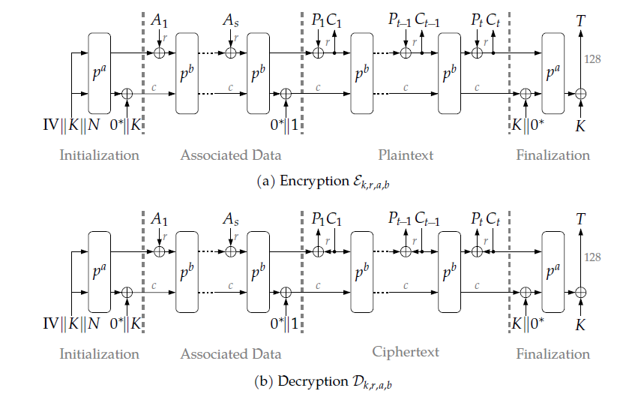
Fig. 1 ASCON Encryption Schematic
This encryption method is meant to be easy to implement and scalable, which is why this paper will examine its performance with the usage of various architectures. This process includes the implementation of the algorithm, defining what performance metrics we will use, and testing these architectures.

- Implementation
Our implementation for the Nexys is different from the ESP32 and the Arduino Mega. The ESP32 and Mega are implemented with the ability to take a user input message that will be encrypted and decrypted. The message is input as a string for the program in these boards. The Nexys program is different and takes a hard coded message that is in hex instead. The ESP32 and Mega implementations are much more comparable than the Nexys. These boards use the US preamble as the input message to encrypt and decrypt.

- Microblaze
The first architecture that we implemented the ASCON algorithm to was the 64-bit Microblaze processor with a 128 kB memory size onto the Nexy A7 100T. Microblaze is a type of microprocessor core that is primarily used for FPGAs, which consists of a RISC and Harvard architecture [3]. The Nexys A7 100T was used for this implementation as mentioned before, which has a system clock frequency of 100 MHz. After implementing the Microblaze to the Nexys FPGA, we recorded the number of flip flops, look up tables, and BRAM count used in the implementation according to the Vivado software.
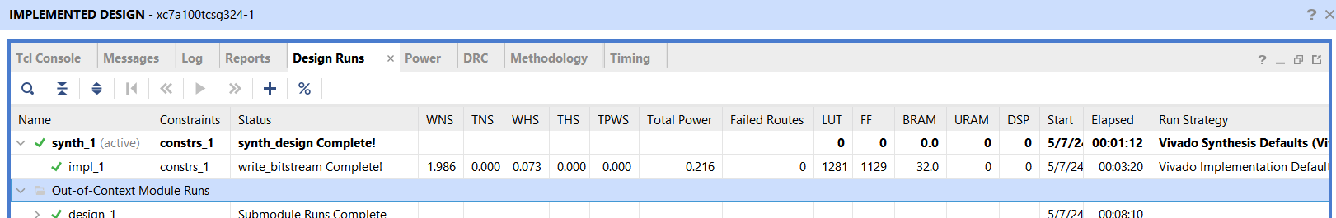
Fig. 2 Microblaze Implemented Design Run Data
The Ascon algorithm was then programmed onto the FPGA using Vitis IDE. The algorithm was coded in C for this implementation. The C program was reduced to 32-bit variables instead of 64-bit variables since the microblaze processor could not handle 64-bit variables during test runs.
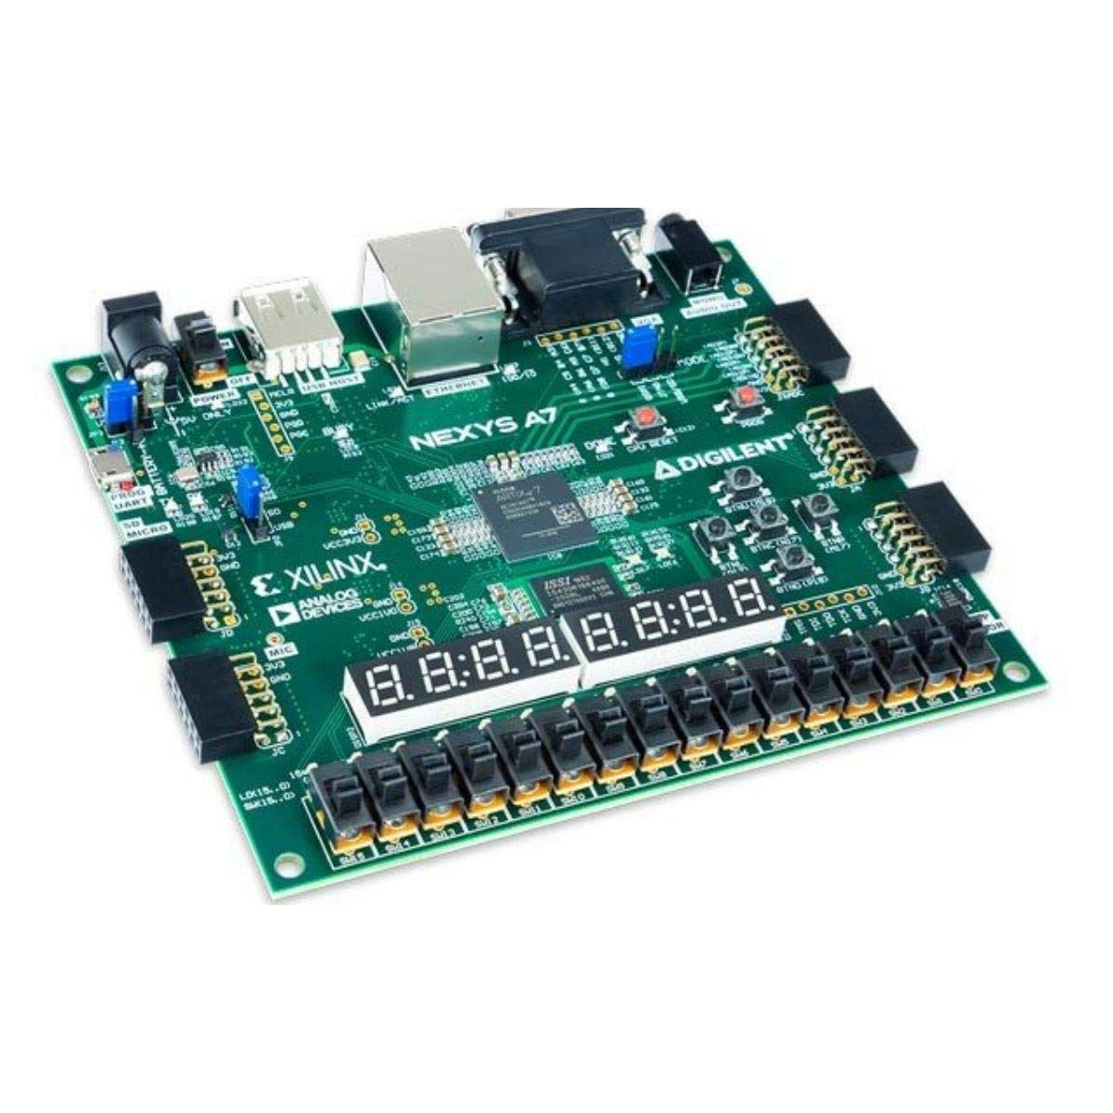
Fig. 6 Nexys A7 100T

- MEGA
The Arduino MEGA 2560 was the next board that we implemented the ASCON algorithm to. Running at 16 MHz, the board was tested to encrypt and decrypt a message, and the time to perform both tasks was measured.
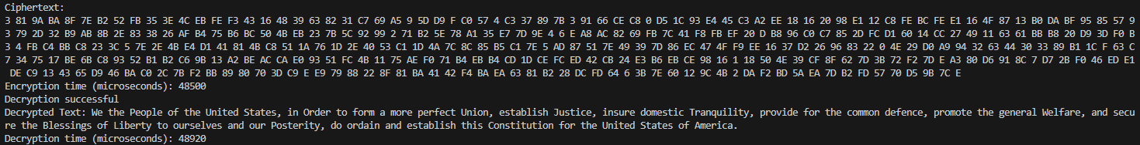
Fig. 4 MEGA 2560 Algorithm Test

From the test, we observed an encryption time of 48500 microseconds and a decryption time of 48920 microseconds (0.0485 seconds and 0.0489 seconds respectively).
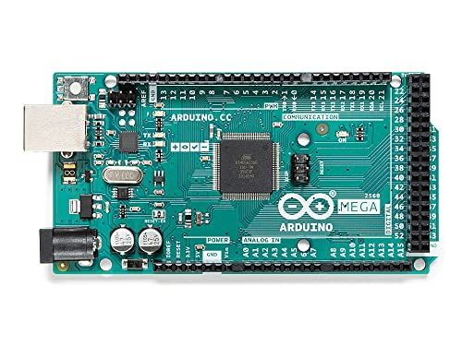
Fig.5 Arduino Mega

- ESP32
The final board that we used the ASCON algorithm with was the ESP32 microcontroller, which runs at 240 MHz. After implementation, the same message used in the Arduino MEGA 2560 test was sent for encryption and decryption, and the times were recorded. The encryption time was 518 microseconds, and the decryption time was 428 microseconds (0.000518 seconds and 0.000428 seconds respectively), magnitudes faster than the Arduino MEGA 2560.
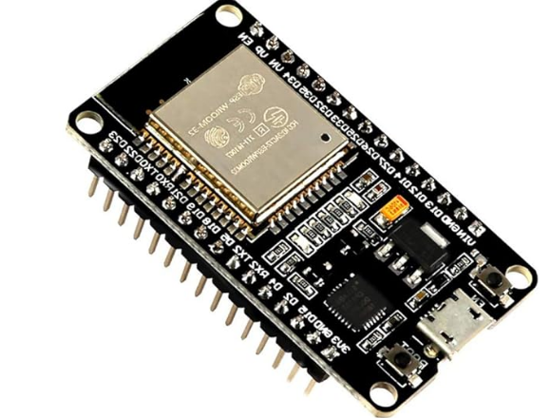
Fig. 4 ESP32

- Benchmarking
To analyze the performance of our boards, we needed to define what metrics we will be comparing to see which is the best for ASCON implementation and usage. We ultimately decided that the power consumption is what we will be examining to determine which architecture is best for this algorithm. The power measurements were taken using a USB wattmeter.

- Microblaze
After encrypting and decrypting a 160 bit message, the following data was measured:

Idle (A) | Program (A) | V | Idle Power (W) | Program Power (W)
0.215 | 0.21 | 5 | 1.075 | 1.05

We define the board being idle as the board loaded with the microblaze processor, but with no program loaded at all.
The ‘program’ measurement is the current measured with the program loaded onto the board.

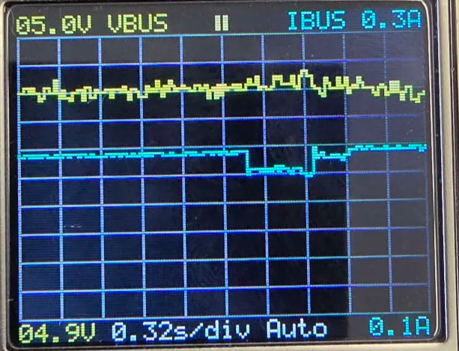
Fig. 3 Nexys Power Measurement

Shown in figure 3 is the scope output measured when the board is running the Ascon program. The program encrypted and decrypted a 160 bit message in this case. The dip in the current (blue line) is the current when the program was running. From the current measurement after encrypting and decrypting a 160 bit message, we can assume that the time for the program to encrypt and decrypt is about 0.5344 seconds.
This value is important as well because we were unable to measure the execution time of the program using the microblaze processor. We will assume that this value is also a good estimate of the execution time of the ASCON program on the board loaded with Microblaze.
This data will be compared to the other methods of ASCON implementation that we used.

- MEGA
The data was measured after encrypting and decrypting the message:

Idle (A) | Program (A) | V | Idle Power (W) | Program Power (W)
0.042 | 0.045 | 5 | 0.21 | 0.225

From the data above, we can observe that the MEGA consumes much less power after running the algorithm than the Microblaze on the Nexys A7-100T.

- ESP32
The same test as the ones used for the Microblaze and MEGA was performed on the ESP32:

Idle (A) | Program (A) | V | Idle Power (W) | Program Power (W)
0.068 | 0.0515 | 5 | 0.34 | 0.2575

From the data, we observe that although the ESP32 performs much faster than the Arduino MEGA, it consumes more power when performing the ASCON algorithm.

D. Execution Time/ Sys Clock Comparisons
Below are the measured execution times of the Ascon program on the boards along with the system clocks for each board. As mentioned before the ESP32 and the Mega use similar programs and encrypt and decrypt the same message, so they are much more comparable than the Nexys implementation. For this reason only these two will be compared here but the Nexys measurements will still be shown.

 | T_{exec} (sec) | Sys Clk (MHz)
Nexys | 0.5344 | 100
Mega | 0.0974 | 16
ESP32 | 0.000946 | 240

The Mega is therefore approximately

0.0974 / 0.000946 = 102.96

102.96 times slower than the ESP32 in execution time for the same sized message.

E. Power Comparisons:
Below are the power measurements shown together in a table.

 | Power (Watts)
Nexys | 1.05
Mega | 0.225
ESP32 | 0.2575

The ESP32 is therefore approximately using

0.2575 / 0.225 = 1.14

1.14 times more power than the Mega to encrypt and decrypt the same message.

- Conclusions
In this paper, we compared the power consumption of the Microblaze, Arduino MEGA, and ESP32 microcontrollers when performing ASCON encryption and decryption. While ASCON consumes little power and is easily applicable, different architectures can consume various amounts of power as shown here. Most notably, the Microblaze consumed the most power when encrypting and decrypting a message as well as having the longest execution time, while the Arduino MEGA consumed the least power. The ESP32 consumed a bit more power than the MEGA, but executed the ASCON algorithm using the same sized input message much faster. The cause for this is most likely because of the difference in system clocks, the MEGA being at 16 MHz while the ESP32 being at an impressive 240 MHz. It's funny to mention that the price of the ESP32 is around 9 dollars, while the MEGA runs for around 20-50 dollars depending on the model. The Nexys goes for 350 dollars. The ESP32 is the quickest and cheapest board to run a simple ASCON algorithm on.
Acknowledgement
This group wishes to acknowledge Dr. Mohamed Aly for providing the concept of ASCON for us to develop and analyze.

References
[1] Christoph Dobraunig, M. E. (n.d.). Ascon. https://ascon.iaik.tugraz.at/
[2] Cintas-Canto, A., Kaur, J., Mozaffari-Kermani, M., & Azarderakhsh, R. (2023). ChatGPT vs. Lightweight security: First work implementing the NIST cryptographic standard ASCON. arXiv preprint arXiv:2306.08178.
[3] AMD microblazeTM processor​. AMD. (n.d.-a). https://www.xilinx.com/products/design-tools/microblaze.html

