ECB’s Target claims and liabilities: A cause or a reflection of the current Eurocrisis?
- Eurocrisis in need of an improved theoretical understanding?
- So far the Policy debate of the Eurocrisis is usually centered around classical textbook arguments. Partial analysis and rely on different shortcuts
- Sinn and Wolmershauser (2012) argue that the failure of the Eurozone lies more in the initial set-up of the whole system.

- What to do?
- The paper provides probably a dozens of interesting ideas. E.g.
- Consequences of different setup of a monetary union.
- Democratic voting system within the Eurozone
- Unconventional monetary policy tools
- Redistribution between agents in the economy (banks, countries, investors, taxpayers etc.) through money growth.
- Market vs. regulations
- Legal issues

- Points, components and tools
- The present situation (sovereign debt and interest rate spreads)
- Is the Eurocrisis purely a sovereign debt crisis?
- Another issue: Prices need to be realigned
- Target claims and liabilities representing accumulated intra balance of payments within the eurozone.
- Interest rate bearing assets without formal redemption possibilities.
- Theoretically sustainable but not politically
- The Eurocrisis is a balance of payment crisis.
- Bretton Woods as a parallel
- Monetary agreement between the US and its allies after the second world war
- US dollar redeemable towards gold
- Other countries currency fixed towards dollar
- No regulations on money supply growth
- Imbalanses in the system started from 1958
- Mechanism of inside and outside money creation
- De Gaule: Redeem US reserves for gold. Nixon: 1971 US dollar no longer redeamble towards the dollar.
- Differences between Bretton Woods and the eurozone:
- - The “conversation ratio” is 1:1 between the currencies.
- Transactions today mainly electronical (Target 2-system)
- Reserves (i.e. Target claims) are without formal redemption possibilities.
- ECB total control over money base creation

- Target based continued
- Without money base creation the Target claims would be zero for all t.
- Target credit is a function of unconventional monetary policy tools
- Policy tools are exogenous
- Two extreme cases:
- Money growth with capital market shut down
Price non-realigment
- Money growth with
Higher interest rate since must be finances by privat capital

- Market mechanism set aside
-Price realignment
- Differnet countires different interest rates
-Redistribution effects

- The case for (PI)G(S)

- Points to neutralize prejudices
- The eurozone is a balance of payment crisis quite similar in design to earlier crisis.
- Money creation constitutes a regulation
- CB is not always nice but can be influenced by special interest group from commercial banking.

- What sections?
- Present situation
- Target claims and liabilities
- Bretton Woods system
- Differences between Bretton Woods and the eurozone crisis
- Target claims and liabilities continued
- Markets not working
- Possible solutions

Rough Outline

Short intro
- So far the Policy debate of the Eurocrisis is usually centered around classical textbook arguments. Partial analysis and rely on different shortcuts.
Component: Development
Tool: Graph of time series

- Sinn and Wolmershauser (2012) analysis is that the failure of the Eurozone lies more in its initial setting.
Component: Development
Tool: Graph of time series

- The paper provides probably a dozens of interesting ideas. E.g.:
- Democratic voting system within the Eurozone
- Unconventional monetary policy tools
- Redistribution within and across countries
- Free markets vs. regulations
- Legal issues
- Initial settings of a monetary union.
- The interaction between a balance of payment crisis and sovereign debt crisis.

Component: Development
Tool: Graph of time series

Present situation
- The present situation (sovereign debt and interest rate spreads)
Component: Development
Tool: Graph of time series
- Is the Eurocrisis solely a sovereign debt crisis?
Component: Arguing
Tool: Example
- Another issue: Need for prihce realignment
Component: Arguing
Tool: Example. If floating.

Target claims and liabilities
- Target claims and liabilities representing accumulated intra-Eurozone balance of payments.
Component: Arguing
Tool: Example, Norway oil fund. Formula. Net out within the Eurozone.

- Target claims are (low ) interest rate bearing assets without any formal redemption possibilities (unlike the federal reserve system).

- Theoretically sustainable but not politically
Component: Arguing
Tool: Example, Norway oil fund. Formula
- Sinn Wolmershauser: (2012): The Eurocrisis is a balance of payment crisis.
Component: Arguing
Tool: Example, Fixed vs. one currency

Bretton Woods as a parallel
- Monetary agreement between the US and its allies after the Second World War
Component: Arguing
Tool: Example, Fixed vs. one currency
- Initial set-up of the system: (1)US dollar redeemable towards gold, (2) Other countries currency fixed towards dollar and (3) No direct regulations on money supply growth
- Component: Arguing
Tool: Example, Fixed vs. one currency

- Imbalances in the system started from 1958
Component: Arguing
Tool: Example, Fixed vs. one currency

- Mechanism of inside and outside money creation
Component: Arguing
Tool: Balance sheets argument
- De Gaule: Redeem US reserves for gold. Nixon: 1971 US dollar no longer redeamble towards the dollar.
Component:
Tool:

Differences between the Eurozone system and Bretton Woods
- The “conversation ratio” is 1:1 between the currencies.
Component:
Tool:

- Transactions today mainly electronical (Target 2-system)
Component:
Tool:

- Target claims are without formal redemption possibilities.
Component:
Tool:

- ECB total control over money base creation
Component:
Tool:

Markets not working?

- Without money base creation the Target claims would be zero for all t.
Component:
Tool:

- Target credit is a function of mainly unconventional monetary policy tools
Component:
Tool:

- Monetary policy invention: Two extreme cases
- Case 1: Electronic Money growth with capital market shut down
Price non-realigment
Case 2: Higher interest rate since must be finances by privat capital

- Solution: Somewhere between. Market plays a stabilizing role within a monetary union by providing a combination of higher interest rate and price deflation
Component:
Tool:
- The case for (PI)G(S)
- Component: Arguing
- Tool: Example

Possible solutions
- Non-market “solutions”:
-Present situation continue or common bonds
- Market “solutions”:
- Redemption possibilities or a partial break up of the whole system

Detaljplanlegging

Present situation

Visual

Dokumentasjon
Lecture slides of main points

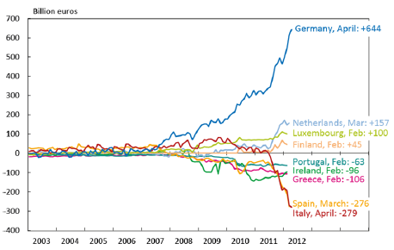

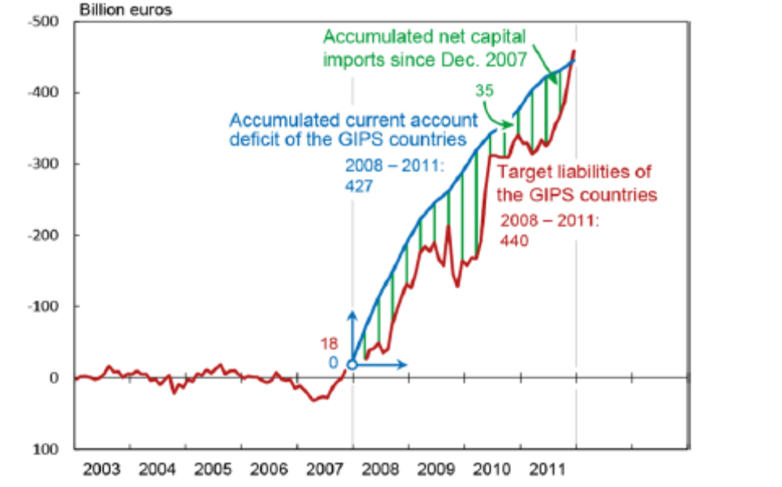

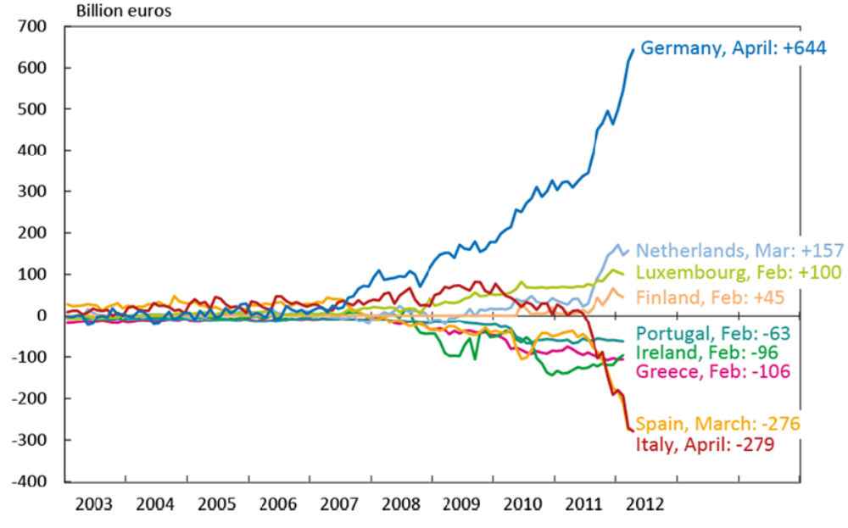

\item Policy of relaxed budget constraints 