Collaborate in Word
  - Word helps you work together
Whether you have a school project, sales pitch, or newsletter for your club, you can share the load in Word by working on a document with others. For practice using collaboration features, watch for Try it text in red throughout this document.

Cloud storage in OneDrive
Collaboration happens online, so the first step is to save your document in OneDrive.
When you save this document in OneDrive, you’ll be able to open it anywhere: on your computer, tablet, or phone. Your changes will be saved automatically.
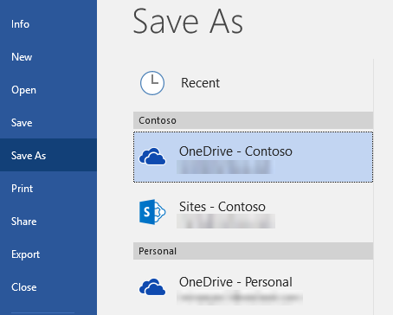
Try it: Select File > Save As, select a OneDrive location, and give this document a name.
Tip: When you’re signed in to Office you’re automatically signed you in to your OneDrive (learn more).

Share your document
Now that this document is in OneDrive, you can share it. People you share it with won’t even need Word to open it (more on that later).

Try it: Select Share near the top of the window (keyboard shortcut: press Alt, then Z and S). Send the link by typing someone’s email address or by copying and pasting the link. You can choose whether or not to allow editing.
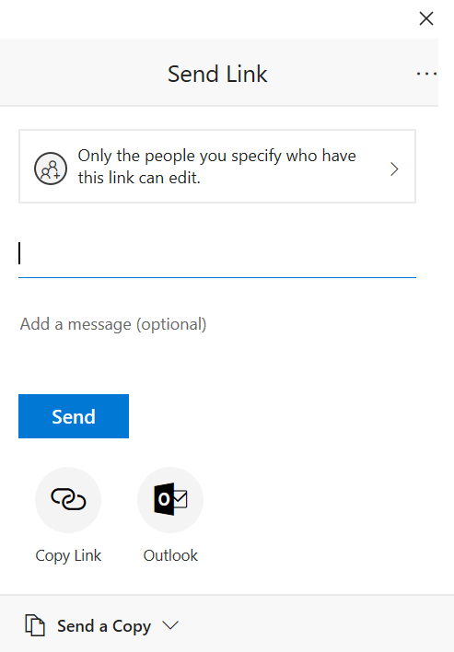
Tip: Can’t think of someone to share with? Try sending a link to yourself, just to see how everything works.

Edit at the same time
When recipients open your link, the document opens in their web browser, in Word Online, so they can edit the document even if they don’t have Word installed.
People who would rather work in their Word app (Windows, Mac, iOS, or Android) can select Open in Word, near the top of the Word Online window, and continue editing in their Word app.
Try it: When someone is working in the document with you, you’ll all see each other’s edits. We call this coauthoring, or real-time collaboration.
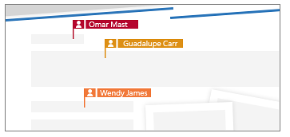
Tip: If you sent the document link to yourself, you can simulate coauthoring by editing the document here in Word and also in Word Online.
Everyone who is using Word Online or Word as part of an Office 365 subscription will see changes as they happen, and changes are saved automatically with AutoSave. If the people you’re sharing with are editing in an older version of Word, or if they’re not an Office 365 subscriber, they’ll have to save the document periodically to sync their changes with yours.
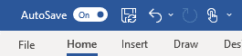
Tip: If you’re not seeing changes automatically, make sure AutoSave is switched on.

Start a conversation with comments
When you want to give feedback or ask questions, use comments to start a conversation that’s connected to the part of the document you’re talking about. Replying to comments lets you have a discussion, even when you're not in the document at the same time as your colleagues.
Try it: On the Review tab, make sure Simple Markup or All Markup is selected so you can see the comment on this page. Then click in the comment and reply to it.
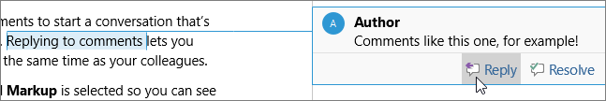

@mention someone in comments
When your document is stored in OneDrive for Business, you can call someone's attention to a spot in your document by typing the @ symbol, followed by their name, when you make a comment. They’ll get email notifying them that you mentioned them, with a link to the comment in the document.
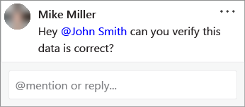
Try it: Make a new comment and @mention yourself (Remember, this only works if the document is in OneDrive for Business, and if you’re signed in to Outlook on your computer).

Keep track of changes
To stay on top of edits, use Track Changes to mark additions, deletions, and changes to formatting. When Track Changes is turned off, Word stops marking changes, but the marks it made while Track Changes was turned on are still in the document.
With changes marked in the document, you can selectively accept and reject each change, removing the markup and making the changes permanent.
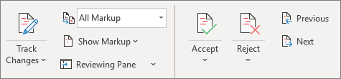
Try it: Go to the Review tab, and use the Previous and Next buttons to go from one change to the next. Undo a change with the Reject button, or make a change permanent with the Accept button.

Learn more
To learn more about how Office 365 brings together the best tools for you and your team to work together, visit the Modern Workplace Training page.

Let us know what you think
We’d love to hear from you about your experience with collaboration features in Word. Go to File > Feedback, and send us a smile, a frown, or your suggestions.
Also, please give us feedback on this learning guide, so we can provide content that’s truly useful and helpful. Thanks!

