

Dance Studio Rental Application

Name: Mladin Raul Gabriel
Group: 30435

Table of Contents
Deliverable 1 3
Project Specification 3
Functional Requirements 3
Use Case Model 3
Use Cases Identification: 3
UML Use Case Diagrams 3
Supplementary Specification 3
Non-functional Requirements 3
Design Constraints 3
Glossary 3
Deliverable 2 3
Domain Model 3
Architectural Design 3
Conceptual Architecture 3
Package Design 4
Component and Deployment Diagram 4
Deliverable 3 4
Design Model 4
Dynamic Behavior 4
Class Diagram 4
Data Model 4
System Testing 4
Future Improvements 4
Conclusion 4
Bibliography 4

Deliverable 1

Project Specification

The application is a system that allows users to interact with dance or fitness studios within a city. Users can either enroll in predefined courses offered by studios or rent studio spaces for private sessions with instructors. The system supports two main user roles:

Students, who can browse, book, and pay for courses or studio rentals

Studio Owners, who manage studios, courses, instructors, and pricing

The application provides authentication and role-based interfaces, where the graphical user interface (GUI) adapts depending on the type of user.

Functional Requirements

User Management
- The system shall allow users to register and log in.
- The system shall differentiate between student and studio owner roles.
- The system shall display different GUI views based on user role.

Studio & Course Management
- Studio owners shall be able to:
  - Add/edit/delete studios
  - Create and manage courses
  - Set pricing for courses and rentals

Booking & Reservations
- Students shall be able to:
  - Browse available studios and courses
  - Book courses
  - Rent a studio for a specific time interval
  - Choose an instructor ( ex. for private lessons)

Payment
- The system shall calculate the total price for bookings.
- The system shall allow users to confirm and complete payments.
- The system shall store transaction details.

Data Management
- The system shall store:
  - Users
  - Studios
  - Courses
  - Reservations
  - Payments

Use Case Model

Use Cases Identification:
- Book a Course:
Primary Actor: Student
Main success scenario:
1)Student logs into the system
2)Student browses available courses
3)Student selects a course
4)System displays course details and price
5)Student confirms booking
6)System processes payment
7)System stores the reservation
8)System confirms booking
Extensions: 3a. No courses available → system shows message
6a. Payment fails → system displays error and cancels booking

- Rent Studio for Private Session:
Primary Actor: Student
Main success scenario:
1)Student logs in
2)Student selects a studio
3)Student chooses date and time interval
4)Student selects an instructor
5)System checks availability
6)System calculates total price
7)Student confirms booking
8)System processes payment
9)System stores reservation
Extensions: 5a. Studio not available → user selects another time
8a. Payment failure → booking not completed

- Manage Courses
Primary Actor: Studio Owner
Main success scenario:
1)Owner logs in
2)Owner accesses course management panel
3)Owner creates or edits a course
4)Owner sets price and schedule
5)System validates input
6)System saves changes
Extensions: 5a. Invalid data → system requests correction

UML Use Case Diagrams

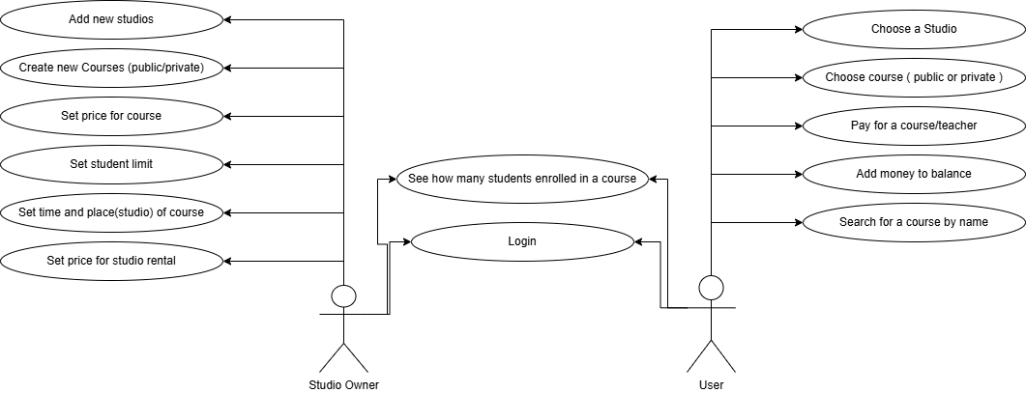

Supplementary Specification

Non-functional Requirements
1. Performance
The system should respond to user actions within a short time (e.g., under 2 seconds). It ensures good user experience, especially when browsing studios or booking.
2. Security
The system must ensure secure authentication and protect user data.
Sensitive data (accounts, payments, personal details) must be protected.
3. Scalability
The system should handle an increasing number of users and studios. Allows future expansion to multiple cities or more users.
4. Maintainability
The system should be easy to modify and extend. It should support adding new features like promotions or new payment methods.

Design Constraints
The application must be developed using Java.
The system must follow a Layered Architecture, one such as MVC (model, view, controller)
The application must use a relational database (e.g., PostgreSQL).

Glossary
User = A person using the system (student or owner)
Studen t= A user who books courses or rents studios
Studio Owner = A user who manages studios and courses
Studio = A location where courses or rentals take place
Course = A scheduled class offered by a studio
Reservation = A booking made by a student
Instructor = A person teaching a course or private session
Payment = Transaction made for a booking
Time Slot = A specific period for booking a studio

Deliverable 2

Domain Model
[Define the domain model and create the conceptual class diagrams]

Architectural Design

Conceptual Architecture
[Define the system’s conceptual architecture; use an architectural style and pattern - highlight its use and motivate your choice.]

Package Design
[Create a package diagram]

Component and Deployment Diagram
[Create the component and deployment diagrams.]

Deliverable 3

Design Model

Dynamic Behavior
[Create the interaction diagrams (2 sequence) for 2 relevant scenarios]

Class Diagram
[Create the UML class diagram; apply GoF patterns and motivate your choice]

Data Model
[Create the data model for the system.]

System Testing
[Describe the testing methides and some test cases.]

Future Improvements
[Present some features that apply to the application scope.]

Conclusion

Bibliography

