What is MQTT?

MQTT is a standards-based messaging protocol, or set of rules, used for machine-to-machine communication. Smart sensors, wearables, and other Internet of Things (IoT) devices typically have to transmit and receive data over a resource-constrained network with limited bandwidth. These IoT devices use MQTT for data transmission, as it is easy to implement and can communicate IoT data efficiently. MQTT supports messaging between devices to the cloud and the cloud to the device.

## What are MQTT components?

MQTT implements the publish/subscribe model by defining clients and brokers as below.

### **MQTT client**

An MQTT client is any device from a server to a microcontroller that runs an MQTT library. If the client is sending messages, it acts as a publisher, and if it is receiving messages, it acts as a receiver. Basically, any device that communicates using MQTT over a network can be called an MQTT client device.

### **MQTT broker**

The MQTT broker is the backend system which coordinates messages between the different clients. Responsibilities of the broker include receiving and filtering messages, identifying clients subscribed to each message, and sending them the messages. It is also responsible for other tasks such as:

* Authorizing and authenticating MQTT clients
* Passing messages to other systems for further analysis
* Handling missed messages and client sessions

### **MQTT connection**

Clients and brokers begin communicating by using an MQTT connection. Clients initiate the connection by sending a CONNECT message to the MQTT broker. The broker confirms that a connection has been established by responding with a CONNACK message. Both the MQTT client and the broker require a TCP/IP stack to communicate. Clients never connect with each other, only with the broker.

## What is an application programming interface (API)?

An application programming interface, or API, enables companies to open up their applications’ data and functionality to external third-party developers and business partners, or to departments within their companies. This allows services and products to communicate with each other and leverage each other’s data and functionality through a documented interface. Programmers don't need to know how an API is implemented; they simply use the interface to communicate with other products and services. API use has surged over the past decade, to the degree that many of the most popular web applications today would not be possible without APIs.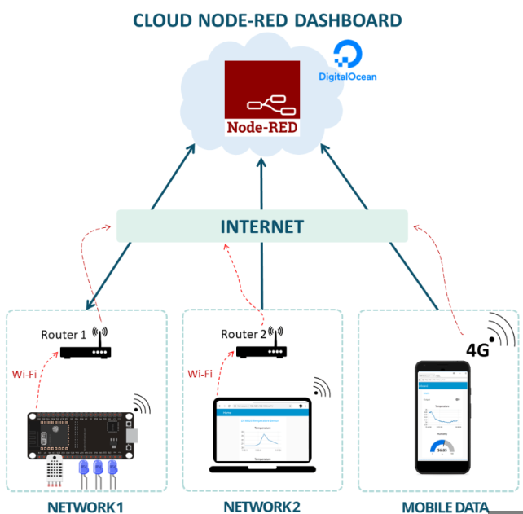

<https://www.ibm.com/cloud/learn/api>

https://aws.amazon.com/what-is/mqtt/