CGV: an integrative platform for comparative gene structure visualization and functional context
Raúl Rojas-Espinoza1,2, Janin Riedelsberger2*, Gonzalo Riadi2*
¹ Doctoral Program in Sciences, specialization in Modeling of Chemical and Biological Systems, University of Talca, Talca, Chile.
² Center for Bioinformatics, Simulation and Modeling (CBSM), Faculty of Engineering, University of Talca, Talca, Chile.
Corresponding authors: jriedelsberger@utalca.cl and griadi@utalca.cl

Abstract
Motivation: Comparing gene structure and functional context across species commonly requires separate genome browsers, annotation portals, alignment programs and sequence utilities. This fragmentation is particularly limiting when users begin with a gene name rather than genomic coordinates.
Results: We present CGV (Comparative Gene Viewer), a web and desktop platform for gene-centered structural comparison. Annotation-derived autocomplete, partial-name suggestions and disambiguation support symbols, identifiers and synonyms. Multi-Gene Search aligns transcript isoforms within one organism, whereas Cross-Species Gene Search provides exon-aware structural alignment, LASTZ blocks and MultiPIP-style conservation. Analytical summaries, functional annotations, interaction networks, literature links and strand-aware sequence extraction provide biological context. Figure Studio assembles structural, alignment and analytical outputs into publication-ready SVG or PNG panels, while read-only interactive reports support reproducible sharing. The web server includes 25 curated references; the desktop catalog provides the same datasets for selective local installation and accepts NCBI or user-supplied assemblies.
Availability and implementation: CGV is available at https://cgvapp.com. Source code, documentation and deployment files are available under the MIT license at https://github.com/raulrojas22/CGV.
Software contact: raul.rojas@utalca.cl
Keywords: comparative genomics; gene structure; transcript isoforms; data visualization; software

1. Introduction
The growing number and taxonomic breadth of genome assemblies have made interpretation, rather than data access, a central practical challenge in comparative genomics (Kriventseva et al., 2019). Exon-intron organization, transcript structure and regulatory sequence context are informative for studying gene-family evolution and functional divergence, but these features are usually examined in separate resources. Genome browsers such as UCSC, IGV and JBrowse are powerful for navigating individual assemblies (Kent et al., 2002; Robinson et al., 2011; Buels et al., 2016), whereas focused tools such as GSDS render gene structures (Hu et al., 2015). Cross-species inspection nevertheless often requires users to reconcile identifiers, open multiple assembly-specific views, run alignments separately and then retrieve Gene Ontology (GO), interaction or promoter information from other services.
CGV was developed to make this gene-centered workflow available in one interface. Users can begin with a gene symbol, identifier or synonym, inspect transcript models, compare genes within an organism or representative models across organisms, and export figures, tables and sequences. CGV displays existing structural and functional annotations; it does not infer orthology, quantify expression or replace genome-wide analysis tools.

2. Implementation and features

2.1 Data sources and deployment
CGV is implemented in R/Shiny (R Core Team, 2024; Chang et al., 2024). Genome sequences are accessed in 2bit format through rtracklayer, and bgzip-compressed GFF3 annotations are queried through tabix indexes, avoiding the need to load complete chromosomes or annotation files into memory (Lawrence et al., 2009; Morgan et al., 2025). A cache stores parsed annotations, lookup indexes and autocomplete entries for reuse. The hosted version runs as a containerized web service. CGV Desktop packages the same application in an Electron shell and starts the Shiny server on a private local port. Its catalog currently contains 25 curated reference datasets spanning animals, plants and fungi. Packages are downloaded individually, verified by checksum and retained with local caches, allowing users to install only the organisms required for a project. Both distributions also accept matching genome and annotation files supplied by the user, and assemblies can be retrieved through the NCBI Datasets interface. Network-dependent layers, including external alias services, STRING and literature retrieval, remain optional.

2.2 Gene search and ambiguity handling
CGV first searches the selected local annotations. Autocomplete terms are derived from GFF3 attributes, while partial-name and gene-family suggestions help recover misspelled or incomplete queries. A local alias index distinguishes stable identifiers, official symbols, gene names and synonyms. When an alias maps to several loci, CGV presents ranked candidates with identifiers, coordinates and provenance and asks the user to choose; ambiguous matches are not assigned automatically. If no suitable local match is found, users may query MyGene.info, NCBI Gene, UniProt and Ensembl. In the cross-species workflow, candidate names are also ranked by their support across the selected organisms.

2.3 Visualization and alignment
CGV provides two complementary workflows. Multi-Gene Search displays several genes from one organism in compact or detailed views. For genes with multiple transcripts, an Align Transcripts view compares translated coding sequences, nucleotide coding sequences or complete spliced exons. Global pairwise alignment is used to relate exon blocks, and the view labels 1:1, 1:n, n:1 and partial correspondences; a canonical transcript is used as reference when available.
Cross-Species Gene Search compares one query across two or more organisms. Representative models can be examined in compact and detailed views or with three alignment strategies. The interface's Aligned Synteny view performs exon-aware structural alignment on translated coding sequence, coding nucleotides or complete exons and draws corresponding blocks in a common 5'-to-3' orientation. LASTZ Blocks shows local pairwise alignments across the selected locus, and MultiPIP summarizes percent identity along a reference window. The latter two views can include configurable flanking sequence when genome data and the LASTZ backend are available (Harris, 2007). These displays compare the models returned for a requested gene; they are not de novo orthology or genome-wide synteny analyses.
Interactive gene cards expose coordinates, strand, transcript and feature information, while ten analytical views summarize gene architecture, sequence composition, genomic neighborhood and multivariate relationships. Figure Studio assembles structural, alignment and analytical views as configurable panels and exports publication-ready SVG or PNG compositions. Analyses can be captured as read-only interactive reports: CGV Web creates an expiring secret URL, whereas CGV Desktop saves a self-contained HTML file. A versioned reproducibility package records queries, source provenance, parameters and captured outputs. CSV tables, FASTA sequences and RDS work sessions, including Figure Studio drafts, remain exportable.

2.4 Functional context and documentation
CGV places structural results alongside complementary information rather than producing new functional annotations. GO terms are read from local GAF/OBO resources where available, with an online fallback (Ashburner et al., 2000). STRING protein-association networks show confidence and evidence channels (Szklarczyk et al., 2023), and Europe PMC queries link genes to recent literature. The promoter tool extracts a configurable upstream interval, applies the reverse complement for genes on the minus strand and exports coordinates and FASTA sequence. An in-application guide and short screencasts cover data selection, both search workflows, interpretation and export.

3. Application examples

3.1 Multi-gene analysis of rice HKT transporters
The HKT transporter family contributes to sodium and potassium homeostasis in plants and is relevant to salinity-tolerance research (Platten et al., 2006; Riedelsberger et al., 2021). The seven protein-coding HKT loci represented in the selected Oryza sativa ssp. japonica RefSeq annotation (GCF_034140825.1) were examined in one Multi-Gene Search (Figure 1B-C); HKT2;2 is absent from this annotation release. CGV retrieved the indexed features and displayed the models side by side. The architecture and correlation panels highlighted the greater intronic contribution to HKT1;4 and HKT1;5 relative to the shorter genes in the query set. GO, STRING and promoter panels could then be inspected without rebuilding the gene set in another program. This example illustrates exploratory comparison of paralogous structures; it is not intended as a phylogenetic analysis of the HKT family.

3.2 Cross-species comparison of TP53
TP53 models from human, chimpanzee, dog, horse, mouse and zebrafish were compared with the Cross-Species workflow (Figure 1D-F). CGV placed representative exon-intron structures in a shared orientation and displayed pairwise LASTZ blocks and a MultiPIP-style view with the human locus as reference. The resulting panels make differences in intron span and the relative concentration of conserved blocks around coding regions directly visible, while retaining access to the underlying transcript identifiers and alignment parameters. Because alignment output depends on the selected transcript, genomic window and identity threshold, these settings are reported rather than interpreted as fixed species-level estimates.

4. Conclusion
CGV combines identifier-aware gene search, transcript and cross-species structural comparison, sequence alignment, quantitative summaries and functional context in a guided interface. The public server supports immediate use, while the desktop distribution provides selective local installation of 25 curated datasets and persistent caches. Figure Studio and read-only reports extend the workflow to publication-ready composition, reproducible review and collaborative sharing without requiring a scripted workflow.

Data availability
Source code, configuration, dataset registries and reconstruction instructions are available at https://github.com/raulrojas22/CGV. The public web service is available at https://cgvapp.com. Production-scale genomes, annotations and GO resources are obtained from their public upstream providers and are maintained outside Git history because of their size and update frequency; the repository records the references used by the application.

Funding
This work was supported by the Agencia Nacional de Investigación y Desarrollo (ANID) doctoral scholarship [grant number 21231442 to R.R.-E.]; and Fondo Nacional de Desarrollo Científico y Tecnológico (FONDECYT) [grant number 1240167 to J.R.; grant number 1231357 to G.R.].
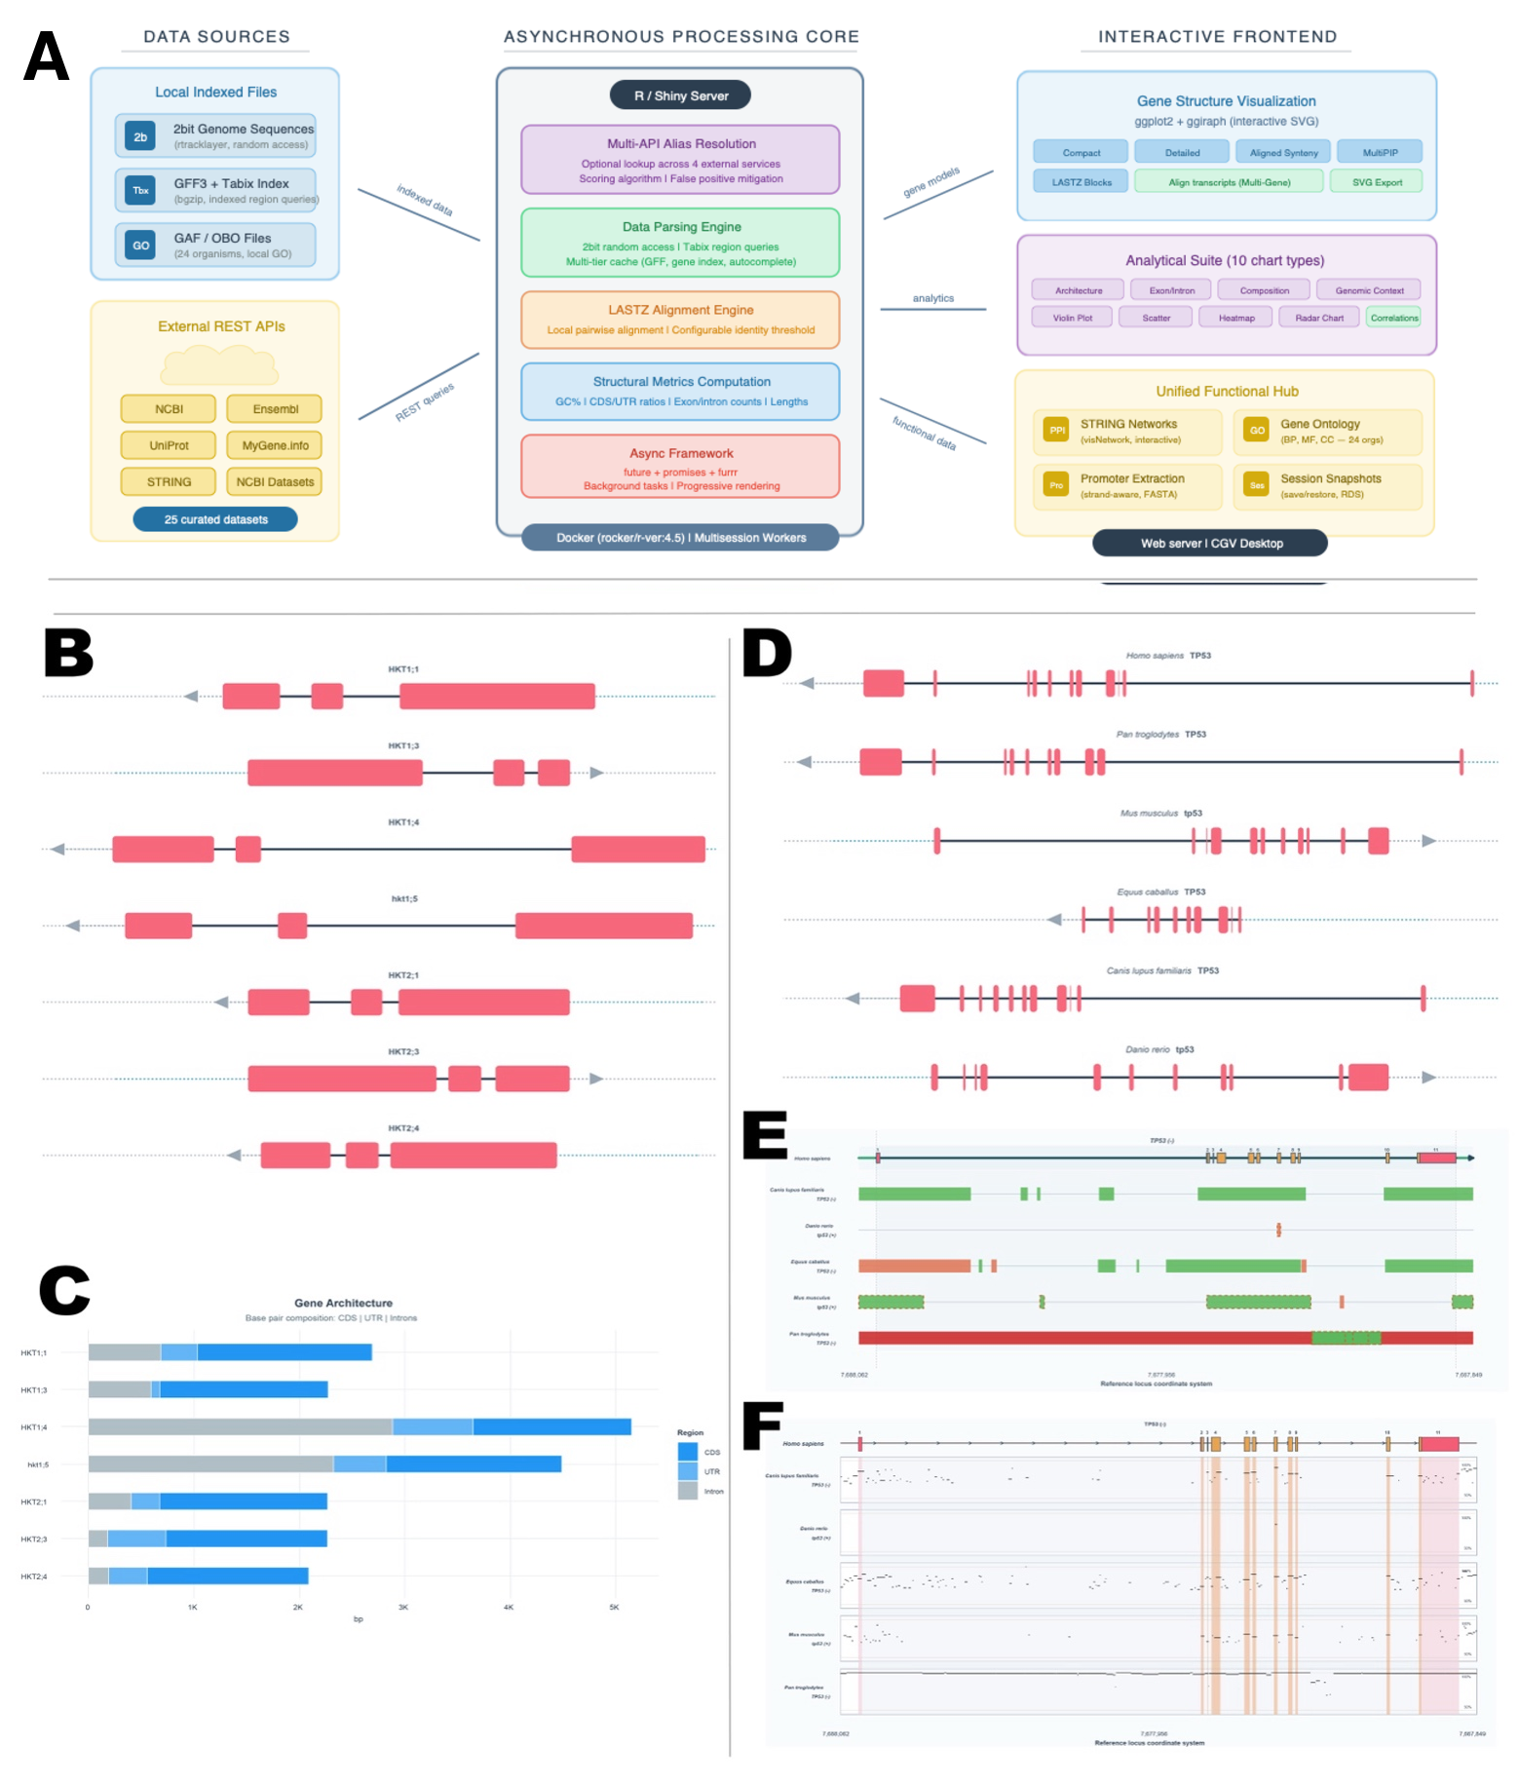
Figure 1. CGV architecture and application examples. (A) CGV combines indexed genome and annotation data with optional external services in an R/Shiny backend. The application can be accessed through the public web server or run locally through CGV Desktop. (B-C) Multi-Gene Search of seven HKT loci in Oryza sativa ssp. japonica, showing interactive gene models and an architecture summary. (D-F) Cross-Species Gene Search of TP53 in six vertebrates, showing representative models, LASTZ local-alignment blocks and a MultiPIP-style percent-identity view. The human TP53 gene body is the reference for D-F; LASTZ blocks were filtered at a minimum local identity of 50%.

References

Ashburner, M. et al. (2000) Gene Ontology: tool for the unification of biology. Nature Genetics, 25, 25-29. https://doi.org/10.1038/75556
Buels, R. et al. (2016) JBrowse: a dynamic web platform for genome visualization and analysis. Genome Biology, 17, 66. https://doi.org/10.1186/s13059-016-0924-1
Chang, W. et al. (2024) shiny: Web Application Framework for R. https://CRAN.R-project.org/package=shiny
Harris, R.S. (2007) Improved pairwise alignment of genomic DNA. PhD thesis, The Pennsylvania State University.
Hu, B. et al. (2015) GSDS 2.0: an upgraded gene feature visualization server. Bioinformatics, 31, 1296-1297. https://doi.org/10.1093/bioinformatics/btu817
Kent, W.J. et al. (2002) The human genome browser at UCSC. Genome Research, 12, 996-1006. https://doi.org/10.1101/gr.229102
Kriventseva, E.V. et al. (2019) OrthoDB v10: sampling the diversity of genomes for evolutionary and functional annotations of orthologs. Nucleic Acids Research, 47, D807-D811. https://doi.org/10.1093/nar/gky1053
Lawrence, M. et al. (2009) rtracklayer: an R package for interfacing with genome browsers. Bioinformatics, 25, 1841-1842. https://doi.org/10.1093/bioinformatics/btp328
Morgan, M. et al. (2025) Rsamtools: binary alignment, FASTA, variant call and tabix file import. https://doi.org/10.18129/B9.bioc.Rsamtools
Platten, J.D. et al. (2006) Nomenclature for HKT transporters, key determinants of plant salinity tolerance. Trends in Plant Science, 11, 372-374. https://doi.org/10.1016/j.tplants.2006.06.001
R Core Team (2024) R: A Language and Environment for Statistical Computing. R Foundation for Statistical Computing, Vienna. https://www.R-project.org/
Riedelsberger, J. et al. (2021) Plant HKT channels: an updated view on structure, function and gene regulation. International Journal of Molecular Sciences, 22, 1892. https://doi.org/10.3390/ijms22041892
Robinson, J.T. et al. (2011) Integrative Genomics Viewer. Nature Biotechnology, 29, 24-26. https://doi.org/10.1038/nbt.1754
Szklarczyk, D. et al. (2023) The STRING database in 2023: protein-protein association networks and functional enrichment analyses for any sequenced genome of interest. Nucleic Acids Research, 51, D638-D646. https://doi.org/10.1093/nar/gkac1000
Wickham, H. (2016) ggplot2: Elegant Graphics for Data Analysis. Springer-Verlag, New York.

