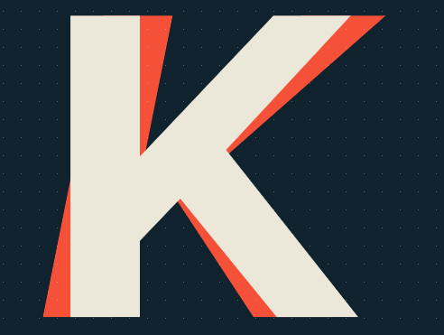
PROYECTO FIN DE CICLO DAW2:

SCRUM SHEET:
This sheet wants to inform about the roles of the project.
In this case, the Scrum master will be M.ª Belén Gil, and the rest of the roles will fall on me. So I am the product owner, Stakeholder, and the development team.
Then, for the scrum methodology, I will use trello, to mark the sprints, and the daily and scheduled work.

Thanks for read, Raul.

