**Estimation for control**

# Introduction

The purpose of this research paper is to obtain a better understanding of the estimation for control. We selected a random project in order to implement it and to observe its behavior. We start by calculating and simulating the nonlinear model of crane. Afterwards, we the linearize around the equilibrium point. Secondly we calculate a controller to stabilize the given system.

We develop an observer to estimate and

**2D overhead crane system**

Consider a crane system shown in Figure 1. We have a pendulum attached to a support which moves only on the x-axis. The system has only one input u, which is force acting on the trolley. We assume that all the initial data is given (x, mt, l, mp, teta). The purpose is to control the movement displacement of the trolley.

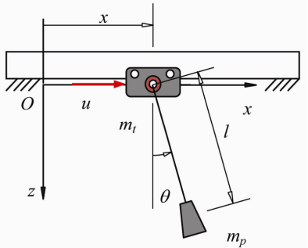

Figure 1

**Nonlinear model**

The equation describing our system are:

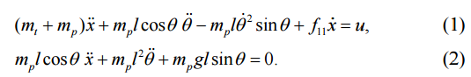

They parameter values are given in the table below.

|  |  |  |
| --- | --- | --- |
| Parameter | Notation | Value |
| Trolley mass | mt | 2 |
| Payload mass | mp | 0.85 |
| Length of rope | L | 0.6 |
| Gravitational acceleration | G | 9.81 |
| Damping coefficient on the trolley | f | 10 |

The equations presented in (1) and (2) are nonlinear. In order to create a linear controller, we will linearization our system. In our case the linearize around 0, meaning our trolley is stationary.

We will observe the behavior of our system using the Simulink model in Figure 2.

**Linearized model**

We evaluate the derivatives in point ???

We simulate our system using the Simulink model presented in Figure 3.

**State-feedback control**

In this part we will calculate a state-feedback control for our the linearized and nonlinearized model. We consider the system ????? where ??? and matrices A, B are the ones calculated. Considering the state feedback law ????? we obtain:

Based on the smth , the system is stable if the following condition is satisfied:???

To do so, we need to check if (A,B) is controllable. ???

If the P obtain is equal with the number of states we can calculate the gain K.

By using “place” function in Matlab, we obtain the following for our linearized system:

???