How to get started with Github and SECK

This step by step guide covers downloading and installing the Github application, forking from someone’s account, cloning to the local directory and importing the project into Eclipse. This guide makes the following assumptions:
- User is running Windows 7
- User does have Eclipse and Maven already installed
- User does not have Github already installed

- Sign up for a free Github account. In your browser’s address bar, enter https://github.com.
- Click the Plans, Pricing and Signup button in the middle of the page.
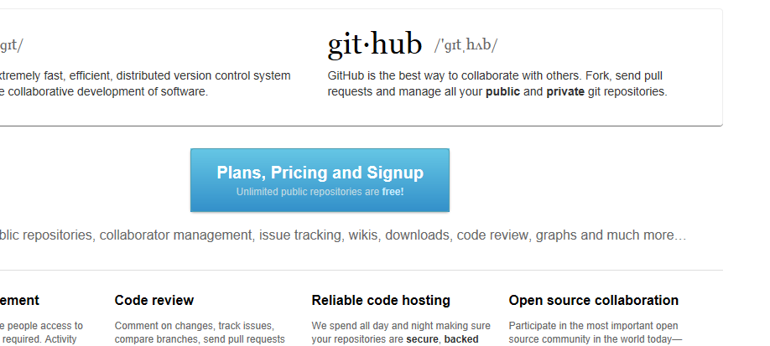

- Click the Create a Free Account button.
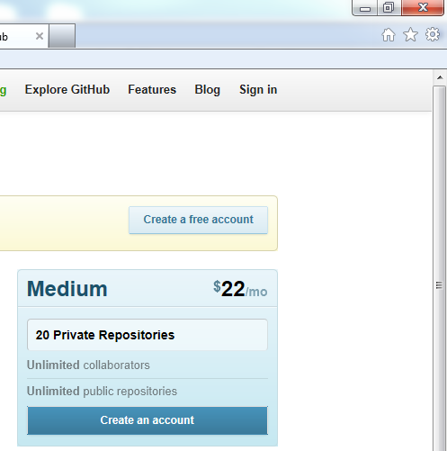

- Fill in the username, email address and password text fields to register for the free Github account. Then click the Create an Account button.

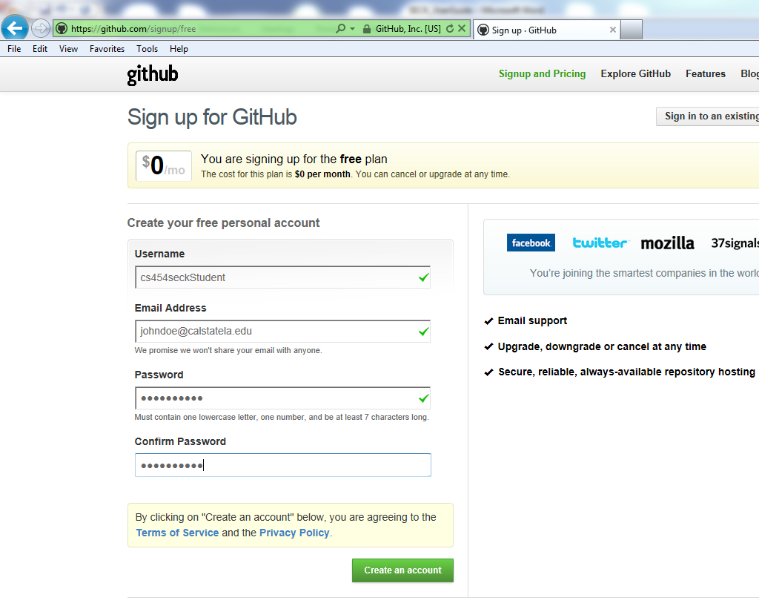
- At the bottom of the next page, click the Github for Windows link under the Client heading.
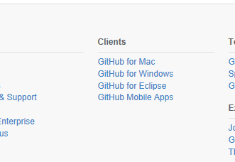
- Click the Download 1.0 button in the upper right hand corner to download the program for Windows XP, Vista, 7 and 8.
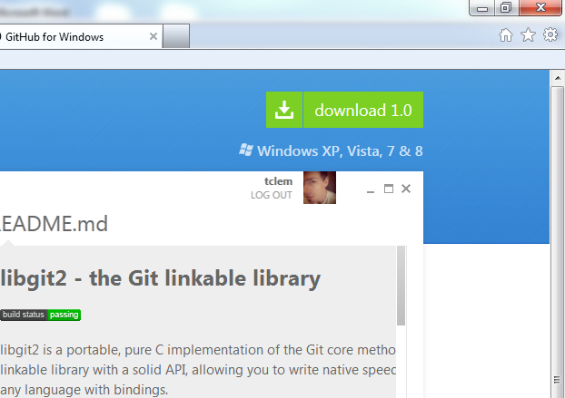

- Navigate to the directory where you would like to save the file. Then click the Save button.
- After the download is complete, navigate to the directory where the file was downloaded. Double click the GitHubSetup file to begin installation.
- In the Open File – Security Warning dialog box, click Run.
- Click the Accept button to accept the terms of the license agreement. Some GitHub setup files will be downloaded. If necessary, the Microsoft .NET framework will also be downloaded and installed.
- If the Application Install – Security Warning dialog box appears, click Install. More files will be downloaded from GitHub.
- After successful installation, the GitHub client launches. Enter the username or email and password then click the Log In button.
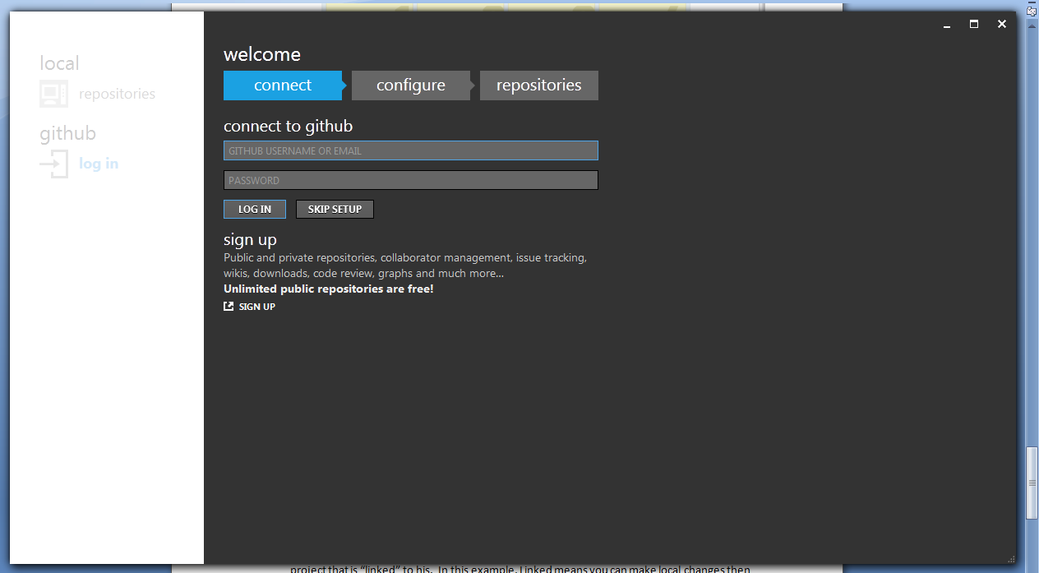

- Then click the Continue button.
- The next screen announces that no local repositories were found. Click the Skip button.

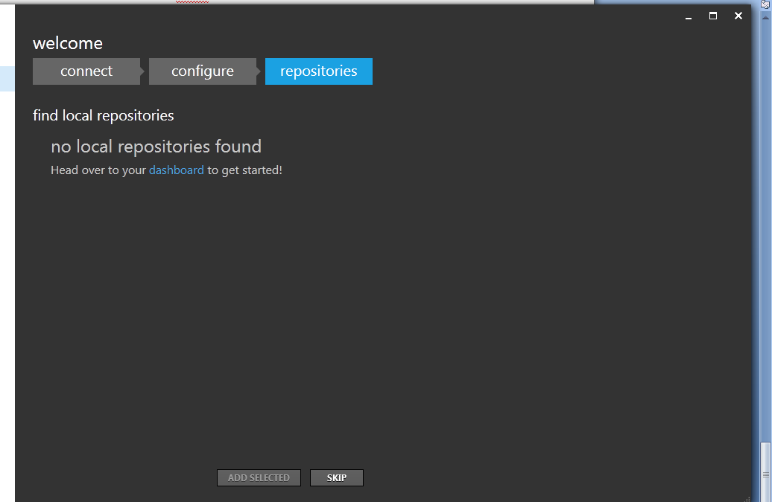

Note: After forking from John’s account, a new local repo will be created. Github has 2 areas for its repositories (or “repos”). There is a local repository and your online repository. For the sake of this class, the local repo refers to your local workspace on Eclipse.

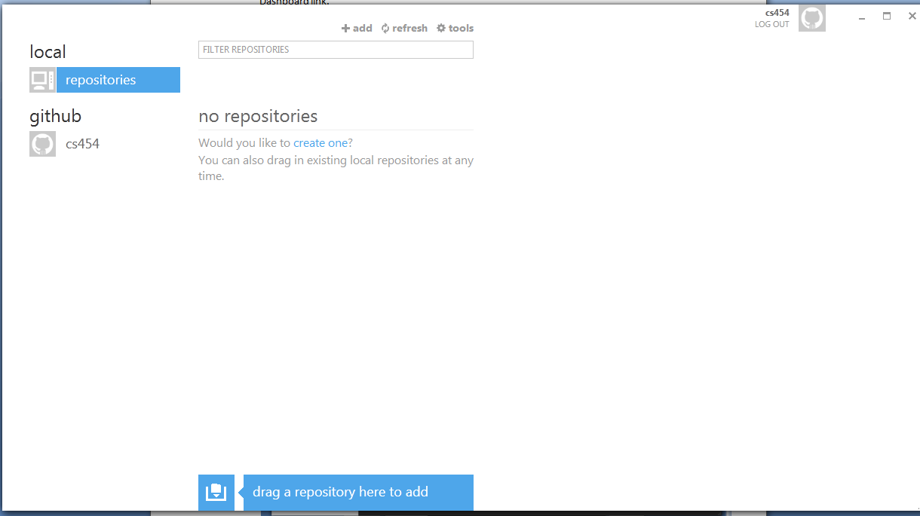

- Once complete, sign in to your online Github account. Go to John’s account http://github.com/pcwerk/seck. Click the Fork button.

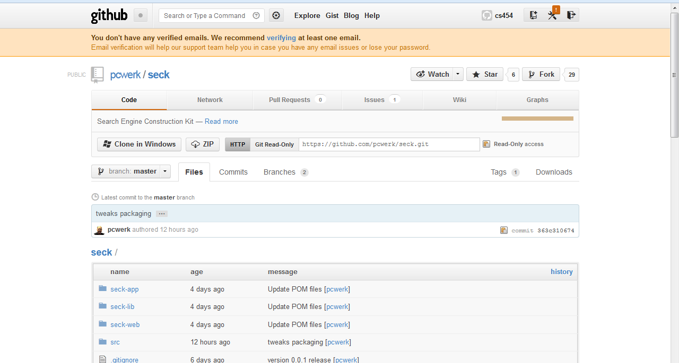

- Then click Clone In Windows.

- In the Launch Application window, click the OK button. This will create a new local repo (for example yourusername\seck) and copy all of the project files there.

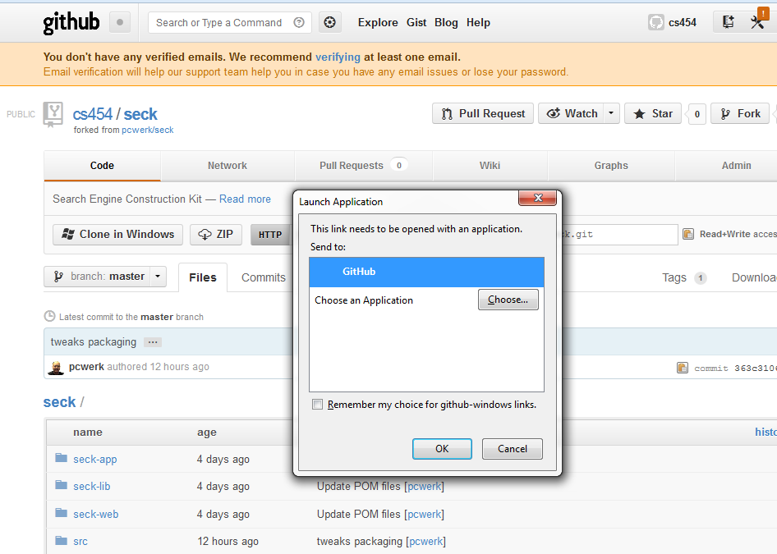

- Open a command line window and navigate to the project to be imported into Eclipse, in this example the project that was just cloned.
- Enter the command ‘mvn eclipse:eclipse’
- Launch Eclipse.
- Click File then click Import.
- In the Import dialog box, select Existing Projects Into Workspace. Then click Next.
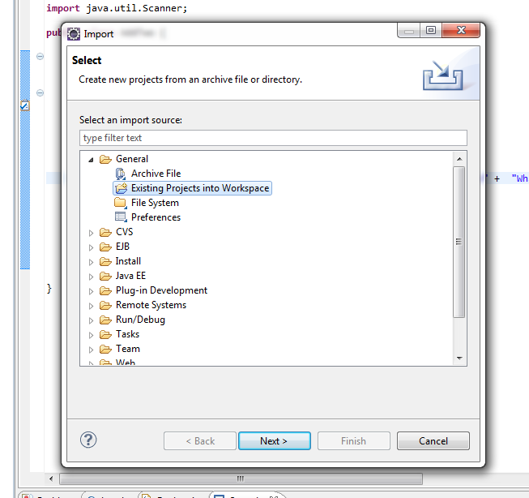
- In the Import Projects dialog box, click the Browse button to the right of Select Root Directory.
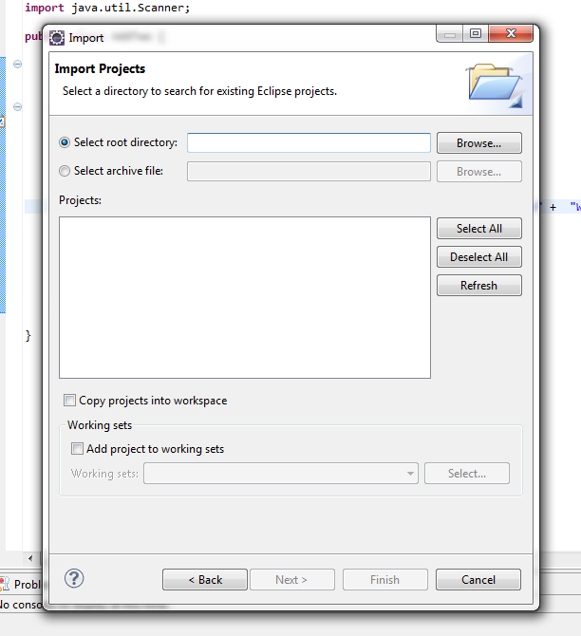

- Navigate to the directory containing the project to import. If this was not changed from the default, the path will be C:\Users\YourUserAccountName\MyDocuments\GitHub\seck\NameOfProject.
- Then click Finish. The project will be imported but there will be at least one error regarding the build path for Maven.
- To configure the build path, right click on the project then click Seck. Select Build Path then click Configure Build Path.
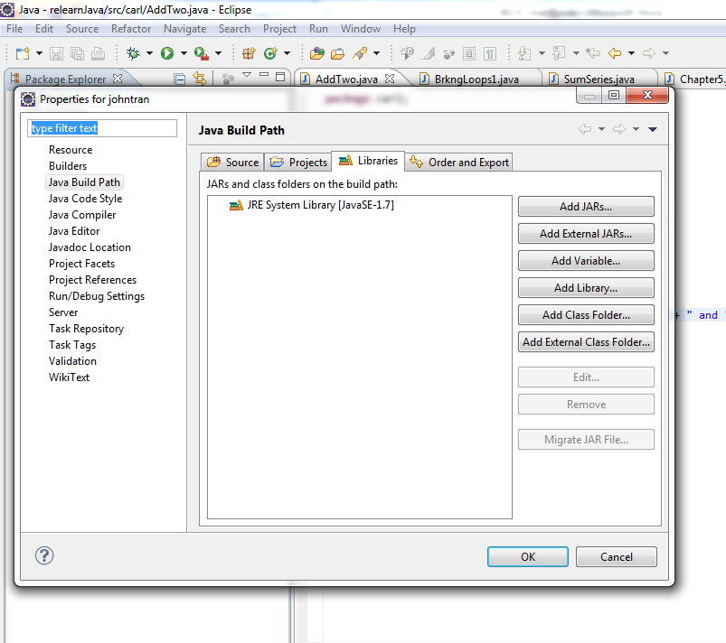
- In the Java Build Path dialog box, select the Libraries tab then click Add Variable.
- In the New Variable Path Class Path dialog box, click the Configure Variable button.
- In the Preferences dialog box, click the New button
- In the New Variable Entry dialog box, enter ‘M2_REPO’ in name text box. Then click the Folder button and navigate to the M2 repository folder. If this was not changed from the default, it will be C:\Users\UserNameAccount\.m2\repository).
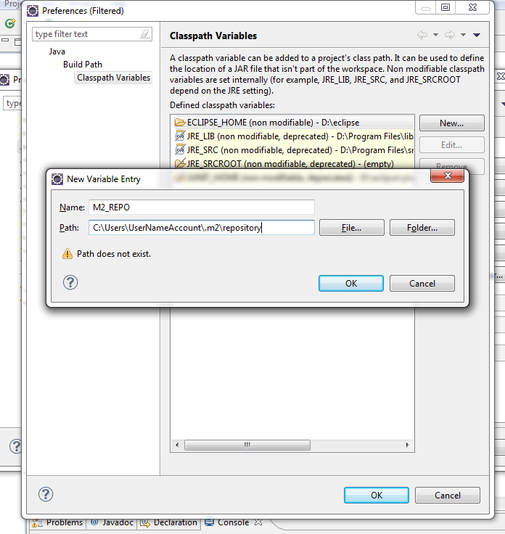

- Then click the OK button.
- Click the OK button to close the Preferences dialog box.
- If necessary, fix any missing import errors or incorrectly named files.

Note: Steps 18 to 33 must be repeated for every project (e.g. once for seck-web, once for seck-lib, etc.)

