Name :- Raunak Sapariya
Registration Number :- 26MCA0052

Problem 1 -> Take 2 stack called odd and even. Get inputs from the users. If input is odd then push it into the odd stack. If input is even then push it into the even stack.

CODE
package main

import "fmt"

func main() {

var n int

fmt.Print("Enter an Nnumber of integer: ")

_, err := fmt.Scan(&n)
if err != nil {
fmt.Println("Error: Invalid input! Please enter an integer.")
}

even := make([]int,0)
odd := make([]int,0)

for i := 0; i < n; i++{
var n int
fmt.Printf("Enter a number %v: ",i+1)
_, err = fmt.Scan(&n)
if err != nil {
fmt.Println("Error: Invalid input! Please enter an integer.")
i --
}

if n%2 == 0 {
even = append(even, n)
} else {
odd = append(odd, n)
}
}

fmt.Println("Even",even)
fmt.Println("Odd",odd)
}

OUTPUT
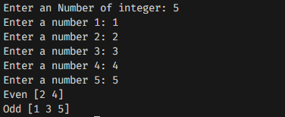

Problem 2 -> Take 2 stack called vowels and consonants. Get inputs from the users. If input is Consonant then push it into the Consonant stack. If input is vowels, then push it into the vowels stack.

CODE
package main

import (
"fmt"
)

func main() {
var n int

fmt.Print("Enter number of characters: ")

_, err := fmt.Scan(&n)
if err != nil {
fmt.Println("Error: Please enter a valid integer.")
return
}

var vowels []string
var consonants []string

for i := 0; i < n; i++ {
var char string

fmt.Printf("Enter character %d: ", i+1)

_, err = fmt.Scan(&char)
if err != nil {
fmt.Println("Error: Invalid input.")
i--
continue
}

if len(char) != 1 {
fmt.Println("Error: Please enter only one character.")
i--
continue
}

c := char[0]
if !((c >= 'A' && c <= 'Z') || (c >= 'a' && c <= 'z')) {
fmt.Println("Error: Please enter an alphabet only.")
i--
continue
}

switch char {
case "a", "e", "i", "o", "u", "A", "E", "I", "O", "U":
vowels = append(vowels, char)
default:
consonants = append(consonants, char)
}
}

fmt.Println("\nVowels:", vowels)
fmt.Println("Consonants:", consonants)
}

OUTPUT
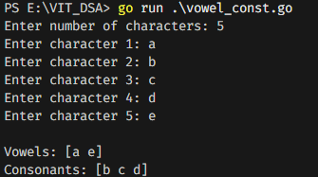

Problem 3 -> Write a program to get Array elements from 2-D array. Then rotate the elements of ROWS of array based on no. count .

CODE
package main

import "fmt"

func displayMatrix(arr [][]int, rows, cols int) {
fmt.Println("\nArray after rotation:")
for i := 0; i < rows; i++ {
for j := 0; j < cols; j++ {
fmt.Printf("%d ", arr[i][j])
}
fmt.Println()
}
}

func main() {
var rows, cols int

fmt.Print("Enter number of rows: ")
fmt.Scan(&rows)

fmt.Print("Enter number of columns: ")
fmt.Scan(&cols)

arr := make([][]int, rows)
for i := 0; i < rows; i++ {
arr[i] = make([]int, cols)
}

fmt.Println("\nEnter array elements:")
for i := 0; i < rows; i++ {
for j := 0; j < cols; j++ {
fmt.Printf("Enter element [%d][%d]: ", i, j)
fmt.Scan(&arr[i][j])
}
}

fmt.Println("\nOriginal array:")
for i := 0; i < rows; i++ {
for j := 0; j < cols; j++ {
fmt.Printf("%d ", arr[i][j])
}
fmt.Println()
}

var count int
fmt.Print("\nEnter rotation count: ")
fmt.Scan(&count)

count = count % cols

for i := 0; i < rows; i++ {

for k := 0; k < count; k++ {

last := arr[i][cols-1]

for j := cols - 1; j > 0; j-- {
arr[i][j] = arr[i][j-1]
}

arr[i][0] = last
}
}

displayMatrix(arr, rows, cols)
}

OUTPUT
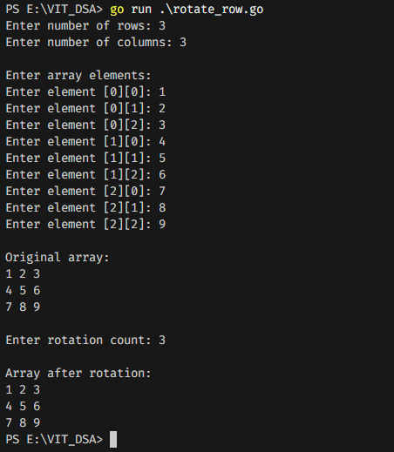

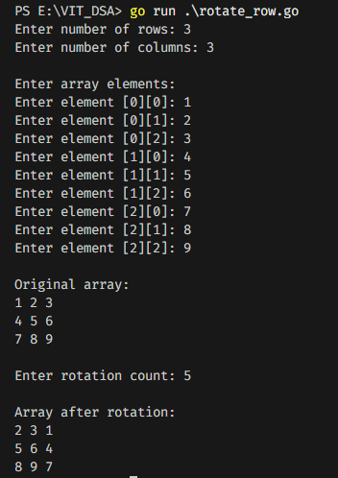

Problem 4 -> Write a program to get Array elements from 2-D array. Then rotate the elements of COLUMNS of array based on no. count.

CODE
package main

import "fmt"

func displayMatrix(arr [][]int, rows, cols int) {
fmt.Println("\nArray after rotation:")
for i := 0; i < rows; i++ {
for j := 0; j < cols; j++ {
fmt.Printf("%d ", arr[i][j])
}
fmt.Println()
}
}

func main() {
var rows, cols int

fmt.Print("Enter number of rows: ")
fmt.Scan(&rows)

fmt.Print("Enter number of columns: ")
fmt.Scan(&cols)

arr := make([][]int, rows)
for i := 0; i < rows; i++ {
arr[i] = make([]int, cols)
}

fmt.Println("\nEnter array elements:")
for i := 0; i < rows; i++ {
for j := 0; j < cols; j++ {
fmt.Printf("Enter element [%d][%d]: ", i, j)
fmt.Scan(&arr[i][j])
}
}

fmt.Println("\nOriginal array:")
for i := 0; i < rows; i++ {
for j := 0; j < cols; j++ {
fmt.Printf("%d ", arr[i][j])
}
fmt.Println()
}

var count int
fmt.Print("\nEnter rotation count: ")
fmt.Scan(&count)

count = count % cols

for j := 0; j < cols; j++ {

for k := 0; k < count; k++{

last := arr[rows-1][j]

for i := rows - 1; i > 0; i--{
arr[i][j] = arr[i-1][j]
}

arr[0][j] = last
}

}

displayMatrix(arr, rows, cols)
}

OUTPUT
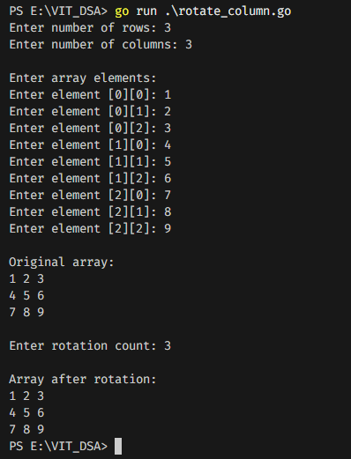
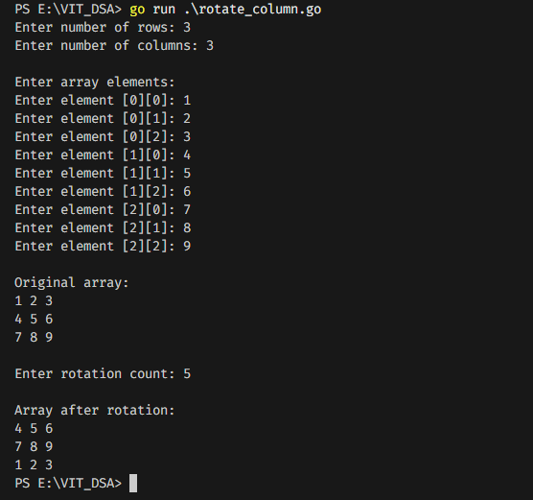

Problem 5 -> 5. Get 1-D array then insert element in specific position and delete from specific position.

CODE
package main

import (
"fmt"
)

func main() {
var n int
fmt.Print("Enter the size of array: ")
fmt.Scan(&n)

arr := make([]int, n)

fmt.Println("Enter the elements of the array:")
for i := 0; i < n; i++ {
fmt.Printf("Element %d: ", i+1)
fmt.Scan(&arr[i])
}
fmt.Println("\nOriginal array:", arr)

// Insert
var position, value int
fmt.Printf("\nEnter the position to insert the element (0 to %d): ", len(arr)-1)
fmt.Scan(&position)

if position < 0 || position >= len(arr) {
fmt.Println("Invalid position!")
return
}

fmt.Print("Enter the value to insert: ")
fmt.Scan(&value)

arr = append(arr[:position], append([]int{value}, arr[position:]...)...)

fmt.Println("Array after insertion:", arr)

// Delete
fmt.Printf("\nEnter the position to delete the element (0 to %d): ", len(arr)-1)
fmt.Scan(&position)

if position < 0 || position >= len(arr) {
fmt.Println("Invalid position!")
return
}

arr = append(arr[:position], arr[position+1:]...)
fmt.Println("Array after deletion:", arr)
}

OUTPUT
