Name :- Raunak Sapariya
Registration Number :- 26MCA0052

Linear Search

CODE
package main

import "fmt"

func LinearSearch(arr []int, target int) int {
for i, v := range arr {
if v == target {
return i
}
}
return -1
}

func main() {
arr := []int{1, 2, 3, 4, 5}
var target int
fmt.Print("Enter the element to search: ")
fmt.Scan(&target)
result := LinearSearch(arr, target)
if result != -1 {
fmt.Printf("Element found at index: %d\n", result)
} else {
fmt.Println("Element not found in the array.")
}
}

OUTPUT

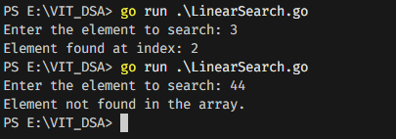

Binary Search

CODE
package main

import "fmt"

func BinarySearch(arr []int, target int) int {
left, right := 0, len(arr)-1
for left <= right {
mid := left + (right-left)/2
if arr[mid] == target {
return mid
} else if arr[mid] < target {
left = mid + 1
} else {
right = mid - 1
}
}
return -1
}

func main() {
arr := []int{10, 20, 30, 40, 50, 60}

var target int
fmt.Print("Enter the element to search: ")
fmt.Scan(&target)

result := BinarySearch(arr, target)
if result != -1 {
fmt.Printf("Element found at index: %d\n", result)
} else {
fmt.Println("Element not found in the array.")
}
}

OUTPUT
