Write a Java program to insert elements at the first and last positions of a linked list. Import java.util.LinkedList;

Public class LinkedListInsertExample {
Public static void main(String[] args) {
// Create a LinkedList of Strings
LinkedList<String> list = new LinkedList<>();

// Add some initial elements
List.add(“B”);
List.add(“C”);

System.out.println(“Original LinkedList: “ + list);

// Insert at the first position
List.addFirst(“A”);

// Insert at the last position
List.addLast(“D”);

// Print the updated LinkedList
System.out.println(“LinkedList after inserting at first and last: “ + list);
System.out.println(“ Ronak Rathore 0873CS231101”);
}}

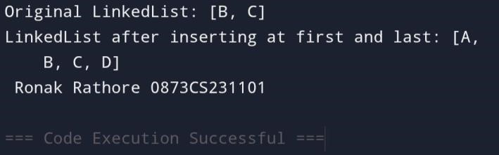

Write a Java program to add all elements from one TreeSet to another TreeSet.

import java.util.TreeSet;

public class TreeSetAddAllExample { public static void main(String[] args) {
// First TreeSet
TreeSet<String> set1 = new TreeSet<>(); set1.add("Apple"); set1.add("Banana"); set1.add("Mango");

// Second TreeSet
TreeSet<String> set2 = new TreeSet<>(); set2.add("Orange"); set2.add("Grapes");

// Display both sets before adding
System.out.println("TreeSet 1: " + set1);
System.out.println("TreeSet 2 (before adding): " + set2);

// Add all elements from set1 to set2 set2.addAll(set1);

// Display TreeSet 2 after adding
System.out.println("TreeSet 2 (after adding): " + set2);
System.out.println(“ Ronak Rathore 0873CS231101”);
}}

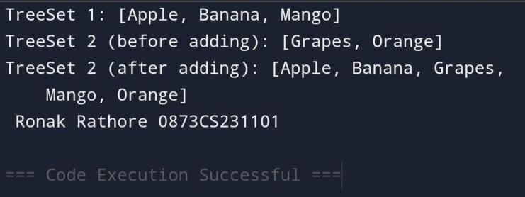
Write a Java program to display the elements of a TreeSet in reverse order.

import java.util.TreeSet; import java.util.Iterator;

public class TreeSetReverseOrder { public static void main(String[] args) {
// Create a TreeSet and add elements TreeSet<String> fruits = new TreeSet<>(); fruits.add("Apple"); fruits.add("Mango"); fruits.add("Banana"); fruits.add("Orange");
System.out.println("TreeSet in ascending order: " + fruits);
System.out.println("TreeSet in reverse order:");
Iterator<String> reverseIterator = fruits.descendingIterator(); while (reverseIterator.hasNext()) {
System.out.println(reverseIterator.next());
}

System.out.println(" Ronak Rathore 0873CS231101");
}}

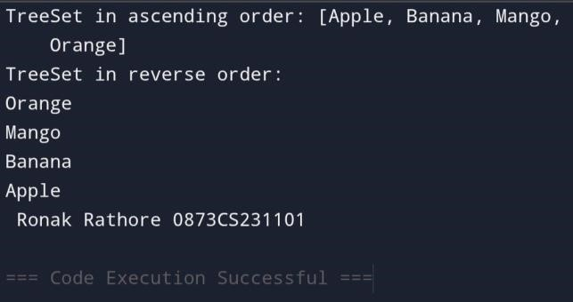
Write a Java program to retrieve the first and last elements from a TreeSet.

Import java.util.TreeSet;

Public class TreeSetFirstLastExample {
Public static void main(String[] args) {
TreeSet<String> animals = new TreeSet<>();
Animals.add(“Zebra”);
Animals.add(“Elephant”);
Animals.add(“Lion”);
Animals.add(“Giraffe”);
System.out.println(“TreeSet: “ + animals);

String first = animals.first();
System.out.println(“First element: “ + first);
String last = animals.last();
System.out.println(“Last element: “ + last);

System.out.println(“ Ronak Rathore 0873CS231101”);
}}

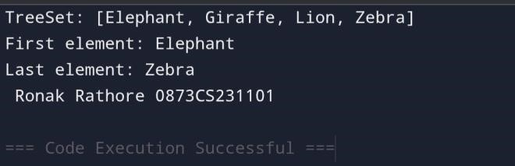
Write a Java program to clone a TreeSet into another TreeSet

Import java.util.TreeSet;

Public class TreeSetCloneExample {
Public static void main(String[] args) { TreeSet<String> originalSet = new TreeSet<>(); originalSet.add(“Apple”); originalSet.add(“Banana”); originalSet.add(“Mango”);
System.out.println(“Original TreeSet: “ + originalSet);
@SuppressWarnings(“unchecked”)
TreeSet<String> clonedSet = (TreeSet<String>) originalSet.clone();

System.out.println(“Cloned TreeSet: “ + clonedSet);

System.out.println(“ Ronak Rathore 0873CS231101”);
}}

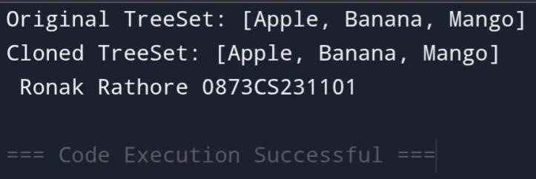
Write a Java program to count the number of elements .

Import java.util.TreeSet;

Public class TreeSetCount {
Public static void main(String[] args) {
TreeSet<String> colors = new TreeSet<>();
Colors.add(“Red”);
Colors.add(“Green”);
Colors.add(“Blue”);
Colors.add(“Yellow”);

System.out.println(“Number of elements in the TreeSet: “ + colors.size());
System.out.println(“ Ronak Rathore 0873CS231101”);
}
}

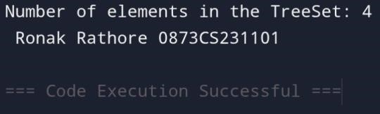

Write a Java program to compare two TreeSets.
Import java.util.TreeSet;
Public class TreeSetCompare {
Public static void main(String[] args) {
TreeSet<String> set1 = new TreeSet<>();
Set1.add(“Apple”);
Set1.add(“Banana”);
Set1.add(“Mango”);
TreeSet<String> set2 = new TreeSet<>();
Set2.add(“Banana”);
Set2.add(“Mango”);
Set2.add(“Apple”);
Boolean isEqual = set1.equals(set2);
System.out.println(“TreeSet 1: “ + set1);
System.out.println(“TreeSet 2: “ + set2);
System.out.println(“Are both TreeSets equal? “ + isEqual);
System.out.println(“ Ronak Rathore 0873CS231101”);
}}
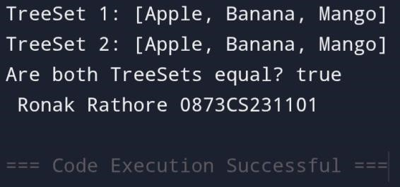

Write a Java program to clone one HashSet into another

Import java.util.HashSet;

Public class HashSetClone {
Public static void main(String[] args) {
HashSet<String> originalSet = new HashSet<>(); originalSet.add(“Red”); originalSet.add(“Green”); originalSet.add(“Blue”);

@SuppressWarnings(“unchecked”)
HashSet<String> clonedSet = (HashSet<String>) originalSet.clone();

System.out.println(“Original HashSet: “ + originalSet);
System.out.println(“Cloned HashSet: “ + clonedSet);
System.out.println(“ Ronak Rathore 0873CS231101”);
}
}
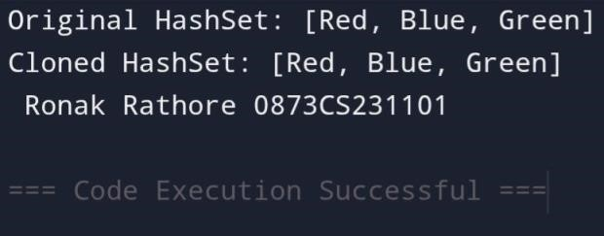

Write a Java program to convert a HashSet into an array.

Import java.util.HashSet;

Public class HashSetToArray {
Public static void main(String[] args) {
HashSet<String> set = new HashSet<>();
Set.add(“Apple”);
Set.add(“Banana”);
Set.add(“Mango”);
String[] array = new String[set.size()];
Set.toArray(array);
System.out.println(“Elements in the array:”);
For (String element : array) {
System.out.println(element);
}
System.out.println(“ Ronak Rathore 0873CS231101”);
}}

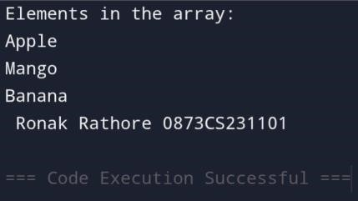

Write a Java program to convert a HashSet into a TreeSet
Import java.util.HashSet;
Import java.util.TreeSet;

Public class HashSetToTreeSet {
Public static void main(String[] args) { HashSet<String> hashSet = new HashSet<>(); hashSet.add(“Banana”); hashSet.add(“Apple”); hashSet.add(“Mango”);

TreeSet<String> treeSet = new TreeSet<>(hashSet);

System.out.println(“HashSet: “ + hashSet);
System.out.println(“Converted TreeSet: “ + treeSet);

System.out.println(“ Ronak Rathore 0873CS231101”);

}}

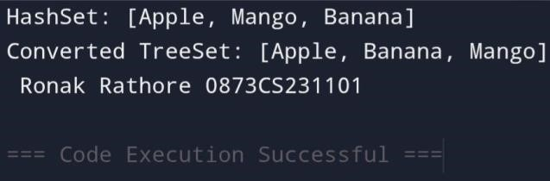

Write a Java program to find numbers less than 7 in a TreeSet

Import java.util.TreeSet;

Public class TreeSetLessThanSeven {
Public static void main(String[] args) {
TreeSet<Integer> numbers = new TreeSet<>();
Numbers.add(1);
Numbers.add(3);
Numbers.add(5);
Numbers.add(7);
Numbers.add(9);
Numbers.add(11);

TreeSet<Integer> lessThanSeven = new TreeSet<>(numbers.headSet(7));
System.out.println(“Original TreeSet: “ + numbers);
System.out.println(“Numbers less than 7: “ + lessThanSeven);
System.out.println(“ Ronak Rathore 0873CS231101”);
}}
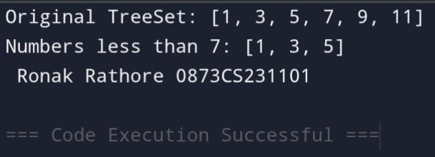

Write a Java program to compare two HashSets.
Import java.util.HashSet;

Public class HashSetCompare {
Public static void main(String[] args) {
HashSet<String> set1 = new HashSet<>();
Set1.add(“Apple”);
Set1.add(“Banana”);
Set1.add(“Mango”);
HashSet<String> set2 = new HashSet<>();
Set2.add(“Banana”);
Set2.add(“Apple”);
Set2.add(“Mango”);
Boolean isEqual = set1.equals(set2);
System.out.println(“HashSet 1: “ + set1);
System.out.println(“HashSet 2: “ + set2);
System.out.println(“Are both HashSets equal? “ + isEqual);
System.out.println(“ Ronak Rathore 0873CS231101”);
}}
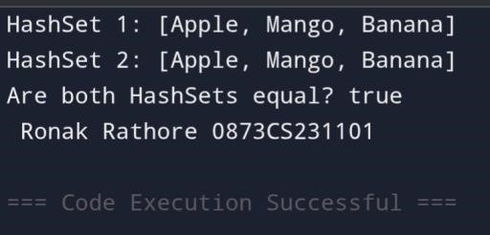

Write a Java program to retain common elements from two sets.

Import java.util.HashSet;

Public class RetainCommonElements {
Public static void main(String[] args) {
HashSet<String> set1 = new HashSet<>();
Set1.add(“Apple”);
Set1.add(“Banana”);
Set1.add(“Mango”);
HashSet<String> set2 = new HashSet<>();
Set2.add(“Banana”);
Set2.add(“Mango”);
Set2.add(“Orange”);
Set1.retainAll(set2);
System.out.println(“Common elements: “ + set1);
System.out.println(“Ronak Rathore 0873CS231101)”
}
}

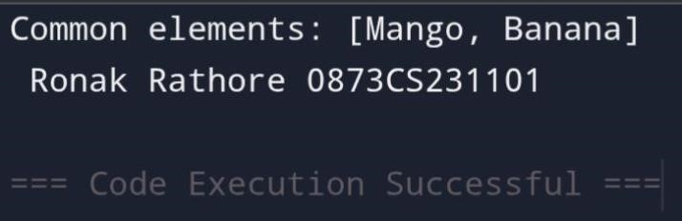

Write a Java program to remove all elements from a HashSet.

Import java.util.HashSet;

Public class HashSetClear {
Public static void main(String[] args) {
HashSet<String> set = new HashSet<>();
Set.add(“Red”);
Set.add(“Green”);
Set.add(“Blue”);

System.out.println(“Original HashSet: “ + set);

Set.clear();

System.out.println(“HashSet after removing all elements: “ + set);
System.out.println(“Ronak Rathore 0873CS231101”);
}
}
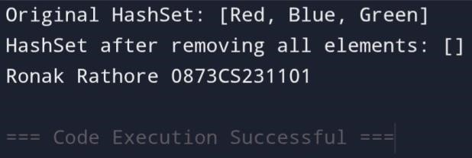

Write a Java program to copy all mappings from one map to another.

import java.util.HashMap; import java.util.Map; public class MapCopy {
public static void main(String[] args) {
HashMap<Integer, String> map1 = new HashMap<>(); map1.put(1, "Apple"); map1.put(2, "Banana"); map1.put(3, "Mango");
HashMap<Integer, String> map2 = new HashMap<>(); map2.putAll(map1);
System.out.println("Original Map (map1): " + map1);
System.out.println("Copied Map (map2): " + map2);
System.out.println("Ronak Rathore 0873CS231101");
}
}

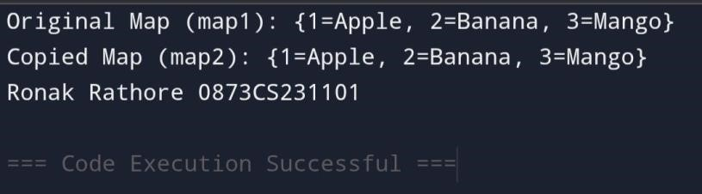
Write a Java program to remove all key-value pairs from a map.

Import java.util.HashMap;

Public class MapClearExample {
Public static void main(String[] args) {
HashMap<Integer, String> map = new HashMap<>();
Map.put(1, “Apple”);
Map.put(2, “Banana”);
Map.put(3, “Mango”);

System.out.println(“Original Map: “ + map);

Map.clear();

System.out.println(“Map after removing all key-value pairs: “ + map);
System.out.println(“ Ronak Rathore 0873CS231101”);
}
}

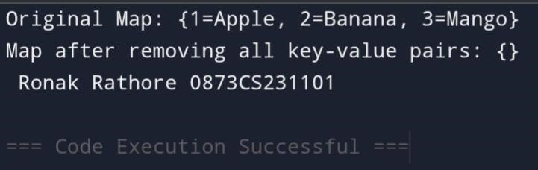
Write a Java program to check if a map is empty or contains key-value mappings.

Import java.util.HashMap;
Public class MapIsEmptyExample {
Public static void main(String[] args) {
HashMap<Integer, String> map = new HashMap<>();
If (map.isEmpty()) {
System.out.println(“The map is empty.”);
} else {
System.out.println(“The map contains key-value mappings: “ + map);
}
Map.put(1, “Apple”);
Map.put(2, “Banana”);
If (map.isEmpty()) {
System.out.println(“The map is empty.”);
} else {
System.out.println(“The map contains key-value mappings: “ + map);
System.out.println(“ Ronak Rathore 0873CS231101”);
}
}
}
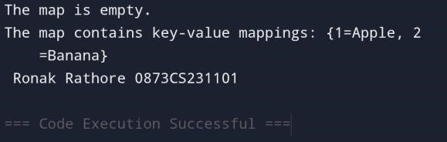

Write a Java program to create a shallow copy of a HashMap instance.

Import java.util.HashMap;

Public class HashMapShallowCopy {
Public static void main(String[] args) {
HashMap<Integer, String> originalMap = new HashMap<>(); originalMap.put(1, “Apple”); originalMap.put(2, “Banana”); originalMap.put(3, “Mango”);

HashMap<Integer, String> shallowCopy = (HashMap<Integer, String>) originalMap.clone();

System.out.println(“Original HashMap: “ + originalMap);
System.out.println(“Shallow Copy of HashMap: “ + shallowCopy);
System.out.println(“ Ronak Rathore 0873CS231101”);

}
}
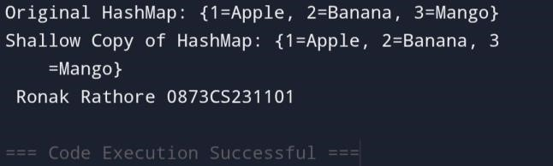

Write a Java program to test whether a specified key exists in the map.

Import java.util.HashMap;

Public class MapKeyCheck {
Public static void main(String[] args) {
HashMap<String, Integer> map = new HashMap<>();
Map.put(“Apple”, 10);
Map.put(“Banana”, 20);
Map.put(“Mango”, 30);

String keyToCheck = “Banana”;

If (map.containsKey(keyToCheck)) {
System.out.println(“Key ‘” + keyToCheck + “’ exists in the map.”);
} else {
System.out.println(“Key ‘” + keyToCheck + “’ does not exist in the map.”); System.out.println(“ Ronak Rathore 0873CS231101”);

}
}}
