PIZZA SALES SQL QUERIES
--Create Database
--Create Table:-
CREATE TABLE pizza_sales_report (
pizza_id INT,
order_id INT,
pizza_name_id VARCHAR(30),
quantity INT,
order_date DATE,
order_time TIME,
unit_price FLOAT,
total_price FLOAT,
pizza_size VARCHAR(15),
pizza_category VARCHAR(20),
pizza_ingredients VARCHAR(300),
pizza_name VARCHAR(100)
);
--Import CSV file and check -> done
-- Preview Data
SELECT * FROM pizza_sales_report LIMIT 5;

Data Exploration & Validation
1. Check Table Row Counts (Data Sanity Check)
SELECT COUNT (*) FROM pizza_sales_report;
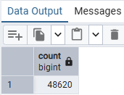
3. Check for NULL Values
SELECT * FROM pizza_sales_report
WHERE
Pizza_id IS NULL
OR
order_id IS NULL
OR
pizza_name_id IS NULL
OR
quantity IS NULL
OR
order_date IS NULL
OR
order_time IS NULL
OR
unit_price IS NULL
OR
total_price IS NULL
OR
pizza_size IS NULL
OR
pizza_category IS NULL
OR
pizza_ingredients IS NULL
OR
pizza_name IS NULL;
->“No missing values found”
A. KPI’s
1. Total Revenue:
SELECT SUM (total_price) AS total_revenue FROM pizza_sales_report;
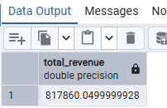
2. Total Orders
SELECT COUNT (DISTINCT order_id) AS total_orders FROM pizza_sales_report;
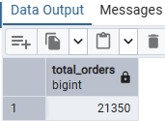
3. Total Pizzas Sold
SELECT SUM (quantity) AS total_pizza_sold FROM pizza_sales_report;
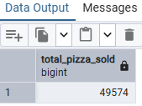

4. Average Order Value
SELECT
(SUM (total_price) / COUNT (DISTINCT order_id)) AS avg_order_value FROM pizza_sales_report;
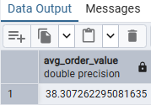
I calculated total revenue and divided it by distinct orders to get average order value.
5. Average Pizzas per Order
SELECT
(SUM (quantity) / COUNT (DISTINCT order_id)) AS avg_pizzas_per_order
FROM pizza_sales_report;
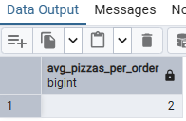

B. Daily Sales Trend
NOTE: - I change year 2015 to 2025 in dataset.
UPDATE pizza_sales_report
SET order_date = MAKE_DATE(2025, EXTRACT(MONTH FROM order_date)::INTEGER,
EXTRACT (DAY FROM order_date):: INTEGER);

Then apply this query: -
SELECT
TO_CHAR (order_date, 'DAY') as order_day,
ROUND (SUM (total_price):: numeric, 2) AS daily_revenue
FROM pizza_sales_report
GROUP BY order_day
ORDER BY daily_revenue DESC;
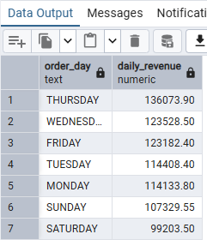

C. Monthly Sales Trend
SELECT
TO_CHAR (order_date, 'MONTH') as order_month,
ROUND (SUM (total_price):: numeric, 2) AS daily_revenue
FROM pizza_sales_report
GROUP BY order_month
ORDER BY daily_revenue DESC;

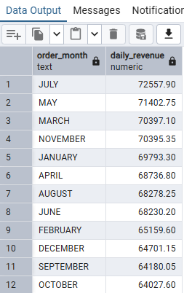

D. Peak hour time
SELECT
EXTRACT(HOUR FROM order_time) AS order_hour,
COUNT(DISTINCT order_id) AS total_orders
FROM pizza_sales_report
GROUP BY order_hour
ORDER BY total_orders DESC;
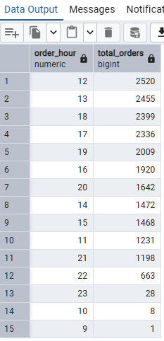

E. % of Sales by Pizza Category
[Formula= categorical revenue *100 / total revenue]
SELECT
pizza_category,
ROUND(
SUM (total_price)::numeric *100 /
(SELECT SUM(total_price)::numeric FROM pizza_sales_report)::numeric,2)
AS perc_sales_by_category
FROM pizza_sales_report
GROUP BY pizza_category
ORDER BY perc_sales_by_category DESC;
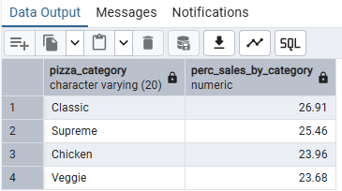
F. % of Sales by Pizza Size
[Formula= size revenue *100 / total revenue]
SELECT
pizza_size,
ROUND(SUM(total_price)::numeric,2),
ROUND(SUM(total_price)::numeric *100 /
(SELECT SUM(total_price)::numeric FROM pizza_sales_report)::numeric,2)
AS per_size_revenue
FROM pizza_sales_report
GROUP BY pizza_size
ORDER BY per_size_revenue DESC;
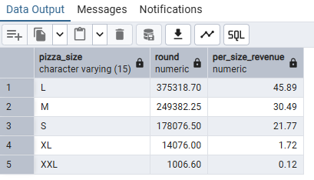
G. Total Pizzas Sold by Pizza Category
SELECT
pizza_category,
SUM (quantity) AS total_quantity_sold
FROM pizza_sales_report
GROUP BY pizza_category
ORDER BY total_quantity_sold DESC;
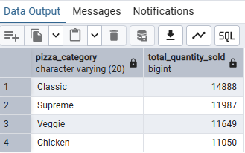
H. Top 5 Pizzas by Revenue
SELECT
pizza_name,
SUM (total_price) AS total_revenue
FROM pizza_sales_report
GROUP BY pizza_name
ORDER BY total_revenue DESC
LIMIT 5;
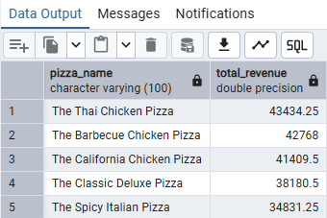
I. Bottom 5 Pizzas by Revenue
SELECT
pizza_name,
ROUND (SUM (total_price)::numeric,2) AS total_revenue
FROM pizza_sales_report
GROUP BY pizza_name
ORDER BY total_revenue
LIMIT 5;
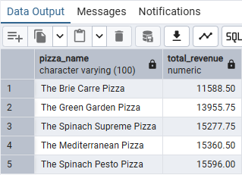

J. Top 5 Pizzas by Quantity
SELECT pizza_name, SUM (quantity) AS total_quantity
FROM pizza_sales_report
GROUP BY pizza_name
ORDER BY total_quantity DESC
LIMIT 5;
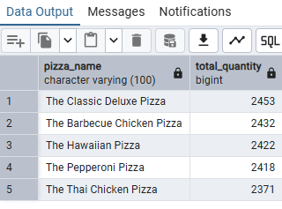
K. Bottom 5 Pizzas by Quantity
SELECT pizza_name, SUM (quantity) AS total_quantity
FROM pizza_sales_report
GROUP BY pizza_name
ORDER BY total_quantity
LIMIT 5;
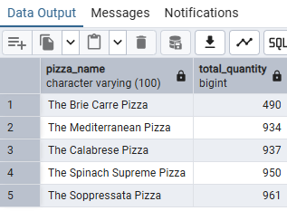

L. Top 5 Pizzas by Total Orders
SELECT pizza_name, COUNT (DISTINCT order_id) AS total_orders
FROM pizza_sales_report
GROUP BY pizza_name
ORDER BY total_orders DESC
LIMIT 5;
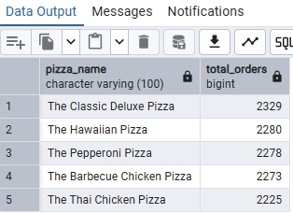
M. Bottom 5 Pizzas by Total Orders
SELECT pizza_name, COUNT (DISTINCT order_id) AS total_orders
FROM pizza_sales_report
GROUP BY pizza_name
ORDER BY total_orders
LIMIT 5;
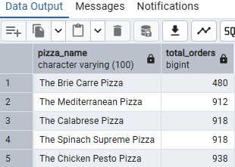

The objective of this project is to analyze pizza sales data to understand overall business performance, identify sales trends, customer purchasing behavior, and product performance. The insights generated will help the business improve revenue, optimize the menu, and make data-driven decisions.

