AI-Based Talent Acquisition &
Skill Gap Analytics Platform
DBMS Mini Project Report
Domain: HR Tech | AI/DS Integration: Candidate Ranking + Skill-Gap Analysis
Submitted by: Raunak
Course: B.E./B.Tech Computer Science

1. Problem Statement & Objective
HR teams handling bulk recruitment struggle to consistently evaluate large numbers of applicants against a job's actual skill requirements. Manual resume screening is slow, inconsistent, and rarely surfaces a candidate's precise skill gap relative to a role.
This project builds a relational database–backed Talent Acquisition platform that stores candidates, jobs, and skills in a normalized schema, and layers an AI/ML scoring engine on top to:
- Automatically rank applicants for a job by a weighted skill-match score.
- Identify the exact skill gap between what a candidate has and what a job requires.
- Expose HR-relevant analytics (applicant volume, skill demand, average scores) through SQL views and a dashboard.
The project is scoped and structured around the 90-mark evaluation rubric covering ER design, normalization, SQL, advanced SQL (procedures/triggers), analytics, AI/ML, dashboarding, and documentation.

2. System Architecture
The database is the foundation of the system; the AI/ML engine is a separate layer that reads candidate/job data, computes scores, and writes results back as ordinary rows (Candidate_Ranking, Skill_Gap) so they can be queried with plain SQL.
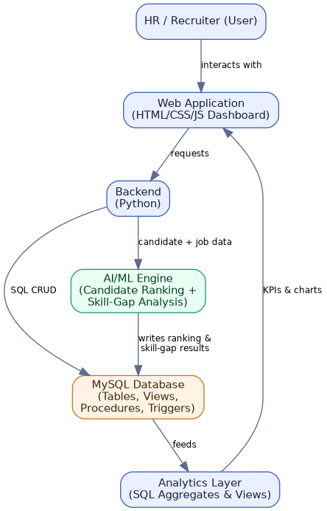

Technology Stack
Layer | Technology
Frontend / Dashboard | HTML5, CSS3, JavaScript, Chart.js
Backend | Python
Database | MySQL 8.0 (SQLite used for local demo/testing)
AI/ML | Python (weighted scoring engine — skill match, experience fit, education fit)
Database Tool | MySQL Workbench

3. ER Diagram & Relational Schema
Eleven entities model the domain: four master/lookup entities (Department, Recruiter, Candidate, Skills), two associative (many-to-many) entities (Candidate_Skills, Job_Required_Skills), the transactional core (Jobs, Applications, Interview), and two entities that store AI/ML output (Candidate_Ranking, Skill_Gap).
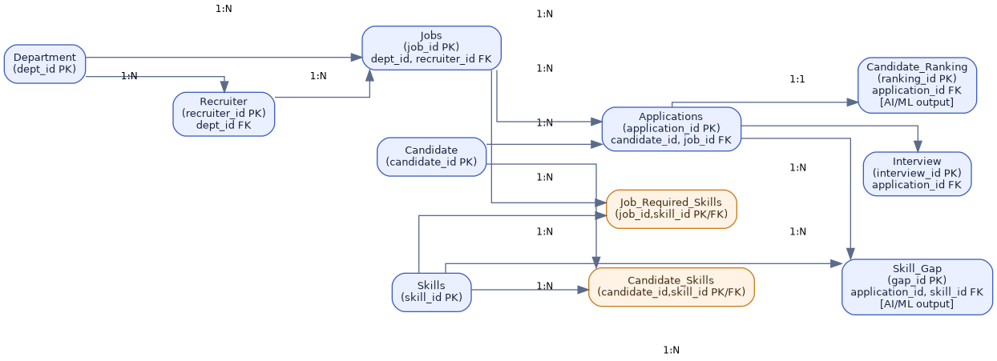

Cardinalities
- Department (1) — (N) Recruiter, Department (1) — (N) Jobs
- Candidate (1) — (N) Candidate_Skills (N) — (1) Skills [many-to-many via junction table]
- Jobs (1) — (N) Job_Required_Skills (N) — (1) Skills [many-to-many via junction table]
- Candidate (1) — (N) Applications (N) — (1) Jobs
- Applications (1) — (N) Interview, Applications (1) — (1) Candidate_Ranking, Applications (1) — (N) Skill_Gap

4. Normalization (1NF → 2NF → 3NF)

Unnormalized form (UNF)
A naive single-table design would look like:
Candidate(ID, Name, Skills, AppliedJobs, RequiredSkillsOfJob, RecruiterName, DeptName ...)
Skills and AppliedJobs are multi-valued (a candidate can have many skills and apply to many jobs), and RequiredSkillsOfJob repeats for every candidate who applies to the same job.

1NF — Eliminate repeating/multi-valued groups
Multi-valued attributes are split into their own rows: one row per (candidate, skill) pair, one row per (job, required skill) pair, one row per (candidate, job) application. This is exactly why Candidate_Skills, Job_Required_Skills, and Applications exist as separate tables instead of comma-separated columns.

2NF — Remove partial dependency
In Candidate_Skills, the composite key is (candidate_id, skill_id). The attribute proficiency depends on the whole key (a specific candidate's level in a specific skill), not on either column alone — so it correctly stays in the junction table rather than being pulled into Candidate or Skills. Likewise required_level and weight_pct in Job_Required_Skills depend on the full (job_id, skill_id) pair.

3NF — Remove transitive dependency
In the original flat design, RecruiterName and DeptName both depend on Jobs indirectly through Recruiter (Jobs → Recruiter → Department is transitive). The final schema removes this by keeping Department and Recruiter as independent tables referenced by foreign key, so every non-key attribute in every table depends only on that table's primary key — satisfying 3NF.
Table | Primary Key | Non-key attributes depend only on PK?
Candidate | candidate_id | Yes — name, email, experience_yrs, degree all describe only the candidate
Candidate_Skills | candidate_id + skill_id | Yes — proficiency depends on the full pair
Jobs | job_id | Yes — dept_id/recruiter_id are FKs, not transitive duplicated data
Job_Required_Skills | job_id + skill_id | Yes — required_level, weight_pct depend on the full pair

5. SQL Implementation
The full DDL/DML lives in schema_mysql.sql. It defines 11 tables with primary keys, foreign keys, NOT NULL, UNIQUE, CHECK and DEFAULT constraints, followed by realistic sample HR data (8 candidates, 4 jobs, 10 skills, 10 applications).

Representative constraint usage
CREATE TABLE Jobs (
job_id INT AUTO_INCREMENT PRIMARY KEY,
job_title VARCHAR(80) NOT NULL,
dept_id INT NOT NULL,
salary_min DECIMAL(10,2) NOT NULL CHECK (salary_min >= 0),
salary_max DECIMAL(10,2) NOT NULL,
status ENUM('Open','Closed') NOT NULL DEFAULT 'Open',
CONSTRAINT fk_job_dept FOREIGN KEY (dept_id) REFERENCES Department(dept_id),
CONSTRAINT chk_salary_range CHECK (salary_max >= salary_min)
);

Multi-table JOIN / GROUP BY / HAVING example
SELECT j.job_title, ROUND(AVG(i.score_out_of_10),2) AS avg_score
FROM Interview i
JOIN Applications a ON i.application_id = a.application_id
JOIN Jobs j ON a.job_id = j.job_id
GROUP BY j.job_title
HAVING AVG(i.score_out_of_10) > 7;
The file also demonstrates subqueries, LIMIT, LEFT JOIN, aggregate functions, and multi-table joins — see Section 6 of schema_mysql.sql for the full analytics query set.

6. Advanced SQL — Views, Stored Procedure, Trigger

View: Top_Candidates_View
CREATE OR REPLACE VIEW Top_Candidates_View AS
SELECT c.candidate_id, c.name AS candidate_name, j.job_id, j.job_title,
r.match_score, r.rank_position
FROM Candidate_Ranking r
JOIN Applications a ON r.application_id = a.application_id
JOIN Candidate c ON a.candidate_id = c.candidate_id
JOIN Jobs j ON a.job_id = j.job_id
ORDER BY j.job_id, r.rank_position;

Stored Procedure: RankCandidatesForJob(job_id)
Recomputes a weighted skill-match score for every applicant to a given job and re-ranks them using a window function. Called as: CALL RankCandidatesForJob(1);
CREATE PROCEDURE RankCandidatesForJob(IN p_job_id INT)
BEGIN
DELETE r FROM Candidate_Ranking r
JOIN Applications a ON r.application_id = a.application_id
WHERE a.job_id = p_job_id;
INSERT INTO Candidate_Ranking (application_id, match_score)
SELECT a.application_id,
ROUND(SUM(CASE
WHEN cs.skill_id IS NOT NULL AND
FIELD(cs.proficiency,'Basic','Intermediate','Advanced') >=
FIELD(jrs.required_level,'Basic','Intermediate','Advanced')
THEN jrs.weight_pct
WHEN cs.skill_id IS NOT NULL THEN jrs.weight_pct * 0.5
ELSE 0 END),2)
FROM Applications a
JOIN Job_Required_Skills jrs ON jrs.job_id = a.job_id
LEFT JOIN Candidate_Skills cs
ON cs.candidate_id = a.candidate_id AND cs.skill_id = jrs.skill_id
WHERE a.job_id = p_job_id
GROUP BY a.application_id;
-- rank_position assigned via RANK() OVER(...) — see schema_mysql.sql
END;

Trigger: trg_after_application_insert
Fires automatically whenever a new row is inserted into Applications. It compares the job's required skills against the candidate's existing skills and logs every missing skill into Skill_Gap immediately — no manual step required.
CREATE TRIGGER trg_after_application_insert
AFTER INSERT ON Applications
FOR EACH ROW
BEGIN
INSERT INTO Skill_Gap (application_id, skill_id, gap_severity)
SELECT NEW.application_id, jrs.skill_id,
CASE WHEN jrs.weight_pct >= 30 THEN 'Critical'
WHEN jrs.weight_pct >= 15 THEN 'Moderate'
ELSE 'Minor' END
FROM Job_Required_Skills jrs
WHERE jrs.job_id = NEW.job_id
AND jrs.skill_id NOT IN (
SELECT skill_id FROM Candidate_Skills WHERE candidate_id = NEW.candidate_id);
END;
This trigger was verified on the SQLite demo build: inserting the 10 sample applications automatically generated 8 skill-gap rows with no application code involved.

7. Data Analytics
Computed directly from the sample dataset via SQL views/aggregates:
Job | Applicants
Data Scientist | 3
Backend Developer | 3
ML Engineer | 2
BI Analyst | 2

Skill | Jobs Requiring It | Avg. Weight %
SQL | 4 | 23.75
Python | 2 | 27.5
Power BI | 2 | 30
Machine Learning | 2 | 32.5
React | 1 | 30
Java | 1 | 40
Excel | 1 | 30
Deep Learning | 1 | 25

8. AI/ML Component — Candidate Ranking & Skill-Gap Analysis
Implemented in ai_ml/ranking_skillgap.py, layered on top of the database (not inside it), matching the rubric's expectation that AI/DS work be a clearly separated component.

Scoring model
match_score = 0.65 * skill_match_pct (weighted required-skill coverage)
+ 0.20 * experience_fit_pct (candidate years / required years, capped 100%)
+ 0.15 * education_fit_pct (degree-tier lookup)
skill_match_pct gives full credit for a required skill held at or above the required proficiency level, half credit if held below the required level, and zero if missing entirely — those zero/half-credit skills become the candidate's skill gap for that application.

Sample output — Data Scientist role
Rank | Candidate | Score | Skill Gap
1 | Sneha Patil | 98.5% | None
2 | Rahul Verma | 85.8% | Power BI
3 | Neha Joshi | 74.55% | Machine Learning, Power BI

Overall top 5 candidates (across all open roles)
Candidate | Job | Score
Sneha Patil | Data Scientist | 98.5%
Sneha Patil | ML Engineer | 90.38%
Rahul Verma | Data Scientist | 85.8%
Rahul Verma | ML Engineer | 82.55%
Priya Iyer | BI Analyst | 78.7%

9. Dashboard & Visualization
A standalone HR Talent Acquisition Dashboard (dashboard/dashboard.html) renders live from the AI/ML engine's JSON output and shows:
- KPIs — total candidates, total jobs, applications, average match score
- Bar chart — most demanded skills across open jobs
- Bar chart — most common skill gaps
- Doughnut chart — applicants per job
- Sortable/filterable table — full candidate ranking with per-skill gap tags, filterable by job

10. Conclusion & Future Scope
The platform demonstrates a complete pipeline: a normalized relational schema (3NF) → constrained SQL storage → an AI/ML scoring layer → analytics views → an interactive dashboard, directly mapped to every component of the evaluation rubric.

Future scope
- Parse real resumes (PDF/DOCX) with NLP to auto-populate Candidate_Skills instead of manual entry.
- Replace the fixed weighting formula with a trained ML model (e.g. logistic regression) once enough hiring-outcome data exists.
- Add role-based authentication for recruiters and an admin panel for managing job postings.
- Deploy the backend as a REST API (FastAPI/Flask) so the dashboard can read live data instead of a static JSON export.

