CIA - 2

Course : Introduction to AI in Business Applications

Topic :

Designing an AI-Powered Business Automation Solution with Data Analytics

Group 3 :

Cinderella Coutinho - 25111308
Narendra Singh - 25111325
Raunak Mukherjee - 25111329

Class: 3 BBA BA C

Date: 19/10/2026

Introduction

Our group chose the theme AI for Future of Work. Within it, we wanted a problem that a real company had faced and talked about in public, so that the evidence did not have to come from us. TCS fits that well. It is India's largest IT services firm with roughly 598,000 employees at the end of September 2026, it has invested heavily in AI training for its own staff, and it has still had to let thousands of people go because of a mismatch between their skills and client demand.

The report follows the order of the assignment brief. Sections 2 to 4 cover the problem, the evidence, the way things work today and where that breaks down. Section 5 names the AI technologies we would use. Section 6 is the data analytics component. Sections 7 and 8 describe the solution and the benefits we expect. Section 9 deals with risks, ethics and the different stakeholders. We close with the limits of our work and a short conclusion.

The Business Problem and the Evidence

The problem in one line

TCS has a large workforce whose skills are not keeping pace with client demand for AI, cloud and agile delivery, and the company has no early, reliable way to find the gap, close it and redeploy people before layoffs become the only option.

Reported So Far
The table lists the main facts we found, with the source for each.
Layoffs: In July 2025, TCS said it would cut about 2% of its workforce (around 12,000 people), mainly in middle and senior grades.
Stated reason: CEO K. Krithivasan said the cuts were due to skill mismatch and the inability to redeploy certain employees, not AI-driven productivity gains.
Reskilling gap: Over 5.5 lakh employees were trained in basic AI and over 1 lakh in advanced skills, but reskilling did not always lead to redeployment, especially for senior staff.
Delivery model shift: Moving from waterfall to agile, product-centric delivery reduced demand for conventional project and program managers.
Wider risk: One analyst estimated 400,000 to 500,000 IT professionals could be at risk over two to three years, about 70% of them with 4 to 12 years of experience.
Workforce and attrition: 598,056 employees at the end of Q2 FY27 (30 September 2026). Attrition was 13.3% over the last twelve months, down from 13.6% in the previous quarter.

How the Process Works Today and Where It Breaks
TCS has not published its internal redeployment process, so the table below is our understanding based on public reports and on how large IT services firms generally manage people between projects.
Project ends: The employee moves to the bench (not allocated to billable client work). Any skill gap is usually noticed only now, after the project has ended.
Matching: A resource management team searches for open requirements and matches benched employees, largely by hand. It is slow, depends on individuals, and skill records are often stale, so good matches are missed.
Training: Employees are pushed into broad programmes, such as basic AI training for hundreds of thousands of staff. One programme for everyone does not tell a given employee which skill would actually get them placed.
Performance review: Appraisals happen on a fixed cycle, usually once a year. This is too infrequent to give an early warning, so a mismatch can build for months before it shows up.
Decision: If no placement is found after a long bench period, the person may be asked to leave. The decision comes late, when options are fewest and the human cost is highest.

Analysis of the Business Issues

Process issues
The first issue is timing. Every stage in Section 3 reacts to something that has already happened. In our dataset, employees who were later released had spent an average of about 52 bench days in the year, compared with about 27 for those retained. By the time the bench time looks alarming, most of the options have gone.
The second is that training is treated as the cure, when what matters is whether it closes the specific gap the market is asking about. TCS's own reporting makes the point: very large numbers were trained and redeployment still fell short. In our data, hours of training and skill match are only moderately related (a correlation of about 0.32), while having completed advanced AI training moves average skill match from about 58% to about 76%. The type of training seems to matter more than the number of hours.

Data issues
Useful information is spread across separate systems: the HR record, the learning platform, project allocation and the client demand pipeline. Unless these are joined, nobody can see in one place that a particular employee has a Java-heavy profile, has done two cloud courses, has been benched for 40 days and fits an open requirement. Skill data is also self-reported or entered once, so it ages quickly. Any model built on weak data will be weak, a point our own results in Section 6 illustrate.

Users and what they need
Employees want to know where they stand and what to do next, without feeling watched. HR and resource managers want an early list of who needs help and clear reasons for each name. Delivery managers want people with the right skills quickly. Leadership wants lower bench cost and fewer painful exits. These needs do not always line up. An employee may not want a risk flag next to their name, while HR wants as much visibility as possible. The design has to give each group something useful without turning into a surveillance tool.

AI Techniques Implemented
We chose AI techniques that match the specific tasks in the process, and which connect to the two course objectives this assessment covers (CO3 on conversational agents and NLP, and CO4 on automation and business processes).

AIs | Purpose
NLP (skill extraction) | Reads CVs, project descriptions and course records and maps them to a common skill list.
Machine learning (risk and match models) | Estimates the chance of a skill mismatch from skill match, bench days, experience band and role family. Scores how well a person fits an open project.
Recommendation engine | Suggests the few courses that close the biggest gap for a given person, and the projects that fit best.
Conversational AI (LLM chat assistant) | Answers employee and HR questions in plain language: What am I missing for a cloud role? Which projects are open for me?
RPA / workflow automation | Sends reminders, enrols people in courses, updates records and schedules follow-ups.

Data Analytics Component
We worked with a dataset of 300 employee records and 16 fields . Each row describes one employee: experience band, years of experience, role family, gender, whether they completed basic and advanced AI training, training hours in the last 12 months, number of certifications, how well their skills match current client demand, days on the bench, billable utilisation, performance rating, redeployment attempts, whether they were successfully redeployed, and the outcome. The outcome has three values: Retained (235 employees, 78.3%), Voluntary Exit (40, 13.3%) and Released for skill mismatch (25, 8.3%).

Because TCS does not release employee-level data, the records are simulated. We set the main proportions to match public figures: voluntary exit at about 13% (TCS reported 13.3%), basic AI training at about 91% (TCS reported roughly 5.5 lakh of about 6 lakh employees) and advanced training at about 14% (about 1 lakh). The share of employees released for skill mismatch is higher in our data (8.3%) than in reality (about 2%).

Tool and method

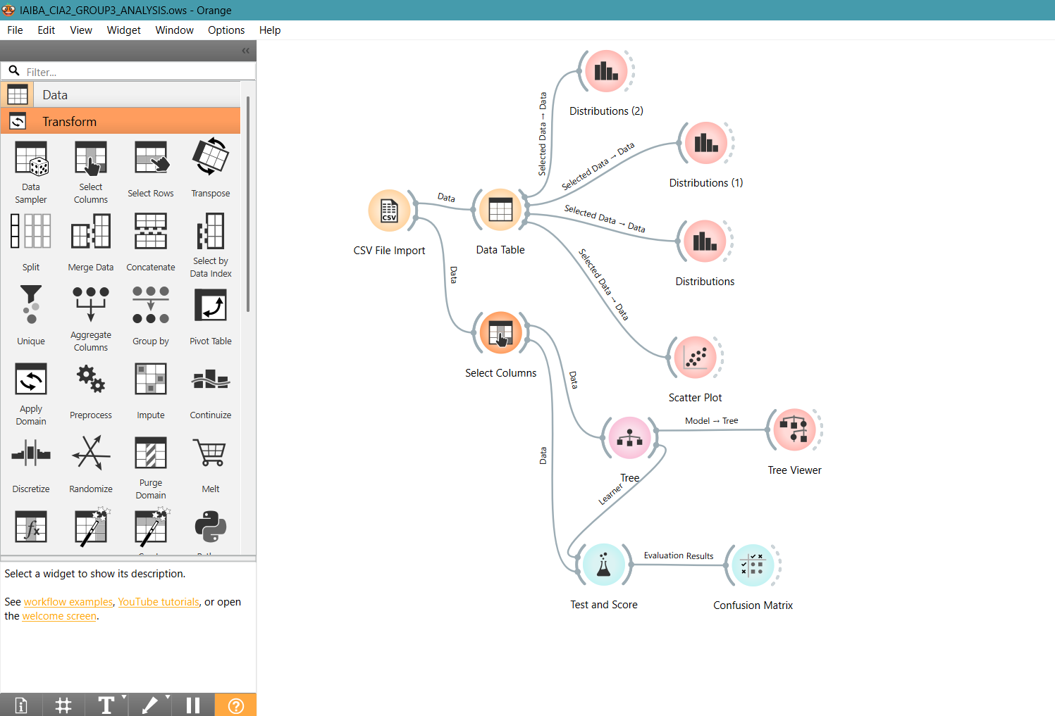
We used Orange for the analysis. We loaded the data, looked at distributions and a scatter plot to understand the main patterns, then trained a decision tree to see whether the outcome could be predicted, and checked it with 5-fold stratified cross-validation and a confusion matrix.

Findings
Figure 1 shows the three outcomes split by gender. Women make up 110 of the 300 employees (37%). Ten percent of women were released against 7% of men, but that is 11 people against 14, which is too few to call a pattern.
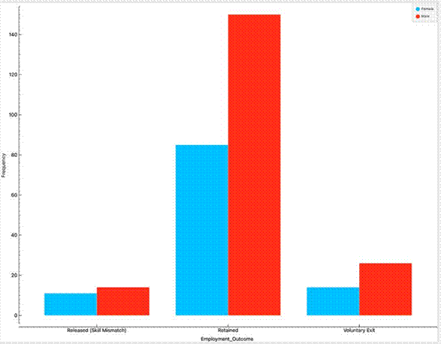
Figure 1: Employment outcome by gender (Orange, Distributions widget)
Figure 2 shows the mix of role families. Software developers are the largest group (82), followed by Data/AI engineers and project/program managers (43 each), infrastructure support (40), cloud/DevOps (36), testers (31) and business analysts (25).
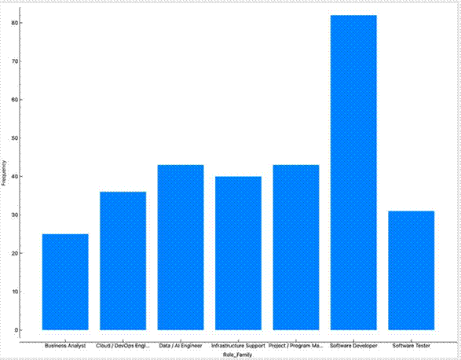
Figure 2: Number of employees by role family

Figure 3 is the most important chart for the argument. Each dot is an employee, with skill match on the horizontal axis and bench days on the vertical axis. The blue dots (released) bunch in the upper left, which is low skill match and long bench time. The green dots (voluntary exits) are scattered with no clear pattern, which makes sense, since people leave for many reasons that skills do not explain.

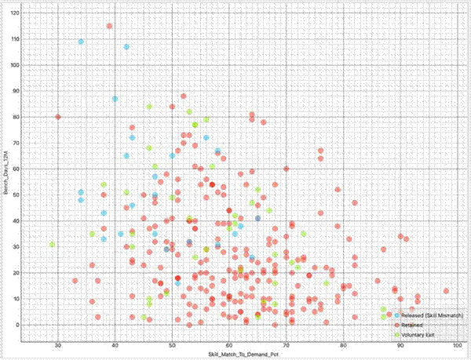
Figure 3: Skill match to demand against bench days, coloured by outcome (Orange, Scatter Plot)
Figure 4 is a cumulative chart of training hours. The median is about 39 hours, and about a third of employees (92 of 300) logged 30 hours or fewer in the year. Training effort is therefore uneven. Released employees averaged about 33 hours against about 40 for retained employees, a gap that is real but not large, which fits the idea that what people train in matters more than how long they train.
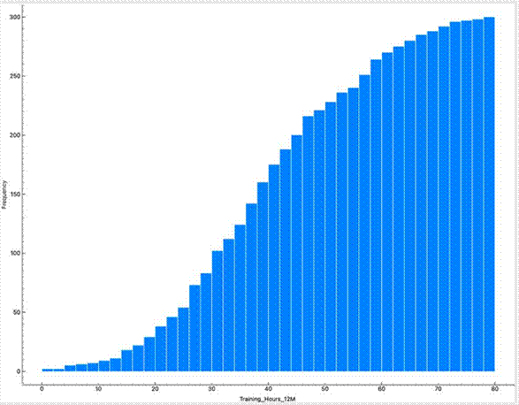
Figure 4: Cumulative distribution of training hours in the last 12 months

Table 1 pulls together the averages by outcome and the redeployment results we use later. These were calculated from the same dataset (for example with Orange's Pivot Table or Feature Statistics widgets).

Measure | Retained (235) | Voluntary exit (40) | Released (25)
Average skill match to demand (%) | 61.9 | 57.1 | 47.9
Average bench days (12 months) | 27.3 | 36.4 | 51.6
Average training hours | 40.2 | 40.0 | 32.8
Average years of experience | 8.8 | 7.4 | 16.4
Average performance rating (1 to 5) | 3.4 | 3.3 | 3.3

Table 1: Average values by employment outcome
Group | Employees | Released | Benched >30 days | Redeployed (of benched)
Skill match below 50% | 66 | 15 (23%) | 40 | 15 (38%)
Skill match 50 to 64% | 130 | 9 (7%) | 62 | 38 (61%)
Skill match 65% or above | 104 | 1 (1%) | 26 | 24 (92%)
Entry level (0 to 3 yrs) | 87 | 2 (2%) | 27 | 22 (81%)
Mid level (4 to 12 yrs) | 133 | 3 (2%) | 54 | 38 (70%)
Senior (13+ yrs) | 80 | 20 (25%) | 47 | 17 (36%)
Project / program managers | 43 | 15 (35%) | 29 | 11 (38%)
Table 2: Release and redeployment by skill match, experience band and role

Skill match works directly and inversely, meaning that the higher it is, the more likely redeployment and the less likely chance of release. And seniority and role matter on top of skill. Senior employees make up 27% of the sample but 80% of those released, and project managers make up 14% of the sample but 60% of those released. This lines up closely with what TCS said about mid and senior staff and about the move away from waterfall project management.
Predictive model
We then asked whether a decision tree could predict the outcome.
It splits first on whether the employee was successfully redeployed, then on years of experience, bench days, training hours and performance rating. One branch shows employees with more than 15 years of experience who were not redeployed and logged more than 18 training hours: this branch is mostly shaded blue, meaning most of them were released.

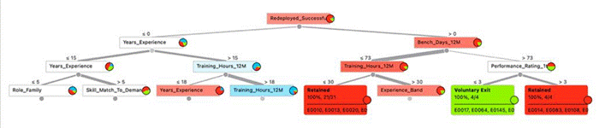
Figure 5: Decision tree for Employment_Outcome (Orange, Tree Viewer, display depth 4)
The evaluation results are less encouraging, and we think it is better to say so plainly. Figure 6 shows 5-fold stratified cross-validation. The tree scores a classification accuracy of 0.743 and an F1 of 0.718, which looks reasonable at first glance. But the AUC is 0.507, which is essentially chance. And since 235 of the 300 employees were retained, a model that predicted Retained every time would be right 78.3% of the time, so the tree's accuracy is in fact below that simple baseline.
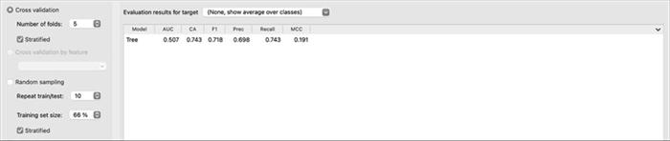
Figure 6: Test and Score results, 5-fold stratified cross-validation

The confusion matrix in Figure 7 shows where the tree goes wrong. It correctly identified 11 of the 25 released employees (44%) and 210 of the 235 retained employees (89%), but only 2 of the 40 voluntary exits (5%). Thirty-five voluntary exits were predicted as retained.
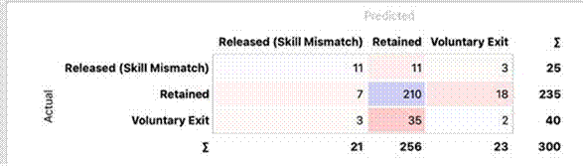
Figure 7: Confusion matrix for the decision tree (Orange)

We see three reasons for the weak result. First, 300 rows is small for a tree with 26 leaves, so it has probably memorised noise. Second, the target has three classes and two of them are small. Third, the tree uses Redeployed_Successfully as an input, and that field is only known after the fact, so it would not be available when making an early prediction.

Interpretation

Early warning is possible. Low skill match and long bench time clearly go with release. A system that watches these two signals could raise an alert weeks before a decision is needed. The simple rule "skill match below 50% or more than 60 bench days" flags 89 employees and includes 18 of the 25 who were released (72%), although only about one in five of those flagged was actually released.

Training should be targeted. The gain comes from advanced, relevant skills and not from hours. A recommendation engine should point each person to the specific skill that closes their gap.

Seniors and project managers need extra attention. They carry most of the risk, so they should be the first groups in a pilot and should get more personal support.

Redeployment is the real lever. Among employees benched for more than 30 days, 60% were redeployed (77 of 128). Raising that number is the most direct way to avoid releases.

The model as built is not good enough to act on its own. This is the challenge. The weak AUC is a good reason to keep HR in the loop, to treat any prediction as a prompt for a conversation and not a verdict, and to check the model regularly.

Proposed AI Solution: SkillSense

TCS SkillSense is a proposed AI solution demonstrated in the form of a website that receives employee data input, and conducts real time analysis.

Its processes can be shown in the figures below :

Figure 8 compares the current process with the proposed one. The main change is that the first alert moves from the end of the process to the start: at about 30 bench days, or earlier if skill match falls below a threshold, and not after 60 or more days with no match.
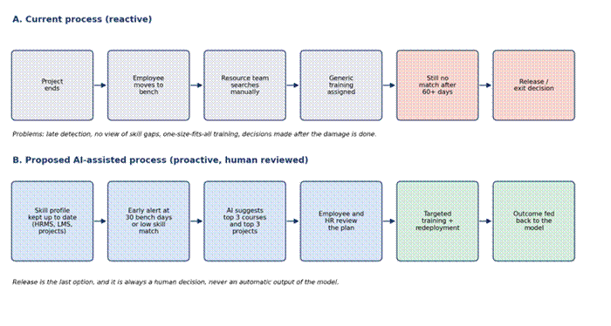
Figure 8: Current process compared with the proposed AI-assisted process

System design
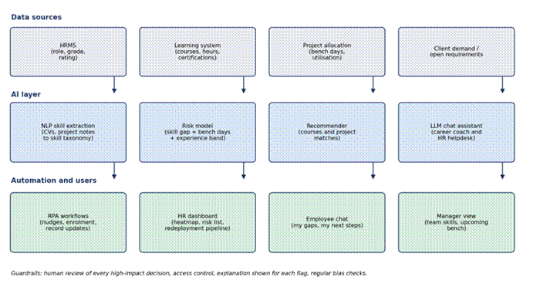
Figure 9 shows the main parts. Four data sources feed an AI layer made up of skill extraction, a risk model, a recommender and a chat assistant. Those outputs reach people through an HR dashboard, an employee chat, a manager view and automated workflows.

Expected Business Benefits

Benefit | Basis and assumption | Estimated effect
Higher redeployment | Among benched employees, redeployment is 38% when skill match is below 50% and 61% when it is 50 to 64% (Table 2). | About 5 more employees redeployed out of 128 benched, so the redeployment rate rises from 60% to about 64%. If all 40 moved, about 10 more, taking it to about 68%.
Fewer skill-mismatch releases | Release rate is 23% in the low-match group against 7% in the middle group (Table 2). | Each person moved out of the low group lowers their chance of release by about 16 percentage points. Across 66 low-match employees, moving half would avoid roughly 5 releases in the sample.
Support for senior staff | Only 36% of benched senior employees were redeployed, against 81% of entry-level. Assume the assistant lifts senior redeployment by 14 percentage points. | About 7 more of the 47 benched seniors were placed in the sample.
Lower HR workload | A chat assistant can handle routine questions about skills, courses and open projects. We have no measured figure for this. | To be measured in the pilot, for example by the share of queries resolved without HR involvement.

Risks, Ethical Concerns
Stakeholder | What worries them
Employees | Being monitored and scored. Seeing a risk flag used against them. Not understanding why they were flagged.
HR and resource managers | Over-trusting a weak model. Being blamed for decisions that were influenced by the tool.
Delivery managers and clients | Recommendations that look good on paper but do not reflect real project needs.
Company leadership | Cost and effort of integration, legal exposure if the system is biased or mishandles data.
Unions and regulators | A tool that is used to justify layoffs. Data protection compliance.

Managerial Impact
We think the idea is feasible if it is built in stages. Phase 1 would clean and connect the data and run the analysis again on real records. Phase 2 would launch the chat assistant and the recommendation engine for one business unit, with senior staff and project managers as the first group. Phase 3 would add the risk model and the HR dashboard once the data has proved good enough, and extend to other units.

On operations, the biggest changes are for resource management teams, whose work shifts from searching manually to reviewing suggestions, and for managers, who will have to release people for training. The biggest practical risk is data quality, followed by adoption. Both are reasons for the pilot to be small, to begin with the groups in most need, and to include people from HR, delivery and employee representation in its governance

Limitations
The employee data is simulated, so the patterns in Section 6 show how the factors relate in a world built from public figures, not what is true inside TCS. The decision tree performed no better than chance and uses a field that would not be known in advance. The sample is of a small range. The description of the current process is based on public reports and general industry practice and not on interviews.
Conclusion
TCS's experience shows that offering AI training to a very large workforce does not by itself solve a skills mismatch. People still have to be matched to work, and the people who find it hardest to move, mainly senior staff and project managers, need earlier and more personal support. Our analysis points in the same direction. Low skill match and long bench time go together with release, advanced skills lift match, and a simple model on this data is not reliable enough to decide anything alone.

For that reason, SkillSense is designed as an early-warning and recommendation tool with people in charge. It would give employees a clearer path, give HR an earlier and better-explained picture, and give the company more chances to keep skilled people instead of replacing them. Whether it works as hoped is something a small, carefully measured pilot would show, and we have set out how we would run one.

References

TCS (2026). TCS begins FY27 with continued growth; wins multiple AI transformation deals (Q1 FY27 press release).
https://www.tcs.com/who-we-are/newsroom/press-release/tcs-financial-results-q1-fy-2027
Zeebiz (2026). TCS headcount rises to nearly 6 lakh in Q2 FY27; attrition rate at 13.3%. https://www.zeebiz.com/companies/news-tcs-headcount-it-behemoth-workforce-strength-rises-to-nearly-6-lakh-in-q2-fy27-attrition-rate-at-133-403613
Business Today (8 October 2026). TCS adds 4,258 employees in Q2. https://www.businesstoday.in/markets/stocks/story/tcs-adds-4258-employees-in-q2-marks-third-quarter-of-headcount-addition-560460-2026-10-08
Reuters via Yahoo Finance (2025). India tech giant TCS layoffs herald AI shakeup of $283 billion outsourcing sector. https://tech.yahoo.com/ai/articles/analysis-india-tech-giant-tcs-052643308.html
GreatAndhra (2025). Skill gaps, not AI, drive TCS job cuts (quoting Moneycontrol interview with K. Krithivasan). https://www.greatandhra.com/articles/special-articles/skill-gaps-not-ai-drive-tcs-job-cuts-148034
Outlook Business (2025). "Skill mismatch, not AI": TCS CEO clarifies reason behind sudden layoffs. https://www.outlookbusiness.com/corporate/skill-mismatch-not-ai-tcs-ceo-clarifies-reason-behind-sudden-layoffs
Fierce Network (2025). TCS layoffs signal AI-driven shift in India's IT industry. https://www.fierce-network.com/modernization/tcs-layoffs-signal-ai-driven-shift-in-indias-it-industry
Deccan Herald (2025). MeitY keeping a watch as TCS announces 12,000 lay-off plan. https://www.deccanherald.com/business/meity-keeping-a-watch-as-tcs-announces-12-000-lay-off-plan-3652780
EmpTrust. The true cost of new hire turnover: why the first 90 days matter (citing Gallup). https://www.emptrust.com/?p=22802
GeekWire (2024). AI overwhelmingly prefers white and male job candidates in new test of resume screening bias (University of Washington study). https://www.geekwire.com/2024/ai-overwhelmingly-prefers-white-and-male-job-candidates-in-new-test-of-resume-screening-bias/

