Name – Raunak Jha
Question 1 : Create a mapping in Informatica IICS to load employee data from a flat file into SnOwflake using expressions, a filter, and a sorter
TASK 1: FLAT FILE SOURCE CONFIGURATION
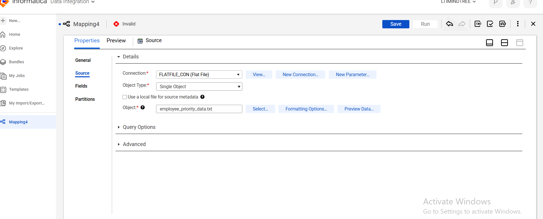

TASK 2 : EXPRESSION -1 (FULL NAME CREATION)
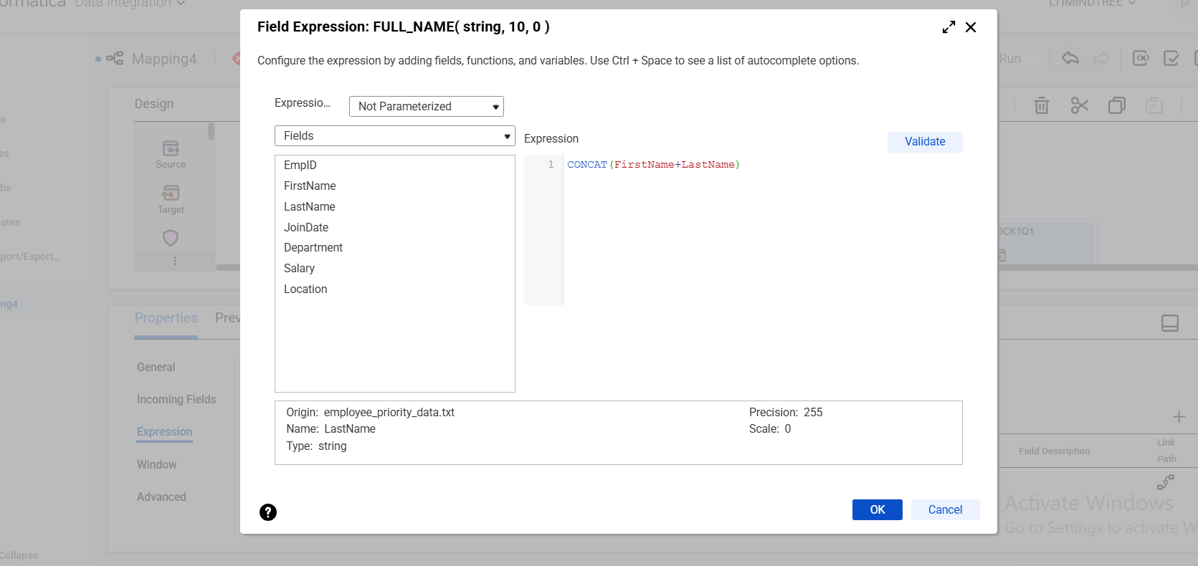

TASK 3 : EXPRESSION -2 (PRIORITY CATEGORY )
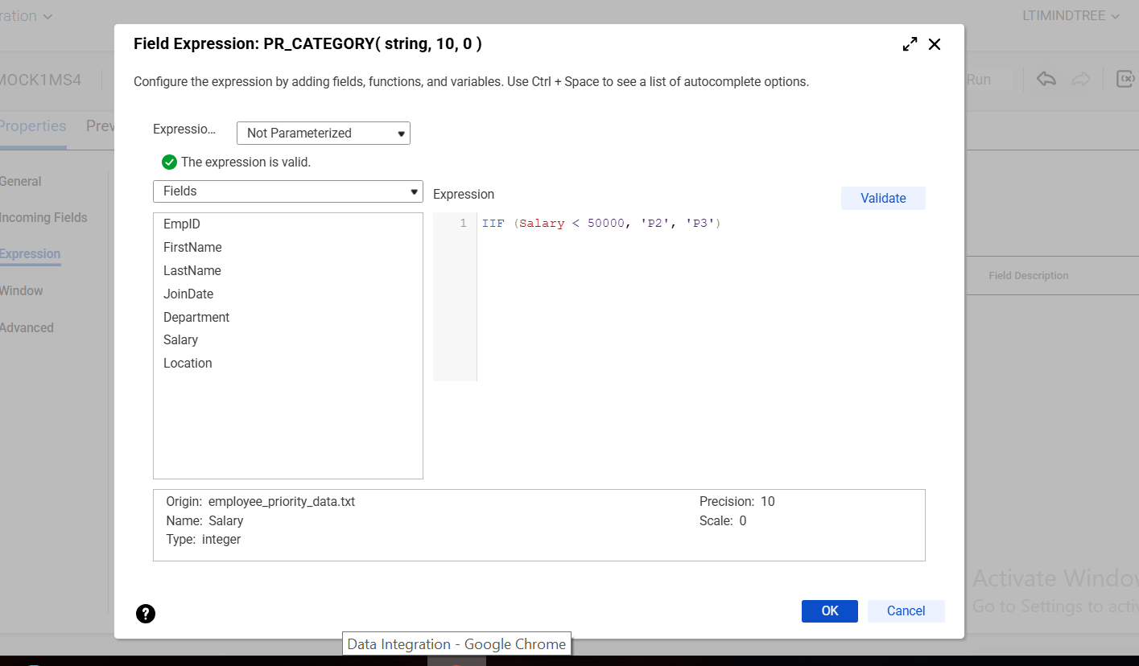

TASK 4:FILTER CONFIGURATION
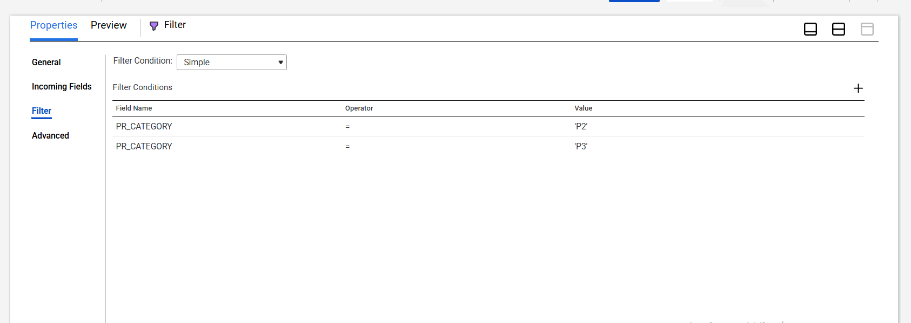

TASK 5 : SORTER EXECUTION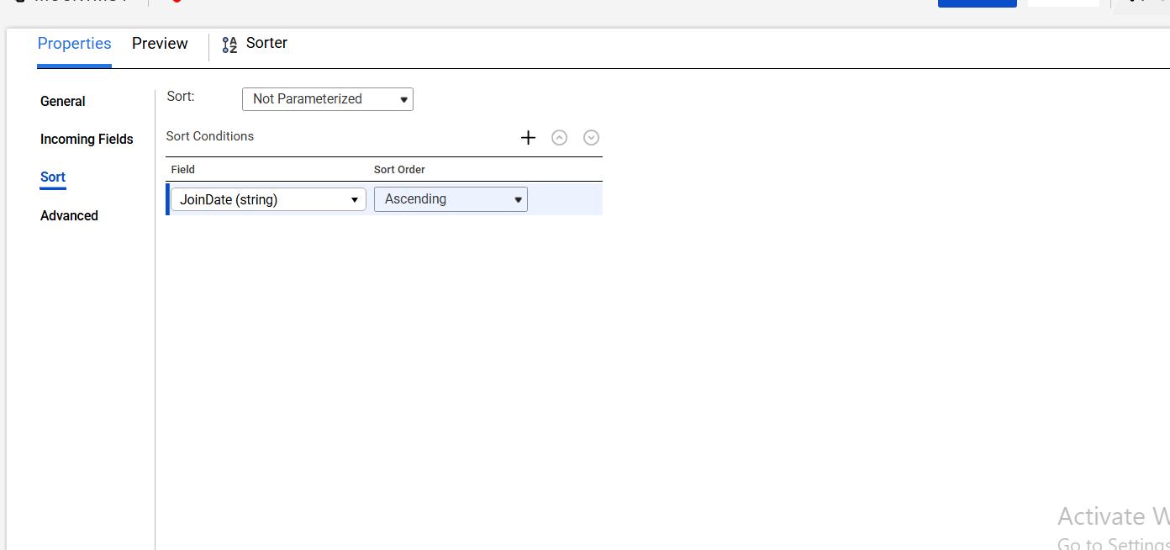

TASK 6: MAPPING EXECUTION SHOWING SUCCESS
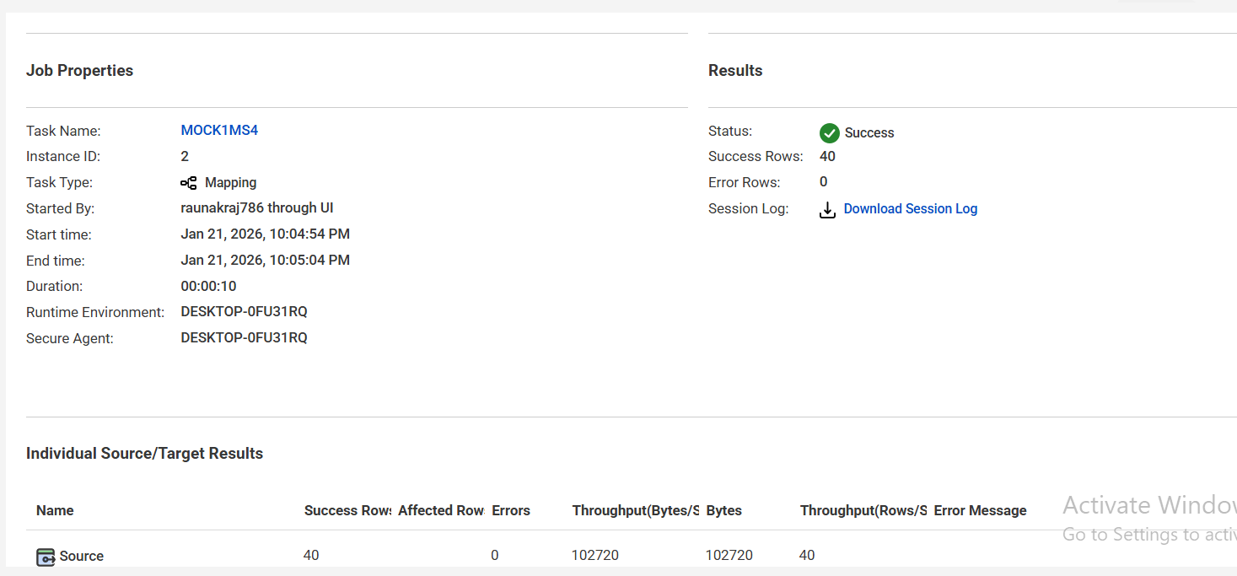

QUESTION 2 : Create a mapping task in informnatica iics to load employee data from a flat file into a snowflake table by using expression a parameterized filter, and a sorter
TASK 1 : FLAT FILE SOURCE CONFIGURATION
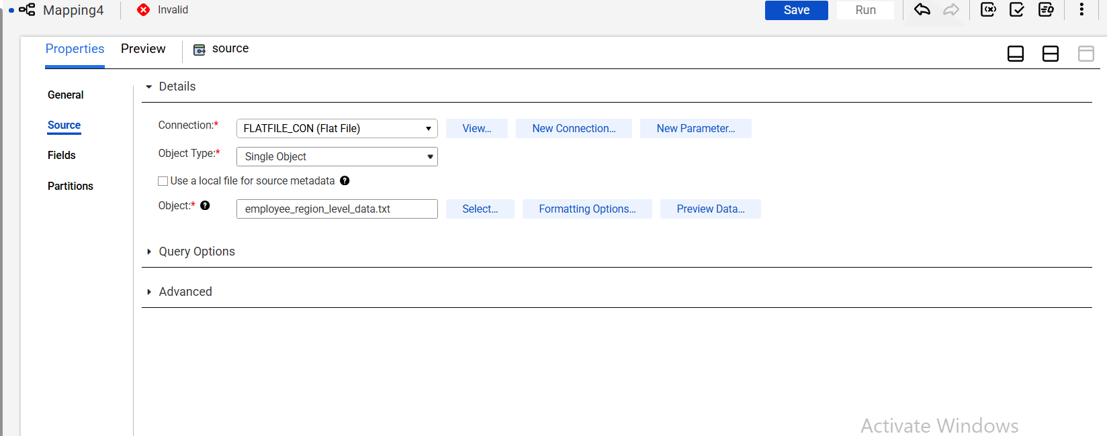

TASK 2 : EXPRESSION 1 CONFIG (REGION DERIVATION)
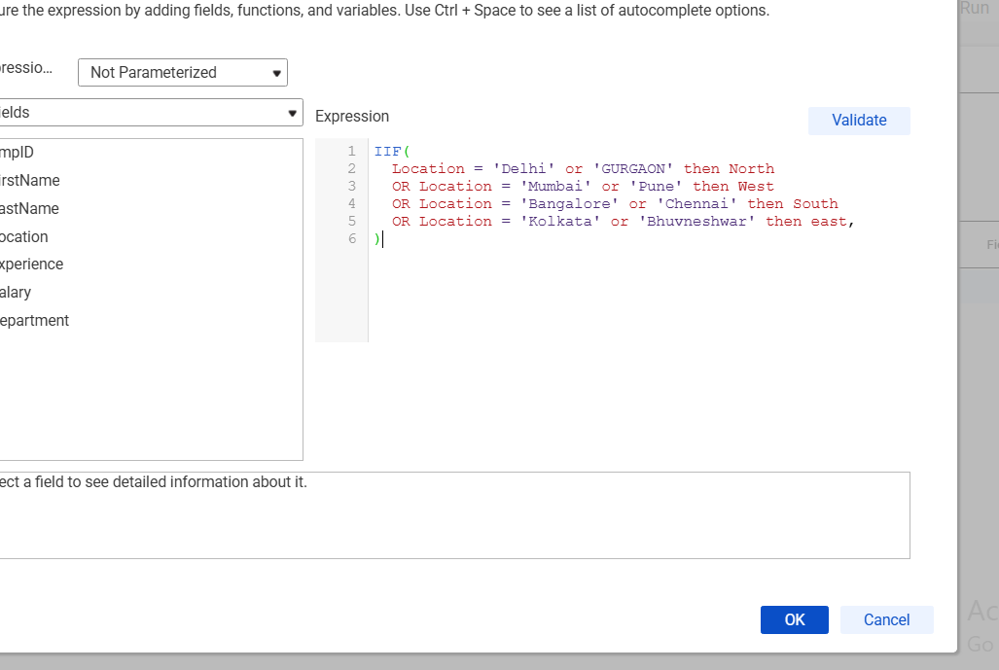

TASK 3 : EXPRESSION 2 (EMPLOYEE LEVEL)
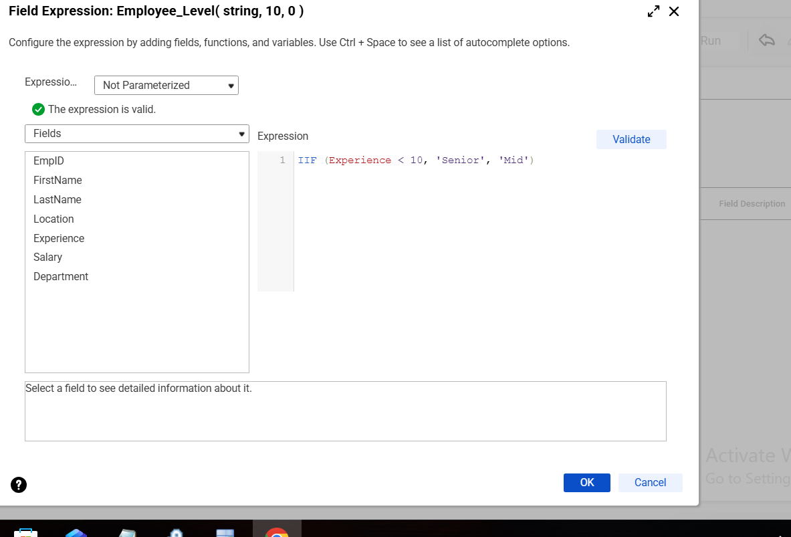

TASK 4 : PARAMETER DEFINITON AND ASSIGNED VALUE
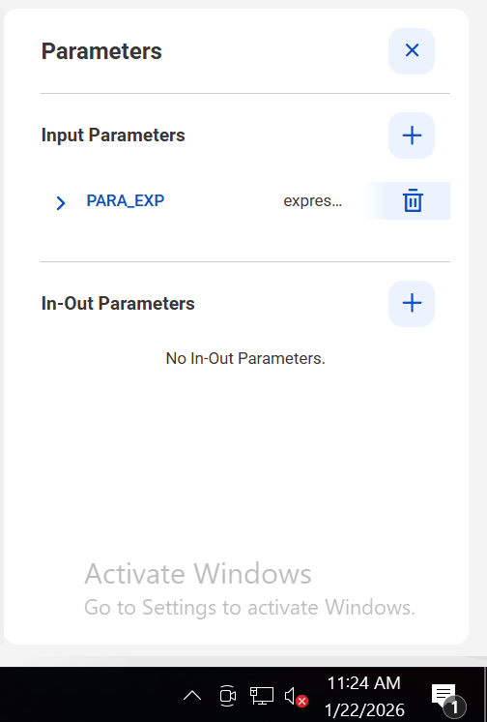

TASK 5 : PARAMTERIZED FILTER CONFIGURATION
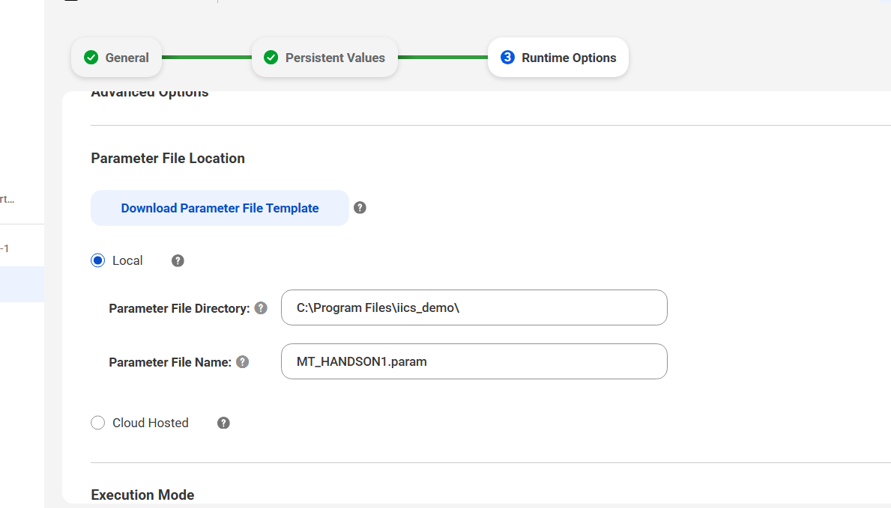

TASK 6 : SORTER CONFIGURATION
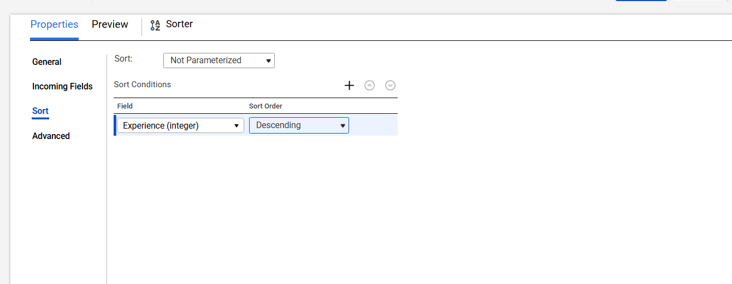

TASK 7: MAPPING SUCCESFUL EXECUTION
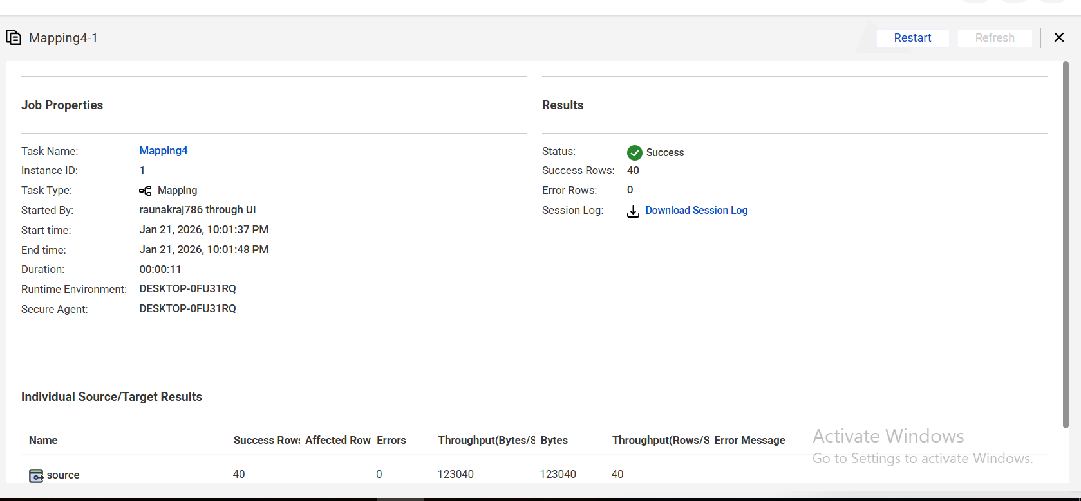

TASK 8 : TARGET TABLE RECORDS
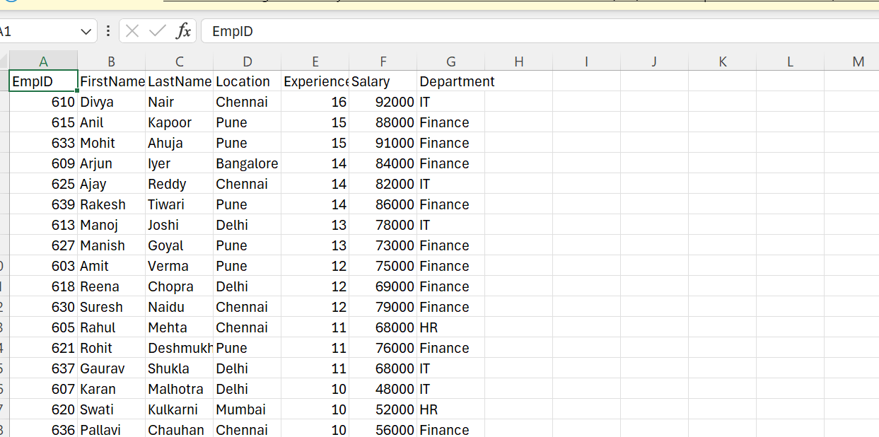

QUESTION 3 : CREATE A MAPPING TO LOAD SALES DATA FROM A FLAT FILE INTO SNOWFLAKE BY DERIVING QUARTER INFORMATION AND APPLYING FILTERS
TASK 1 : FLAT FILE SOURCE CONFIGURATION
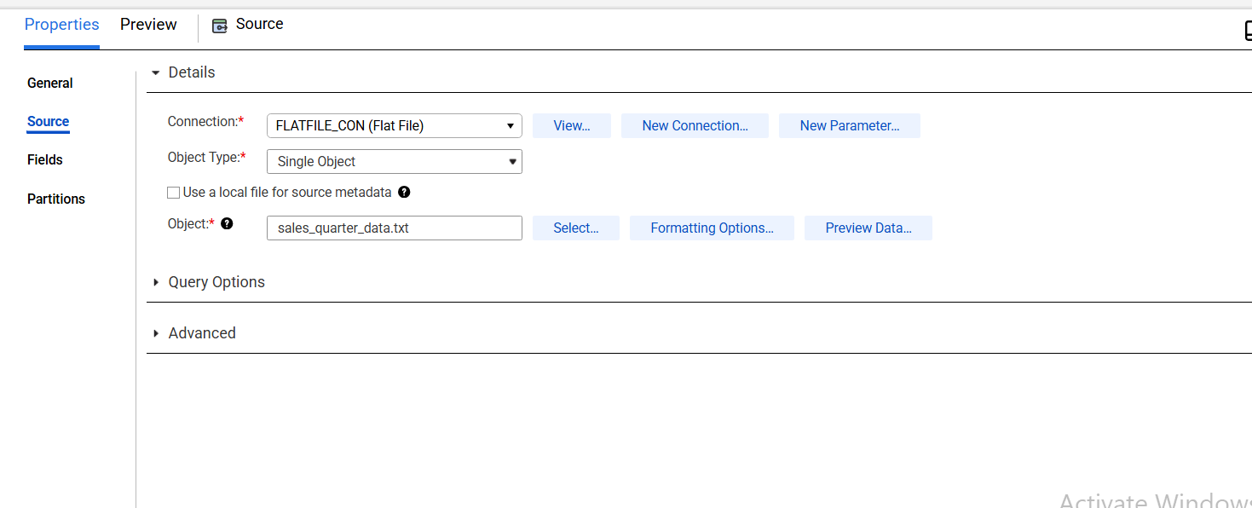

TASK2 : EXPRESSION CONFIGURATION FOR QUARTER DERIVATION
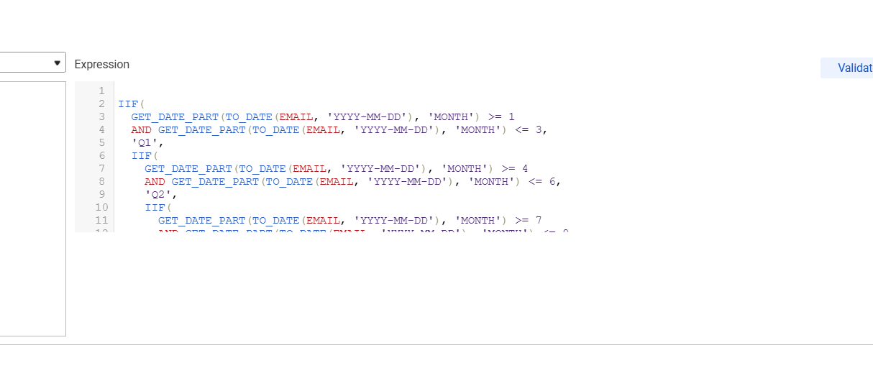

TASK 3 : FILTER CONFIGURATION
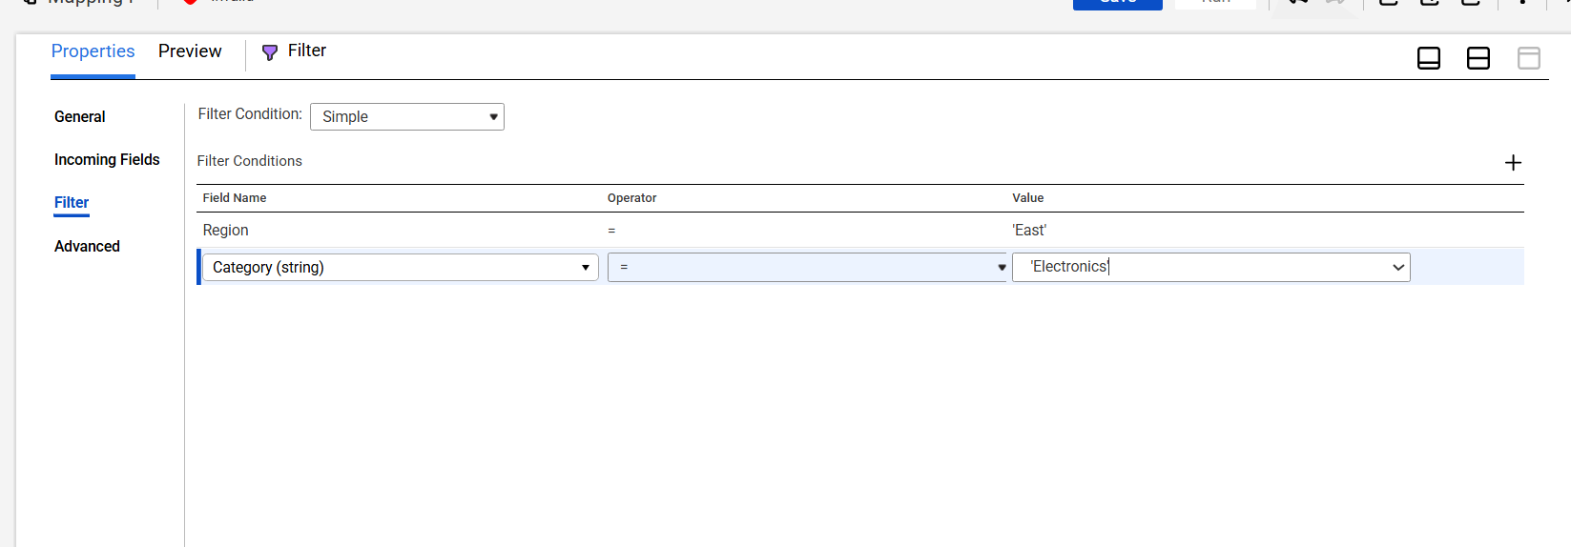

TASK 4 : SORTER CONFIGURATION
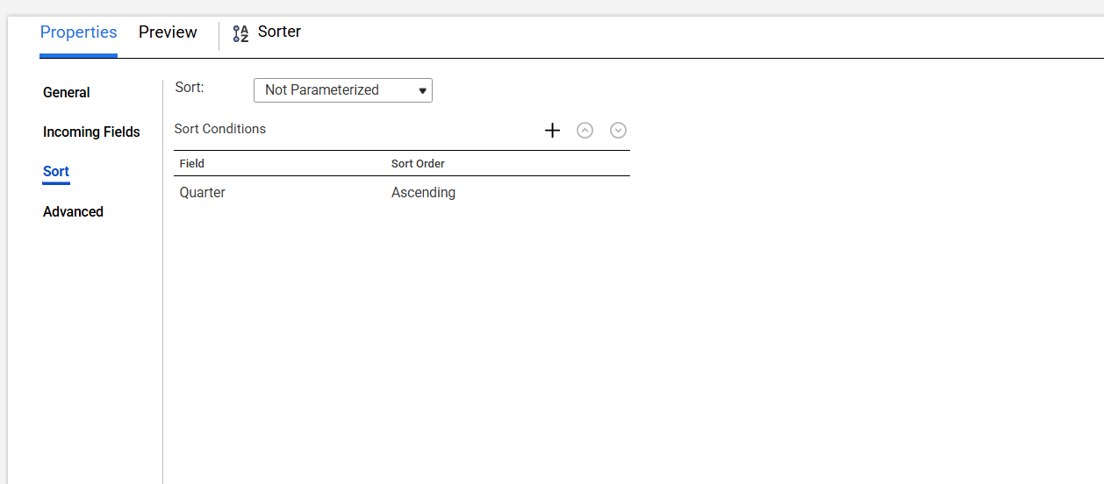

TASK 5 : MAPPING EXECUTION SUCCESS
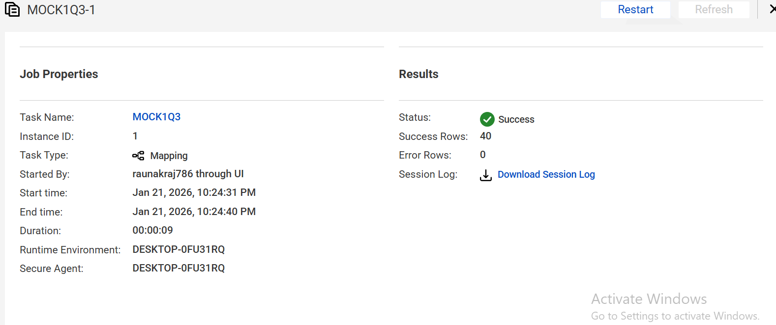

TASK 6 : TARGET TABLE WITH LOADED DATA
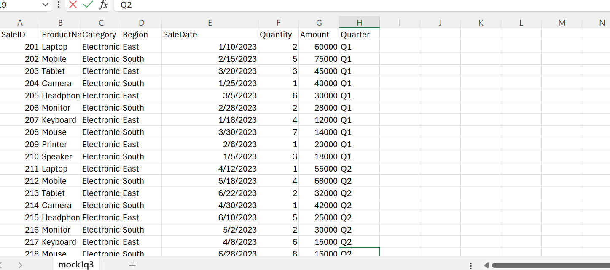

QUESTION 4 : Create a linear taskflow in informatica iics that consists of two mapping task and a decision step based on the execution status of the first mapping
TASK 1 : MAPPING TASK 1 DESIGN AND EXECUTION
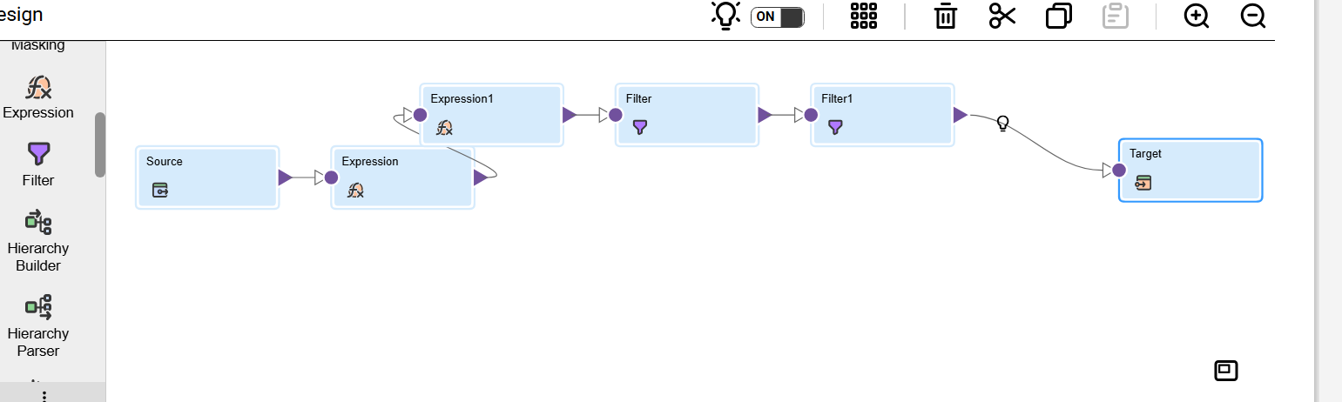

EXECUTION
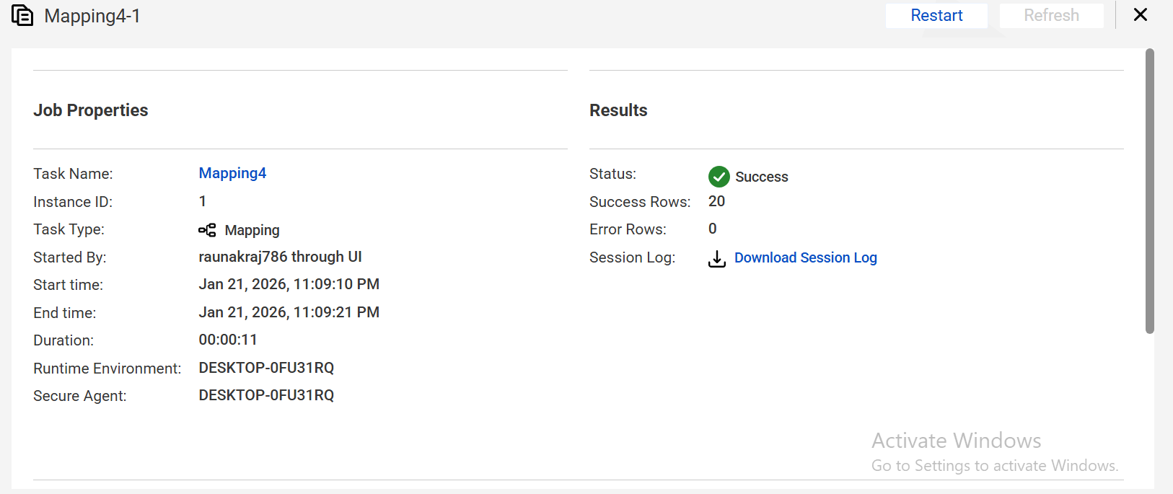

TASK 2 : DECISION STEP CONFIGURATION
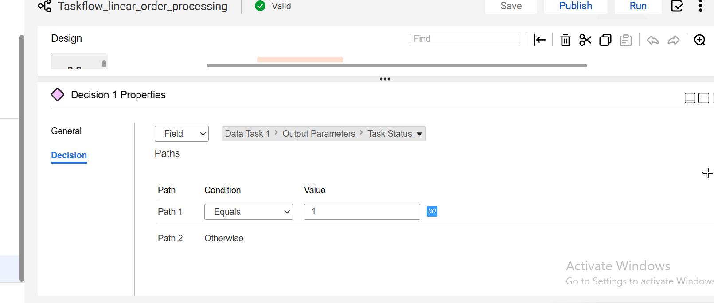

TASK 4 : LINEAR TASKFLOW DIAGRAM WITH SUCCESSFUL EXECUTION
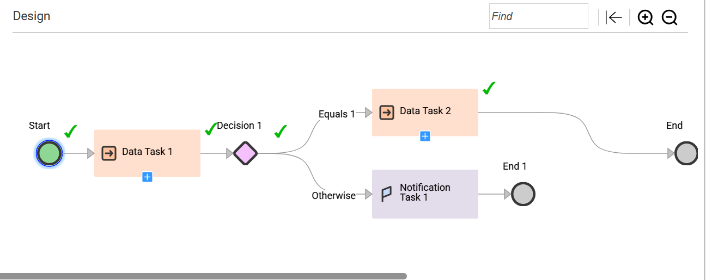

TASK 5: MAPPING TASK 2 DESGIN AND EXECUTION
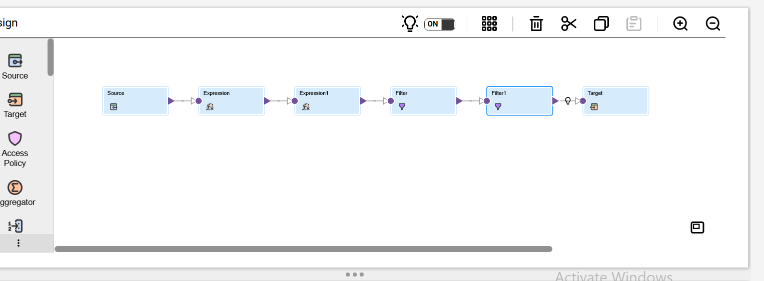

TASK 6 : FINAL FLAT FILE OUTPUT

