Name – Raunak Jha
Question 1 : 2 flat files -> joiner -> aggregator -> rank -> (top 3 category) -> router
Task -1 Scrrenshot of mapping desing
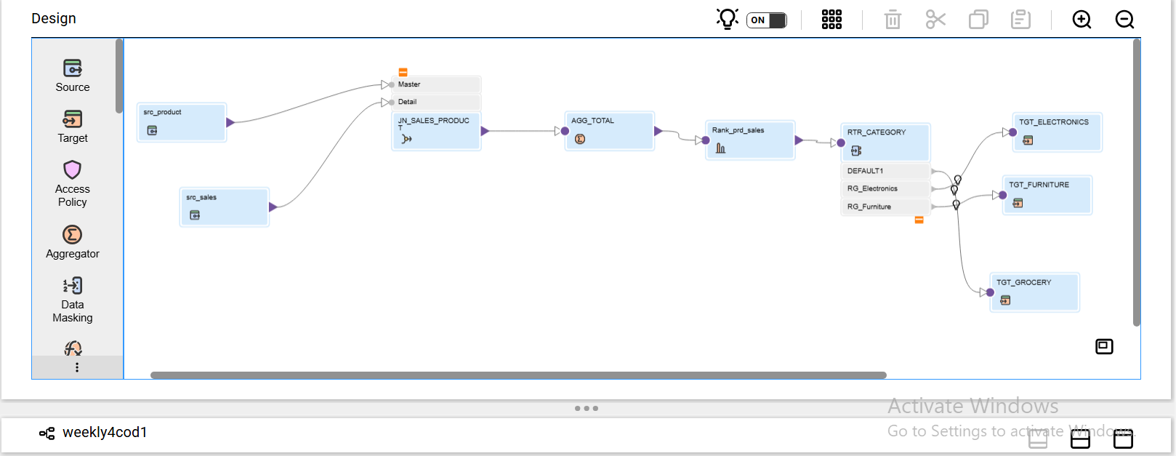

TASK 2 : MAPPING SUCCESSFUL EXECUTION
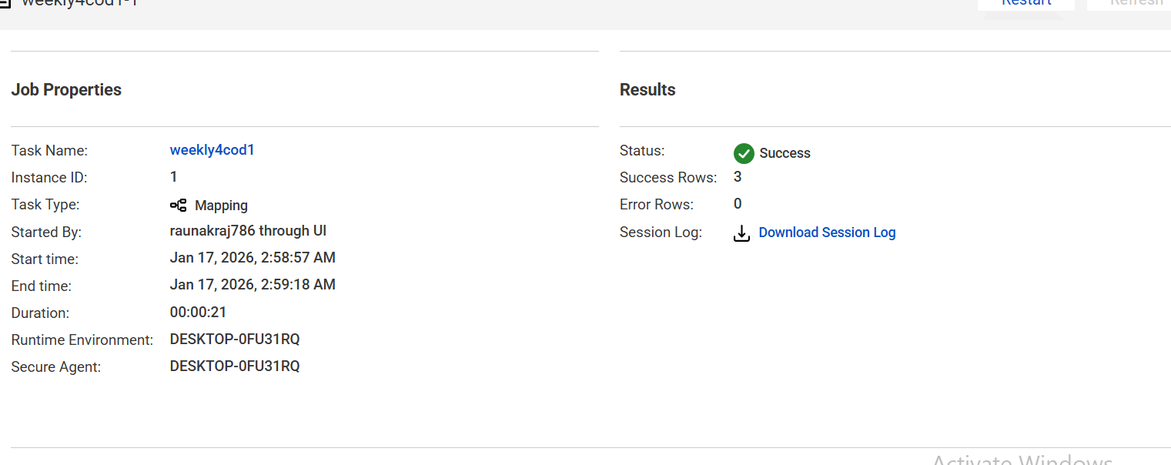

TASK 3 :
(A) JOINER CONDITION
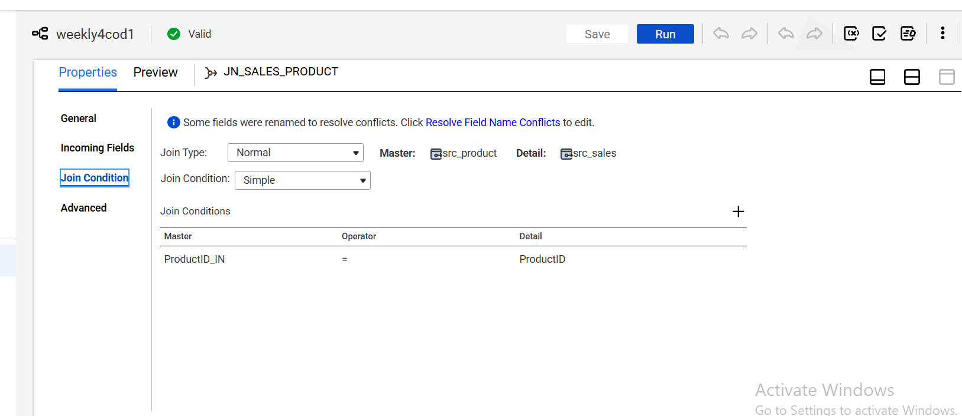

(B) AGGREGATOR CONDITION
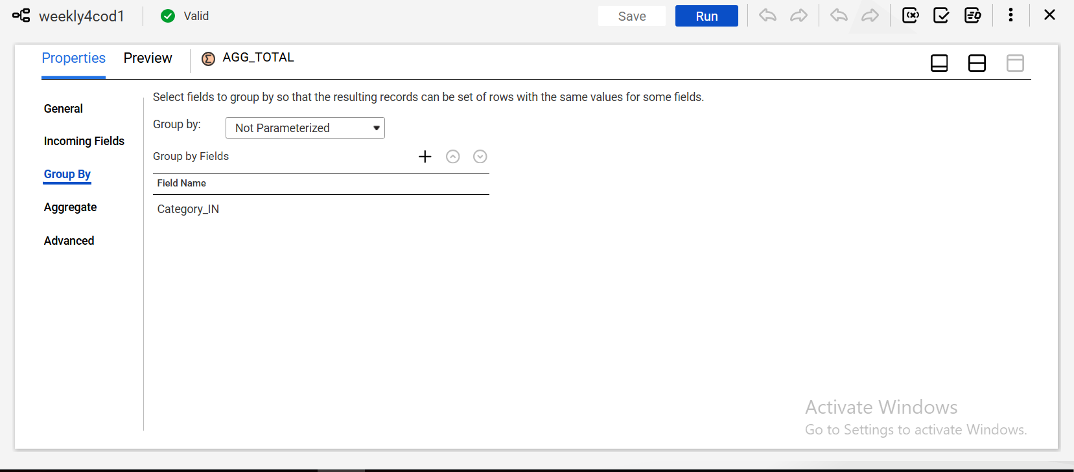

© RANK CONDTION
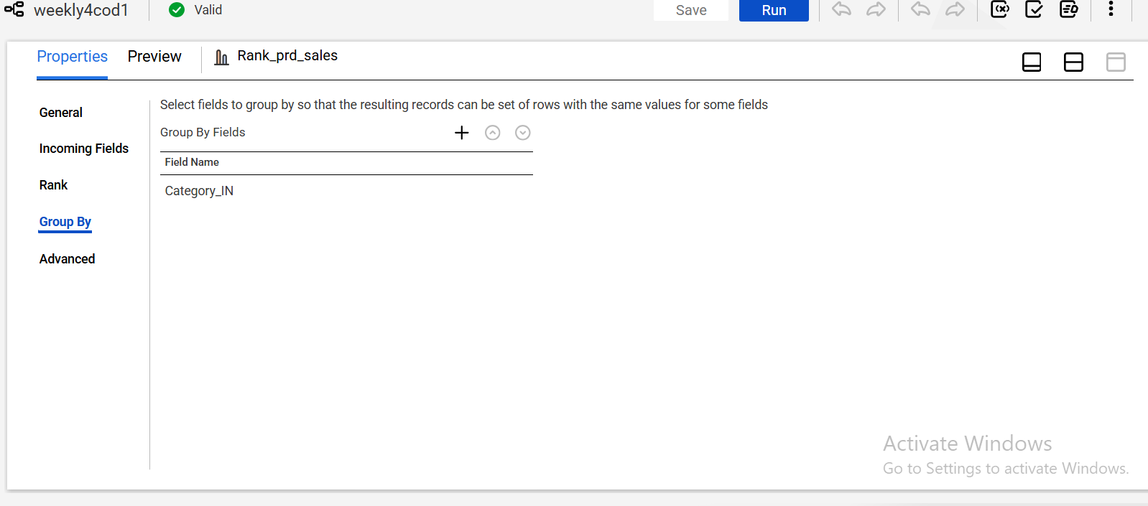

(D) ROUTER CONDTITION
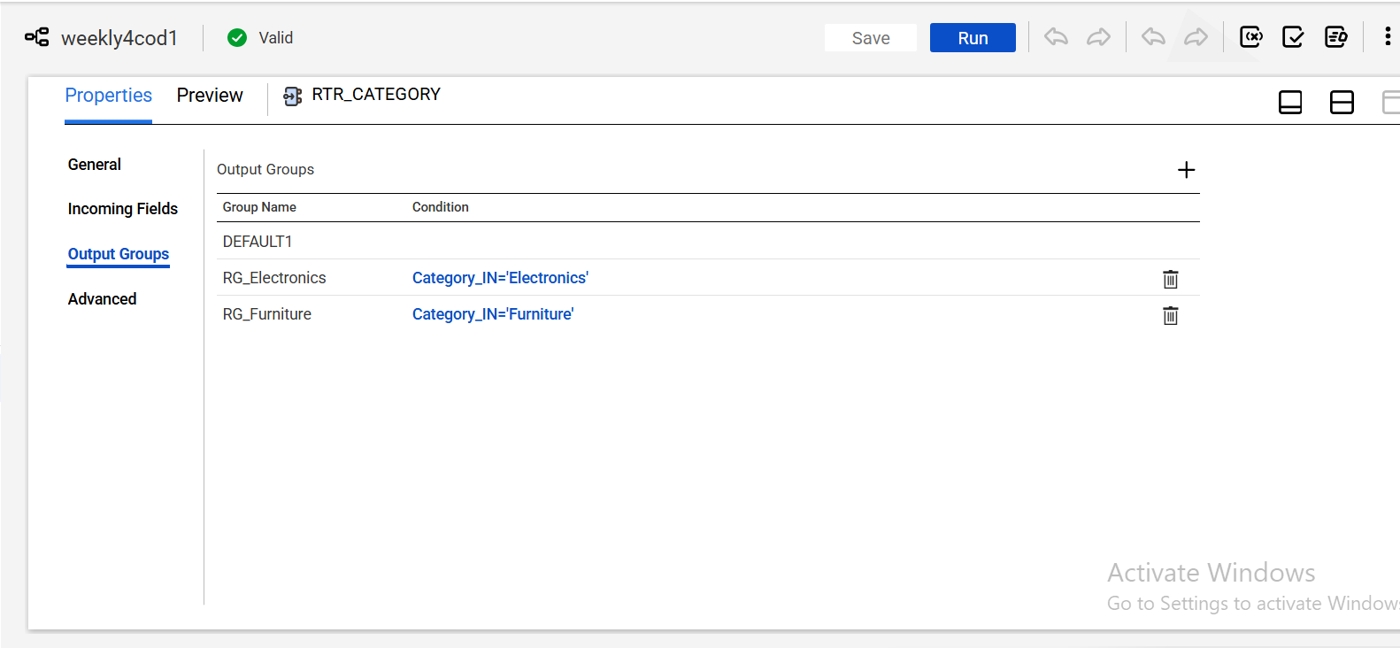

TASK 4 : SCREENSHOT SHOWING RANK CONFIGURATION
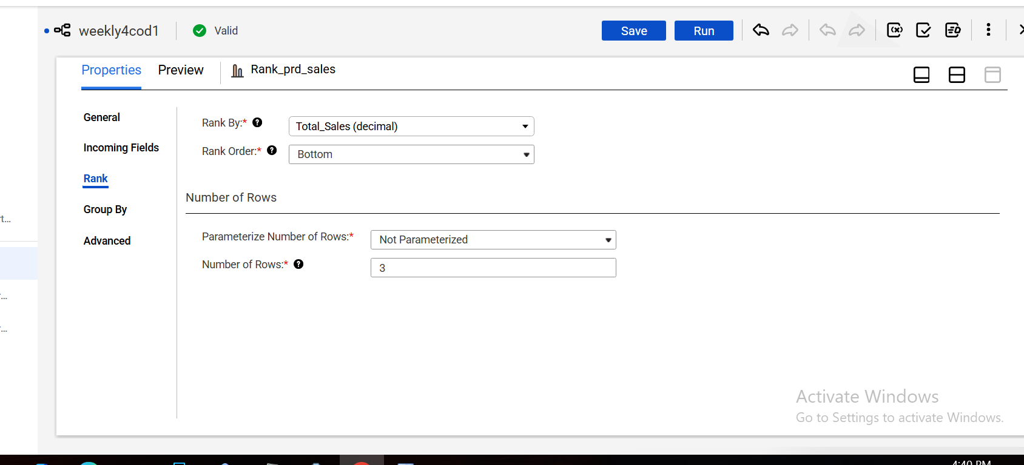

TASK 5 : CODE CONFIGURATION SCREENSHOT
(A) TOTAL SALES SUM
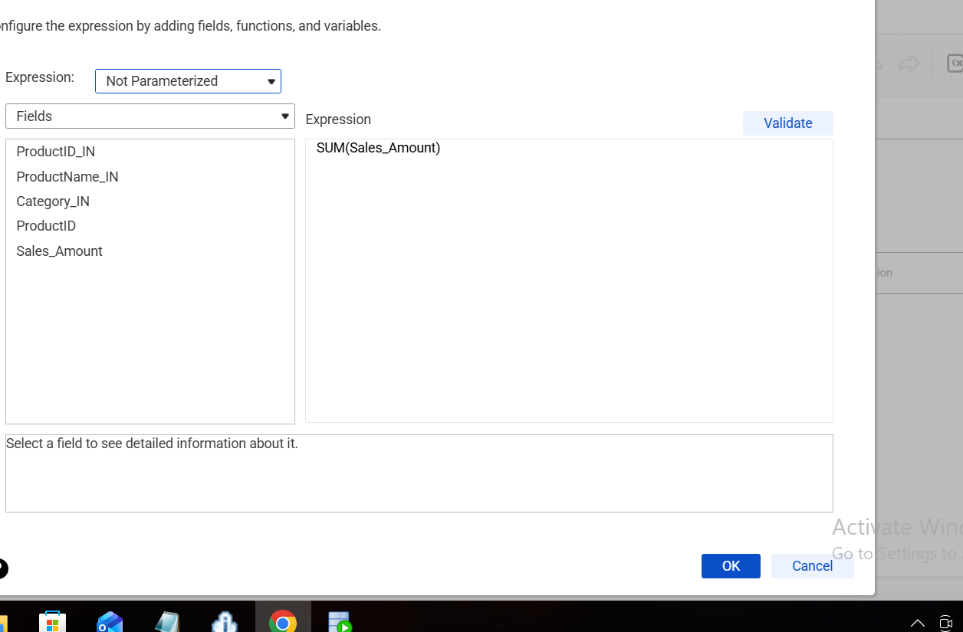

(b) screenshot of final output
electronics
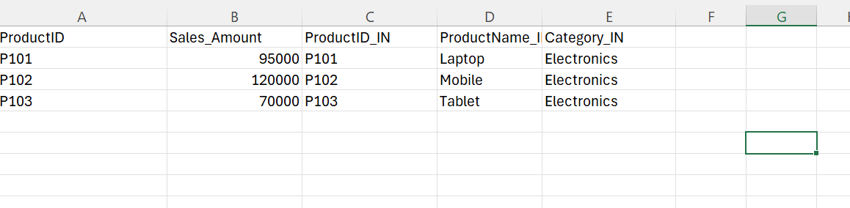

Furniture
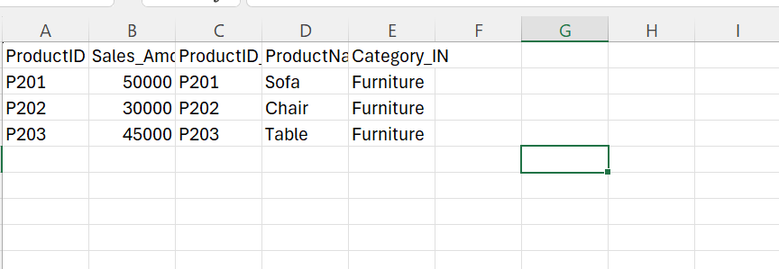

Grocery
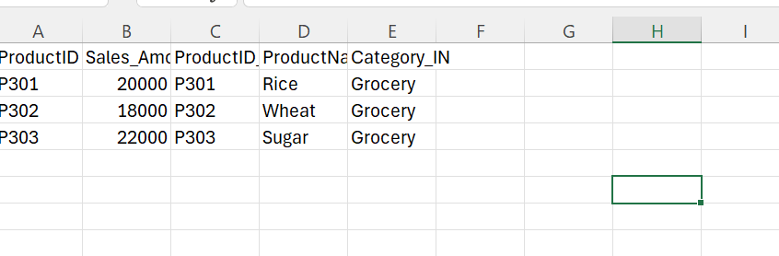

Q2: mapping 2 flat filed -> lookup -> expression -> sorter
TASK 1 : SCREENSHOT OF MAPPING DESIGN BEFORE EXECUTION
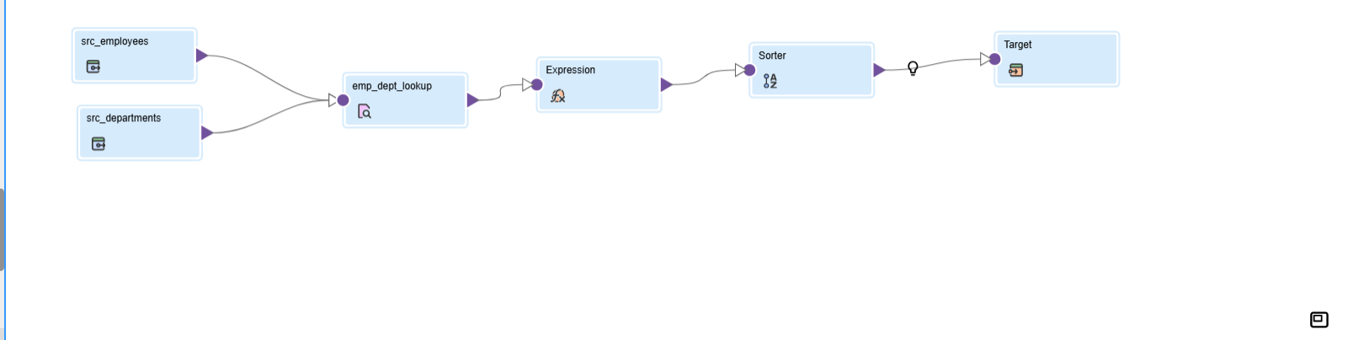

TASK 2 : MAPPING AFTER SUCCESSFUL EXECUTION

TASK 3 : LOOKUP CONDITION AND REUTRNED PORTS
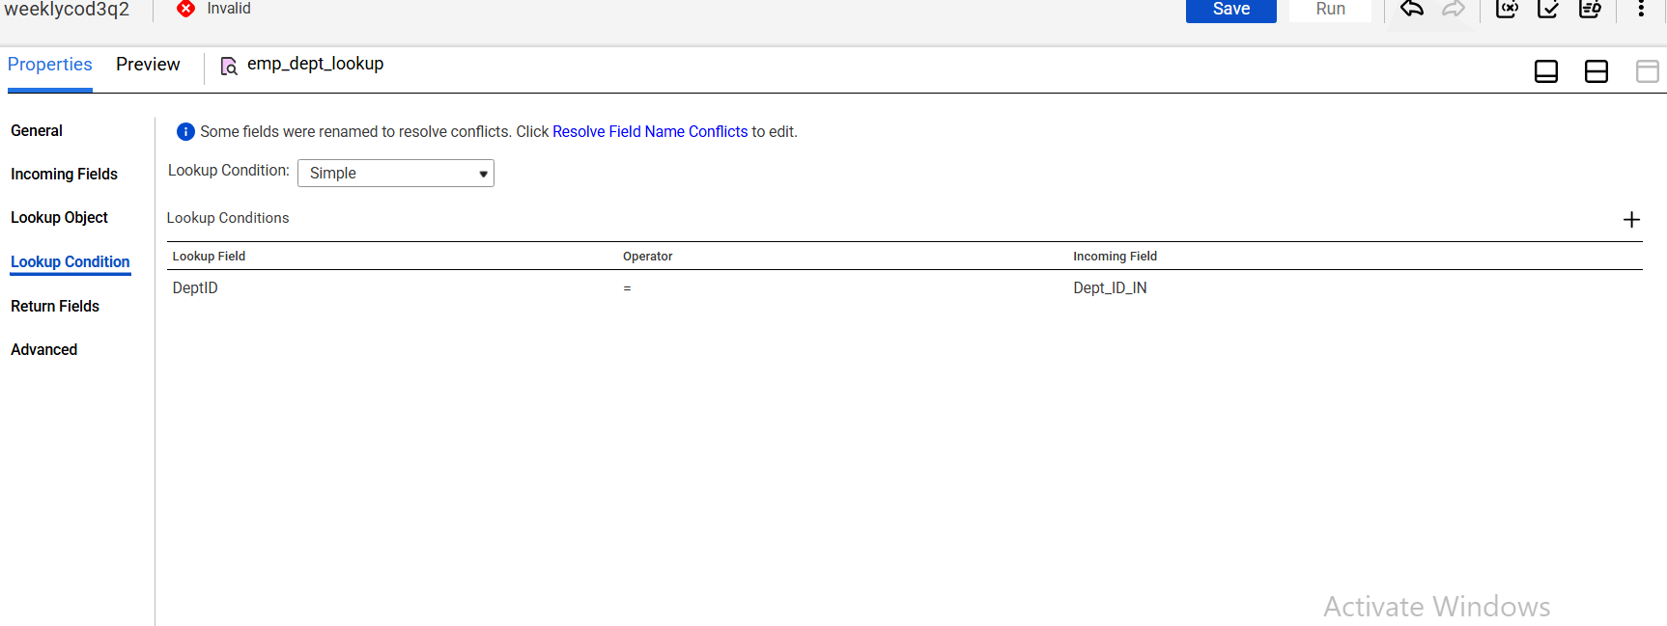
Returned ports
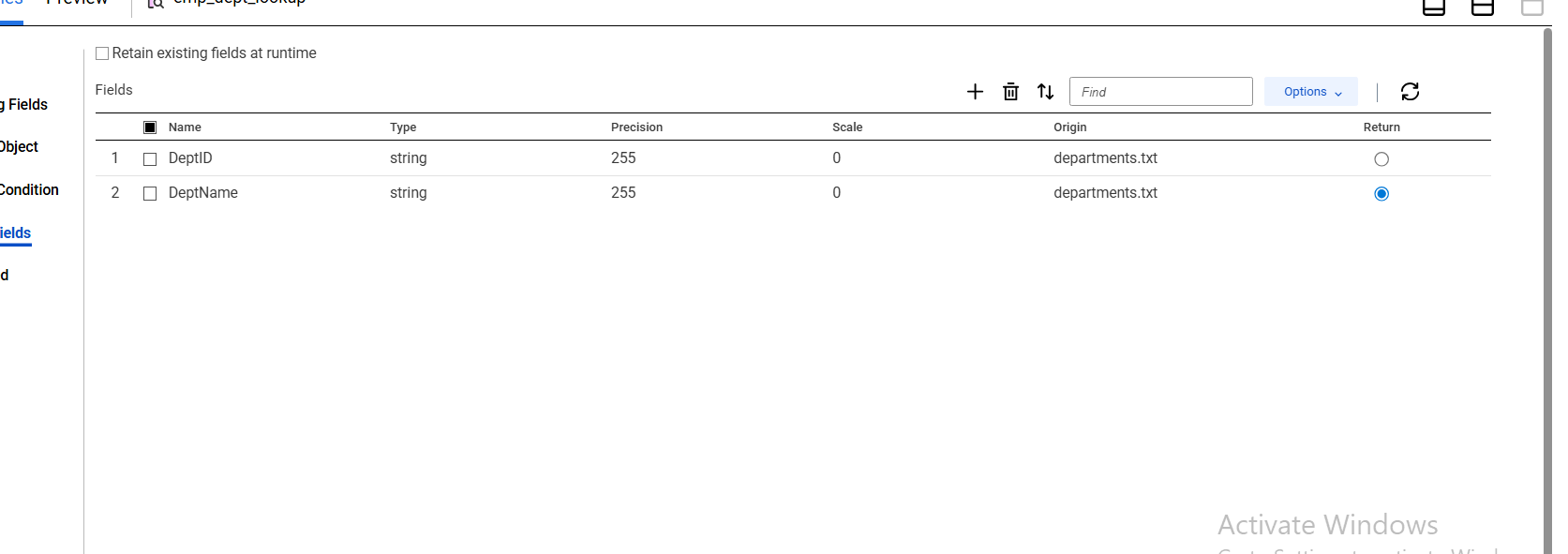

TASK 4 : EXPRESSION TRANSFORMATION
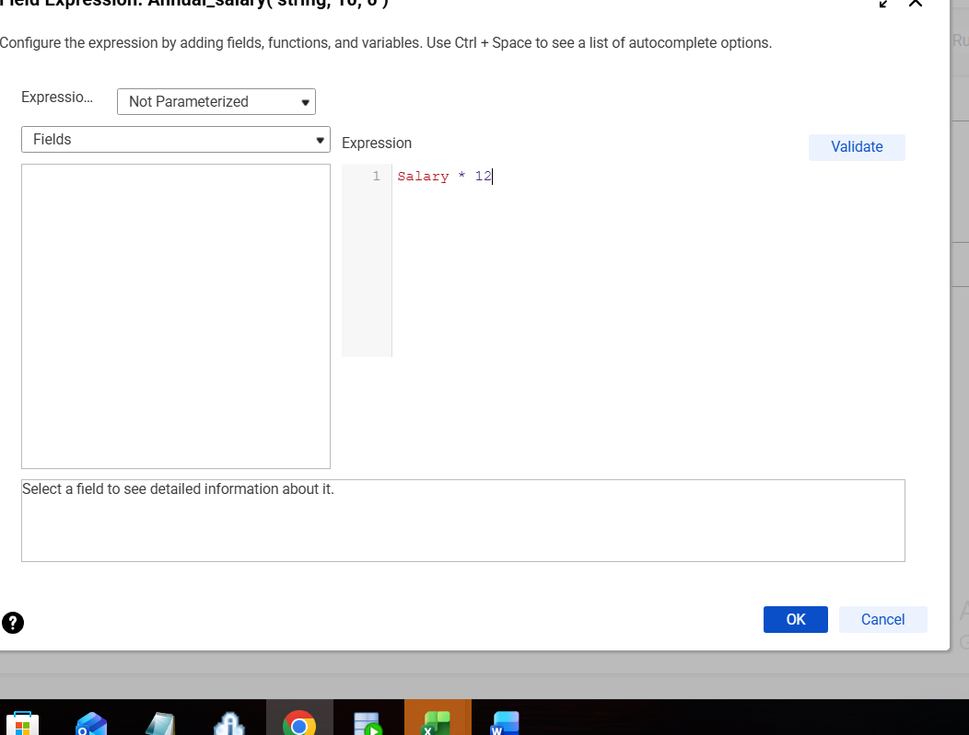

TASK 5 : SORTER CONFIGURATION
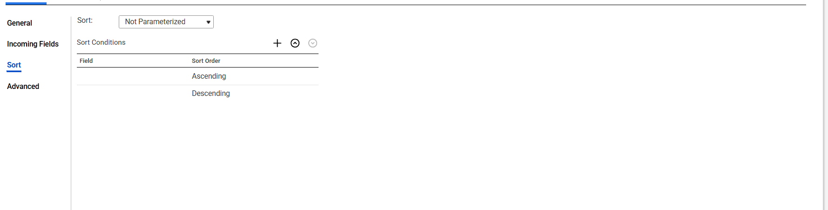

TASK 6 : FINAL OUTPUT TABLE

