Name – Raunak Jha
Question 1: Snowflake AWS S3 External Stage Load and Materialized view Creation
TASK-1 : External stage and table creation
Table creation
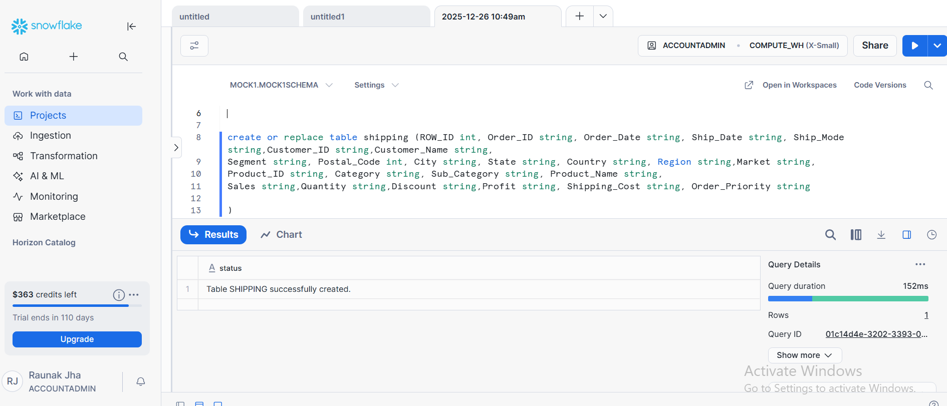
External stage creation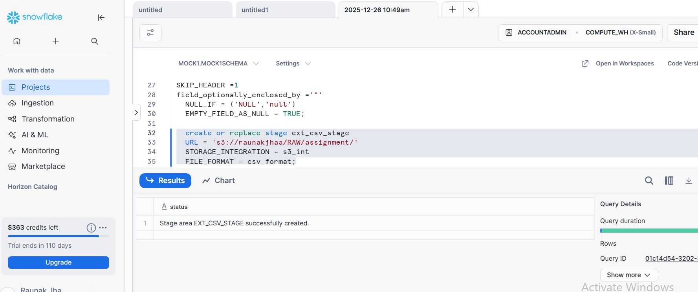

TASK 2: LOADING DATA FROM AWS S3

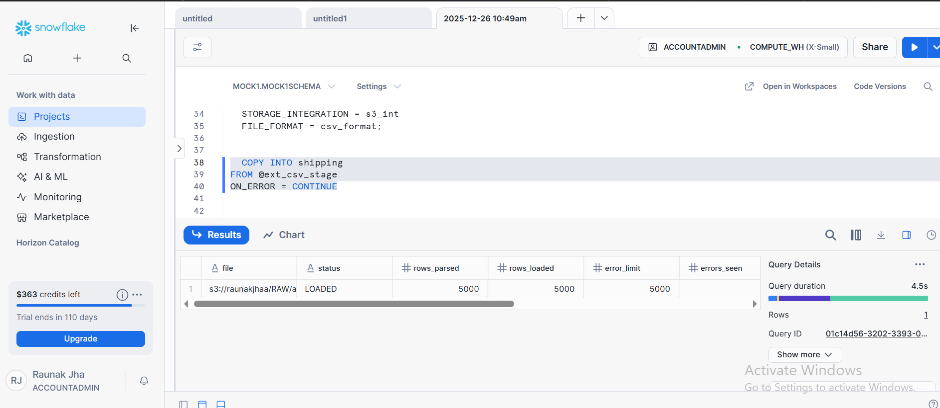

Task 3 – Materialized View Creation
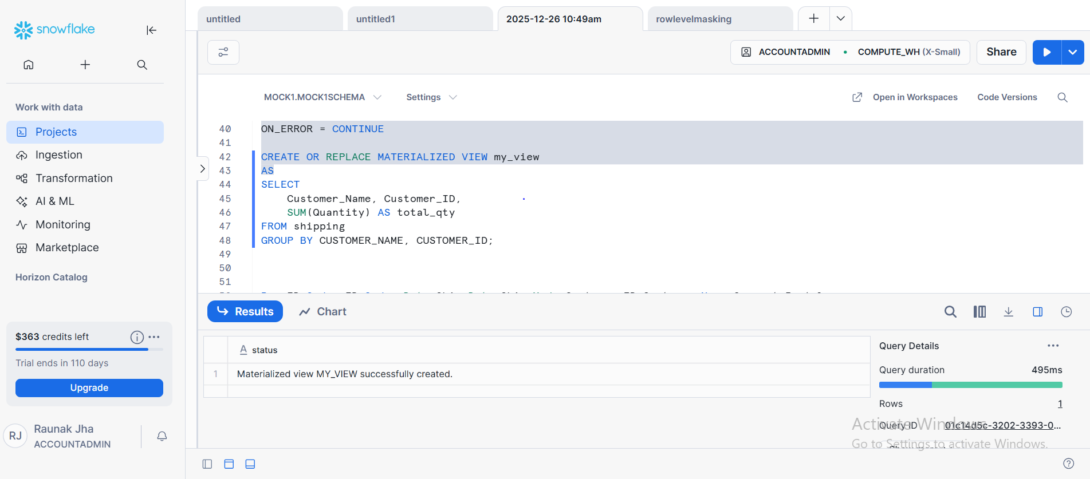

TASK4: QUERY OUTPUT MATERIALIZED VIEW
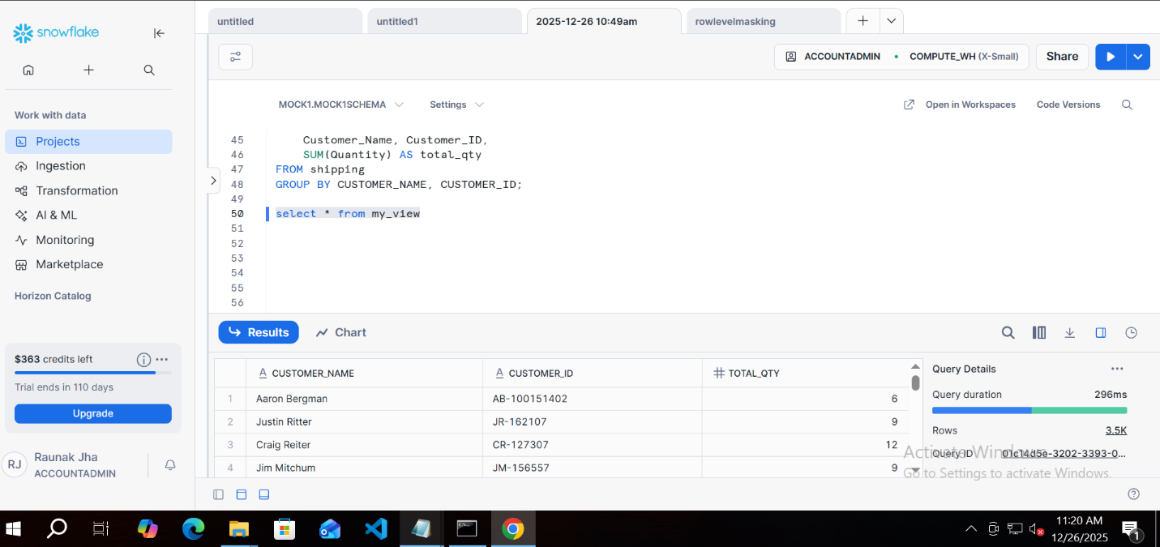

Question 2: Snowflake Named Internal Stage – DatA load unload and integrity validation
TASK1: Creation named internal stage for dataset
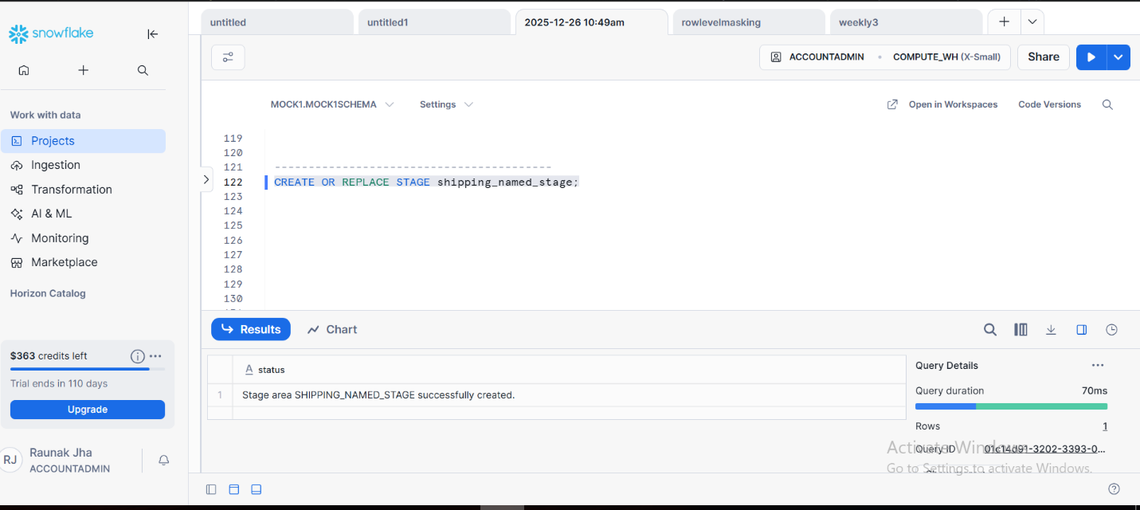
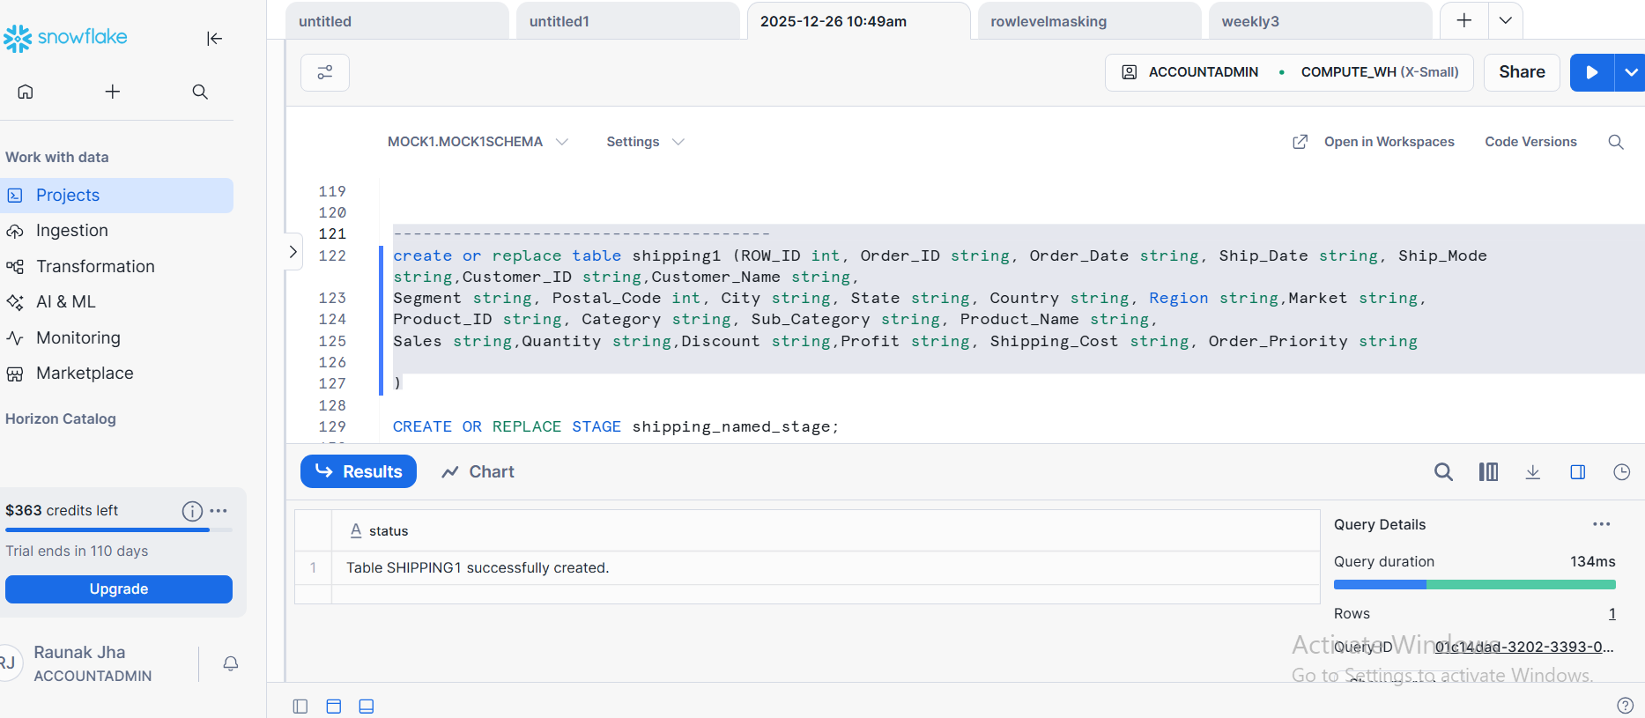

TASK 2: LOADING AND UNLOADING OPERATIONS
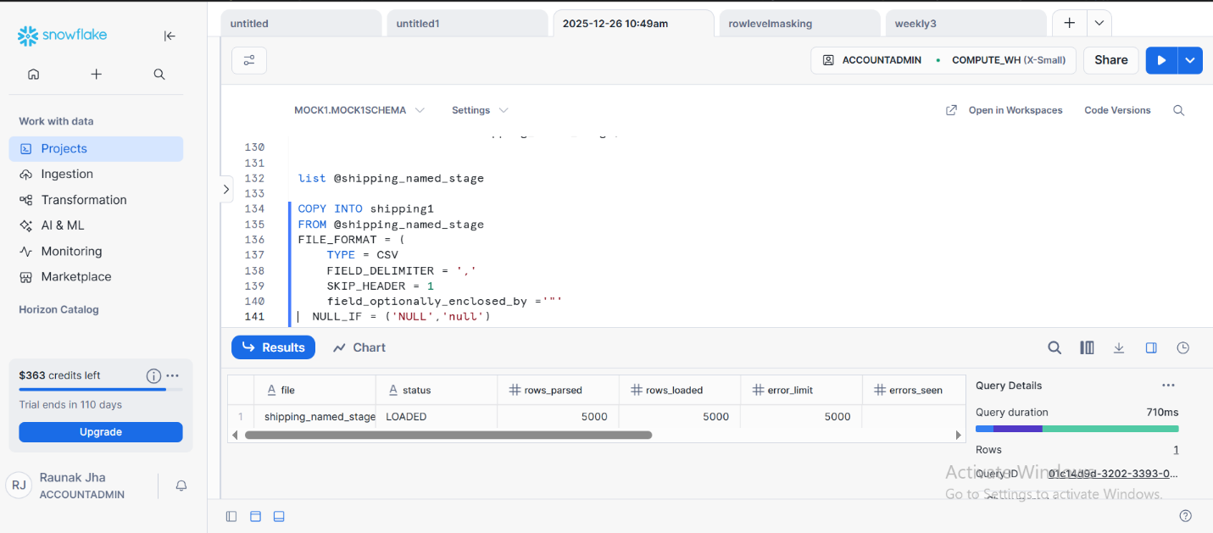
UNLOADING
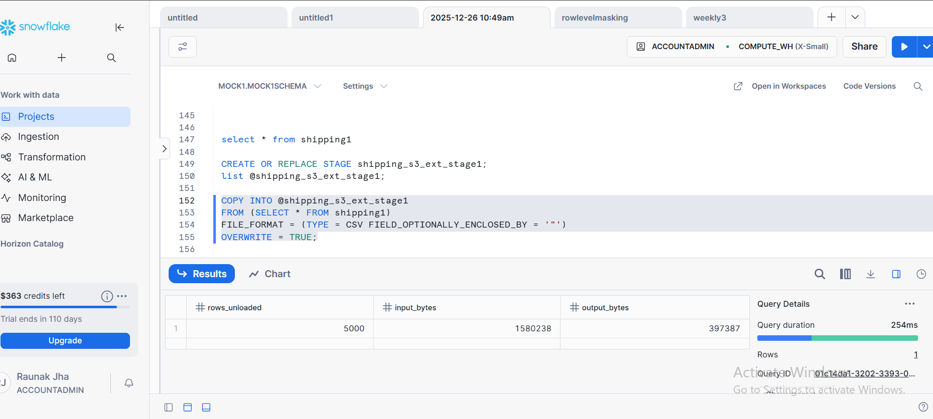

TasK 3: query used for data validation
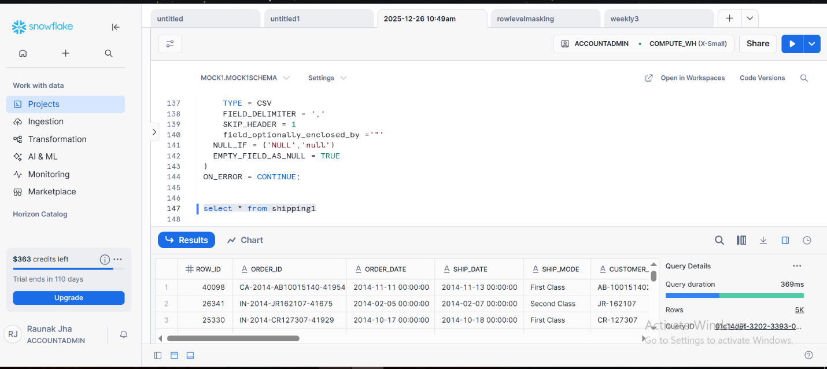

Task-4:Data consistency count
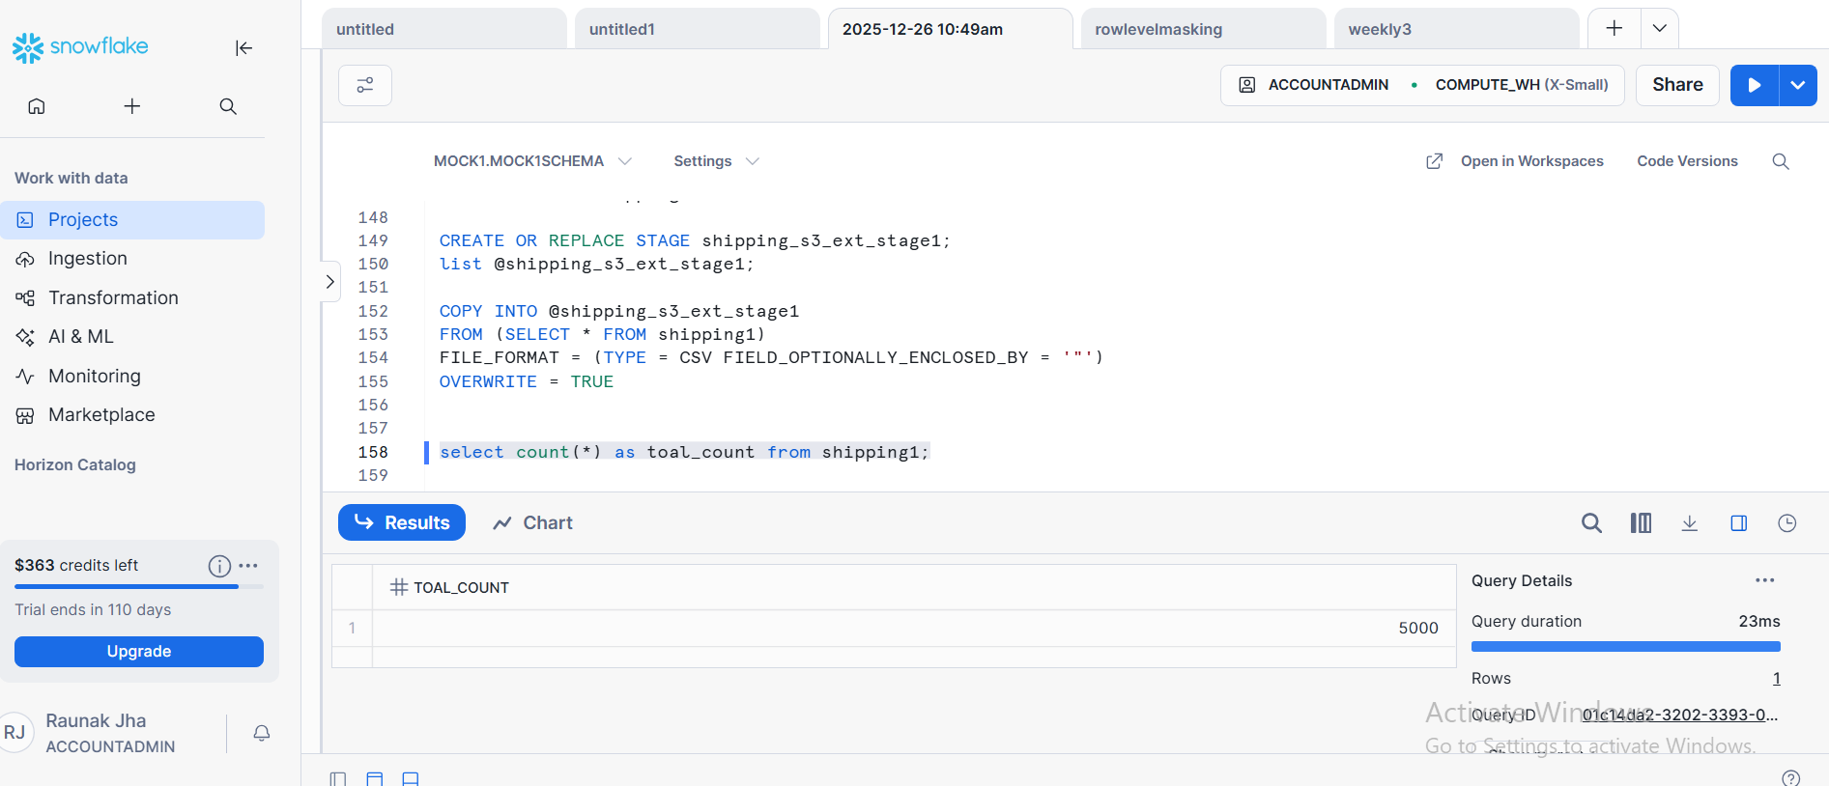

Q3 : Snowflake external stage data load with row access policy implementation
TASK 1 External stage and table creation
External stage creation

TASK 2: LOADING DATA FROM AWS S3

TASK 3: ROLE CREATION AND PRIVILEGE GRANTS
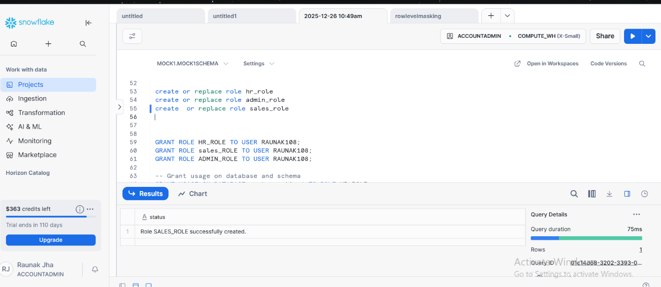

PRIVILEDGE GRANTS
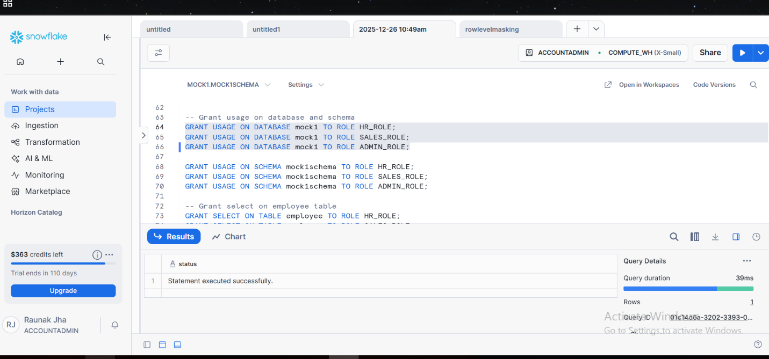

Task:4 Row Policy creation and assignment
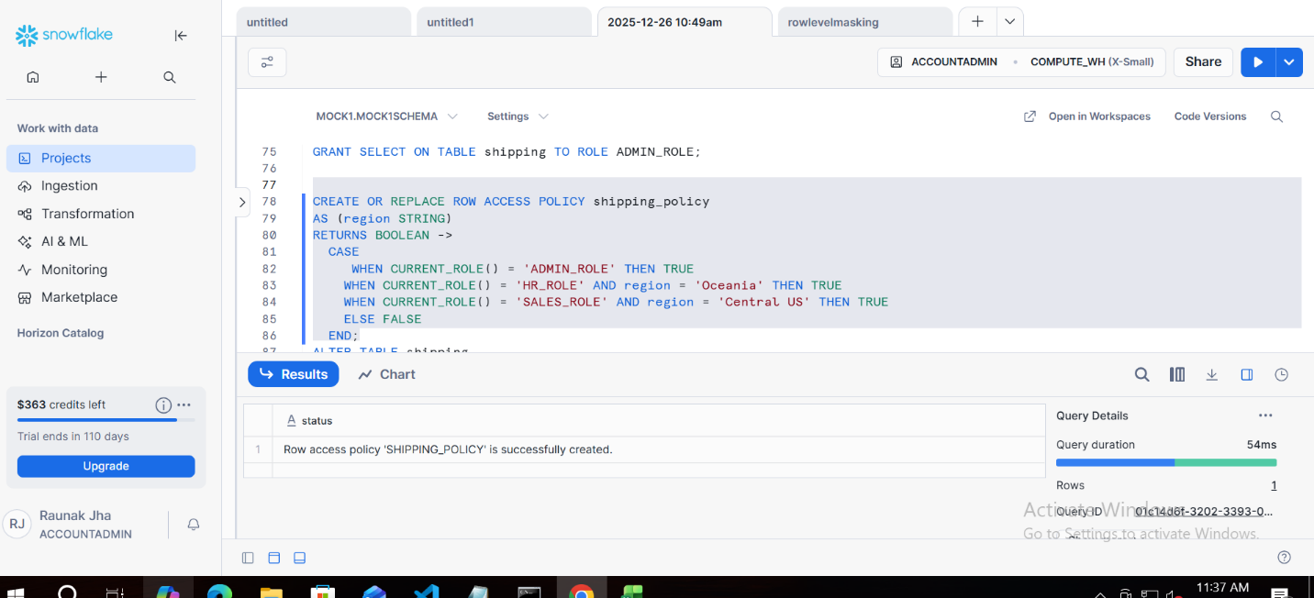
assignment
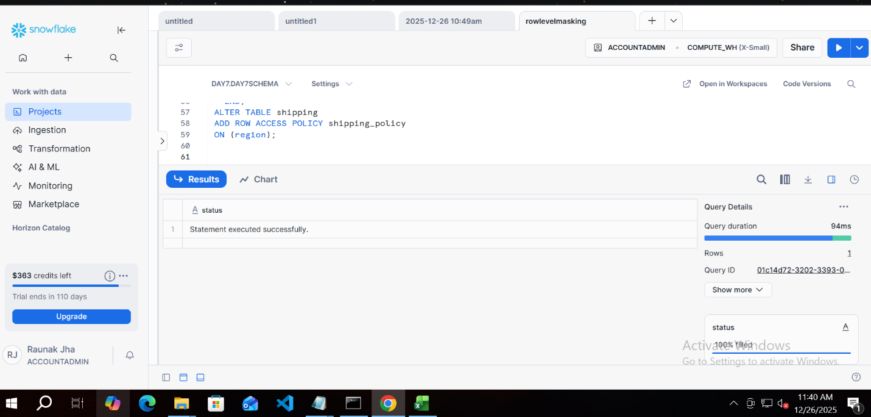

TASK 5 : Validating row level access policy
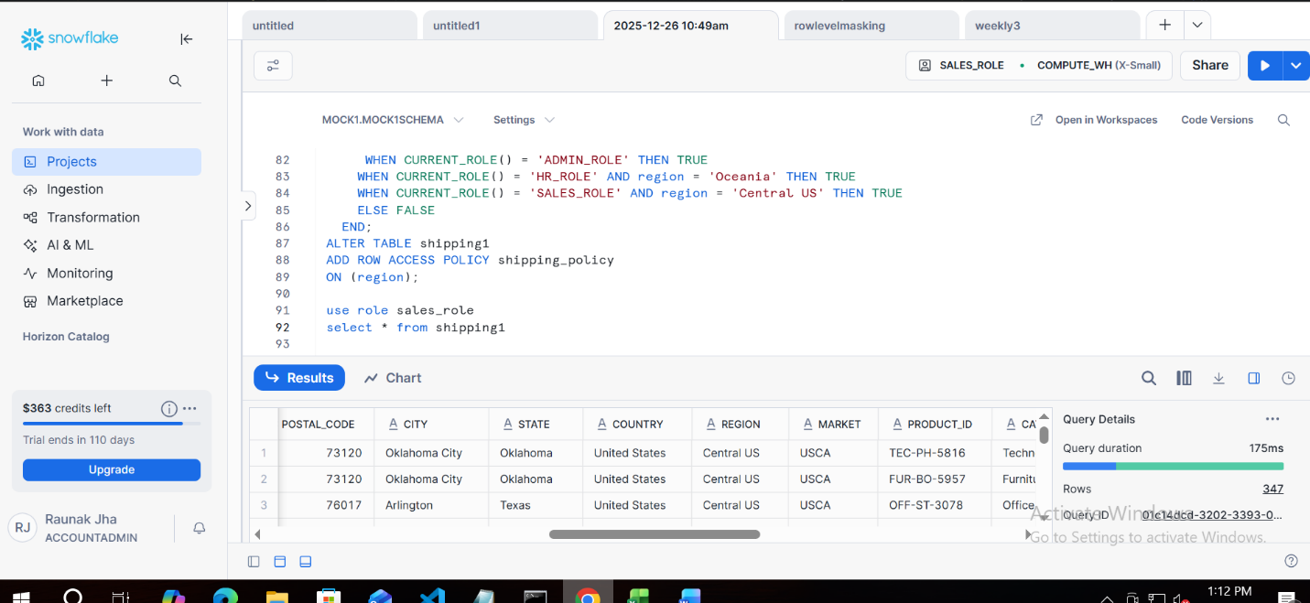
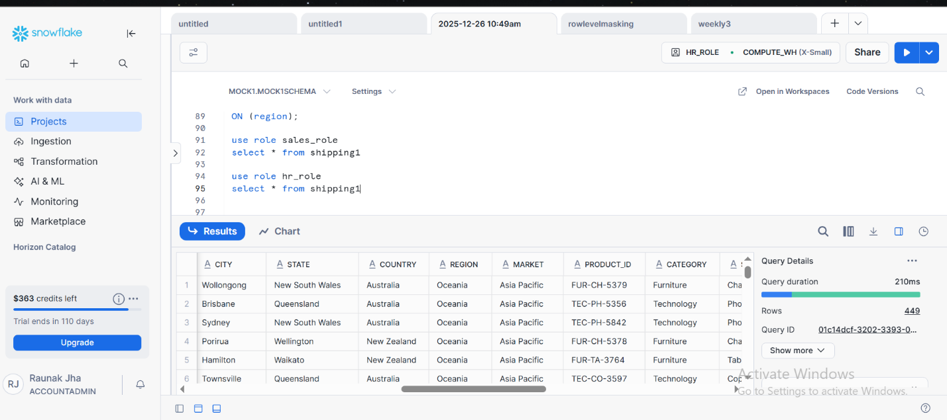

Q4: END To end cdc handling using snowflake streams and tasks
Task 1: BASE TABLE AND AUDIT TABLE CREATION
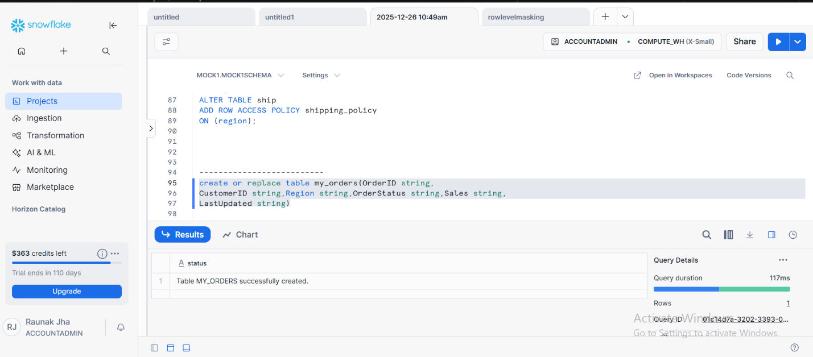
AUDIT TABLE
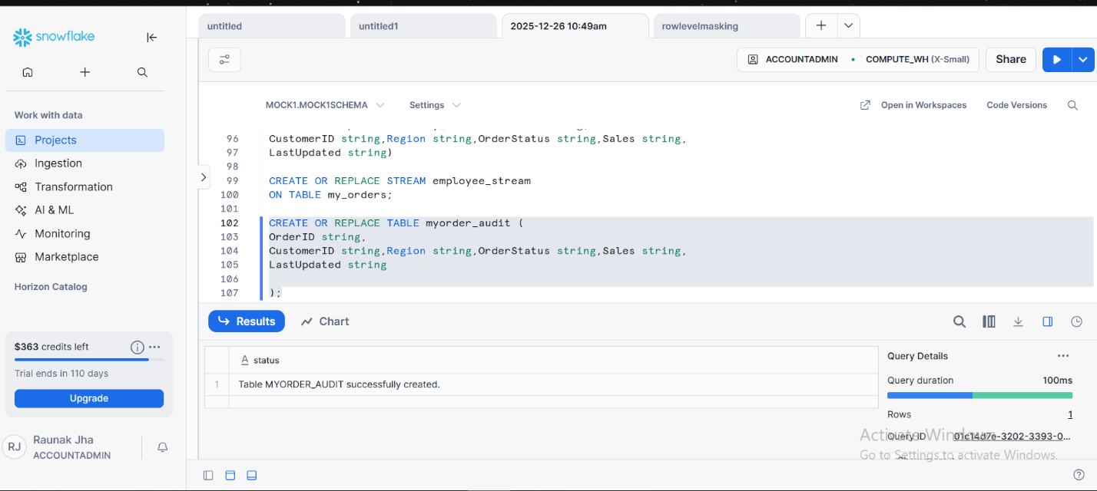
TASK2: STREAM CREATION
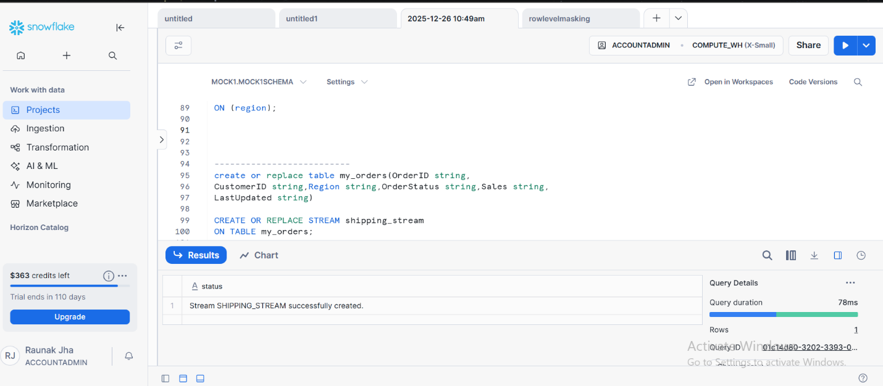

TASK 3: TASK CREATION
