Name – Raunak Jha
Q1 – Snowpipe Auto-Ingest Data Loading Using AWS S3
TASK1 :External stage and table creation
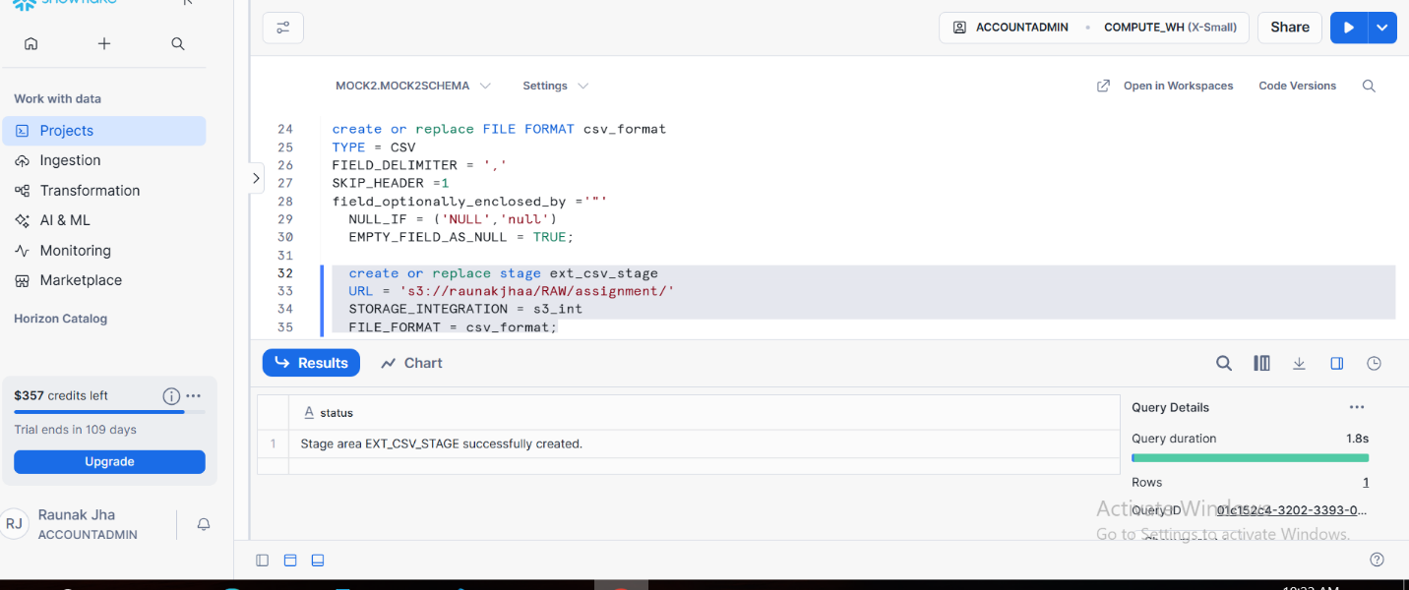
TABLE CREATION
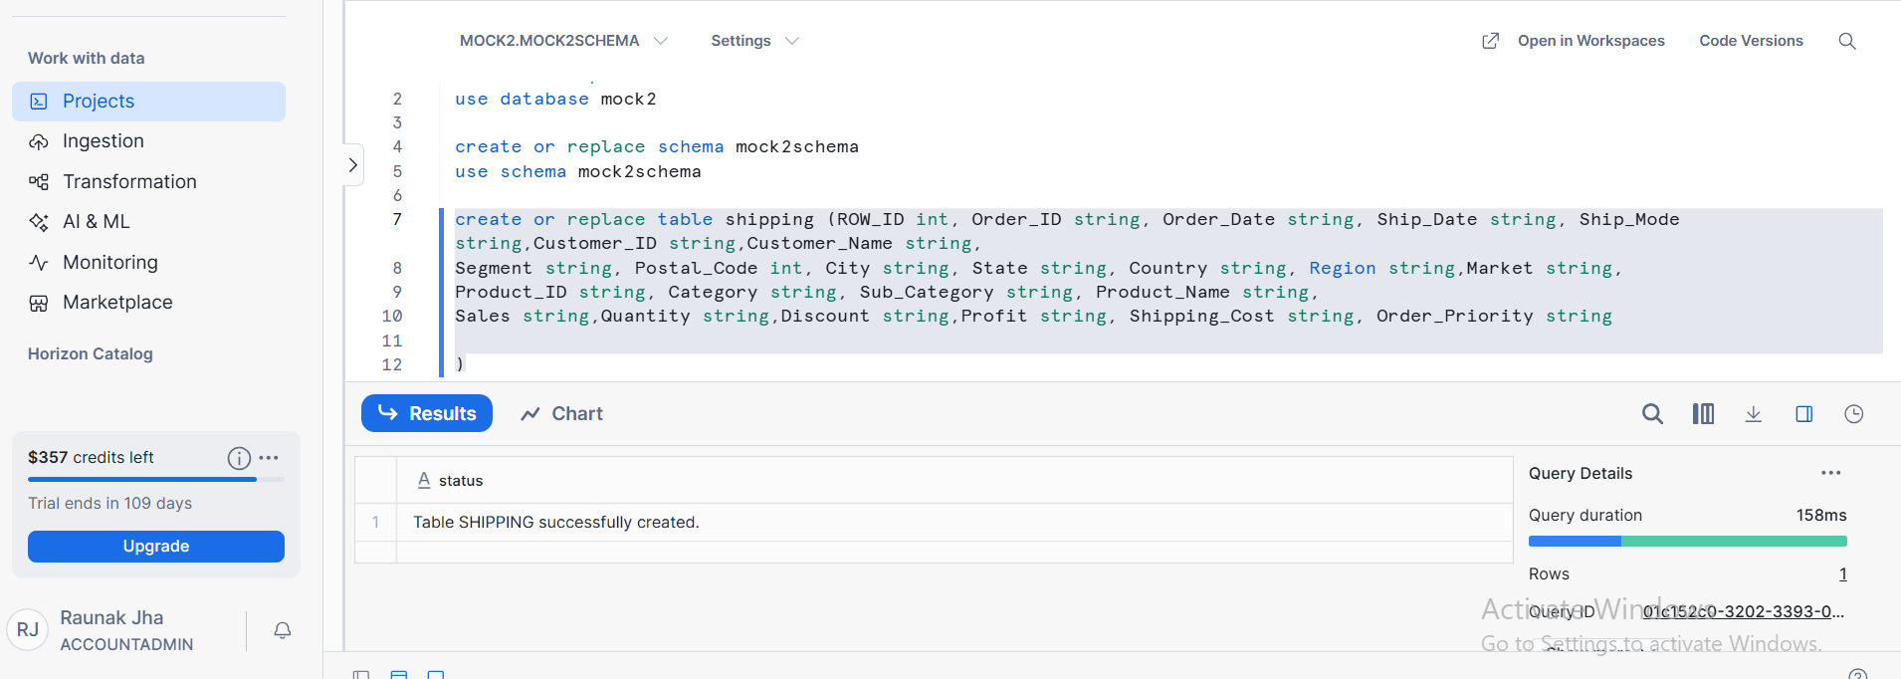

TASK 2: SQL USED FOR SNOWPIPE CREATION
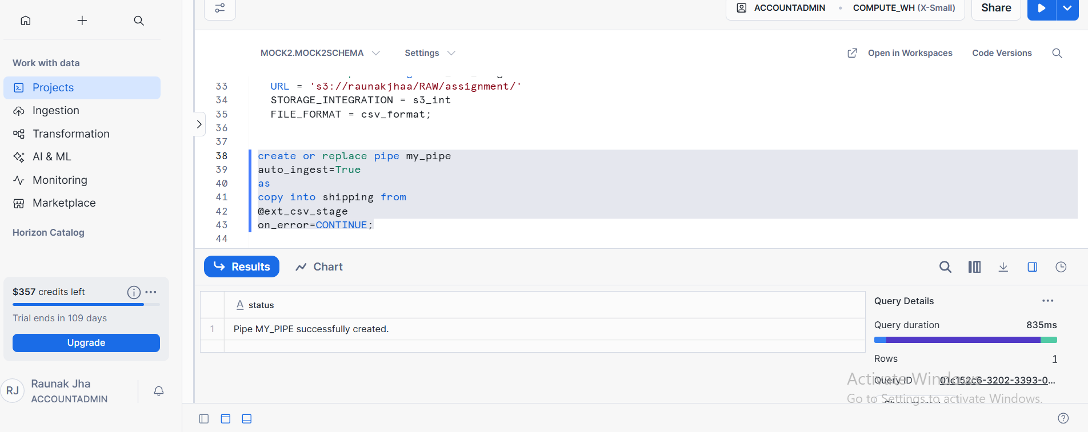

TASK 3:
EVIDENCE OF AUTO_INGESTED DATA
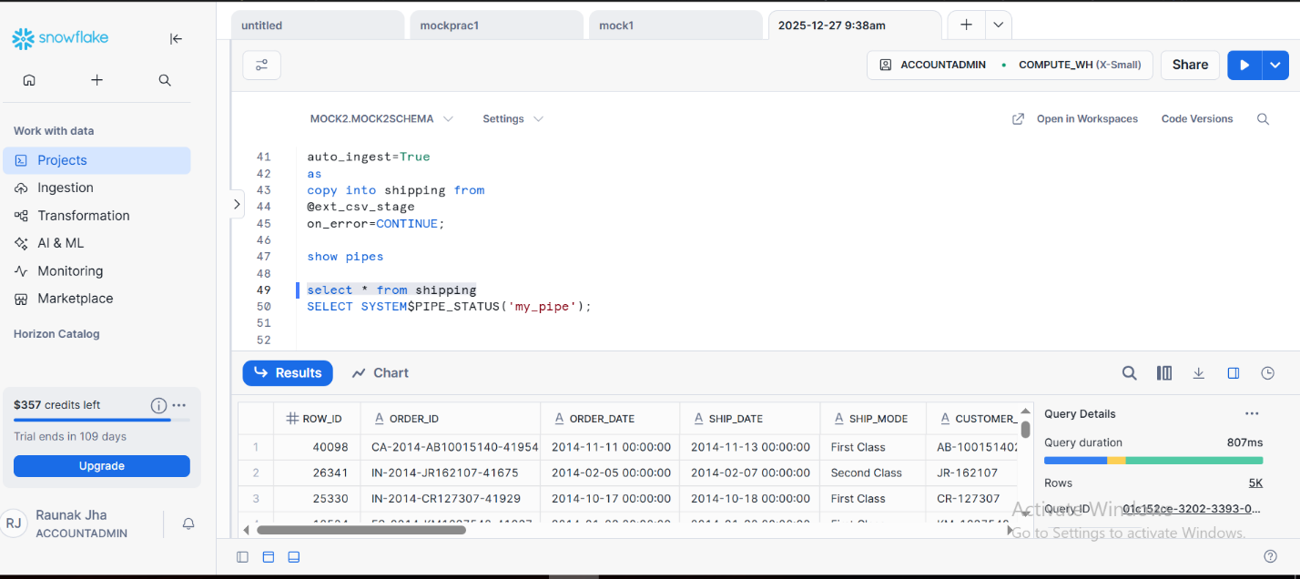

TASK:4
SNOWPIPE LOAD HISTORY OF AUTO INGESTED DATA
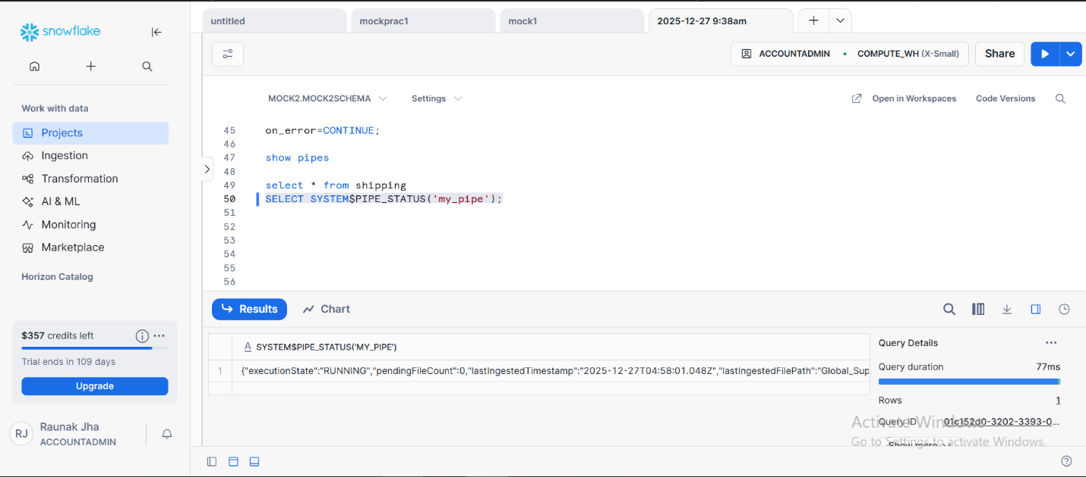

Q2 : Snowflake AWS S3 EXTERNAL STAGE – DATA LOAD AND SECURE DATA SHARING
TASK 1:
EXTERNAL STAGE AND TABLE CREATION
TABLE CREATION

TASK 2: LOADING DATA FROM AWS S3
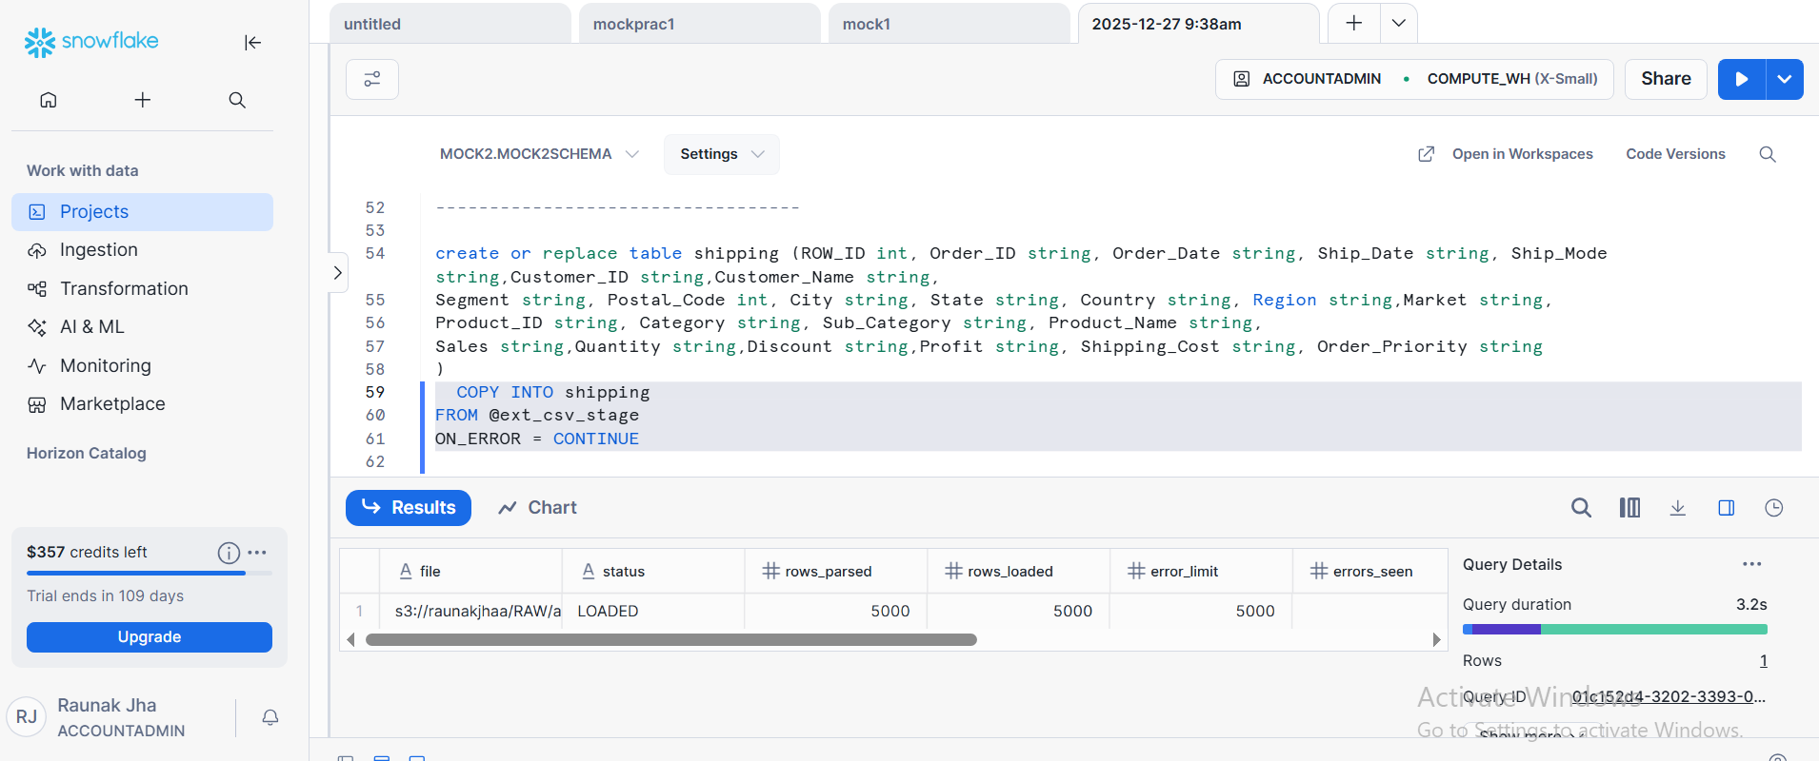

TASK 3: SECURE VIEW CREATION
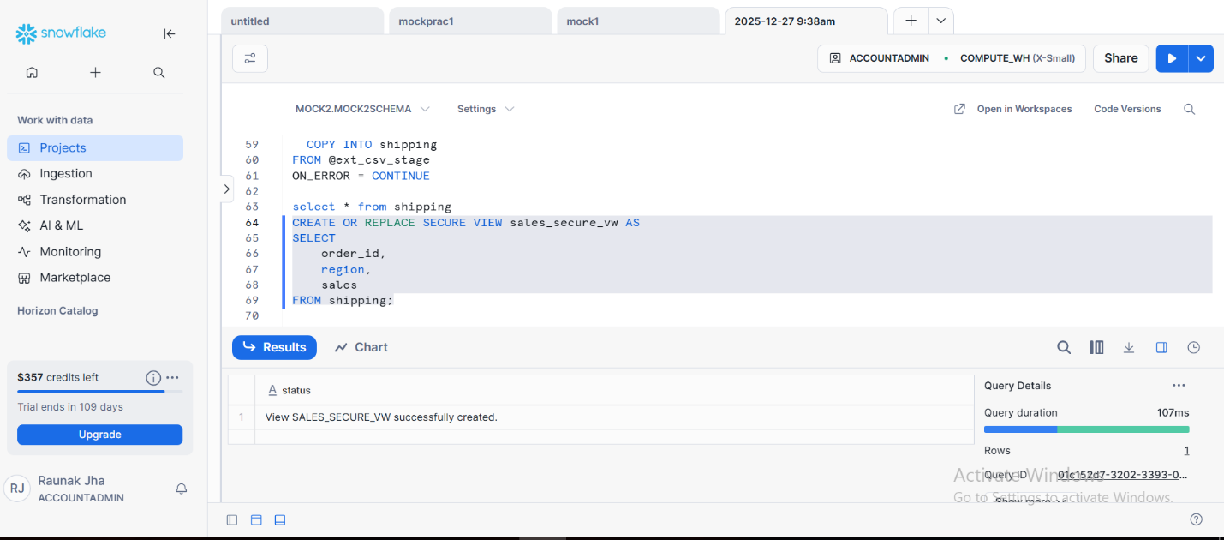

TASK 4: DATA SHARE CONFIGURATION
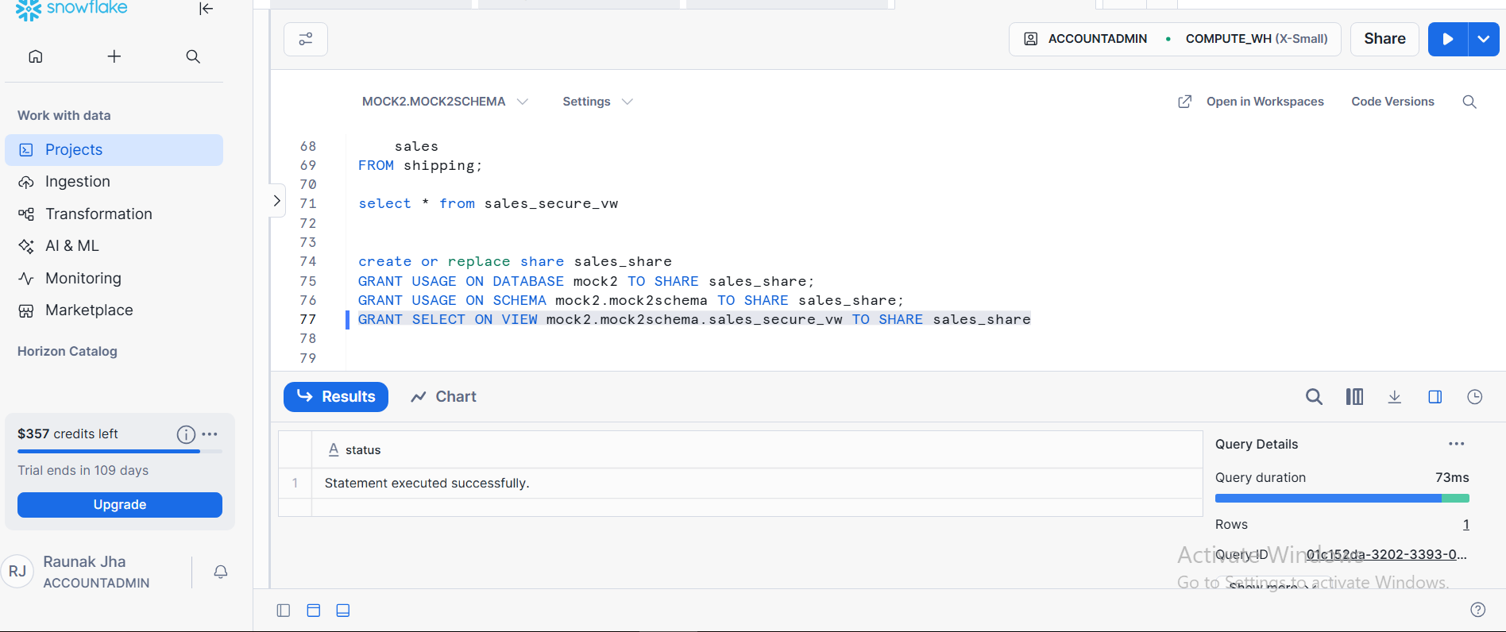

TASK 5: DATA SHARE IS ACTIVE
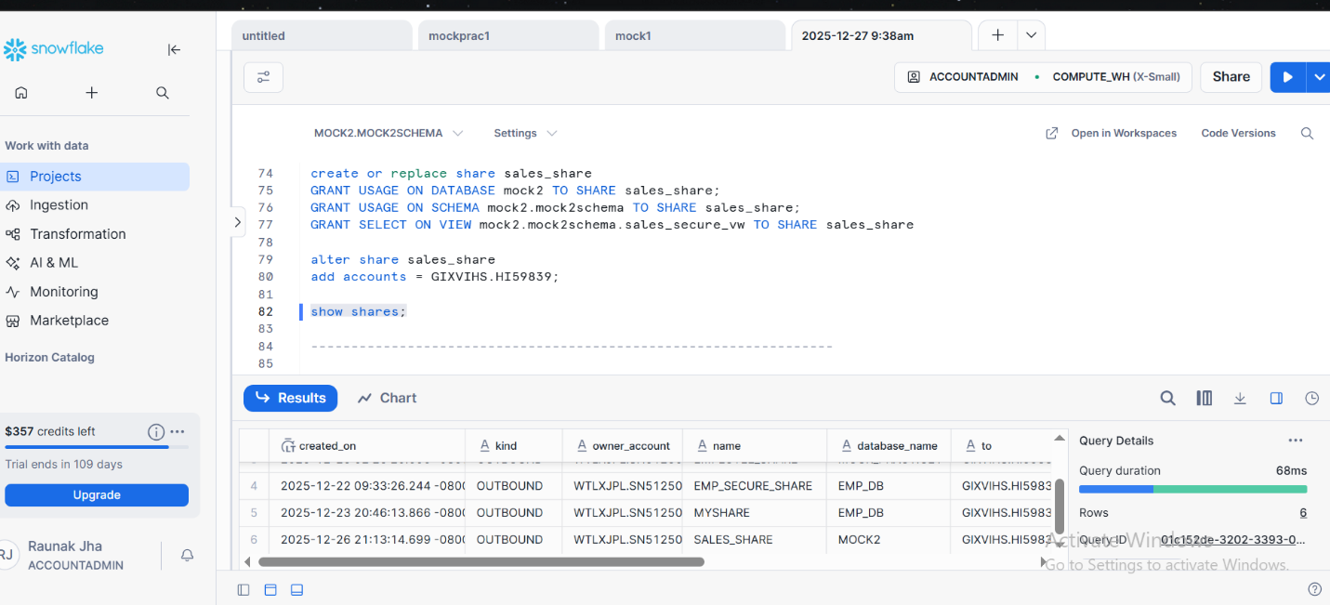

Q3: SNOWFLAKE ZERO COPY CLONING OF DATABASE SCHEMA AND TABLE
TASK 1: DATABASE CLONING
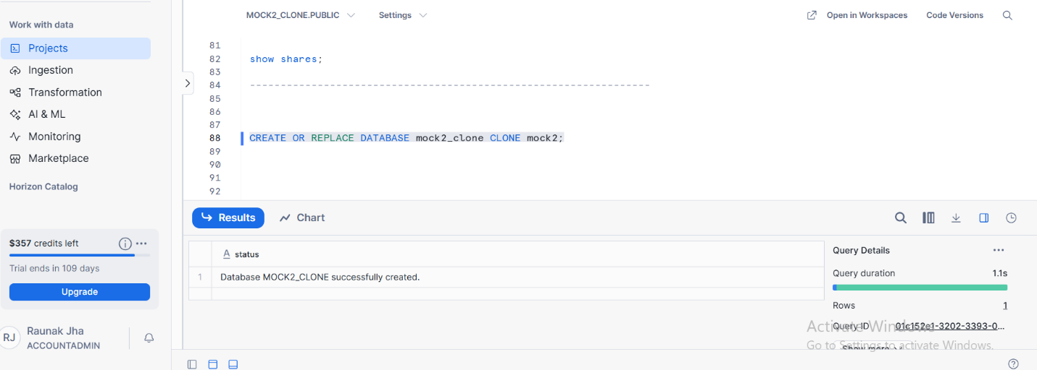

TASK 2: SCHEMA CLONING
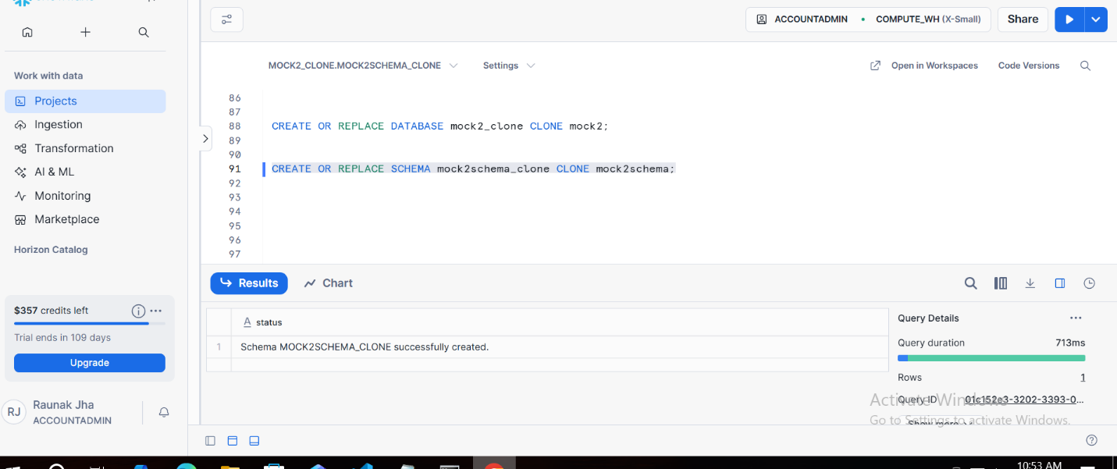

TASK 3: TABLE CLONING
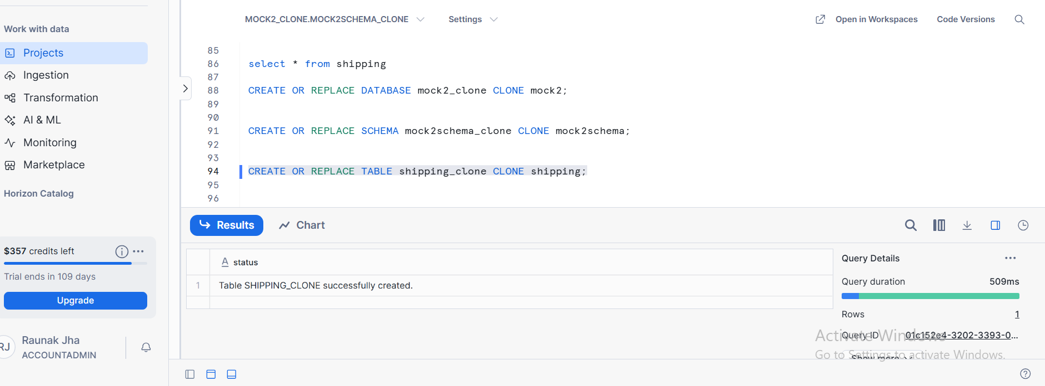

TASK 4 : DML Operation
We have performed dml operation of all showing the delete one in clone table
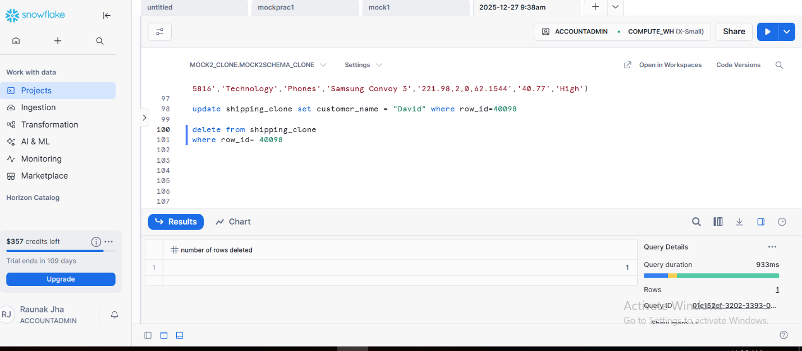

TASK 5: SOURCE TABLE REMAINS UNCHAGED
Source table still has data with id = 40098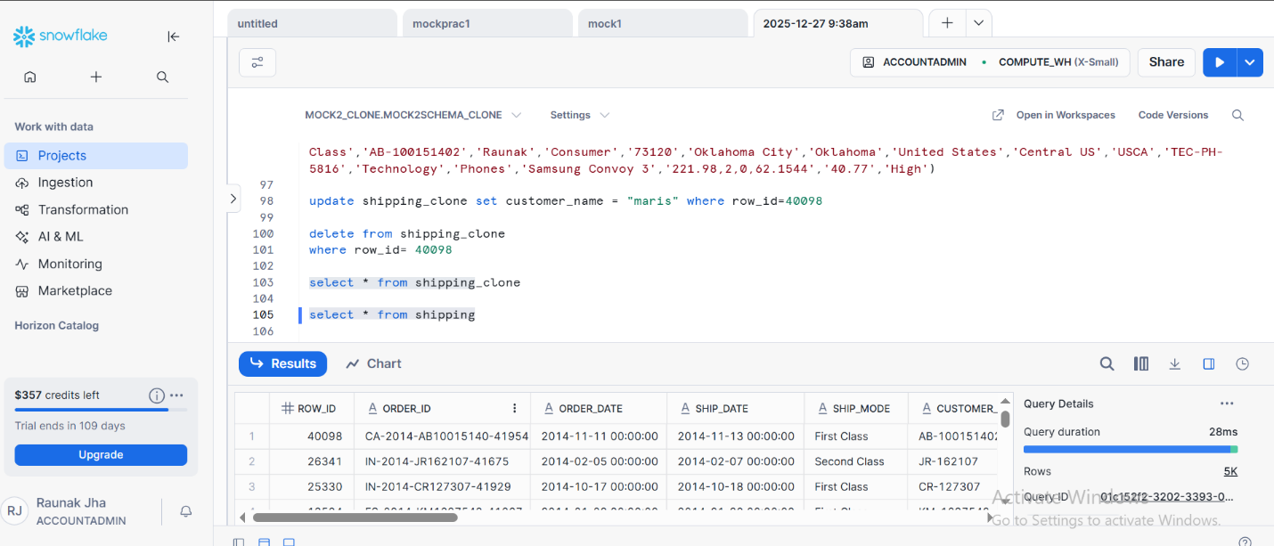

Q4 : Dynamic data masking and row Access policy using roles
TASK 1: SQL USED FOR ROLE CREATION AND PRIVILEDGE GRANTS
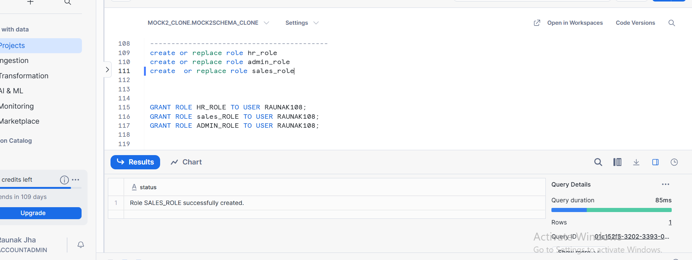

PRIVILEDGE GRANTS
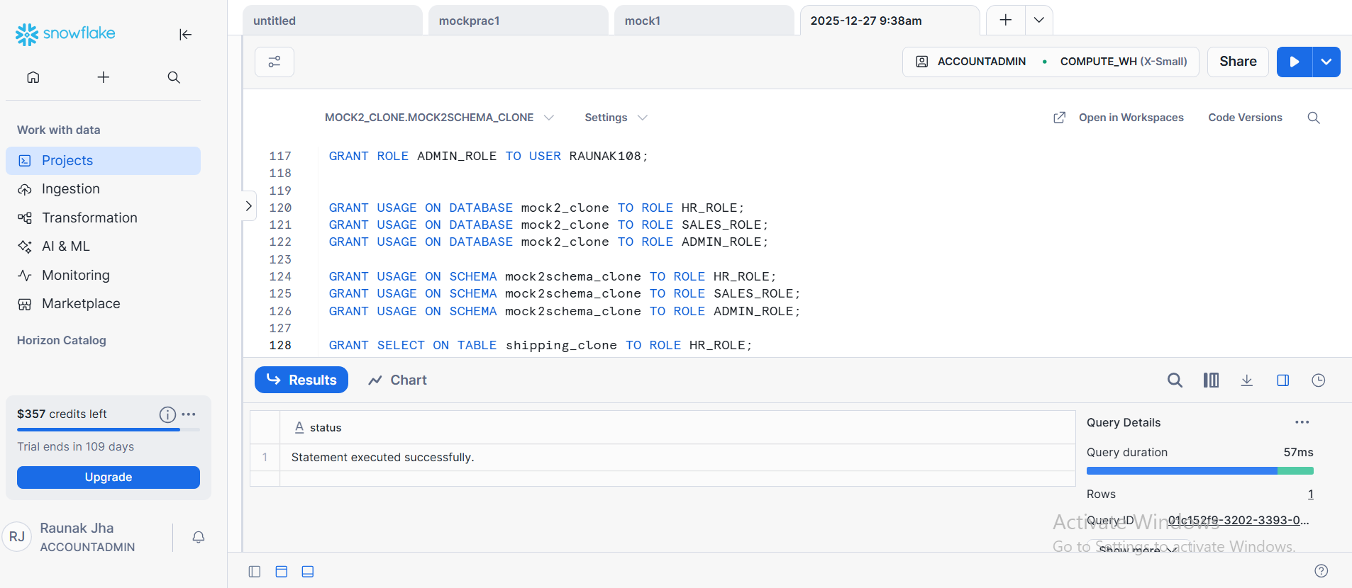

TASK 2:
MASKING POLICY CREATION OF NUMBER AND STRING
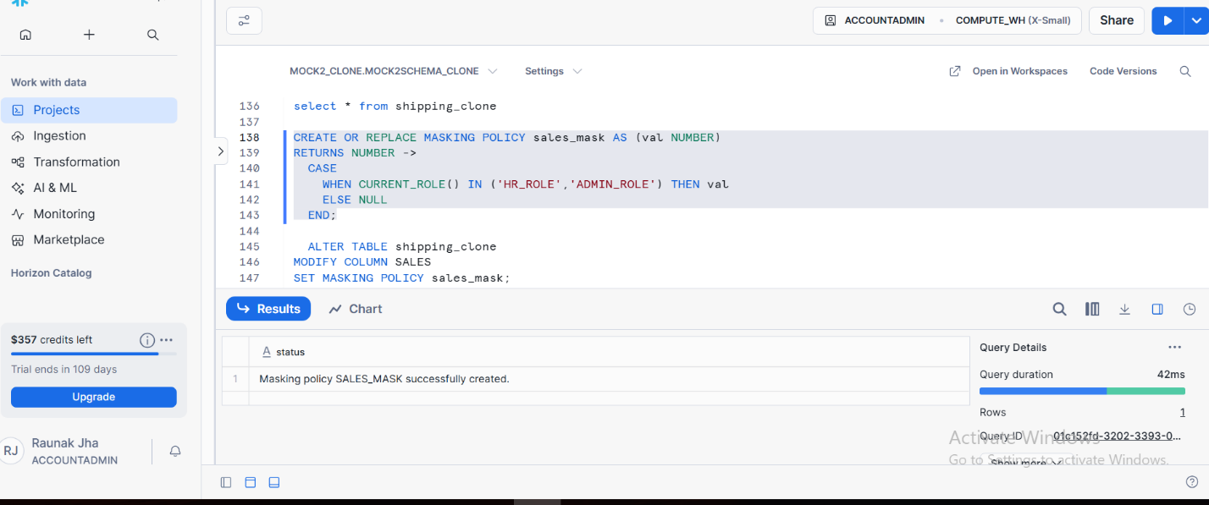
STRING MASKING POLICY CREATION
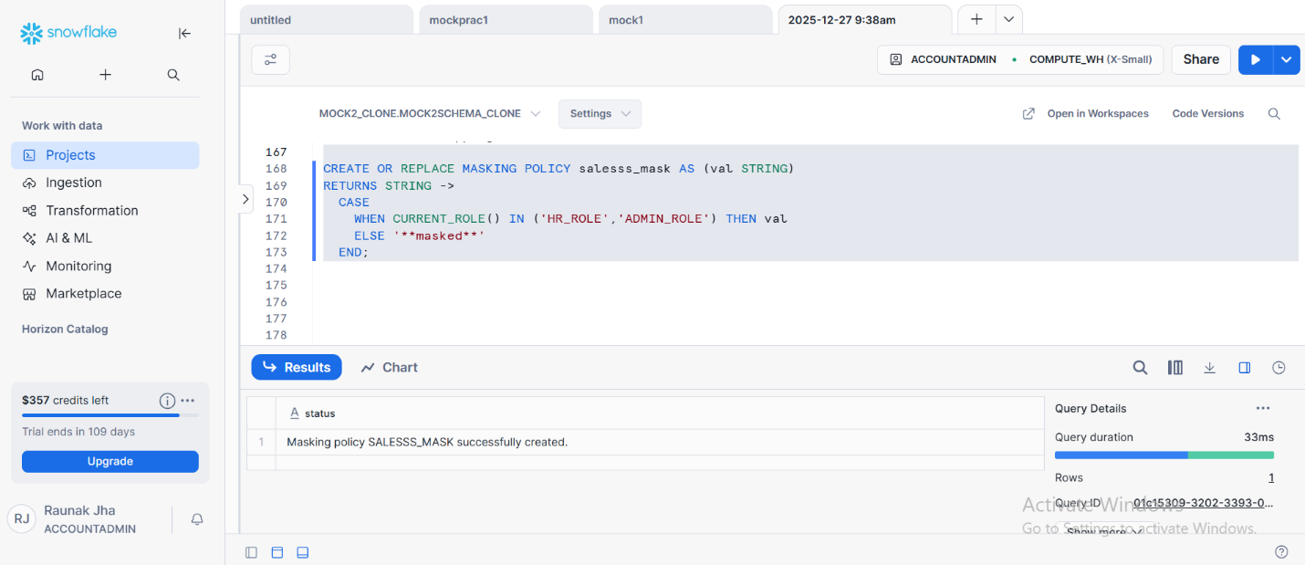

TASK 3 :
APPLYING MASKING POLICIES OF NUMBER AND STRING MASKING
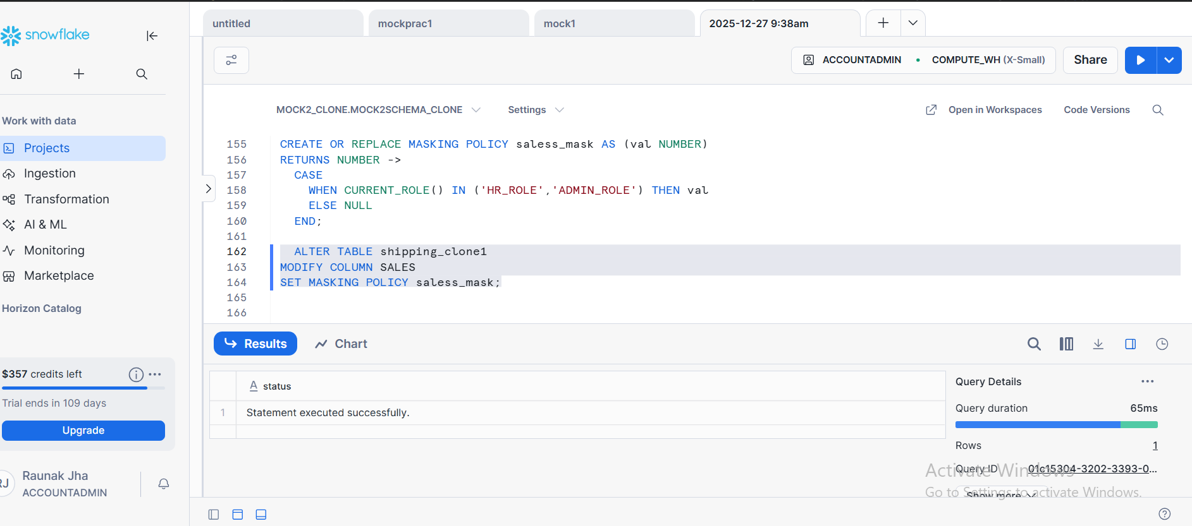

APPLYING MASKING POLICY STRING
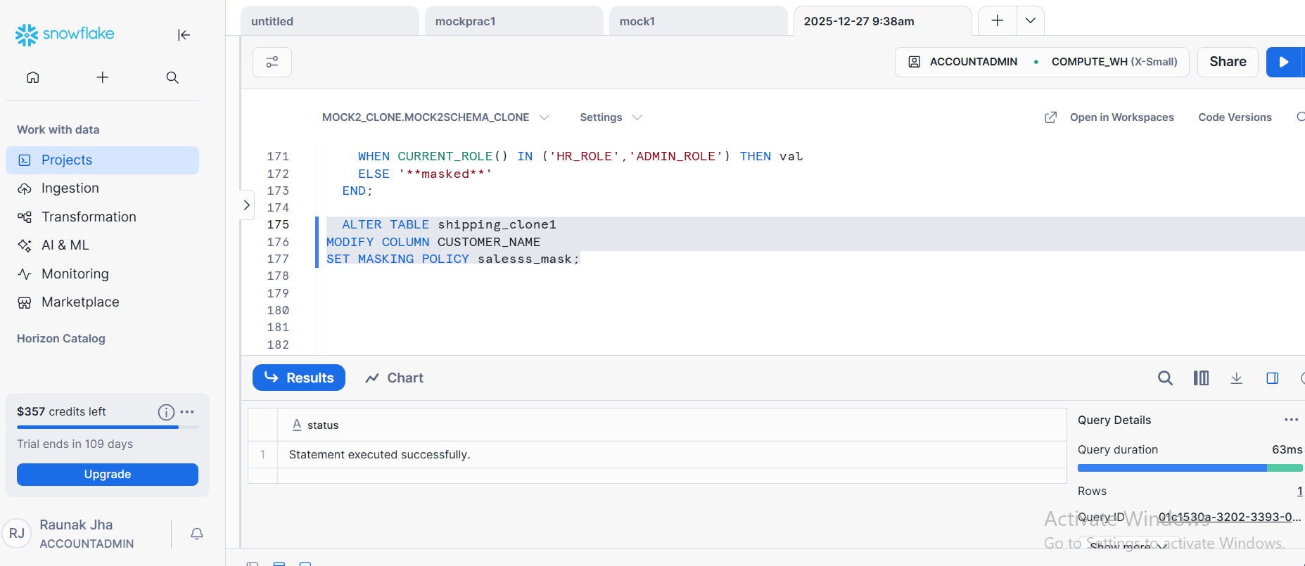

TASK 4 :
ROW ACCESS POLICY CREATION AND ASSIGNMENT
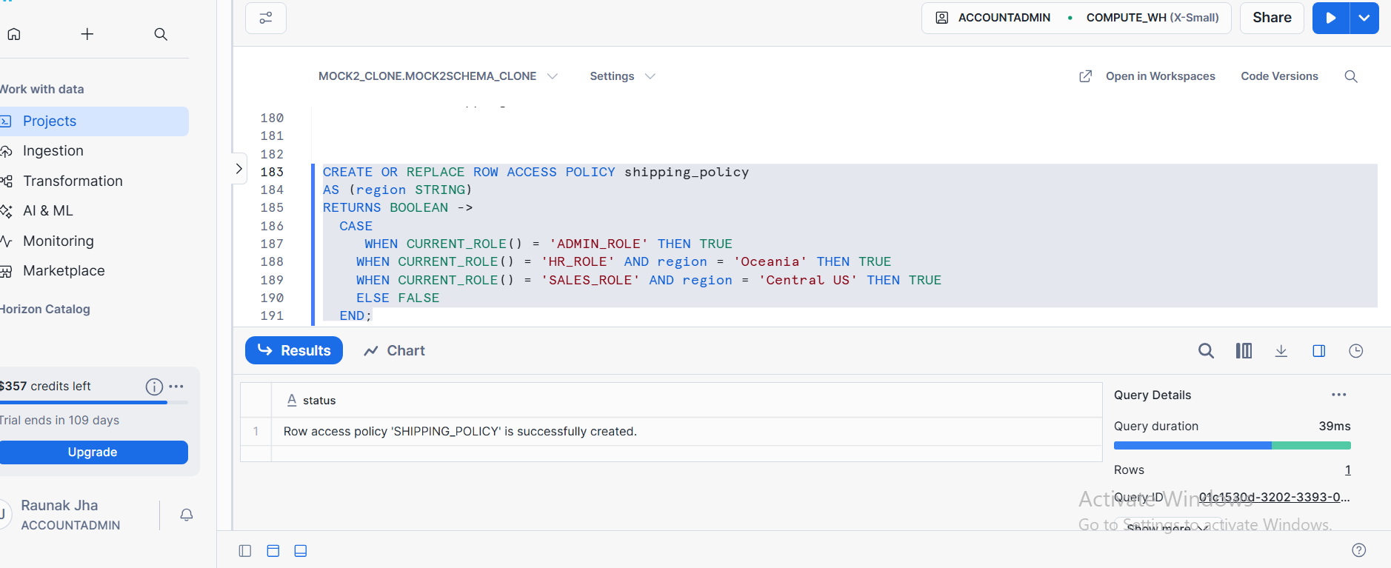
ASSIGNING ROW ACCESS POLICY
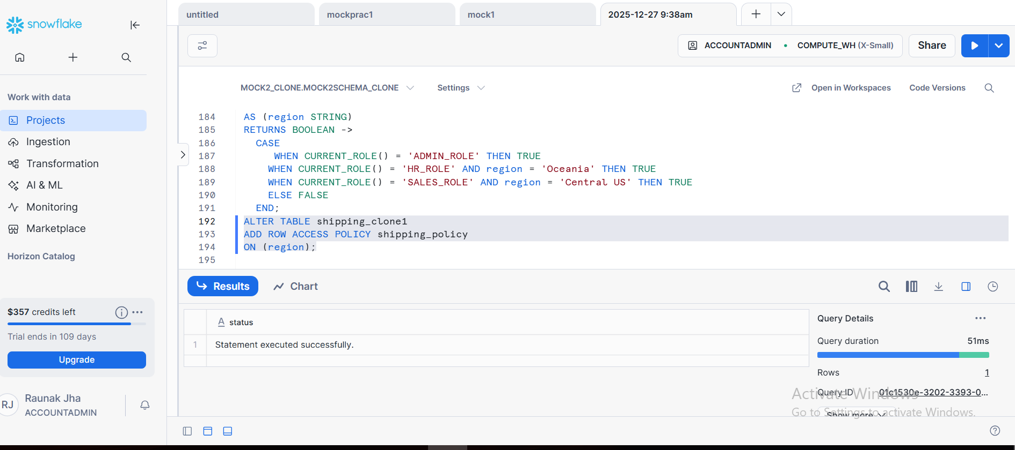

TASK 5 :
MASKED VS UNMASKED COLUMN VALUES
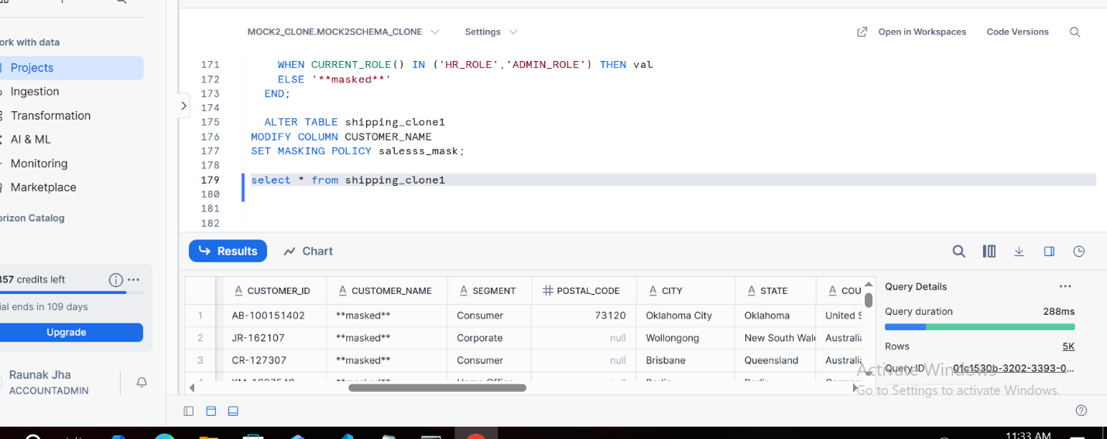

UNMASKED COLUMN VALUES
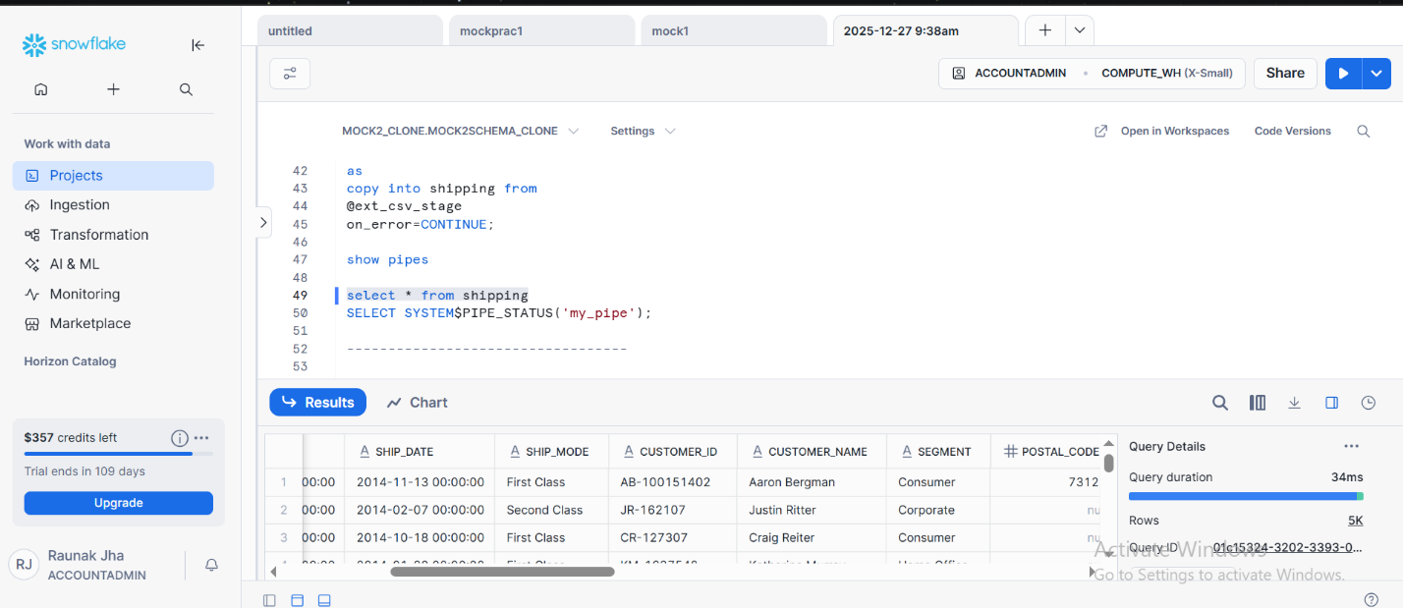

ROW ACCESS POLICY USING DIFFERENT ROLES
USING SALES ROLE
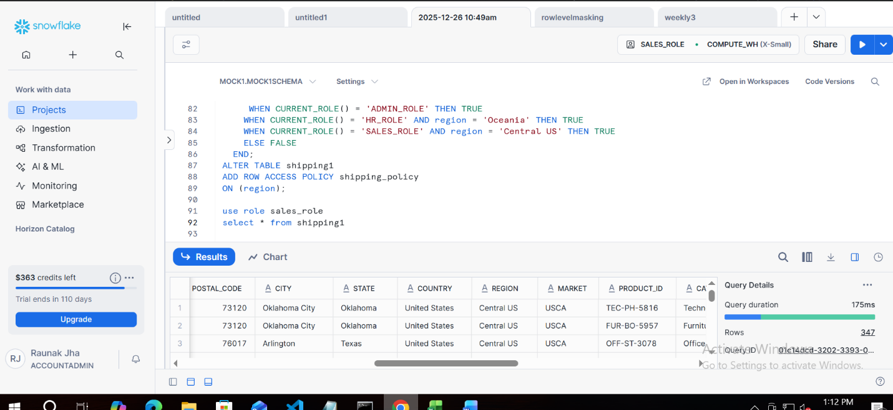
USING HR ROLE
